Parker Area Historical Society Comments on Proposed Sale/Annexation of Twin Houses Property

History.
For the record, the 14 acres of land at the southeast corner or Parker Rd and Stroh Rd (6940 Stroh Road) has historical significance in the development of Parker, Douglas County and Colorado.
William W. Cantril came to the Cherry Creek area in 1859 and settled on what later would come to be known as the Allison Ranch, (6940 Stroh Road property) He built and maintained a sawmill on this property using trees felled from nearby land. Cantril built and donated the first courthouse for Douglas County, using lumber cut from this property.

Around 1890, F. H. Allison replaced Cantril on the sawmill site, Cantril having moved on to Castle Rock. Allison constructed one of the best waterworks on the creek using tubing which carried water through ditches to a reservoir which was then used during dry periods to irrigate his crops.

About two years later, the water from a spring on the Allison Ranch was analyzed and it was shown to have medicinal properties, without any injurious sulphates. Allison became intrigued with the idea of having a hot spring resort. He contracted for the building of an eight-room house for his resort. He named it Ponce de Leon Chalybeate Springs. The resort was an almost instant success, and another eight-room building was added to the property.

By the turn of the century, Parker had become a draw for Easterners with consumption (tuberculosis).

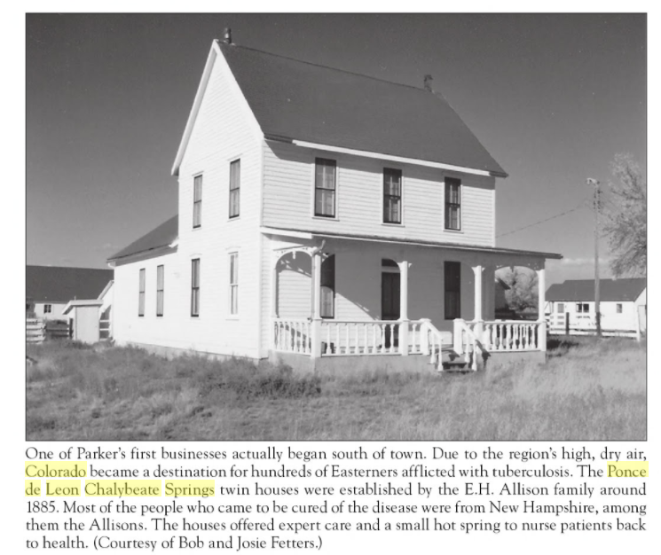

F. H. Allison was the proprietor of the health resort into 1897. From 1897 thru 1900 a man named L. G. Smith ran the operation.

William O’Brien and his wife Annie rented the hotel operation about 1900. William farmed, took on various carpentry projects, and raised a small herd of dairy cattle, while Annie operated the hotel (by this time dubbed the Twin Houses) for health seekers, principally from Vermont.
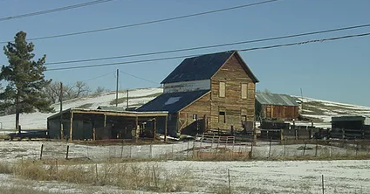
The O’Briens eventually purchased their own land, 360 acres adjoining the Allison land on the East side, and farmed it until 1919, when they sold out and moved into Parker.

After about a decade of popularity, business fell off, and eventually one of the houses was turned into a barn. It is the structure that still stands just south of the intersection of Stroh Road and Highway 83. In 1970, Mrs. Louis Kraglund purchased the other twin house and had it moved about four miles north of Parker to her property. It was used as a specialty dress shop for a time, but now is unoccupied.

Recommendation.

Due to its historic significance, the Parker Area Historical Society would recommend photographs be taken of the existing structures and archiving of these documents in the Douglas County History Research Center. Further, if the developer or Town of Parker is so inclined, the remaining Twin structure could be moved, restored and saved at Preservation Park.

Conclusion.
Thank you for the opportunity to comment on the proposed site plan and annexation.

Jan Truskolaski,
President, Parker Area Historical Society
December 29, 2017

