S. PARKER RD. & STROH RD.
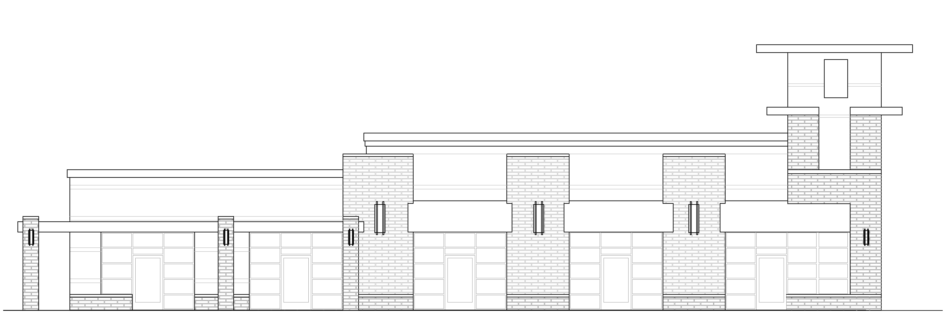

DESIGN GUIDELINES

PARKER, COLORADO
FEBRUARY 2017

Introduction
S. Parker Rd. and Stroh Rd. is a 14.6 acre property located in Parker Colorado. The Commercial project is anticipated to be a high quality commercial center. The project will occupy a high visibility location and provide desirable amenities to the Town of Parker and the surrounding community.

Purpose
These Guidelines (hereafter referred to as “Guidelines”) and this 14.6 acre property (hereafter referred to as the “Project”) are intended to assist in ensuring the Project develops into a viable, high-quality commercial center, providing needed and desirable services for the Town of Parker. These Guidelines will provide flexibility and encourage creativity while ensuring consistent quality and design. Where flexibility is specifically provided for in these design guidelines, the Town of Parker’s Planning Department shall have the authority to interpret or make judgments as to the necessity and extent of the same.
Governing Documents
The Project shall comply with the following requirements (hereafter referred to as the “Governing Documents”), listed in “descending order” (that is, an item in the following list takes precedence over any item below it in the list).
- Town of Parker regulations, ordinances, codes and other requirements.
- A site specific, previously approved Final Site Plan/Architectural document.
- These Design Guidelines.
Administrative review by the Town
To facilitate development and review of each phase, for the town deems appropriate.

Building Location: Changes, modifications, or adjustments of building locations shall be considered an Amendment as determined by the Town of Parker or Site Plan review if they do not vary from the principals contained in these Design Guidelines, maintain the general building locations and follow the intent of the Preliminary Overall Plan.
Off-street Parking: Change affecting off-street parking shall be considered an Amendment as determined by the Town of Parker or Site Plan review so long as the parking provided for each use or tenant meets the minimum requirement of the Governing Documents.
An applicant may appeal such decisions rendered by the Town of Parker’s Planning Director in regard to the application of these guidelines during the administrative review process. Appeals will be through the Town’s Planning Commission.

Phasing
The Project will be developed in phases as the market conditions dictate. The Final Site Plan for each lot will be submitted and approved individually. Approved Site Plans are to be adhered to, no changes or modifications may be made without prior approval. The Town of Parker will determine the process for modifying the Approved Site Plan.

Site Design and Elements
Objective
The overall objective is to develop this site in an organized and logical fashion by placement of buildings, architectural continuity, roadways, parking and pedestrian areas, while providing a project with texture, visual interest, sensitivity to the surrounding environment and human scale. Secondary objectives are to promote ease of use from vehicular and pedestrian levels in conjunction with providing way finding throughout the site, allowing for various landscape opportunities, pedestrian areas, and encourage cross-site pedestrian traffic. S. Parker Rd. frontage will be of great importance in developing the objectives above and creating visual texture for all residents and visitors to the community. The elements below will develop the objectives stated above.
Frontage
Create an appealing project perimeter will occur by varying building placement and minimizing impact of building elevations and parking areas from frontage areas. The frontage will utilize landscape improvements and building placement to reinforce and define views into and through the site.
Gateway
Primary vehicular gateways will be located in relation to adjacent roadways and internal traffic patterns.
Pedestrian gateways will be provided into and within site at key locations.
Vehicular Circulation and Parking
Conflicts between vehicles and pedestrians will be minimized by clearly defining crossing and pedestrian circulation. Traffic patterns shall be sensitive to service area traffic and parking areas by minimizing interaction. Where possible alignments of internal roadways will be simplified and number of access points into and out of parking areas onto primary internal roadways will be configured for ease of the user.

Pedestrian Areas and Circulation
Pedestrian nodes are encouraged to established and create a localized sense of place and incorporate pedestrian scale and design elements. These nodes will be located with logical connectivity to allow the user to experience the projects vernacular and move them through the site. Pedestrian connectivity shall be provided for safe and practical circulation corridors, through parking lot islands and along buildings. Internal sidewalks within the development shall be a consistent dimension where shared with bicycles. Major pedestrian crossings should be located where vehicular traffic is required to stop.

Outdoor pedestrian areas may be enhanced with paving materials, plant material and site furnishings. Site furnishings such as benches, trash receptacles and bike racks are encouraged to create a pedestrian scale environment. Site furnishings shall be Steelsites RB Series by Victor Stanley. Planter wells, sidewalk grates are encouraged where practical.

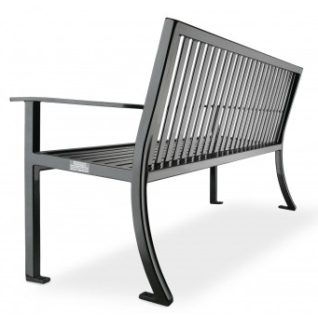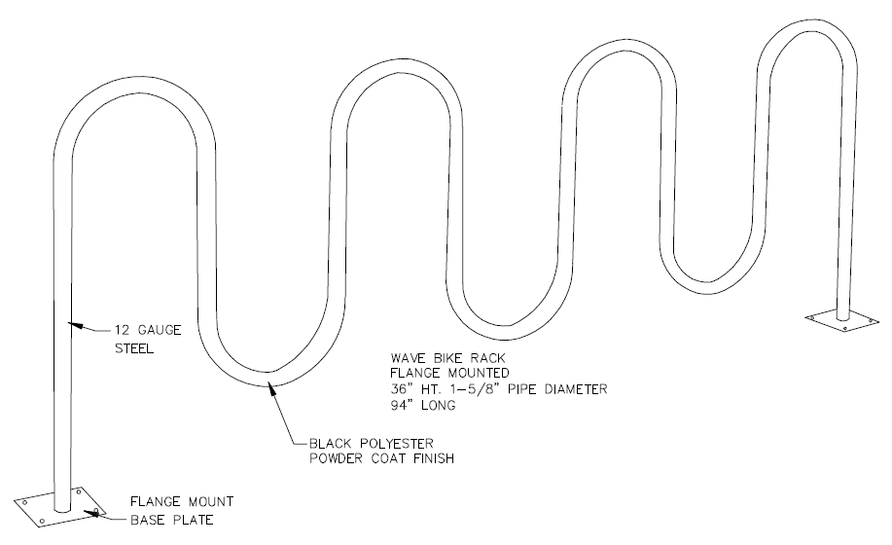

Views and Visibility
As noted in the objectives above, views and visibility through the site are of high importance. The project will incorporate openings in perimeter landscape buffers to maintain view corridors. Maintaining view corridors and maximize appealing views from outdoor pedestrian nodes shall happen areas where possible. Structures will be located to maximize visibility from both S. Parker Rd. and Stroh Rd. and avoid blocking interior uses from view and promote the recognition of tenant while approaching and upon arrival to the site. To maintain an aesthetically pleasing appearance views of service areas and mechanical equipment related elements shall be minimized with screening using architectural elements and landscaping.

Site Signage
Provide project signage and other identification elements visible from S. Parker Rd. as landmark features. Utilize high-quality building materials for signage and monumentation. All site signage shall be in accordance with the Town of Parker regulations and ordinances, where applicable, and these design guidelines. Any modifications to the city sign code will need to be approved through the town. All signage shall be submitted to the Town of Parker for approval prior to manufacturing and installation.

Lighting of signage shall be integral to the structure of the sign or from an otherwise concealed source. Painting of signs on buildings, walls, doors, windows, equipment, monuments, etc. is not permitted. Monument signs shall be provided as a part of an overall center signage program, and shall be approved by the Town of Parker. Signage code modifications allowed by the town are to allow one multi-tenant freestanding sign for the shopping center and not allow individual freestanding signs on each lot. The approved shopping center signage shall be based on the Town of Parker regulations and will be reviewed and approved on an individual basis. Said sign must be setback the minimum 10 feet from the property line. Each buildings individual wall sign will be reduced by that proportional share of signage on the multi-tenant sign for that building, subject to site plan/architectural review approval by the City Council. Regulatory signs shall not be mounted on building, building elements, columns, light poles, site furnishings or fixtures.
Site Walls and Fencing
Provide site walls in locations as necessary utilizing high-quality building materials. Stagger, step and/or terrace retaining walls where possible to reduce their scale. Where multiple walls are used, allow enough appropriate plant materials if possible.

Site Lighting
Provide a hierarchy of project-specific, high-quality site lighting throughout the Project. Provide a safe environment for moving through the public areas of the site during nighttime hours. Limit the impact of site lighting on adjacent properties. All exterior lighting shall be LED. Finish color of poles, fixtures and wall-paks shall be dark bronze. Wall mounted/building mounted shall be down cast. Outdoor pedestrian areas may incorporate only pedestrian and pathway/bollard lighting type into their site-specific design. All site lighting throughout the site shall utilize the same standard style and color as that used for the site furnishings. All similar lighting types, i.e. - parking area, pedestrian and pathway/bollard shall be of the same style, finish and color. All parking area lighting shall utilize full cutoff type or shielded fixtures. All parking area and pedestrian light fixtures shall be LED. Up lighting of buildings or landscape is discouraged.
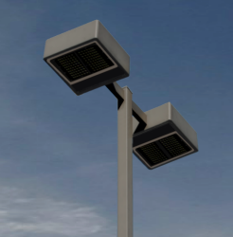

Landscape and Irrigation Design
The goal of the Landscape design guidelines is to create attractive environments, soften visual impacts, and establish high success rate of survival, while ensuring an overall cohesiveness/interconnection of plant selection, design intent, define views into and through the site, and its compatibility with the overall established landscape theme. The following design guidelines apply to the entire Parker Pointe Development including all privately owned lots, shared drives, and Public ROW’s. All Landscape and irrigation designs shall be in accordance with the Town of Parker’s Landscape Regulations, where applicable, and these design guidelines.

Landscape Design Theme
The plant material chosen will be compatible with the project surroundings, with a focus on locally indigenous, historically adaptable, low maintenance, seasonal colors & texture palette of turf, plants, and trees. Landscape designs is encouraged utilize water conservation including the concepts of xeriscaping as noted in the Town of Parker’s Landscape Regulations.

Street Right of Ways and Common Access Drives Trees
All public right of way and along common access roads with in this development shall consist of the following trees, spaced 40’ on center minimum, within the tree lawns/plant beds per the Town of Parker Landscape Regulations:
A. Quercus Alba – Swamp White Oak
B. Gymnocladus dioica 'Espresso' - Espresso Kentucky Coffeetree
C. Gleditsia triacanthos inermis 'Skyline' - Skyline Locust
D. Catalpa speciose - Northern Catalpa
E. Quercus macrocarpa - Burr Oak

-Common internal drive shall have the following trees along the privately owned lots:
LOT 1, Northern road property line: Northern Catalpa
LOT 1 – Lot 3, Western road property line: Espresso Kentucky Coffeetree
LOT 4, Western road property line: Spring Snow White Crab
LOT 5 – Lot 7, Western road property line: Swamp White Oak
LOT 7, Southern road property line: Northern Catalpa
LOT 8, Northern road property line: Burr Oak
LOT 11, Eastern road property line: Swamp White Oak
LOT 11, Northern road property line: Skyline Locust
LOT 12, Southern road property line: Skyline Locust
LOT 12 – Lot 14, Eastern road property line: Espresso Kentucky Coffeetree

Recommended Plant List
DECIDUOUS SHADE TREES
Acer grandidentatum Schmidt/Big Tooth Maple
Catalpa speciosa Northern Catalpa
Celtis occidentalis Western Hackberry
Gleditsia triacanthos inermis 'Imperial' Imperial Locust
Gleditsia triacanthos inermis 'Shademaster' Shademaster Locust
Gleditsia triacanthos inermis 'Skyline' Skyline Locust
Gymnocladus dioica 'Espresso' Espresso Coffeetree
Quercus Alba Swamp White Oak
Quercus macrocarpa Burr Oak
Sophora japonica Japanese Pagoda Tree
Tilia cordata 'greenspire' Greenspire Linden

ORNAMENTAL DECIDUOUS TREES
Amerlanchier x grandiflora 'Autumn Brilliance' A. Brilliance Serviceberry
Acer ginnala Amur Maple
Cercis Canadensis Eastern Redbud
Crataegus crus-galli var. inermis Thornless Hawthorn
Koelreuteria paniculata Goldenrain Tree
Malus ‘Prairiefire’ Prairiefire Pink Crab
Malus x ‘Spring Snow’ Spring Snow White Crab
Prunus virginiana 'shubert' Canada Red Chokecherry
Quercus gambelii Gambel Oak
Syringa reticulata Japanese Tree Lilac

EVERGREEN TREES
Abies concolor White Fir
Picea pungens var. glauca Colorado Blue Spruce
Pinus aristata Bistlecone Pine
Pinus edulis Pinon Pine
Pinus nigra Austrian Pine
Pinus ponderosa Ponderosa Pine
Pinus sylvestris Scotch Pine
Pseudotsuga menziesii Douglas fir

DECIDUOUS SHRUBS
Amelanchier Canadensis Shadblow Serviceberry
Berberis thunbergii ‘Atropurpurea Nana’ Crimson Pygmy BarberryCaryopteris x clandonensis Blue Mist Spirea
Cercocarpus intricatus L.L. Mountain Mahogany
Chamaebatiara millefolium Fernbush
Chrysothamnus nauseosus 'Dwarf Blue' Dwarf Rabbitbrush
Fallugia paradoxa Apache Plume
Forestiera meomexicana New Mexico Privet
Hypericum frondosum 'Sunburst' Sunburst Hypericum
Ligustrum vulgare ‘Lodense' Lodense Privet
Perovskia atriplicifolia Russian Sage
Physocarpus opulifolius 'Donna May' Little Devil Ninebark
Prunus besseyi 'Pawnee Buttes' Pawnee Buttes Sand Cherry
Prunus besseyi 'Western' Western Sand Cherry
Rhus aromatica 'Gro-low' Gro-low Sumac
Rhus glabra 'Cismontana' Rocky Mountain Sumac
Rhus trilobata Three Leaf Sumac
Ribes alpinum Alpine Currant
Spiraea nipponica 'Snowmound' Snowmound Spirea
Syringa patula 'Miss kim' Miss Kim Lilac
Syringa vulgaris Common Purple Lilac
Viburnum rhytidophylloides 'Alleghany' Leatherleaf Viburnum

EVERGREN SHRUBS
Arctostaphylos x coloradensis 'Chieftain' Chieftain Manzanita
Arctostaphylos x coloradensis 'Panchito' Panchito Manzanita
Arctostaphylos uva-ursi Kinnikinnick
Cytisus purgan 'spanish gold' Spanish Gold Broom
Juniperus horizontalis 'Blue Chip' Blue Chip Juniper
Juniperus x media Sea Green Juniper
Juniperus sabina 'Buffalo' Buffalo Juniper
Mahonia aquifolium compacta Comp. Oregon Grape Holly
Pinus mugo 'slowmound Slowmound Mugo Pine
Yucca filamentosa Adam's Needle

ORNAMENTAL GRASSES
Andropogon gerardii Big Bluestem Grass
Calamagrostis acutiflora 'Karl Foerster' Feather Reed Grass
Festuca glauca 'Elijah Blue' Blue Fescue Grass
Helictotrichon sempervirens Blue Avena Grass
Miscanthus sinensis Maiden Grass
Nassela tenuissima Mexican Feather Grass
Oryzopsis hymenoides Indian Rice Grass
Panicum virgatum 'Shanadoah' Red Switch Grass
Pennisetum orientale 'Karley Rose' Oriental Fountain Grass
Schizachyrium scoparium Little Bluestem Grass

PERENNIALS
Agastache rupestris 'sunset' Sunset Hyssop
Aquilegia chrysantha 'paprika' Pink Yarrow
Aquilegia sp. Rocky Mountain Columbine
Centranthus ruber Jupiters Beard
Cerastium tomentosum Snow-in-Summer
Coreopsis verticillata 'Moonbean' Moonbean Coreopsis
Delosperma dyeri 'Psdold' Red Mountain Ice Plant
Echinacea purpurea 'Alba' White Coneflower
Eriogonum umbellatum Buckwheat
Hemerocallis 'Stella De Oro' Stella D'oro Daylily
Knipofia uvaria Torch Lily
Liatris spicata Gayfeather
Nepeta faassenii ‘Walker's low' Walker's Low Catmint
Penstemon strictus R.M. Penstemon
Salvia pachyphylla Mojave Sage
Sedum spectabile 'Autumn joy' Autumn Joy Sedum
Vinca minor 'Bowles' Periwinkle
ANNUALS (PLANTER POTS AND OWNER SPECIFIED AREAS ONLY – MAY INCLUDE BUT NOT LIMITED TO)
Antirrhinum majus Snap Dragons
Cosmos bipinnatus Cosmos
Gomphrena globosa Globe amaranth
Ophiopogon planiscapus 'Nigrescens' Black Mondo Grass
Pennisetum setaceum 'Rubrum' Purple Fountain Grass
Salvia sclarea Clary Sage
Tropaeolum majus 'Alaska' Nasturtium

Plant Material Specifications
- Plant calipers, heights, container sizes and installation speciﬁcations shall conform to the American Association of Nurserymen and the Colorado Nursery Act Rules and Regulation Standards.
- Minimum planting/installation sizes of plant material shall conform to Town of Parker Landscape Standards.
- Mulches: Rock Mulch are required per the following speciﬁcations:
  - Rock mulch: 4" dia. multi-color river rock cobble to a minimum depth of 4”.
- Acceptable locations for mulch types:
  - Tree saucers in turf areas shall be wood mulch.
- Shrub Beds are permitted to have all rock mulch (as speciﬁed above) except the individual plants which must have a double shredded cedar wood mulch, not chipped or chunks, ring around them. Cedar mulch shall be a ﬁbrous material (1/1 to 3/1 pieces) capable of matting together and interlocking when moistened and settled. Tree wood mulch rings shall be 3-4’ in diameter, wood mulch rings around shrubs shall be the size of the rootball container.
- Building foundations may have a 3-4’ wide border of speciﬁed rock mulch if not next to hardscape.
- Geo Textile Fabric (Install and maintain in accordance with manufacturer's specifications): Dewitt pro-5 weed barrier fabric under all rock mulch shrub beds. No landscape fabric shall be used in wood mulch areas.
- Approved Turf Grasses (See Town of Parker’s Landscape Regulations):
  - Sod (Install and maintain in accordance with manufacturer's specifications):
    - Legacy Buffalo Grass: Located through Green Valley Turf Company, 13159 N. US Hwy 85, Littleton, CO 80125, (303) 798-6764.
    - Canadian Blue Fescue: Located through Turf Masters Company, 3327 Giddings Road, Fort Collins, CO 80524 (970) 493-8311.
    - Prior to seeding or sodding, fertilizer with a 10-10-10 or comparable ratio shall be spread evenly over the surface at the rate of five (5) pounds per thousand square feet (1/2 pound of actual nitrogen per 1000 square feet).
- Tree Wrap: Standard nursery crepe tape not less than 4” wide, designed to prevent winter sun-scald. Secure every 24” by taping.
- Steel Edger: All edging shall be 14 gauge, overlap at joints a minimum of 6-inches, and shall be fastened with a minimum of 4 pins per each 10 foot section. The top of all edging material shall be a rolled top and 1/2 inch above the finished grade of adjacent lawn or mulch areas. Color: Green.
- Stakes and Guys: Stakes for Trees shall use the following:
  - Use treated woods posts w/ 12 gauge galvanized wire, grommeted tree straps at end of wire.
  - 24'' x 3/4'' p.v.c. markers (typical) over wires.
  - For deciduous trees 3” cal. and under, use 2 guy assemblies.
  - For deciduous trees 3” cal. and over as well as all evergreens, use 3 guy assemblies.

Irrigation Design
The irrigation design shall be in accordance with the Town of Parker’s Landscape Regulations. At a minimum, the irrigation design shall have the following:
- The irrigation system be installed, to the maximum extent possible, to conserve water by using the following devices and systems: matched precipitation rate technology on rotor and spray heads (wherever possible), rain sensors, and multi-program computerized irrigation controllers featuring sensory input capabilities and smart ET technology.
- All non-turf planted areas will be drip irrigated. Sodded/seeded areas shall be irrigated with spray or rotor heads at 100% head-to-head coverage.
- The system will have appropriate backflow prevention devices installed to prevent contamination of the potable source per local, state, and federal code.

Landscape Maintenance
Landscape maintenance is the responsibility of the individual lot owner/developer unless otherwise set forth in development agreements, purchase agreement, declarations, or any other agreements. Landscape and irrigation maintenance shall consist of all regular and normal maintenance practices of landscaping including weeding, irrigation, fertilizing, pruning, mowing, and irrigation leak prevention. Plant materials that exhibit signiﬁcant levels of insects, pests, diseases and/or damage shall be appropriately treated by the individual lot owner/developer. All dead plant materials shall be removed and replaced immediately by owner/developer with living plant materials that match the town approved landscape plans.

Architectural Concepts
The goal of the Architectural Concepts is to promote the development of a high quality retail center that will endure as a lively and exciting shopping environment. This concept will provide flexibility and encourage creativity while ensuring consistent quality and design.

The architectural vocabulary is based on a variety of materials ranging from integrally colored concrete block, synthetic stone veneer, metal roofing and fabric awning accents. The objective is to achieve consistency among elements through the use of materials. Integration of architectural style and character with national tenants that have distinguished signature design shall be allowed.
Exterior Materials
Provide human interest, scale and variety through the use of different materials and colors.

Material transitions shall be clean and complete and shall reflect the traditional locations and use of the material. Colors shall be complementary and varied, and shall blend well with adjoining architectural styles and the natural environment with bright colors only used for accents. At least 30% of each facade shall be textured masonry units, stone, textured form liner or tile. Concrete masonry construction shall be integrally colored that is in keeping with the approved material palette. See the approved material/color palette for acceptable materials.

Glazing and Windows
Promote visual interest in products and merchandise for pedestrian traffic with use of glazing and windows. Provide consistency with design in all storefront, frames, including doors, throughout the center. Doors shall have medium-size style and rail. National tenant Prototype configurations of storefront may be used. Glass shall be clear insulated system.
No tinted or reflective glazing will be allowed. Windows and storefront shall be placed to provide direction to major entries. Windows shall not be placed at loading and service areas. Placement of windows shall provide interesting views to the exterior and interior environments.
Mechanical Equipment
Reduce the visual and acoustical impacts of mechanical systems. Rooftop equipment, piping, vents, flashings and parapet back panels shall be screened from view. Mechanical equipment, transformers, meters, etc. should be located out of public view wherever practical to do so or appropriately screened with landscaping or architectural elements.

Architectural Massing and Scale
Provide changes in scale and form to complement the overall architectural style of the project. Shifts in the building footprint and articulations of the building parapets and rooflines shall be provided. Shifts in the parapet shall not happen at regular intervals. Provide appropriate quantities of landscape and open space to create an attractive and visually pleasing edge.

Standards
- Facades greater than 50 feet, measured horizontally shall have projections or recesses that extend at least 10% of the entire length of the façade.

- The use of Timbers are encouraged at prominent building locations.

- Ground floor facades with public entrances that face major pedestrian ways shall have arcades, display window, entry areas, awnings, or other such features along no less than 25% of their horizontal length and utilize a min of 20% synthetic stone veneer.

- Primary building entrances shall be clearly defined with architectural treatments and use of premium exterior finish materials.

- Accessory structures shall be compatible with the main buildings and be compatible with adjacent buildings.

- Loading docks, outdoor storage and service areas and accessory use entrances shall be screened from public streets where possible and operate with sensitivity to pedestrian traffic.

- Encourage a tri-part design consisting of a base, middle and top with higher quality materials at pedestrian level and accent cornice lines at the top of the wall.

- Encourage and entice pedestrians year round by placing outdoor seating/dining areas on south facing exposures.

- Rear and parking facing facades shall incorporate 360 degree architecture.

Building Signage
Regulate the use and display of signage to promote aesthetics and ensure an orderly and consistent appearance while providing for tenants, trademark identity. All signage shall be in accordance with the Town of Parker’s regulations and ordinances, where applicable, and these design guidelines. All signage shall be submitted to the Town of Parker for approval prior to manufacturing and installation. Tenant signage should complement the project architecture and be consistent throughout while providing for individual tenant identity.

Material Palette and Specifications
Note:
Alternate materials to the table below may be substituted for the specified manufacturers and materials as an administrative review with the approval by the Developer and town of Parker. Tenants may propose additional colors and materials which will require approval from the Developer and town of Parker.

Exterior insulation and finish system
· EIFS-1 - “Van Dyke” #xxx, by Dryvit
· EIFS-2 - “Gull Gray” #xxx, by Dryvit
· EIFS-3 - “Parchment” #xxx by Dryvit
· All EIFS to be Sandpebble texture

Pre-finished metal roofing and parapet cap
· Metal-1 “Dark Bronze” by Berridge
· Painted flashings, gutters, and downspouts color to match “Dark Bronze” by
Berridge
· Metal-2 “Satin Finish Galvalume” by Berridge
Paint Colors
· Paint-1 - “Pavilion Beige” #SW7512, by Sherwin Williams
· Paint-2 - “Aged White” #SW9180, by Sherwin Williams
· Paint-3 - “Umber Rust” #SW9100, by Sherwin Williams
· Paint-4 - “Sanderling” #SW7513, by Sherwin Williams
· Paint-5 - “Georgian Bay” #SW6509, by Sherwin Williams
· Paint-6 - “Eclipse” #SW6166, by Sherwin Williams
Concrete Masonry Units
· Brick -1 Charcoal Ironspot, by Summit Brick, base
· Brick -2 Sunset Red, by Summit Brick, field color
Fabric Awning
· Awn -1 “Flagship Rouge”, by Sunbrella
· Awn -2 “Flagship Ivy”, by Sunbrella
· Awn -3 “Blackcherry”, by Sunbrella

