

Town of Parker Community Development Department
Development Review Division
Attention: Carolyn Parkinson

Application Type: Site Plan
Status: First Referral
Application Name: Parker Pointe
Case/AP#: Lot 10
Referral Received: December 1, 2017
Comments Due: December 29, 2017

Application Location: S/E Corner of Parker Road and Stroh Road

Review date: December 5, 2017
Plan reviewer: Randall L. Capra, rcapra@parkeronline.org
Phone: 303.805.3168

Narrative: The applicant is proposing a Site Plan for a 7,200 sf. multi-tenant retail building to be located on the future Lot 10, Parker Pointe locates south and east of Parker Road and Stroh Road.

Code Reference: 2015 International Fire Code, 2015 International Building Code

UNRESOLVED ISSUES/COMMENTS

- The submittal documents do not address the full extent of the site infrastructure that is to take place prior to the construction of a building on Lot 10; the submittal shall documents shall indicate clearly the level of infrastructure to be completed before work on Lot 10 is allowed to progress (i.e. the ring road, all hydrants around the ring road, all access three access points into the subdivision, etc.). Address this issue when resubmitting.

- Sheet C7.02: The applicant has used the incorrect signature block for fire sign off; see below (later in response letter) information on the correct signature block. Ensure that this block is noted on the cover page of the utility drawings and on the Overall Utility page.

- Sheet C7.02: The proposed hydrant distribution system is not adequate; the hydrant distribution shall meet the requirements of the 2015 IFC, Sections 507.5 and Appendix B and Appendix C as well as NFPA 24, Section 7.2.3 where this section requires that a fire hydrant be located not less than 40 feet from the building to be protected. Fire hydrants shall be located at each of the three entry ways into the site as well as locating hydrants around the ring road proposed (there are currently no fire hydrants shown on the east side of the ring road). The applicant shall include the east entry on the Overall Utility plan set.

I would encourage the applicant to reach out to me with any questions.

- The Parker Pointe Utility Study indicates that applicant is using a fire-flow of 1,000 gpm as the fire-flow for a fully sprinklered building; the demand is not correct. The applicant must be able to define the fire-flow for each building to be constructed; the fire-flow is based upon the square footage of the building as well as the construction type of the building. A 25% reduction in the fire-flow is allowed for a fully sprinklered building, in accordance with NFPA 13 and section 903.3.1.1 though the minimum fire-flow for a fully sprinklered Type V-B, 3,600 square foot (or smaller building) would be 1,125 gpm.

The applicant shall revisit the utility study and correct the fire flow requirements to correctly reflect the requirements of the code.

I would encourage the applicant to reach out to me for assistance in this area.

- Sheet C7.02: The Utility plan set shall show the size of all water lines; the plans shall show the size of the water mains, hydrant lines, and the size of the underground fire lines (UFL); the submittal shall also identify each UFL on the plan set.

- Sheet C7.02 (Sheet identified as the applicant has not provided an overall site plan page): The access shown for Lot 11 seems to indicate that only one point of access is to be provided; the applicant shall be aware that full movement access shall be provided to all lots with that access being made available off of the yet to be named ring road.

- Sheet C7.02: The Overall Utility documents shall not be used for the UFL submittal package; a separate package shall be created that complies with all requirements of NFPA 24 (i.e. includes stamped and signed thrust block calculations, identifies length of the UFL, provides the full scope of work to be installed,etc. I have included the submittal requirements below to assist the applicant as the project progresses.

TYPICAL COMMENTS (as applicable)

- The applicant shall provide an auto turn analysis indicating that apparatus can navigate all portions of this site (both sides of the gas canopy);

- NO PARKING – FIRE LANE signage is required for any portion of the access where the 20 foot clear width requirement cannot be met; this requirement is applicable for both the ring road and any internal lot.

- The Town of Parker requires that fire apparatus access roads meet the clear-width and weight-bearing standards of the jurisdiction in which the project is located. Roadways shall be designed to support the imposed weight of fire apparatus, 24 ton two axle and 30 ton three axle vehicles. An unimpeded clear width of 20 feet shall be maintained at all times. As such, any location where parked vehicles would obstruct this clear width requirement will require “NO PARKING – FIRE LANE” signage. This signage shall be red on white.

- The applicant shall provide first lift of asphalt and curb and gutter before going vertical on this site. All fire hydrants, street signage, and building address are required to be installed prior to going vertical.

- An updated signature block has been created with regard to the utility drawing package; typically, this signature block is located on the cover sheet and the overall utility page of the water drawings. The signature block is noted below.

GENERAL COMMENTS (as applicable)
All engineering documents submitted to the Town of Parker shall bear the wet signature and seal of the engineer or architect in responsible charge of the design.

Water distribution and site access components shall be installed and in service prior to the construction of any portion of the structure, except by special permit issued by the Fire District.

Underground fire lines
When thrust blocks are used as part of the pipe restraint system, submitted plans for permit shall provide detailed documentation that the thrust blocks satisfy all requirements of 13 NFPA 24: 10.8.2, including specific thrust block dimensions and mathematical calculations for block dimensions per guidelines provided in Annex A.10.8.2.

FIRE ACCESS ROAD DESIGN CRITERIA

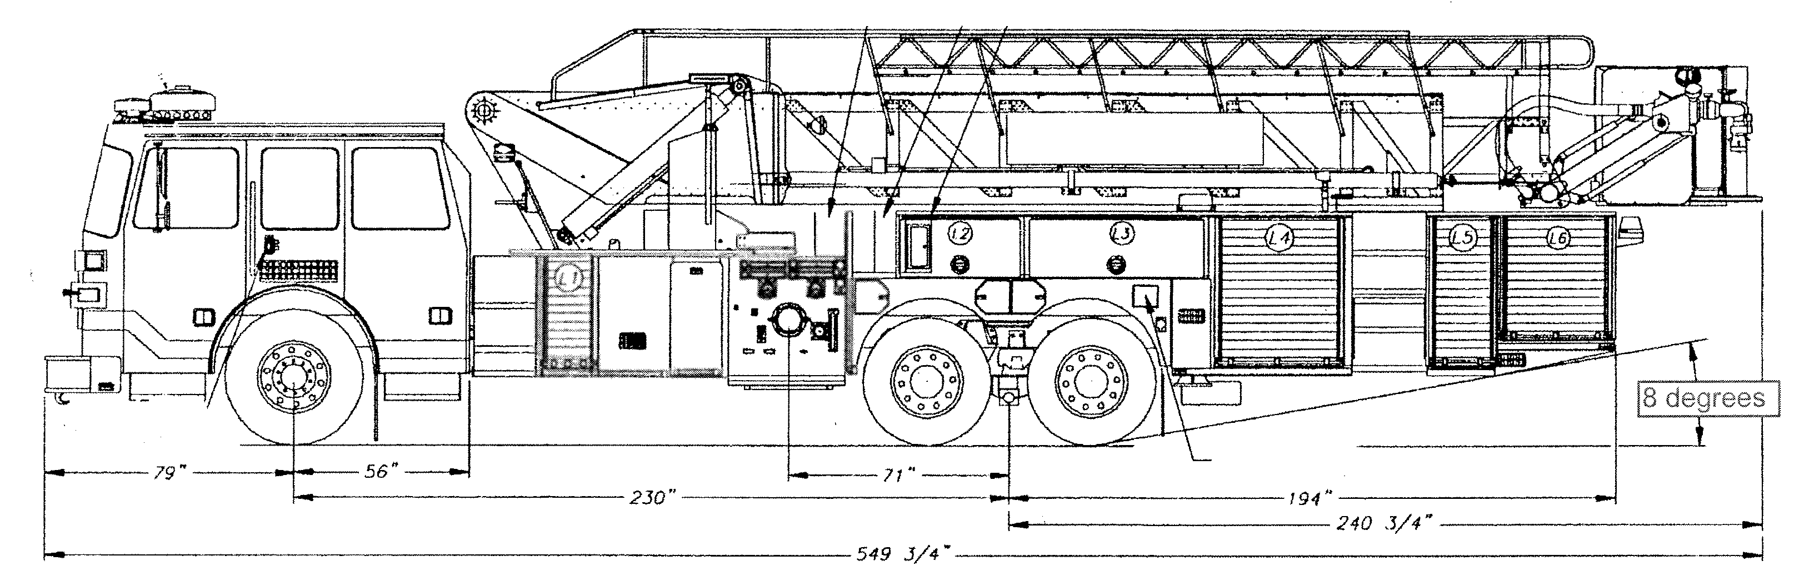

Vehicles specifications
Length = 47.5’
Width = 10’ 1” mirror to mirror
Height = 11’ 6” [a minimum unobstructed vertical clearance of 13’ 6” is required] 06, 09 IFC 503.2.1
Inside Turning Radius = 27 feet
Outside Turning Radius = 45 feet

Access Roads
Width unobstructed: 20 feet minimum [15 IFC 503.2.1]

Grade: 6% maximum within 150 feet of structures. Grades for other roads shall not exceed that of the appropriate county or municipal roadway standard. [15 IFC 503.2.7]

Design load: 72,000 pounds [15 IFC 503.2.3]

Surface: All-weather material of asphalt or concrete

FIRE CODE REVIEW BLOCK
All fire hydrants shall be installed according to water utility standards. The number and locations of the fire hydrants as shown on the Overall Utility Plan are correct as specified by the Town of Parker, Community Development Department.

Fire Code Official or Designated Representative Date

(NOTE – Underground Fire Line (UFL) submittal documents must meet the requirements of NFPA 24 when submitting for review.)

Underground Fire Line - Submittal Requirements

Reference: 2013 NFPA 24 Installation of Private Fire Service Mains and Their Appurtenances

A separate permit is required and will be issued pending review of a detailed submittal which must include the following: [15 IFC 901.2]

4.1.1 Working plans shall be submitted for approval to the authority having jurisdiction before any equipment is installed or replaced.

4.1.2 Deviation from approved plans shall require permission of the authority having jurisdiction.

4.1.3 Working plans shall be drawn to an indicated scale on sheets of uniform size, with a plan of each floor as
applicable, and shall include the following items that pertain to the design of the system:

(1) Name of owner
(2) Location, including street address
(3) Point of compass
(4) A graphic representation of the scale used on all plans
(5) Name and address of contractor
(6) Size and location of all water supplies
(7) The following items that pertain to private fire service mains:
(a) Size
(b) Length
(c) Location
(d) Material (ductile iron, pvc, etc)
(e) Point of connection to city main
(f) Sizes, types, and locations of valves, depth at which the top of the pipe is laid below grade
(g) Method of restraint (Meg-a-Lug or similar)

4.1.4 The working plan submittal shall include the manufacturer's installation instructions for any specially listed equipment, including descriptions, applications, and limitations for any devices, piping, or fittings. Submittals must include installation specifications for thrust blocks, corrosion protection, restraint system, bedding, detail of pipe under the building up to, and including, the flange. When it is intended that a different contractor will extend the fire line from a stopping point outside the building, to the inside flange, a second submittal and permit is required.

All tees, plugs, reducers, valves, and hydrant branches shall be restrained against movement by thrust blocks [10.8.2] or restrained joint systems [10.8.3]. When thrust blocks are used as part of the pipe restraint system, submitted plans shall provide detailed documentation that the thrust blocks satisfy all requirements of Section 10.8.2, including specific thrust block dimensions and mathematical calculations for block dimensions per guidelines provided in Annex A.10.8.2.

Any individual or company who physically works on or installs any part of a fire suppression system, including underground supply lines, from public water lines to system risers and backflow preventers, must be registered with the Colorado Division of Fire Safety. [Dept of Public Safety, Division of Fire Safety, Fire Suppression Program 8 CCR 1507-11:3.1.2] Documentation of valid annual registration may be required with plan submittal.

The following website for the Colorado Division of Fire Safety will provide registration instructions.
http://dfs.state.co.us/SuppAppsProcInsp.htm
All submittals must display a wet stamp and original signature by a Colorado licensed professional engineer or NICET III, or higher, in fire suppression systems. [Dept of Public Safety, Division of Fire Safety, Fire Suppression Program 8 CCR 1507

