

Town of Parker Community Development Department
Development Review Division
Attention: Carolyn Parkinson

Application Type: Site Plan
Status: First Referral
Application Name: Parker Auto Plaza F1 L1 B3 - Retail Preliminary Site Plan
Case/AP#: SP18-047
Referral Received: June 7, 2018
Comments Due: July 8, 2018

Application Location: Generally located at the s/w corner of Parker Road and Pine Lane

Review date: July 2, 2018
Plan reviewer: Randall L. Capra, rcapra@parkeronline.org
Phone: 303.805.3169

TOWN OF PARKER - FIRE/LIFE SAFETY:

1st Submittal – Reviewed July 2, 2018
2nd Submittal – Reviewed December 28, 2018 (Comments in red, italicized font)

Narrative: The applicant, EVT Parker Colorado, LLC is proposing a Preliminary Site Plan for a multi-lot commercial development that includes retail, restaurants, office and automotive orientated uses on Lot 1 Block 3 of the Parker Auto Plaza subdivision. The site is located at the southwest corner of Parker Road and Pine Lane.

Code Reference: 2015 International Fire Code, 2015 International Building Code

The applicant has noted that this is a “conceptual” plan and as such, a “conceptual” plan cannot be approved by FIRE LIFE SAFETY. Fire Life Safety will approve documents based upon what has been provided; at 30%, the documents must be accurate as shown… understanding that the site plan may change at a later date. Once the applicant has fully addressed all Fire Life Safety comments, based upon the documents provided, I will be able to sign off for Fire Life Safety.

UNRESOLVED ISSUES/COMMENTS

- The applicant has modified the furthest west building (adjacent to Twenty Mile Road) and in doing so, has created a dead-end that exceeds 150 feet. An approved turn around is required for any dead-end that exceeds 150 feet, as required per 2015 IFC Section 503.1.1. Address this issue when resubmitting.

- The applicant shall see [15 IFC Section D106.3 Remoteness] where the code states that where two access points are required, the access shall be separated by ½ the diagonal of the lot. The east access is required and the n/e access can remain if the applicant so chooses. Address this issue when resubmitting. Noted; the applicant has indicated that this lot is “conceptual” and has acknowledged the requirement noted above. The applicant shall address the issue fully when a more “concrete” plan is developed.

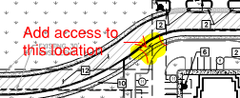

- The applicant shall add a fire hydrant to address the response road just east of Lot 6. Noted; the applicant has indicated that this lot is “conceptual” and has acknowledged the requirement noted above. The applicant shall address the issue fully when a more “concrete” plan is developed.

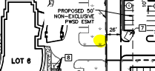

- The applicant has not documented the location of the riser room for any of the buildings; two of the buildings, Lot 7 and Retail A do indicate that a fire line has been anticipated without showing the exact location of the riser rooms. Lot 6 will require a fire line and Lot 4 more than likely will be required to be sprinkled based upon access. The applicant shall be aware that any building where access cannot be provided to within 150 feet of where the first in due apparatus parks shall be required to be provided with sprinklers. All riser room locations are required to be approved and all locations shall be in the area of the fire hydrant provided adjacent to the building. Access to the building shall be provided either through the riser room of through a door adjacent to the riser room. Riser rooms shall be sized to accommodate both the riser and the fire alarm control panel; a three-foot clear space is required around the FACP as well as the riser. The FACP is required to be located on an interior wall. The applicant has acknowledged the requirement noted above.

- The applicant shall be aware that no vertical construction on this site will be allowed until such time that curb gutter and first lift of asphalt are installed; a site inspection will be required to ensure that this requirement is made prior to allowing vertical construction to commence. The applicant has acknowledged the requirement noted above.

- The applicant shall be aware that the Town of Parker will officially have adopted the 2018 ICC codes on January 1, 2019; any submittal documents made after January 1, 2019 shall comply with the 2018 ICC codes. Note – the Town of Parker officially adopted the 2017 NEC on January 1, 2018. The applicant has acknowledged the requirement noted above.

- The applicant shall provide an auto turn analysis indicating that apparatus can navigate all portions of this site (both sides of the gas canopy) as well as all private roads and private drives; NO PARKING – FIRE LANE signage is required for any portion of the access where the 20-foot clear width requirement cannot be met. The applicant has acknowledged the requirement noted above stating that both the auto turn analysis and signage will be included with the final site plan submittal.

- The Town of Parker requires that fire apparatus access roads meet the clear-width and weight-bearing standards of the jurisdiction in which the project is located. Roadways shall be designed to support the imposed weight of fire apparatus, 30 two axle and 40 ton three axle vehicles. An unimpeded clear width of 20 feet shall be maintained at all times. As such, any location where parked vehicles would obstruct this clear width requirement will require “NO PARKING – FIRE LANE” signage. This signage shall be red on white. Update design criteria has been provided at the end of this document; ensure compliance when resubmitting. The applicant has acknowledged the requirement noted above.

- The applicant has not provided a signature block for Fire Life Safety (South Metro Fire Rescue Authority is not a reviewer for this project); an updated signature block has been created with regard to the utility drawing package; typically, this signature block is to be located on the cover sheet and the overall utility page of the water drawings. The signature block is noted at the end of this document; address as applicable. The applicant has acknowledged the requirement noted above stating that the signature block will be included on the final site plan and constructions documents.

- The applicant shall identify the length of the underground fire line and label the line on the plan set. The applicant has acknowledged the requirement noted above stating that the fire line labels will be included on the final site plan and constructions documents.

GENERAL COMMENTS (as applicable)
All engineering documents submitted to the Town of Parker shall bear the wet signature and seal of the engineer or architect in responsible charge of the design. The applicant has acknowledged with current submittal

Water distribution and site access components shall be installed and in service prior to the construction of any portion of the structure, except by special permit issued by the Fire District. The applicant has acknowledged with current submittal

Underground fire lines
When thrust blocks are used as part of the pipe restraint system, submitted plans for permit shall provide detailed documentation that the thrust blocks satisfy all requirements of 13 NFPA 24: 10.8.2, including specific thrust block dimensions and mathematical calculations for block dimensions per guidelines provided in Annex A.10.8.2. The applicant has acknowledged with current submittal

Underground Fire Line - Submittal Requirements

Reference: 2013 NFPA 24 Installation of Private Fire Service Mains and Their Appurtenances

A separate permit is required and will be issued pending review of a detailed submittal which must include the following: [15 IFC 901.2]

4.1.1 Working plans shall be submitted for approval to the authority having jurisdiction before any equipment is installed or replaced.

4.1.2 Deviation from approved plans shall require permission of the authority having jurisdiction.

4.1.3 Working plans shall be drawn to an indicated scale on sheets of uniform size, with a plan of each floor as
applicable, and shall include the following items that pertain to the design of the system:

(1) Name of owner
(2) Location, including street address
(3) Point of compass
(4) A graphic representation of the scale used on all plans
(5) Name and address of contractor
(6) Size and location of all water supplies
(7) The following items that pertain to private fire service mains:
(a) Size
(b) Length
(c) Location
(d) Material (ductile-iron, PVC., etc.)
(e) Point of connection to city main
(f) Sizes, types, and locations of valves, depth at which the top of the pipe is laid below grade
(g) Method of restraint (Meg-a-Lug or similar)

4.1.4 The working plan submittal shall include the manufacturer's installation instructions for any specially listed equipment, including descriptions, applications, and limitations for any devices, piping, or fittings. Submittals must include installation specifications for thrust blocks, corrosion protection, restraint system, bedding, detail of pipe under the building up to, and including, the flange. When it is intended that a different contractor will extend the fire line from a stopping point outside the building, to the inside flange, a second submittal and permit is required.

All tees, plugs, reducers, valves, and hydrant branches shall be restrained against movement by thrust blocks [10.8.2] or restrained joint systems [10.8.3]. When thrust blocks are used as part of the pipe restraint system, submitted plans shall provide detailed documentation that the thrust blocks satisfy all requirements of Section 10.8.2, including specific thrust block dimensions and mathematical calculations for block dimensions per guidelines provided in Annex A.10.8.2.

Any individual or company who physically works on or installs any part of a fire suppression system, including underground supply lines, from public water lines to system risers and backflow preventers, must be registered with the Colorado Division of Fire Safety. [Dept of Public Safety, Division of Fire Safety, Fire Suppression Program 8 CCR 1507-11:3.1.2] Documentation of valid annual registration may be required with plan submittal.

The following website for the Colorado Division of Fire Safety will provide registration instructions.
http://dfs.state.co.us/SuppAppsProcInsp.htm
All submittals must display a wet stamp and original signature by a Colorado licensed professional engineer or NICET III, or higher, in fire suppression systems. [Dept. of Public Safety, Division of Fire Safety, Fire Suppression Program 8 CCR 1507]

FIRE ACCESS ROAD DESIGN CRITERIA

VEHICLE SPECIFICATIONS are provided for the largest apparatus in use by South Metro Fire Rescue. Fire Apparatus Access Roads shall be capable of accommodating this apparatus.

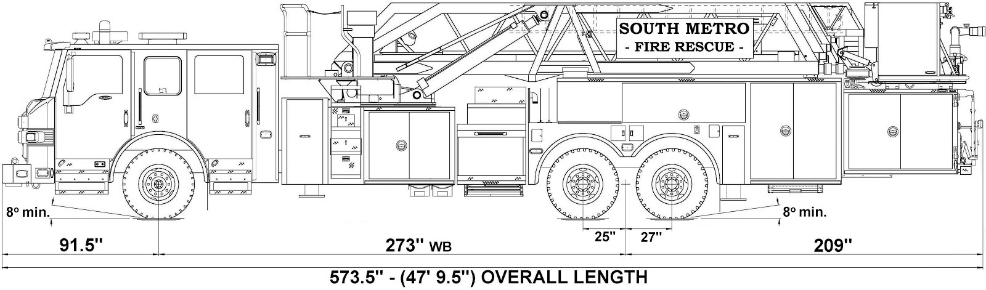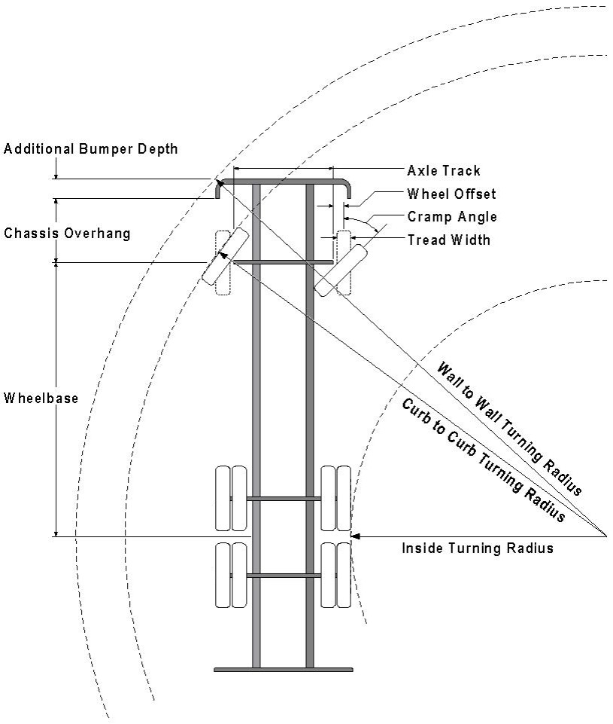

Vehicle Specifications
Length: 47’ 9.5”
Width: 8’ 5” - (10’ 1” mirror to mirror)
Height: 10’ 9”
Wheelbase: 273 in.
Design load: 80,000 pounds Inside Cramp Angle: 40° Axle Track: 83”
Wheel Offset: 5.3”
Tread Width: 13.5”

Turning Radii:
Inside Turn: 26 ft. 1 in. Curb to curb: 41 ft. 11 in. Wall to wall: 46 ft. 8 in.

Where objects are present adjacent to the fire apparatus access road, particularly on turns and turn arounds which require backing, a reasonable safety margin shall be provided to prevent potential damage to the property and to the fire apparatus.

PRIVATE ROADS that provide access to more than two dwellings or one or more commercial buildings shall be constructed to meet the roadway standards approved by the South Metro Fire Rescue Authority for fire apparatus access. Private roads that do not meet the roadway standard may be accepted provided that alternative methods and materials are incorporated into the subdivision that addresses the fire and life safety of the citizens.

FIRE CODE REVIEW BLOCK
All fire hydrants shall be installed according to water utility standards. The number and locations of the fire hydrants as shown on the Overall Utility Plan are correct as specified by the Town of Parker, Community Development Department.

Fire Code Official or Designated Representative Date

(NOTE – Underground Fire Line (UFL) submittal documents must meet the requirements of NFPA 24 when submitting for review.)

