

Town of Parker Community Development Department
Development Review Division
Attention: Paul Workman

Ap Application Type: Site Plan
Status: First Referral
Application Name: Parker MOB III
Case/AP#: SP18-081
Referral Received: August 31, 2018
Comments Due: October 1, 2108
Application Location: Generally located at the southeast of Parker Road and E-470 on Crown Crest Boulevard.

Review date: September 27, 2018
Plan reviewer: Randall L. Capra, rcapra@parkeronline.org
Phone: 303.805.3169

Narrative: The applicant, Parker Adventist Hospital, is requesting a Site Plan Amendment to add a new 5-story, 115,333 sf medical office building to their campus located in Crown Point, Filing No.1 Amendment 18. The site is located southeast of Parker Road and E-470 on Crown Crest Boulevard. Note – the applicant has modified the proposed building (since the last submittal, 9 months ago) such that the building is now being submitted as a 4-story, 88,291 sf medical office building.

Code Reference: 2018 International Fire Code, 2018 International Building Code

TOWN OF PARKER FIRE/LIFE SAFETY:

1st Submittal – September 27, 2018
2nd Submittal – December 3, 2018 (comments in red, italicized font)
3rd Submittal – August 22, 2019 (comments in bold, red, italicized font)
4th Submittal – September 18, 2019 (comments in bold, red, italicized font with a yellow highlight)

UNRESOLVED ISSUES/COMMENTS

- The application is calling for the proposed “elevated bridge” to be an alternate with regard to the submittal; the applicant shall either remove the “elevated bridge” from the project or remove the designator “alternate”. The applicant shall submit for exactly what is to be constructed. Comments such as “alternate” shall be removed from all plans and documents. Address this issue when resubmitting. Not satisfied; applicant did not address with current submittal.

- The applicant shall be aware that no vertical construction on this site will be allowed until such time that curb gutter and first lift of asphalt are installed; a site inspection will be required to ensure that this requirement is made prior to allowing vertical construction to commence. Satisfied; applicant acknowledged with current submittal

- The applicant shall be aware that the Town of Parker will officially have adopted the 2018 ICC codes on January 1, 2019; any submittal documents made after January 1, 2019 shall comply with the 2018 ICC codes. Note – the Town of Parker officially adopted the 2017 NEC on January 1, 2018. Satisfied; applicant acknowledged with current submittal

- The riser room location is not acceptable; the location proposed is shown to be in a higher traffic area as well as having the pedestrian bridge in this location. The applicant shall revisit the site plan and relocate the riser room to the s/e corner of the building. A fire hydrant shall be located within 40 of the riser room location. Satisfied; applicant addressed with current submittal

- The overall utility plan does not reference the location of fire hydrants in the new parking lot nor does it show the location of existing fire hydrants within 1000 feet of the proposed building; it may be beneficial to sit down with me to address this issue (as well as the riser room issue noted in item number 3). Feel free to contact me or shoot me a pdf that we can look at and discuss via a phone call. Satisfied; applicant addressed with current submittal

- The applicant shall identify the length of the underground fire line and label the line on the plan set. Not satisfied; applicant did not provide the overall utility plan or even the rest of the utility drawings. When resubmitting, submit an overall utility plan that identifies the length of the ULF and the size of the UFL on the plan set. The applicant shall also include the correct Fire Life Safety signature block (both noted on this response and provided by Tyler Sandt with engineering); the plans shall be stamped on both the overall utility page and the cover sheet. Not satisfied; applicant did not provide the overall utility plan as was indicated in the applicant’s lasted response to Fire/Life Safety. Partially satisfied; the submittal does address the size and length of the UFL though the civil construction documents do not show that doors have been provided into the riser room from the exterior of the building. As discussed, access is required into the riser room with immediate access into the building provided either adjacent to the riser room or through the riser room.

- The riser room shall be sized to accommodate both the fire sprinkler riser and the fire alarm control panel (FACP); a three-foot clear space is required around both the riser and the FACP. Any other equipment located in this room shall not encroach in the clear space areas noted. Note – The FACP is required to be located on an interior wall. Satisfied; applicant has stated that the room is sized to accommodate the FACP and riser with current submittal

- Due to the height of the building, a fire pump may be required for this structure; the applicant should work with a fire protection engineer to determine the fire flow requirements, size of the underground fire line, and whether the room is sized to accommodate a fire pump, a controller, etc. Address this issue when resubmitting. Partially satisfied; applicant has stated that a 750 gpm pump will be installed in the building… being supported by an 8” UFL. What was not addressed is where the applicant is to install the fire pump; preliminary discussion indicates that the fire pump is to be installed in the riser room. The applicant shall verify that the room is large enough to accommodate both the fire pump and valves as well as the controller, jockey pump, etc. Satisfied; applicant has provided documentation that the riser room has been looked at with regard to proposed systems.

- The applicant shall provide access into the building, either with an access door directly into the building that is immediately adjacent to the riser room or provided with access through the riser room area itself. Satisfied; applicant has stated that access to the building will be provided adjacent to the riser room.

- The applicant did not provide a full set of utility drawings; when developing the utility drawings, ensure that the correct Fire Life Safety signature block is provided on both the cover sheet and the overall utility sheet. The required signature block can be located at the end of this document. Not satisfied; applicant did not provide the overall utility plan or even the rest of the utility drawings. When resubmitting, submit an overall utility plan that identifies the length of the ULF and the size of the UFL on the plan set. The applicant shall also include the correct Fire Life Safety signature block (both noted on this response and provided by Tyler Sandt with engineering); the plans shall be stamped on both the overall utility page and the cover sheet. Not satisfied; applicant did not provide the overall utility plan as was indicated in the applicant’s lasted response to Fire/Life Safety. Not satisfied; applicant did not provide the overall utility plan as was indicated in the applicant’s lasted response to Fire/Life Safety… this document shall be independent of the civil construction documents.

- The applicant shall provide an auto turn analysis indicating that apparatus can navigate all portions of this site (both sides of the gas canopy); NO PARKING – FIRE LANE signage is required for any portion of the access where the 20-foot clear width requirement cannot be met. Satisfied; applicant addressed with current submittal

- The Town of Parker requires that fire apparatus access roads meet the clear-width and weight-bearing standards of the jurisdiction in which the project is located. Roadways shall be designed to support the imposed weight of fire apparatus, 30-ton axle and 40-ton three axle vehicles. An unimpeded clear width of 20 feet shall be maintained at all times. As such, any location where parked vehicles would obstruct this clear width requirement will require “NO PARKING – FIRE LANE” signage. This signage shall be red on white. Update design criteria has been provided at the end of this document; ensure compliance when resubmitting.

GENERAL COMMENTS (as applicable)
All engineering documents submitted to the Town of Parker shall bear the wet signature and seal of the engineer or architect in responsible charge of the design.

Water distribution and site access components shall be installed and in service prior to the construction of any portion of the structure, except by special permit issued by the Fire District.

Underground fire lines
When thrust blocks are used as part of the pipe restraint system, submitted plans for permit shall provide detailed documentation that the thrust blocks satisfy all requirements of 13 NFPA 24: 10.8.2, including specific thrust block dimensions and mathematical calculations for block dimensions per guidelines provided in Annex A.10.8.2.

Underground Fire Line - Submittal Requirements

Reference: 2013 NFPA 24 Installation of Private Fire Service Mains and Their Appurtenances

A separate permit is required and will be issued pending review of a detailed submittal which must include the following: [15 IFC 901.2]

4.1.1 Working plans shall be submitted for approval to the authority having jurisdiction before any equipment is installed or replaced.

4.1.2 Deviation from approved plans shall require permission of the authority having jurisdiction.

4.1.3 Working plans shall be drawn to an indicated scale on sheets of uniform size, with a plan of each floor as
applicable, and shall include the following items that pertain to the design of the system:

(1) Name of owner
(2) Location, including street address
(3) Point of compass
(4) A graphic representation of the scale used on all plans
(5) Name and address of contractor
(6) Size and location of all water supplies
(7) The following items that pertain to private fire service mains:
(a) Size
(b) Length
(c) Location
(d) Material (ductile-iron, PVC., etc.)
(e) Point of connection to city main
(f) Sizes, types, and locations of valves, depth at which the top of the pipe is laid below grade
(g) Method of restraint (Meg-a-Lug or similar)

4.1.4 The working plan submittal shall include the manufacturer's installation instructions for any specially listed equipment, including descriptions, applications, and limitations for any devices, piping, or fittings. Submittals must include installation specifications for thrust blocks, corrosion protection, restraint system, bedding, detail of pipe under the building up to, and including, the flange. When it is intended that a different contractor will extend the fire line from a stopping point outside the building, to the inside flange, a second submittal and permit is required.

All tees, plugs, reducers, valves, and hydrant branches shall be restrained against movement by thrust blocks [10.8.2] or restrained joint systems [10.8.3]. When thrust blocks are used as part of the pipe restraint system, submitted plans shall provide detailed documentation that the thrust blocks satisfy all requirements of Section 10.8.2, including specific thrust block dimensions and mathematical calculations for block dimensions per guidelines provided in Annex A.10.8.2.

Any individual or company who physically works on or installs any part of a fire suppression system, including underground supply lines, from public water lines to system risers and backflow preventers, must be registered with the Colorado Division of Fire Safety. [Dept of Public Safety, Division of Fire Safety, Fire Suppression Program 8 CCR 1507-11:3.1.2] Documentation of valid annual registration may be required with plan submittal.

The following website for the Colorado Division of Fire Safety will provide registration instructions.

http://dfs.state.co.us/SuppAppsProcInsp.htm

All submittals must display a wet stamp and original signature by a Colorado licensed professional engineer or NICET III, or higher, in fire suppression systems. [Dept of Public Safety, Division of Fire Safety, Fire Suppression Program 8 CCR 1507

FIRE ACCESS ROAD DESIGN CRITERIA

VEHICLE SPECIFICATIONS are provided for the largest apparatus in use by South Metro Fire Rescue. Fire Apparatus Access Roads shall be capable of accommodating this apparatus.

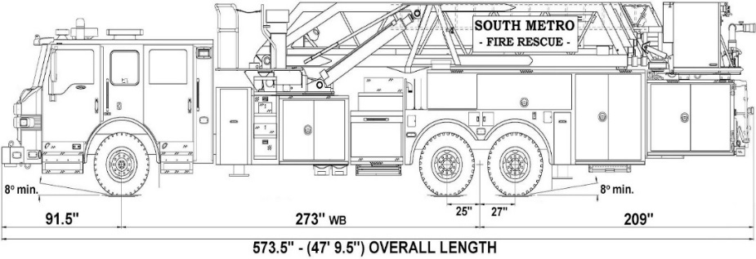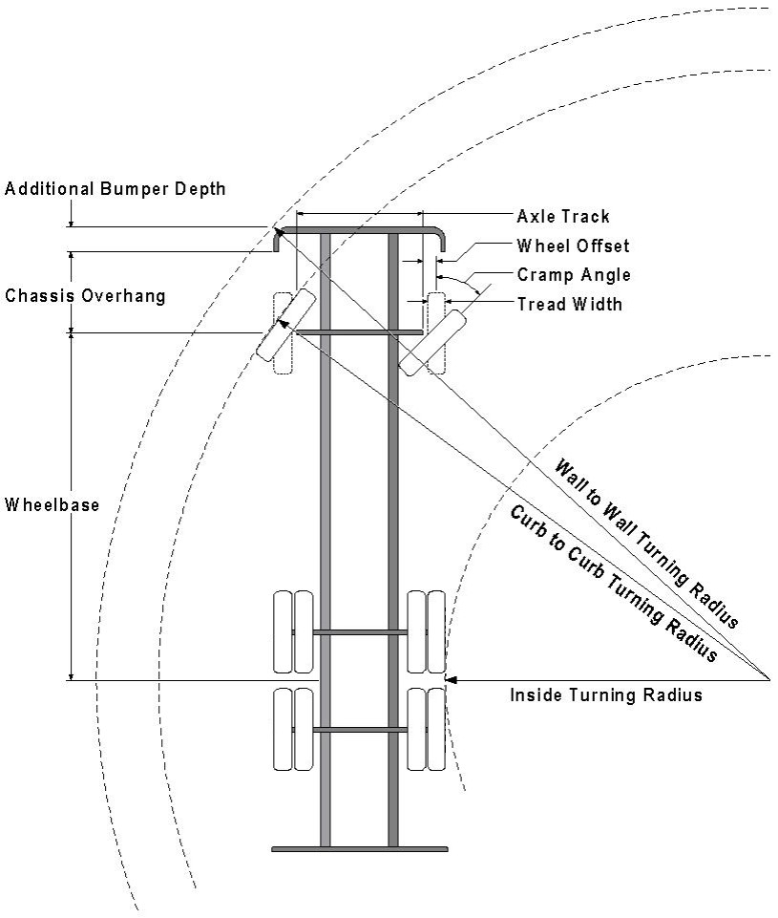

Vehicle Specifications
Length: 47’ 9.5”
Width: 8’ 5” - (10’ 1” mirror to mirror)
Height: 10’ 9”
Wheelbase: 273 in.
Design load: 80,000 pounds Inside Cramp Angle: 40° Axle Track: 83”
Wheel Offset: 5.3”
Tread Width: 13.5”

Turning Radii:
Inside Turn: 26 ft. 1 in. Curb to curb: 41 ft. 11 in. Wall to wall: 46 ft. 8 in.

Where objects are present adjacent to the fire apparatus access road, particularly on turns and turn arounds which require backing, a reasonable safety margin shall be provided to prevent potential damage to the property and to the fire apparatus.

PRIVATE ROADS that provide access to more than two dwellings or one or more commercial buildings shall be constructed to meet the roadway standards approved by the South Metro Fire Rescue Authority for fire apparatus access. Private roads that do not meet the roadway standard may be accepted provided that alternative methods and materials are incorporated into the subdivision that addresses the fire and life safety of the citizens.

Posting of Fire Lanes: The posting of the “Fire Lanes” is required.
Fire Lane Sign Dimensions. NO PARKING – FIRE LANE signs shall be 12 inches wide and 18 inches high.
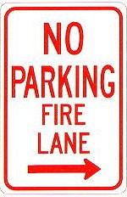
2 ” High 1/8 ”
Stroke
Red letters
3” High
¼ ” Stroke Red Letters
12”
18”

Fire Lane Sign Characteristics: Signs shall be engineer grade reflective sheeting on 0.80 aluminum with red lettering on a white background.
Fire Lane Sign Locations. Fire apparatus access roadways between 20 and 28 feet wide, signs shall be posted on both sides. Fire apparatus access roadways between 28 feet wide and 34 feet wide, signs may be posted on one side only.
Fire Lane Sign Installation. NO PARKING – FIRE LANE signs shall be installed as follows:
- Bottom edge of the signs shall be 7 feet above surface (sidewalk) and post shall be placed 24 inches from flow line (curb).
- One sign at the beginning of the restriction (one arrow pointing towards the restriction zone).
- One sign at the end of the restriction (one arrow pointing back into restricted zone).
- One sign at least every 150 ft. within the restricted area (double arrow pointing in each direction, to indicate the continuing restriction).
- Spaced evenly within the restriction (for straight curbs/zones). For example, if the parking restriction zone is 300 ft long, only one double arrow sign is required at a distance of 150 ft. from the beginning of the restriction. If the restriction zone is 400 ft. long, two double arrow signs are required; spaced 100 ft. evenly from each other and from the beginning/ending signs.
- Spaced so that at least one readable sign is visible in front of a parked vehicle from any point along the restriction (for curved curbs/zones and areas that may present visual obstacles.)
- Set at an angle of no fewer than 30 degrees and no more than 45 degrees with the lane of traffic flow visible to approaching traffic.
- Signs shall be provided at all normal and emergency access points to structures and within 20 feet of each fire hydrant and fire department connection (FDC) in compliance with UFC 901.4.2.
- Some areas may need additional fire lane signs. Check with the Division of Life Safety for any additional requirements.

Fire Lane Sign Types. The diagrams below indicate the types of signs that may be used, and the recommended placement.

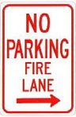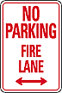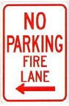
200 feet
200 feet

Additional sign styles may be used – provided the same type is used consistently.

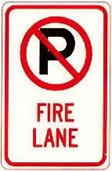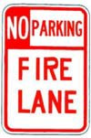

Painting of Curbs or Streets. In addition to the required signage, South Metro Fire Rescue does permit fire lanes to be painted with curb or street markings. However, these markings shall not replace the required fire lane signs. Curbs may be painted red with 3 inch white block letters stating NO PARKING – FIRE LANE. Lettering shall be spaced every 15 feet.

FIRE CODE REVIEW BLOCK
All fire hydrants shall be installed according to water utility standards. The number and locations of the fire hydrants as shown on the Overall Utility Plan are correct as specified by the Town of Parker, Community Development Department.

Fire Code Official or Designated Representative Date

(NOTE – Underground Fire Line (UFL) submittal documents must meet the requirements of NFPA 24 when submitting for review.)

