

Development Review Division

Community Development Department: Town Hall / 20120 East Mainstreet Parker, CO 80138 Phone: 303.841.2332 Fax: 303.841.3223

MEMORANDUM

TO: Cyntergy Attn; Adam Ward

810 S Cincinnati Ave STE 200

Tulsa, OK

FROM: Carolyn Parkinson Planner I

DATE: 2.13.19

SUBJECT: Parker Pointe MDP L4- Ziggys Coffee (SP18-098)

The following are the comments regarding your application. All comments must be responded to, and if you disagree with a comment please indicate the reasoning of your disagreement. Please sign and return this memo with your next submittal. A follow-up meeting with the reviewing agencies can be scheduled to provide additional guidance.

CI&MF = Commercial, Industrial and Multifamily Design Standards
LDO = Land Development Ordinance

TOWN OF PARKER PLANNING DEPARTMENT:
ATTN:
E-MAIL:
FAX: 303-841-3223
PHONE: 303-841-2332

SHEET 1 OF 11

- Please revise sheet index to remove cross outs.
Please amend.

Complied: Yes No
Response: ______________________________________________________________________
_______________________________________________________________________________

- Please add revision dates at resubmittal.

Please remove.

Complied: Yes No
Response: ______________________________________________________________________
_______________________________________________________________________________

SHEET 2 OF 11

- Please revise to provide 10’ width for all parking spaces adjacent to curbs per LDO Section 13.06.050 (f) (1). Please revise all appropriate sheets.

Please remove.

Complied: Yes No
Response: ______________________________________________________________________
_______________________________________________________________________________

- Please consider adding a curb between the pedestrian cross walk and the parking spaces adjacent, per CI&MF III.1.D, as shown on redline.

Please amend.

Complied: Yes No
Response: ______________________________________________________________________
_______________________________________________________________________________

SHEET 3 OF 11

- The scale of the SP is far too large. Please split this sheet to increase the size to that used on the landscape plan, or 1’=10’.

Please amend.

Complied: Yes No
Response: ______________________________________________________________________
_______________________________________________________________________________

- Staff requested that the submittal be divided into a site plan set and a CD set. The applicant did separate sheets, but the information on some of these sheets contain both site plan appropriate information and CD appropriate information. This information includes all notes and details. This information must be separated and included in the appropriate set. Building construction information is not relevant to the site plan with the exception of exterior elements. Planners do not stamp engineering, public works, or construction documents, only the site plan set as described in the site plan development packet. Please separate all info into the appropriate set so that staff has a complete site plan set to approve at the end of the process.
Please amend.

Complied: Yes No
Response: ______________________________________________________________________
_______________________________________________________________________________

- Per CI&MF III.1.D, all parking lots shall have pedestrian crosswalks that are distinguished from driving surfaces through the use of durable, low maintenance surface materials such as pavers, bricks, or scored, colored concrete to enhance pedestrian safety and comfort, as well as the attractiveness of the walkways.
Please amend.

Complied: Yes No
Response: ______________________________________________________________________
_______________________________________________________________________________

- Bicycle racks are shown on the site plan but are not included in the site criteria data. Please add bicycle parking to site criteria.
Please amend.

Complied: Yes No
Response: ______________________________________________________________________
_______________________________________________________________________________

- Please sort through the legend abbreviations and remove those that belong in the CD's or on utility sheet or grading sheet. Add appropriate abbreviations to the sheets they pertain to.
Please amend.

Complied: Yes No
Response: ______________________________________________________________________
_______________________________________________________________________________

- Keynote U pertains to a ‘Rockwater feature’ that staff does not find on the site plan. Perhaps it was added or left on in error?
Please amend.

Complied: Yes No
Response: ______________________________________________________________________
_______________________________________________________________________________

SHEET 4 OF 11

- Buffalo grass is not appropriate in internal landscape area and has been historically difficult to establish. Even when established, which takes 2-3 years, it doesn't have a 'landscaped' appearance. Additional trees or shrubs could be added that would be more aesthetically pleasing for drivers waiting in line. Please see redline
Please amend.

Complied: Yes No
Response: ______________________________________________________________________
_______________________________________________________________________________

- Buffalo grass will not be accepted adjacent to the sidewalk. Please consider a turf grass in this area provided the total turf does not exceed 15%. Please see redline.
Please amend.

Complied: Yes No
Response: ______________________________________________________________________
_______________________________________________________________________________

- As noted above, Buffalo is difficult to establish and takes 2-3 years. Please consider using an approved native seed instead for the area in the easement along Parker Road as noted on redline.
Please amend.

Complied: Yes No
Response: ______________________________________________________________________
_______________________________________________________________________________

- There is not enough variation in variety of plant species to ensure the continued appeal of a project in those instances where a particular species is killed through insect or disease activity. 13.06.070 (g) (3). Please increase variety of species. Please see redline.
Please amend.

Complied: Yes No
Response: ______________________________________________________________________
_______________________________________________________________________________

SHEET 5 OF 11

- Please provide justification for the substitutions noted on the checklist, there appears to be enough room to accommodate the required number of trees required. A note with this explanation needs to appear on the sheet itself. Please see redline.
Please amend.

Complied: Yes No
Response: ______________________________________________________________________
_______________________________________________________________________________

- Please the checklist, to read Town of Parker as opposed to City of Parker. Please see redline.
Please amend.

Complied: Yes No
Response: ______________________________________________________________________
_______________________________________________________________________________

- No streetscape has been included. Streetscape is in addition to perimeter landscaping and is required for all public and private roadways.
Please amend.

Complied: Yes No
Response: ______________________________________________________________________
_______________________________________________________________________________

- Please add a note stating that any changes to the landscape plan requires prior approval from the Town.
Please amend.

Complied: Yes No
Response: ______________________________________________________________________
_______________________________________________________________________________

SHEET 10 OF 11

- Building construction information is provided on this sheet but is not relevant to the site plan with the exception of exterior elements. Planners do not stamp construction documents, only the site plan set as described in the site plan development packet. Please remove building construction info so that staff has a complete site plan set to approve at the end of the process.
Please amend.

Complied: Yes No
Response: ______________________________________________________________________
_______________________________________________________________________________

- Staff noted several errors in the elevation keynotes that also occur in the elevations themselves. Staff reviewed for errors, but please re-review the material callouts to ensure that any additional errors are corrected. Please see redline.
Please amend.

Complied: Yes No
Response: ______________________________________________________________________
_______________________________________________________________________________

- A sample board of exterior finishes has not been provided. This is required prior to a second referral review.
Please amend.

Complied: Yes No
Response: ______________________________________________________________________
_______________________________________________________________________________

- Black and White elevations are required. Please provide at re-submittal.
Please amend.

Complied: Yes No
Response: ______________________________________________________________________
_______________________________________________________________________________

- The columns of the porte cache are a predominant architectural element and should emphasis high quality materials. EIFS is not a high quality material and be a used as a secondary material. Staff has provided a mock up. Please consider adding masonry to the columns as shown on redline and on the north and south elevations. CI&MF III.2.B (2 & 3) III.2.C (1).
Please amend.

Complied: Yes No
Response: ______________________________________________________________________
_______________________________________________________________________________

- Please provide a detail of the cornice as noted on redline.
Please amend.

Complied: Yes No
Response: ______________________________________________________________________
_______________________________________________________________________________

- Please correct the cardinal directions on the elevations. The long sides are east and west, the short sides are north and south.
Please amend.

Complied: Yes No
Response: ______________________________________________________________________
_______________________________________________________________________________

- Please correct the call out for the material on the elevation shown as east, as noted on redline. How does this material tie into the rest of the structure? It is currently identified as #6, but appears to be #8. I have no sample board with which to compare it to verify what the material is. This is the only location where this material is used on the structure, it should be repeated elsewhere to balance the architecture or replaced with another material already in use, such as the masonry suggested by staff.
Please amend.

Complied: Yes No
Response: ______________________________________________________________________
_______________________________________________________________________________

- The elevation that faces Parker Rd., shown as north, is very visible and currently presents more than half the length as a blank wall facing towards the busiest road in Town. From the roadway perspective, this elevation is the front. Articulation is needed that will present less of a 'back of house' to Parker Road. There are a variety of ways this might be accomplished, through the use of materials, details such as lighting, an extension of the portico, or even signage, provided the colors and proportions are aesthetically pleasing. Staff has provided a mock up as one idea to address this issue, staff is open to other options that meet the intent. Please see redline.

The blank wall also exists on the opposite side of the building. Please consider a mirror image on this elevtion.
Please amend.

Complied: Yes No
Response: ______________________________________________________________________
_______________________________________________________________________________

SHEET 10 OF 11

- The Fixtures are not shown on this photometric or on the elevations as is required. If luminaire's are being used, be sure to provide the height of the pole. All lighting is required to be fully shielded, please indicate on the site plan that proposed lighting meets this requirement. LDO Section 13.10.140 (c) (9)
Please amend.

Complied: Yes No
Response: ______________________________________________________________________
_______________________________________________________________________________

- The north and south boundaries exceed the maximum lumens allowed at the property line. Maximum is 1. While strict adherence to the maximum may be difficult, please work to bring this area closer into compliance. LDO Section 13.10.140 (c) (7)
Please amend.

Complied: Yes No
Response: ______________________________________________________________________
_______________________________________________________________________________

- The statistical data table does not conform to uniformity ratio requirements per LDO Section 13.10.140 (c) (7). See below.
Please amend.

Complied: Yes No
Response: ______________________________________________________________________
_______________________________________________________________________________

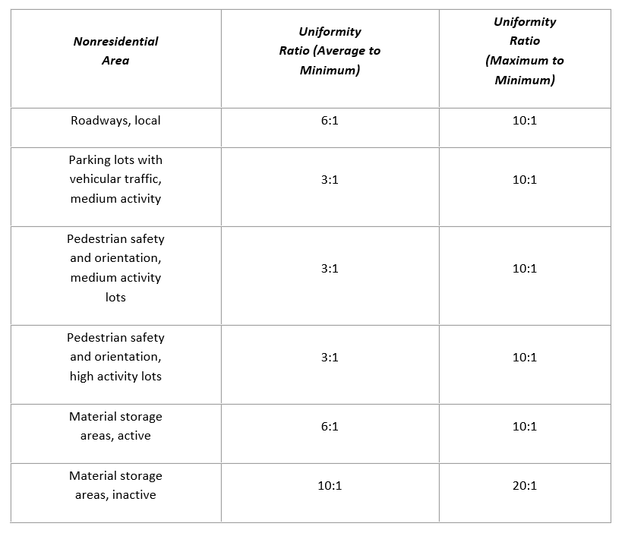

OUTSIDE REFERRAL AGENCY COMMENTS

- Please address all outside referral agency comments with a written response. These comments are available on etrakit.
Complied: Yes No
Response: ______________________________________________________________________
_______________________________________________________________________________
_______________________________________________________________________________

_______________________________________ __________________
Property Owner Date

_____________________________________ __________________
Project Representative Date

