

Town of Parker Community Development Department
Development Review Division
Attention: Carolyn Parkinson

Application Type: Site Plan
Status: First Referral
Application Name: Parker Pointe L4 - Ziggi's Coffee
Case/AP#: SP18-098
Referral Received: January 10, 2019
Comments Due: February 7, 2019

Application Location: Generally located on the east side of Parker Road and located just south of Stroh Road.

Review date: January 18, 2019
Plan reviewer: Randall L. Capra, rcapra@parkeronline.org
Phone: 303.805.3169

Narrative: The applicant, Pleasant Hill Blendz, LLC is proposing a new 624 sq. ft. drive through coffee service facility located on Lot 14 of Parker Pointe near the southeast corner of Parker Road and Stroh Road.

Code Reference: 2015 International Fire Code, 2015 International Building Code

TOWN OF PARKER | FIRE/LIFE SAFETY DIVISION:

1st Submittal – Reviewed January 18, 2019

UNRESOLVED ISSUES/COMMENTS

- The applicant shall be aware that no vertical construction on this site will be allowed until such time that curb gutter and first lift of asphalt are installed; a site inspection will be required to ensure that this requirement is made prior to allowing vertical construction to commence.

- The applicant shall be aware that effective January 1, 2019 that the Town of Parker will officially have adopted the 2018 ICC codes; any submittal documents made after January 1, 2019 shall comply with the 2018 ICC codes. Note – the Town of Parker officially adopted the 2017 NEC on January 1, 2018.

- The applicant shall add a fire hydrant to the location shown below… per the requirements of NFPA 24; this section states that a hydrant shall be located not > 40 feet from the building to be served:

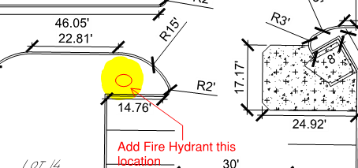

- The applicant has used the correct “Fire Life Safety” signature block on the overall utility drawings; a copy of this block has been provided at the end of this response letter. This signature block shall be provided on the overall utility cover page and on the overall utility page. Address when resubmitting… including the required utility drawings (this item was also noted in item number 6).

- The applicant shall provide an auto turn analysis indicating that apparatus can navigate all portions of this site (both sides of the gas canopy); NO PARKING – FIRE LANE signage is required for any portion of the access where the 20-foot clear width requirement cannot be met.

- The Town of Parker requires that fire apparatus access roads meet the clear-width and weight-bearing standards of the jurisdiction in which the project is located. Roadways shall be designed to support the imposed weight of fire apparatus, 30 two axle and 40 ton three axle vehicles. An unimpeded clear width of 20 feet shall be maintained at all times. As such, any location where parked vehicles would obstruct this clear width requirement will require “NO PARKING – FIRE LANE” signage. This signage shall be red on white. Update design criteria has been provided at the end of this document; ensure compliance when resubmitting.

- An updated signature block has been created with regard to the utility drawing package; typically, this signature block is located on the cover sheet and the overall utility page of the water drawings. The signature block is noted below; address as applicable.

GENERAL COMMENTS (as applicable)
All engineering documents submitted to the Town of Parker shall bear the wet signature and seal of the engineer or architect in responsible charge of the design.

Water distribution and site access components shall be installed and in service prior to the construction of any portion of the structure, except by special permit issued by the Fire District.

FIRE ACCESS ROAD DESIGN CRITERIA

VEHICLE SPECIFICATIONS are provided for the largest apparatus in use by South Metro Fire Rescue. Fire Apparatus Access Roads shall be capable of accommodating this apparatus.
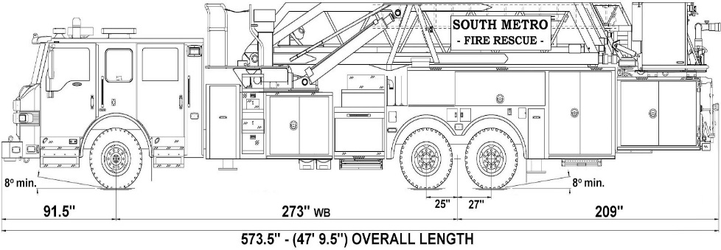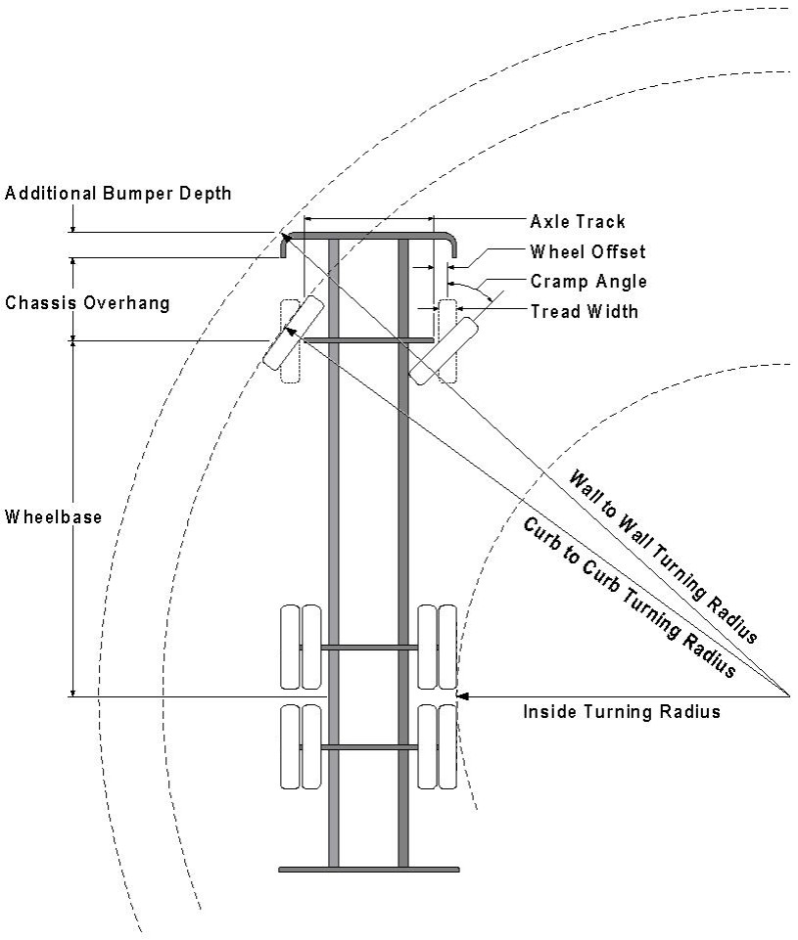

Vehicle Specifications
Length: 47’ 9.5”
Width: 8’ 5” - (10’ 1” mirror to mirror)
Height: 10’ 9”
Wheelbase: 273 in.
Design load: 80,000 pounds Inside Cramp Angle: 40° Axle Track: 83”
Wheel Offset: 5.3”
Tread Width: 13.5”

Turning Radii:
Inside Turn: 26 ft. 1 in. Curb to curb: 41 ft. 11 in. Wall to wall: 46 ft. 8 in.

Where objects are present adjacent to the fire apparatus access road, particularly on turns and turn arounds which require backing, a reasonable safety margin shall be provided to prevent potential damage to the property and to the fire apparatus.

PRIVATE ROADS that provide access to more than two dwellings or one or more commercial buildings shall be constructed to meet the roadway standards approved by the South Metro Fire Rescue Authority for fire apparatus access. Private roads that do not meet the roadway standard may be accepted provided that alternative methods and materials are incorporated into the subdivision that addresses the fire and life safety of the citizens.

Posting of Fire Lanes: The posting of the “Fire Lanes” is required.
Fire Lane Sign Dimensions. NO PARKING – FIRE LANE signs shall be 12 inches wide and 18 inches high.

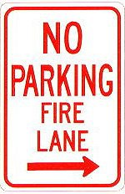
3” High
¼ ” Stroke Red Letters
2 ” High 1/8 ”
Stroke
Red letters
12”
18”

Fire Lane Sign Characteristics: Signs shall be engineer grade reflective sheeting on 0.80 aluminum with red lettering on a white background.
Fire Lane Sign Locations. Fire apparatus access roadways between 20 and 28 feet wide, signs shall be posted on both sides. Fire apparatus access roadways between 28 feet wide and 34 feet wide, signs may be posted on one side only.
Fire Lane Sign Installation. NO PARKING – FIRE LANE signs shall be installed as follows:
- Bottom edge of the signs shall be 7 feet above surface (sidewalk) and post shall be placed 24 inches from flow line (curb).
- One sign at the beginning of the restriction (one arrow pointing towards the restriction zone).
- One sign at the end of the restriction (one arrow pointing back into restricted zone).
- One sign at least every 150 ft. within the restricted area (double arrow pointing in each direction, to indicate the continuing restriction).
- Spaced evenly within the restriction (for straight curbs/zones). For example, if the parking restriction zone is 300 ft long, only one double arrow sign is required at a distance of 150 ft. from the beginning of the restriction. If the restriction zone is 400 ft. long, two double arrow signs are required; spaced 100 ft. evenly from each other and from the beginning/ending signs.
- Spaced so that at least one readable sign is visible in front of a parked vehicle from any point along the restriction (for curved curbs/zones and areas that may present visual obstacles.)
- Set at an angle of no fewer than 30 degrees and no more than 45 degrees with the lane of traffic flow visible to approaching traffic.
- Signs shall be provided at all normal and emergency access points to structures and within 20 feet of each fire hydrant and fire department connection (FDC) in compliance with UFC 901.4.2.
- Some areas may need additional fire lane signs. Check with the Division of Life Safety for any additional requirements.

Fire Lane Sign Types. The diagrams below indicate the types of signs that may be used, and the recommended placement.

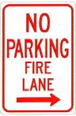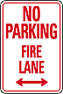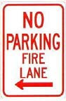
200 feet
200 feet

Additional sign styles may be used – provided the same type is used consistently.

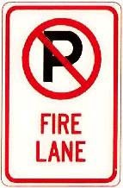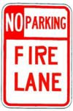

Painting of Curbs or Streets. In addition to the required signage, South Metro Fire Rescue does permit fire lanes to be painted with curb or street markings. However, these markings shall not replace the required fire lane signs. Curbs may be painted red with 3 inch white block letters stating NO PARKING – FIRE LANE. Lettering shall be spaced every 15 feet.

FIRE CODE REVIEW BLOCK
All fire hydrants shall be installed according to water utility standards. The number and locations of the fire hydrants as shown on the Overall Utility Plan are correct as specified by the Town of Parker, Community Development Department.

Fire Code Official or Designated Representative Date

(NOTE – Underground Fire Line (UFL) submittal documents must meet the requirements of NFPA 24 when submitting for review.)

