August 11th , 2021

RE: SP21-063; Douglas 234 F6 L1 - Gas and Convenience Store
Review Comments 01

RESPONSE TO COMMENTS:
General Transparency Calculations based on a 13’-0” ceiling height inside the store. T.O. Steel height is 14’-3” on the east side, and 13’-2” on the west side. The height used for the transparency calculations was 13’-0”, which is also the typical ceiling height inside the store. The roof slopes down from east to west.

West Elevation:
We updated the area used for the transparency calculation and provided dimensions of glazing and the architectural mural. All calculations were revised. The 5’-0” dimension was noted incorrectly. The storefront window is 7’-0” tall

East Elevation:
We updated the area used for the transparency calculation and provided dimensions of glazing and the façade for the required transparency calculation.

South Elevation:
We included calculations for the south elevation. Spaces along the south elevation include the mechanical room, the FACP room, the back of house walk-in cooler, and back of house storage racks. The only area we can use for transparency is the corridor next to the restrooms. We maximized the glazing in this corridor. See Floor Plan below.

North Elevation:
A note about signage has been added to each relevant sheet.

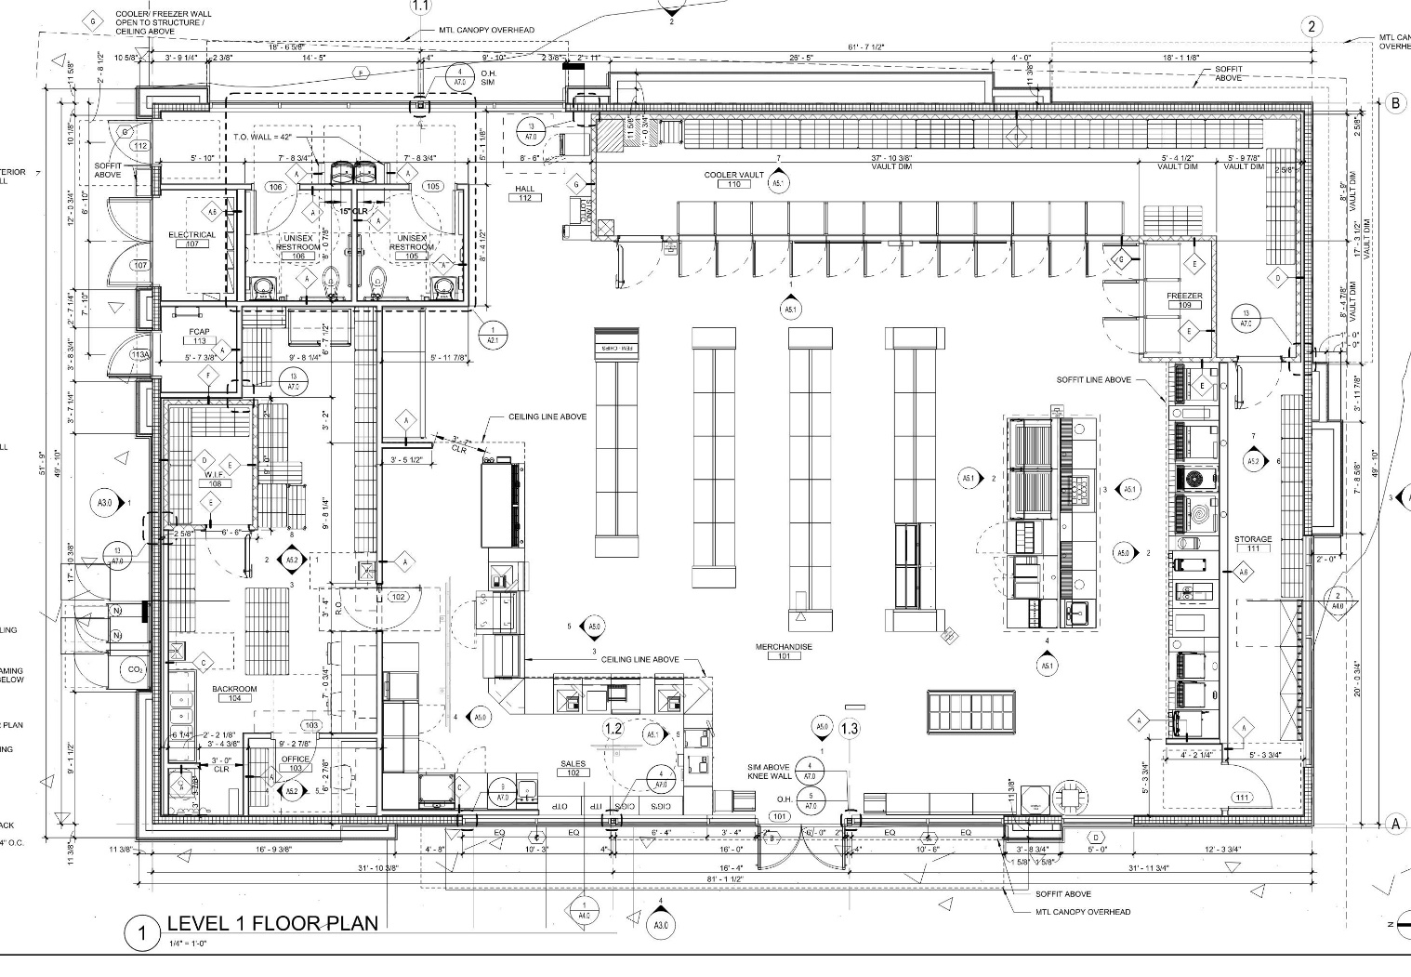

Sincerely,
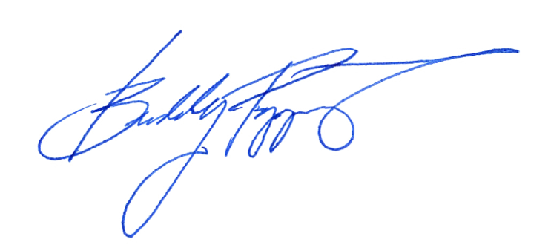
101Architecture LLC

_______________________________

Buddy Poppitt, LEED AP
Principal, Design Director

