

Town of Parker Community Development Department
Development Review Division
Attention: BrieAnna Simon

Application Type: Site Plan
Status: First Referral
Application Name: Douglas 234 F6 AMD 1 L3 – McDonalds
Case/AP#: SP21-067
Referral Received: July 14, 2021
Comments Due: August 12, 2021

Application Location: Generally located at the northeast corner of Chambers Road and Hess Road

Review date: August 2, 2021
Plan reviewer: Randall L. Capra, rcapra@parkeronline.org
Phone: 303.805.3169

Narrative: The applicant, Kimley Horn and Associates, is proposing a site plan for a 4,445 sq. ft. fast food restaurant. The project is located on the northeast corner of Chambers Road and Hess Road.

Code Reference: 2018 International Fire Code, 2018 International Building Code, 2017 NEC (valid through 12/31/21)

TOWN OF PARKER FIRE/LIFE SAFETY:

1st Submittal – Reviewed August 2, 2021
2nd Submittal – Reviewed October 11, 2021(comments in red, italicized font)

UNRESOLVED ISSUES/COMMENTS

Note - The applicant shall be aware that the Town of Parker has officially adopted the 2018 ICC codes as of January 1, 2019; all submittal documents are required to comply with the 2018 ICC codes. Note – The Town of Parker will have officially adopted the 2021 ICC family on January 1, 2022; the 2020 NEC will be adopted at this time, as well. Any submittals received after December 31, 2021 will be required to meet the newly adopted codes.

- The applicant shall be aware that no vertical construction on this site will be allowed until such time that curb gutter and first lift of asphalt are installed; a site inspection will be required to ensure that this requirement is made prior to allowing vertical construction to commence. Satisfied; applicant has noted/acknowledged with current submittal.

- The applicant shall be aware that the access road hydrant distribution was not planned to address the suppression needs for all commercial properties within this subdivision; this site requires the addition of one hydrant (to be located at the s/w corner island of the building… as required per NFPA 24 Section 7.2.3… see the snap shot of the red-lined fire hydrant location shown under item 4 below: Satisfied; applicant has noted/acknowledged/addressed with current submittal.

- Per the requirements of [18 IFC Section 503.1.1 Buildings and Facilities] approved fire apparatus access roads shall be provided for every facility, building, portion of a building hereafter constructed or moved into or within the jurisdiction. The fire apparatus access road shall comply with the requirements of this section and shall extend to within 150 feet of all portions of the facility and all portions of the exterior walls of the first story of the building as measured by an approved route around the exterior of the building or facility (i.e. a building is a 120 feet long and 45 feet wide and cannot meet the requirement as measured from the center line of the fire apparatus as measured by an approved route from any point that a fire engine might park when responding to a call at this building). Satisfied; applicant has noted/acknowledged/addressed with current submittal.

Note - This submittal does provide for this requirement of the code. Per the requirements of the code, the fire code official is allowed to increase the dimension of the 150 feet provided that the applicant meets Exception 1.1 of this section… “The building is equipped throughout with an approved automatic sprinkler suppression system installed in accordance with section 903.1.1, 903.1.2, or 903.3.1.3.

- As discussed in the pre-application meeting, the applicant will need to provide a fire hydrant interior to this site (once was not provided as directed); the applicant shall provide a fire hydrant in the area just southeast of the southeast corner of the building… as required per NFPA 24, Section 7.2.3 (this section states that a fire hydrant shall be located not less than 40’ from the building to be protected. See below for two acceptable locations and address this issue as required: Satisfied; applicant has noted/acknowledged/addressed with current submittal.

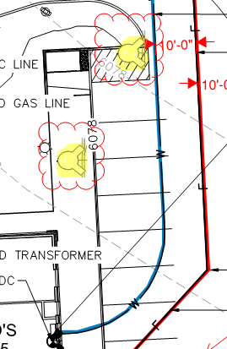

- The applicant shall, in addition to notating that the UFL is a 6:” line, notate the length of the UFL as measured from the “T” in the street to the flange in the building. Address this issue when resubmitting. Not satisfied; applicant has not provided overall utility drawings that document on the current submittal. The required Fire Life Safety signature block shall be provided on the cover sheet and the overall utility page. Address this issue when resubmitting.

- With regard to the fire sprinkler control valve room, this room shall be sized to accommodate the following: Satisfied; applicant has noted/acknowledged/addressed with current submittal.

- Exterior access is required into the riser room with access into the building provided either adjacent to the riser room or through the riser room.
- The FACP will be required to be located in the fire sprinkler control valve room; ensure that the riser room is sized to accommodate the FACP and the riser. A three-foot clearance is required in front of the FACP as well as the sprinkler riser (as well as the three foot 18” to center or FACP/riser... each side.
- The underground fire line shall enter the building and turn up no further than 24 inches from foundation wall; three feet of clearance is required in front of the fire riser.
- The FACP shall be located on an interior wall.
- A 5’x5’ pad is required in front of the FDC.
- A sidewalk is required to both the FDC location and the riser room

The riser room layout shall be provided in advance to assure that all requirements are met.

- The applicant shall provide an auto turn analysis indicating that apparatus can navigate all portions of this site; NO PARKING – FIRE LANE signage is required for any portion of the access where the 20-foot clear width requirement cannot be met. Satisfied; applicant has noted/acknowledged/addressed with current submittal.

- The Town of Parker requires that fire apparatus access roads meet the clear-width and weight-bearing standards of the jurisdiction in which the project is located. Roadways shall be designed to support the imposed weight of fire apparatus, 30 two axle and 40 ton three axle vehicles. An unimpeded clear width of 24-feet shall be maintained at all times. As such, any location where parked vehicles would obstruct this clear width requirement will require “NO PARKING – FIRE LANE” signage. This signage shall be red on white. Update design criteria has been provided at the end of this document; ensure compliance when resubmitting. Satisfied; applicant has noted/acknowledged/addressed with current submittal.

- The location of the “Drive Thru” is of concern; while the fire code does not address a “Drive Thru”, the lack of stacking with regard to the order boards is an issue. This issue was addressed in the pre-application meeting and does not appear to be addressed with this submittal. As evident at the McDonalds located at both the Lincoln and Jordan location and the Parker Road and Mainstreet location, the stacking in these lanes daily obstruct the access in the front (east for both buildings) as cars line up to place orders. This stacking will affect access into the site specific to emergency apparatus, access to the required fire hydrant, and access to the riser room. The stacking will also impact access for other types of emergency response including rescue units, command vehicles, etc. This issue must be addressed moving forward. Note – This issue will only be exacerbated when the proposed high school is constructed in Hess Ranch to the south of this area. Not satisfied; while applicant has provided a queuing line that appears to keep vehicles internal, based upon usage of drive through lanes at other Parker McDonald’s locations, the four cars shown within the queue lines located just before the order screens indicates that the queuing will likely obstruct access through the site as well as corresponding parking located on the south side of the building. While not speaking for Planning and Zoning or for Engineering, it may be feasible for McDonald’s to put together a plan that would require management to monitor the queuing lines at peak times (and high usage times)… placing an employee outside the building to direct people out of the queuing line and into a parking stall. Signage would be required that stated “NO CARS ALLOWED TO WAIT IN LINE BEFORE THIS POINT”. McDonald’s and its Franchisees would be responsible for ensuring compliance or risk having the drive through lanes shut down for lack of compliance in order to ensure that emergency access is not compromised. Note – This is much like what is done for Charter Schools.

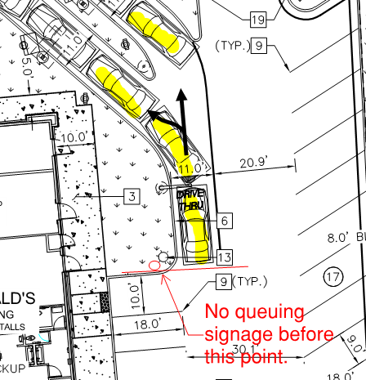

GENERAL COMMENTS (as applicable) Satisfied; applicant has noted/acknowledged/addressed with current submittal.

All engineering documents submitted to the Town of Parker shall bear the wet signature and seal of the engineer or architect in responsible charge of the design.

Water distribution and site access components shall be installed and in service prior to the construction of any portion of the structure, except by special permit issued by the Fire District.

Underground fire lines
When thrust blocks are used as part of the pipe restraint system, submitted plans for permit shall provide detailed documentation that the thrust blocks satisfy all requirements of 16 NFPA 24: 10.8.2, including specific thrust block dimensions and mathematical calculations for block dimensions per guidelines provided in Annex A.10.8.2.

Underground Fire Line - Submittal Requirements

Reference: 2016 NFPA 24 Installation of Private Fire Service Mains and Their Appurtenances

A separate permit is required and will be issued pending review of a detailed submittal which must include the following: [18 IFC 901.2]

4.1.1 Working plans shall be submitted for approval to the authority having jurisdiction before any equipment is installed or replaced.

4.1.2 Deviation from approved plans shall require permission of the authority having jurisdiction.

4.1.3 Working plans shall be drawn to an indicated scale on sheets of uniform size, with a plan of each floor as
applicable, and shall include the following items that pertain to the design of the system:

(1) Name of owner
(2) Location, including street address
(3) Point of compass
(4) A graphic representation of the scale used on all plans
(5) Name and address of contractor
(6) Size and location of all water supplies
(7) The following items that pertain to private fire service mains:
(a) Size
(b) Length
(c) Location
(d) Material (ductile-iron, PVC., etc.)
(e) Point of connection to city main
(f) Sizes, types, and locations of valves, depth at which the top of the pipe is laid below grade
(g) Method of restraint (Meg-a-Lug or similar)

4.1.4 The working plan submittal shall include the manufacturer's installation instructions for any specially listed equipment, including descriptions, applications, and limitations for any devices, piping, or fittings. Submittals must include installation specifications for thrust blocks, corrosion protection, restraint system, bedding, detail of pipe under the building up to, and including, the flange. When it is intended that a different contractor will extend the fire line from a stopping point outside the building, to the inside flange, a second submittal and permit is required.

All tees, plugs, reducers, valves, and hydrant branches shall be restrained against movement by thrust blocks [10.8.2] or restrained joint systems [10.8.3]. When thrust blocks are used as part of the pipe restraint system, submitted plans shall provide detailed documentation that the thrust blocks satisfy all requirements of Section 10.8.2, including specific thrust block dimensions and mathematical calculations for block dimensions per guidelines provided in Annex A.10.8.2.

Any individual or company who physically works on or installs any part of a fire suppression system, including underground supply lines, from public water lines to system risers and backflow preventers, must be registered with the Colorado Division of Fire Safety. [Dept of Public Safety, Division of Fire Safety, Fire Suppression Program 8 CCR 1507-11:3.1.2] Documentation of valid annual registration may be required with plan submittal.

The following website for the Colorado Division of Fire Safety will provide registration instructions.
http://dfs.state.co.us/SuppAppsProcInsp.htm

All submittals must display a wet stamp and original signature by a Colorado licensed professional engineer or NICET III, or higher, in fire suppression systems. [Dept. of Public Safety, Division of Fire Safety, Fire Suppression Program 8 CCR 1507

FIRE CODE REVIEW BLOCK
All fire hydrants shall be installed according to water utility standards. The number and locations of the fire hydrants as shown on the Overall Utility Plan are correct as specified by the Town of Parker, Community Development Department.

Fire Code Official or Designated Representative Date

(NOTE – Underground Fire Line (UFL) submittal documents must meet the requirements of NFPA 24 when submitting for review.)

FIRE ACCESS ROAD DESIGN CRITERIA

VEHICLE SPECIFICATIONS are provided for the largest apparatus in use by South Metro Fire Rescue. Fire Apparatus Access Roads shall be capable of accommodating this apparatus.

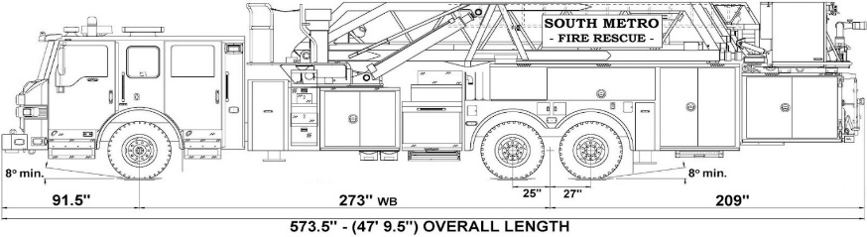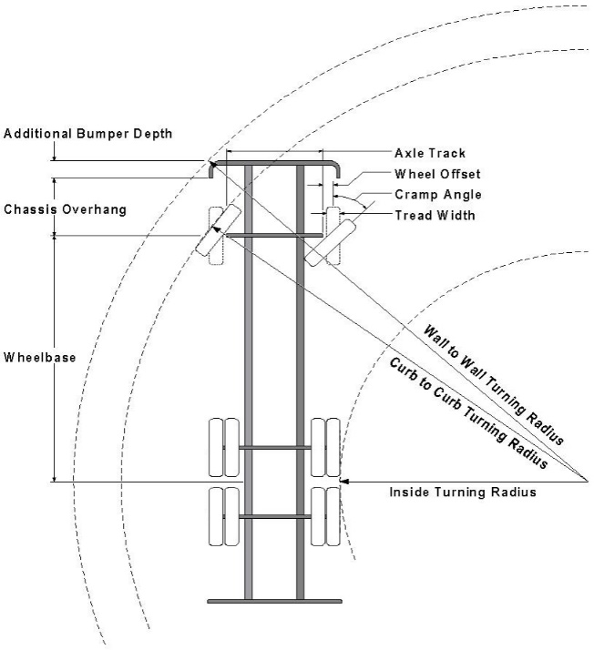

Vehicle Specifications
Length: 47’ 9.5”
Width: 8’ 5” - (10’ 1” mirror to mirror)
Height: 10’ 9”
Wheelbase: 273 in.
Design load: 80,000 pounds Inside Cramp Angle: 40° Axle Track: 83”
Wheel Offset: 5.3”
Tread Width: 13.5”

Turning Radii:
Inside Turn: 26 ft. 1 in. Curb to curb: 41 ft. 11 in. Wall to wall: 46 ft. 8 in.

Where objects are present adjacent to the fire apparatus access road, particularly on turns and turn arounds which require backing, a reasonable safety margin shall be provided to prevent potential damage to the property and to the fire apparatus.

PRIVATE ROADS that provide access to more than two dwellings or one or more commercial buildings shall be constructed to meet the roadway standards approved by the South Metro Fire Rescue Authority for fire apparatus access. Private roads that do not meet the roadway standard may be accepted provided that alternative methods and materials are incorporated into the subdivision that addresses the fire and life safety of the citizens.

