

Town of Parker Community Development Department
Development Review Division
Attention: Stacey Nerger

Application Type: Site Plan
Status: First Referral
Application Name: Lincoln Professional Park L3 - Andy's Custard
Case/AP#: SP22-113
Referral Received: October 5, 2022
Comments Due: November 2, 2022

Application Location: Generally located on the south side of Lincoln Avenue between Dransfeldt Road and Parker Road Review date: October 21, 2022
Plan reviewer: Randall L. Capra, rcapra@parkeronline.org
Phone: 303.805.3163

Narrative: The applicant, Galloway, is proposing a 1,947 sq. ft. frozen custard drive through. The site is located on the south side of Lincoln Avenue between Dransfeldt Road and Parker Road.

Code Reference: 2021 International Fire Code, 2021 International Building Code, 2020 NEC

TOWN OF PARKER FIRE/LIFE SAFETY:

1st Submittal – Reviewed October 21, 2022
2nd Submittal – Reviewed January 18, 2023 (Comments in red, italicized font)
3rd Submittal – Reviewed (Comments in bold, red, italicized font)

UNRESOLVED ISSUES/COMMENTS

The items noted below with a comment number (1, 2 etc.) are items that need to be corrected to show compliance with the applicable codes. Please provide a written response to this letter indicating where the corrections are made on the plans (cloud the plans as applicable). This will speed up the second review process.

- The applicant shall be aware that no vertical construction on this site will be allowed until such time that curb gutter and first lift of asphalt are installed; a site inspection will be required to ensure that this requirement is made prior to allowing vertical construction to commence. Satisfied; applicant has acknowledged with second submittal.

- The applicant shall provide NO PARKING – FIRE LANE signage for any portion of the access where the 24-foot clear width requirement cannot be me; areas that are required to have this signage are located on both the north and sides of the building. Not satisfied; the applicant will be required to provide two NO PARKING – FIRE LANE signs in the area shown below. Address this issue when resubmitting.

Note - The Town of Parker requires that fire apparatus access roads meet the clear-width and weight-bearing standards of the jurisdiction in which the project is located. Roadways shall be designed to support the imposed weight of fire apparatus, 30-ton, two axle and 40-ton, three axle vehicles. An unimpeded clear width of 24-feet shall be maintained at all times. As such, any location where parked vehicles would obstruct this clear width requirement will require “NO PARKING – FIRE LANE” signage. This signage shall be red on white. Update design criteria has been provided at the end of this document; ensure compliance when resubmitting.

- The applicant shall be aware that the access road hydrant distribution was not planned to address the suppression needs for all commercial properties within this subdivision; this site requires the addition of one hydrant (to be located at the s/e corner island of the building… as required per NFPA 24 Section 7.2.3. Note – This issue was addressed satisfactorily, my thanks to the team. A response is not required. Satisfied; applicant has acknowledged with second submittal.

- The applicant was informed during the pre-application meetings that the building is required to be sprinklered based upon access. Per the requirements of [21 IFC Section 503.1.1], this section states “approved fire apparatus access roads shall be provided for every facility, building, portion of a building hereafter constructed or moved into or within the jurisdiction. The fire apparatus access road shall comply with the requirements of this section and shall extend to within 150 feet of all portions of the facility and all portions of the exterior walls of the first story of the building as measured by an approved route around the exterior of the building or facility”. The code further states, “the fire code official is allowed to increase the dimension of the 150 feet provided that the applicant meets Exception 1.1 of this section… “The building is equipped throughout with an approved automatic sprinkler suppression system installed in accordance with section 903.1.1, 903.1.2, or 903.3.1.3”. Not satisfied; the applicant has stated that the hose length can be met without providing a document indicating how this hose length is met. I have taken measurements (very loosely as I don’t have the necessary tools to do this electronically) that indicate that the hose pulls on the south would be 151 feet and in excess of 180 feet on the north side. This rough measurement does not fully address the radius required of the hose (see below). When resubmitting, show a hose pull off the apparatus (as shown below) in a radius that will ensure that the hose does not kink. Address this issue when resubmitting. Note – in order to be allowed not to sprinkler this building per the requirements of 503.1.1, this documentation shall be required.

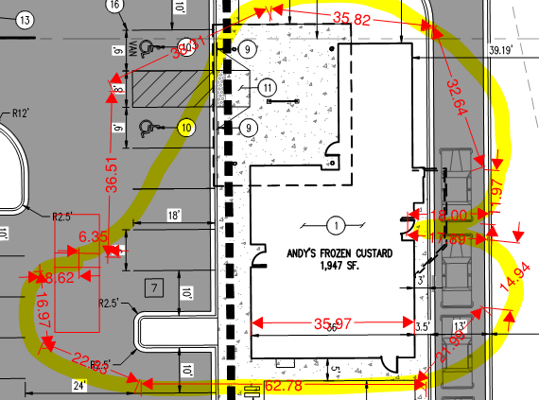

As an access road cannot be provided around this facility, the building will be required to be sprinklered as the access is dependent on a hose length of 150 feet… typically measured from the center of the required access road. See below for the required route:

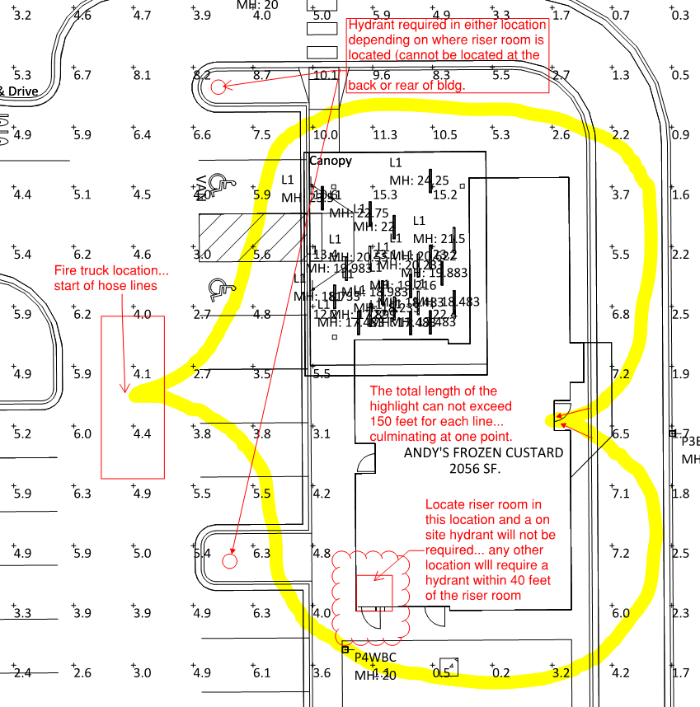
- The applicant shall provide a design of the fire sprinkler control valve room floor plan to ensure that the riser room is sized to accommodate the following: Not satisfied; the applicant has not indicated that this is not required as a suppression system is not required. Until the applicant has addressed item #4 adequately, this issue cannot be satisfied one way or the other.

- The sprinkler riser is allowed to enter no further than 24-inches into the building (and any less than 12-inches into the building).
- A three-foot clearance shall be provided in front of the riser (with 18” of clearance on either side of the riser).
- The fire alarm control panel (FACP) is required to be located on an interior wall.
- A three-foot clearance is required in front of the FACP.
- Exterior access is required to be provided into the riser room; this access shall be approved.
- Access into the building shall be provided through the riser room or immediately adjacent to the riser room.
- While domestic water can be located in the riser room, the domestic cannot be located in any way that conflicts with the access requirements for both the FACP and the sprinkler riser.

- When resubmitting, the utility drawings shall address the following: Satisfied; applicant has addressed with second submittal.

- The correct Fire Life Safety signature block is provided on the correct pages; the signature block shall only be provided on the cover sheet of the Utility Plan set and the Overall Utility page (the Site Plan cover sheet currently has this signature block located on this sheet… this block shall be deleted from the Site Plan)… the review block used is correct though a new overall utility page will be required to address the UFL location and hydrant if applicable).
- The domestic is not allowed to be pulled off of the underground fire line (UFL).
- The UFL is not allowed to share the same line as the fire hydrant.
- The UFL is not allowed to enter any further than 24-inches into the building (and any less than 12-inches into the building (as noted above).
- The Utility drawings shall clearly identify the UFL by name, length and size on the plan set (a note can address this though the line itself shall also bear these notations).

- While the applicant has provided an auto-turn analysis, in addition to what was provided, two additional routes shall be provided when resubmitting; see the redlined drawing below for the required locations… apparatus shall be able navigate all portions of this site… and address this issue when resubmitting: Partially satisfied; applicant has provided the required auto turn analysis. The analysis indicates a clear movement though this movement can be obstructed by vehicles in the drive through access. As such, signage shall be provided at the intersection on the south end “DO NOT OBSTRUCT ACCESS”. Address this issue when resubmitting.

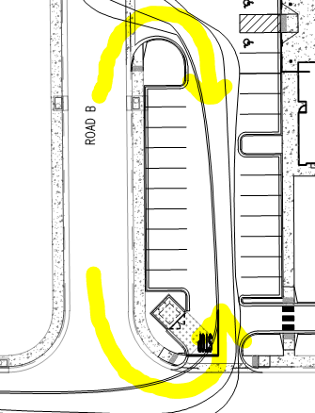

GENERAL COMMENTS (as applicable)
All engineering documents submitted to the Town of Parker shall bear the wet signature and seal of the engineer or architect in responsible charge of the design.

Water distribution and site access components shall be installed and in service prior to the construction of any portion of the structure, except by special permit issued by the Fire District.

Underground fire lines
When thrust blocks are used as part of the pipe restraint system, submitted plans for permit shall provide detailed documentation that the thrust blocks satisfy all requirements of 19 NFPA 24: 10.8.2, including specific thrust block dimensions and mathematical calculations for block dimensions per guidelines provided in Annex A.10.8.2.

FIRE ACCESS ROAD DESIGN CRITERIA

VEHICLE SPECIFICATIONS are provided for the largest apparatus in use by South Metro Fire Rescue. Fire Apparatus Access Roads shall be capable of accommodating this apparatus.

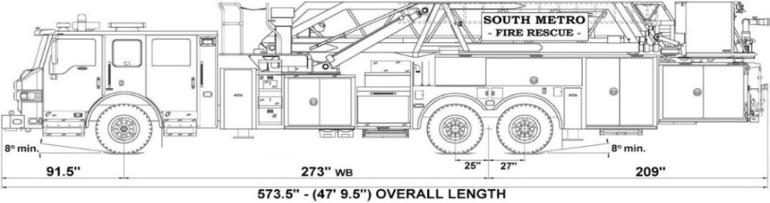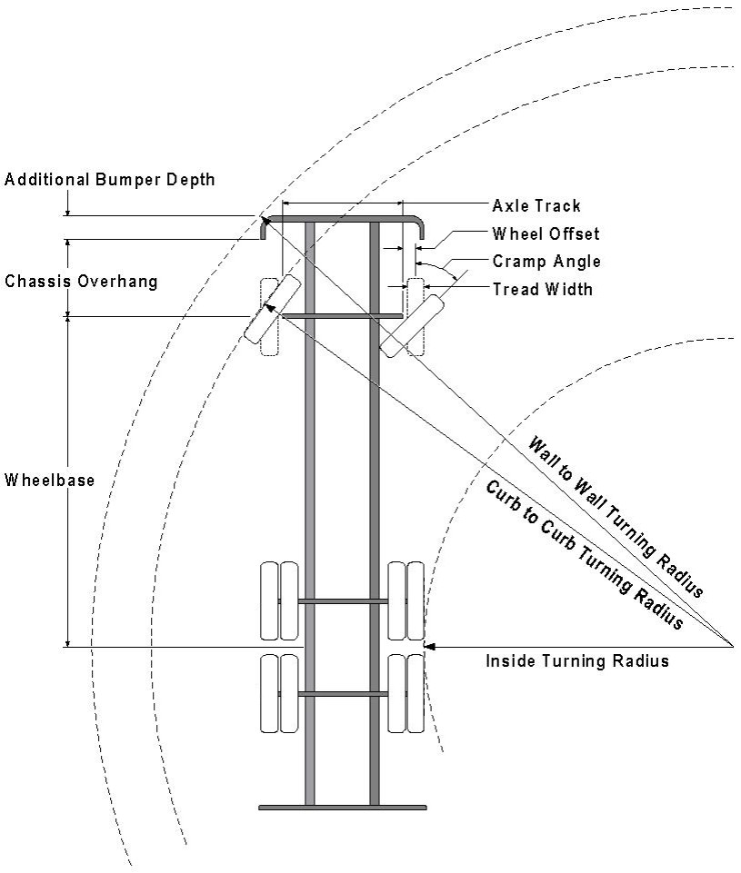

Vehicle Specifications
Length: 47’ 9.5”
Width: 8’ 5” - (10’ 1” mirror to mirror)
Height: 10’ 9”
Wheelbase: 273 in.
Design load: 80,000 pounds Inside Cramp Angle: 40° Axle Track: 83”
Wheel Offset: 5.3”
Tread Width: 13.5”

Turning Radii:
Inside Turn: 26 ft. 1 in. Curb to curb: 41 ft. 11 in. Wall to wall: 46 ft. 8 in.

Where objects are present adjacent to the fire apparatus access road, particularly on turns and turn arounds which require backing, a reasonable safety margin shall be provided to prevent potential damage to the property and to the fire apparatus.

PRIVATE ROADS that provide access to more than two dwellings or one or more commercial buildings shall be constructed to meet the roadway standards approved by the South Metro Fire Rescue Authority for fire apparatus access. Private roads that do not meet the roadway standard may be accepted provided that alternative methods and materials are incorporated into the subdivision that addresses the fire and life safety of the citizens.

FIRE CODE REVIEW BLOCK
All fire hydrants shall be installed according to water utility standards. The number and locations of the fire hydrants as shown on the Overall Utility Plan are correct as specified by the Town of Parker, Community Development Department.

Fire Code Official or Designated Representative Date

(NOTE – Underground Fire Line (UFL) submittal documents must meet the requirements of NFPA 24 when submitting for review.)

Underground Fire Line - Submittal Requirements

Reference: 2019 NFPA 24 Installation of Private Fire Service Mains and Their Appurtenances

A separate permit is required and will be issued pending review of a detailed submittal which must include the following: [21 IFC 901.2]

4.1.1 Working plans shall be submitted for approval to the authority having jurisdiction before any equipment is installed or replaced.

4.1.2 Deviation from approved plans shall require permission of the authority having jurisdiction.

4.1.3 Working plans shall be drawn to an indicated scale on sheets of uniform size, with a plan of each floor as
applicable, and shall include the following items that pertain to the design of the system:

(1) Name of owner
(2) Location, including street address
(3) Point of compass
(4) A graphic representation of the scale used on all plans
(5) Name and address of contractor
(6) Size and location of all water supplies
(7) The following items that pertain to private fire service mains:
(a) Size
(b) Length
(c) Location
(d) Material (ductile-iron, PVC., etc.)
(e) Point of connection to city main
(f) Sizes, types, and locations of valves, depth at which the top of the pipe is laid below grade
(g) Method of restraint (Meg-a-Lug or similar)

4.1.4 The working plan submittal shall include the manufacturer's installation instructions for any specially listed equipment, including descriptions, applications, and limitations for any devices, piping, or fittings. Submittals must include installation specifications for thrust blocks, corrosion protection, restraint system, bedding, detail of pipe under the building up to, and including, the flange. When it is intended that a different contractor will extend the fire line from a stopping point outside the building, to the inside flange, a second submittal and permit is required.

All tees, plugs, reducers, valves, and hydrant branches shall be restrained against movement by thrust blocks [10.8.2] or restrained joint systems [10.8.3]. When thrust blocks are used as part of the pipe restraint system, submitted plans shall provide detailed documentation that the thrust blocks satisfy all requirements of Section 10.8.2, including specific thrust block dimensions and mathematical calculations for block dimensions per guidelines provided in Annex A.10.8.2.

Any individual or company who physically works on or installs any part of a fire suppression system, including underground supply lines, from public water lines to system risers and backflow preventers, must be registered with the Colorado Division of Fire Safety. [Dept of Public Safety, Division of Fire Safety, Fire Suppression Program 8 CCR 1507-11:3.1.2] Documentation of valid annual registration may be required with plan submittal.

The following website for the Colorado Division of Fire Safety will provide registration instructions.
http://dfs.state.co.us/SuppAppsProcInsp.htm

All submittals must display a wet stamp and original signature by a Colorado licensed professional engineer or NICET III, or higher, in fire suppression systems. [Dept. of Public Safety, Division of Fire Safety, Fire Suppression Program 8 CCR 1507

