

Town of Parker Community Development Department
Development Review Division
Attention: Ashley Chasez

Application Type: Site Plan
Status: First Referral
Application Name: Crown Point F1 AMD 20 L4E - Land of Sushi
Case/AP#: SP23-006
Referral Received: February 21, 2023
Comments Due: March 21, 2023

Application Location: Generally located on the south side of Cottonwood Drive west of E-470.

Review date: March 16, 2023
Plan reviewer: Randall L. Capra, rcapra@parkeronline.org
Phone: 303.805.3169

Narrative: The applicant, Galloway and Company, is proposing a site plan for a new 5,680 sq. ft. restaurant with an outdoor patio area. The site is located on the south side of Cottonwood Drive west of E-470.

Code Reference: 2021 ICC Codes including 2021 International Fire Code, 2021 International Building Code, 2020 NEC

TOWN OF PARKER - FIRE/LIFE SAFETY:

1st Submittal – March 16, 2023
2nd Submittal – June 7, 2023 (Comments in red, italicized font)
3rd Submittal – (Comments in bold, red, italicized font)
4th Submittal – (Comments in bold, red, italicized font with a yellow highlight)

UNRESOLVED ISSUES/COMMENTS

The items noted below with a comment number (1, 2 etc.) are items that need to be corrected to show compliance with the applicable codes. Please provide a written response to this letter indicating where the corrections are made on the plans (cloud the plans as applicable). This will speed up the review process when resubmitting. Address all items not shown as “Satisfied” when resubmitting.

- The applicant shall be aware that no vertical construction on this site will be allowed until such time that curb gutter and first lift of asphalt are installed; a site inspection will be required to ensure that this requirement is made prior to allowing vertical construction to commence. Satisfied; applicant noted or acknowledged or addressed with second submittal.

- During the pre-application meetings, the need to provide a fire hydrant on site… this was not addressed. A fire hydrant will be required at the s/e island by the s/e corner of the building. See the redlined drawings and the detail below for the location of the required fire hydrant. Satisfied; applicant noted or acknowledged or addressed with second submittal.

- There are issues with the unitality; typical comments are provided below. Ensure that the drawings address the following when resubmitting: Partially satisfied; applicant noted or acknowledged or addressed with second submittal. The applicant’s only response to the noted requirements was that “plans have been revised to have separate lines to hydrant to the riser room. Added UFL callout to the sheets”.

- The correct Fire Life Safety signature block is provided on the correct pages; the signature block shall only be provided on the cover sheet of the Utility Plan set and the Overall Utility page. This block can be seen at the end of this response letter. Not addressed with second submittal
- The domestic is not allowed to be pulled off of the underground fire line (UFL).
- The UFL is not allowed to share the same line as the fire hydrant.
- The UFL is not allowed to enter any further than 24-inches into the building (and any less than 12-inches) into the building (as noted below). Not addressed with second submittal.
- The Utility drawings shall clearly identify the UFL by name, length and size on the plan set (a note can address this though the underground fire line itself shall also bear these notations. The measurement shall be made from the “T” at the water main ending at the flange in the fire sprinkler control valve room. Not addressed with second submittal

- The overall utility plan shall be modified to address the addition of the required fire hydrant as well as relocate the UFL as shown below; address this issue when resubmitting: Satisfied; applicant noted or acknowledged or addressed with second submittal.

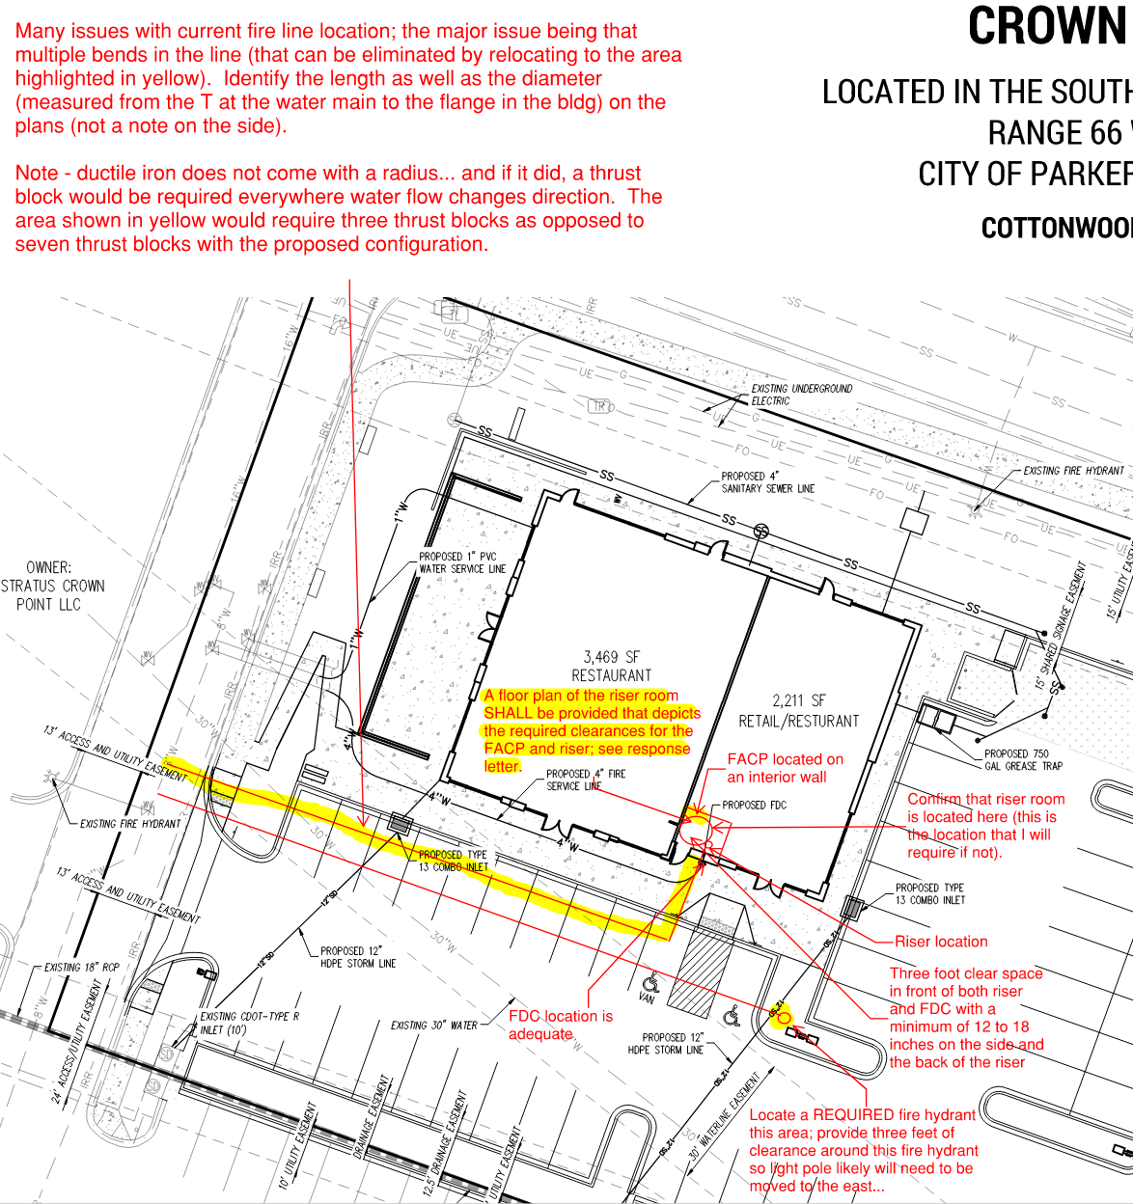

- The applicant has identified where the UFL is to enter the building without providing documentation as to the location of the fire sprinkler control valve room. When resubmitting, the applicant shall provide the following information (using the redlined portion of the utility drawings shown above): Partially satisfied; applicant noted or acknowledged or addressed with second submittal. The applicant’s only response to the noted requirements was that “riser room requirements have been met with this submittal”. The required details of the riser room has not been provided that shows how the riser room is to be laid out. When resubmitting, ensure that this issue is addressed including the location of the FACP (required on an interior wall), emergency lighting over the FACP, location of where the UFL turns up, and the required clearances with respect to the sprinkler riser and the FACP. This detail (or floor plan) is required prior to approval for this project.

- An exterior door shall be provided into the riser room
- A door, either adjacent to the riser room or a door that provides immediate access into the building through the riser room shall be provided (as noted above)
- The riser room shall be sized such that a three-foot clear space is provided around the sprinkler riser with the Fire Alarm Control Panel being located on an interior wall. A three-foot clear space is required in front of the FACP. A minimum of 12” is required behind the riser.
- A sidewalk is required to be provided from the drive aisle to the riser room
- A 5’ x 5’ concrete pad shall be provided in front of the FDC with a sidewalk provided to the FDC.
- A detail of the riser room is required to show how the room is to be laid out (arranged), that all clearances are met, and that the exterior access has been provided into the riser room with the required access into the building. This is a requirement and will not be allowed to be deferred.

- The Town of Parker requires that fire apparatus access roads meet the clear-width and weight-bearing standards of the jurisdiction in which the project is located. Roadways shall be designed to support the imposed weight of fire apparatus, 30-ton, two axle and 40-ton three, axle vehicles. An unimpeded clear width of 20-feet shall be maintained at all times as well as the required 28’ clear width along the western portion of the building. As such, any location where parked vehicles would obstruct this clear width requirement will require “NO PARKING – FIRE LANE” signage. This signage shall be red on white. Update design criteria has been provided at the end of this document; ensure compliance when resubmitting. Satisfied; applicant noted or acknowledged or addressed with second submittal.

- While the applicant has provided an auto turn analysis, the applicant has not addressed the access on the eastern portion of the site. When resubmitting, the applicant shall provide an auto turn analysis indicating that apparatus can navigate all portions of this site (east side of the building); NO PARKING – FIRE LANE signage is required for any portion of the access where the 20-foot clear width requirement cannot be met. See below for the areas required to be included in the auto turn analysis (in addition to what already has been shown) and address when resubmitting: Not satisfied; applicant has provided the required area for the analysis though the auto turn shows quite a bit of encroachment into the landscaping on the north end. Clean up the analysis to ensure access when resubmitting.

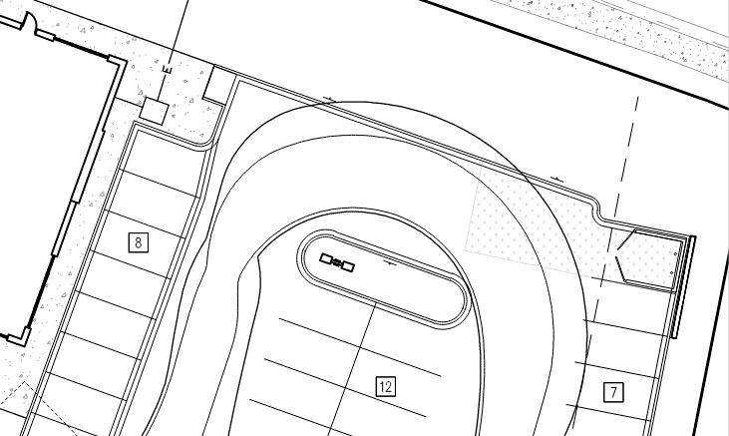

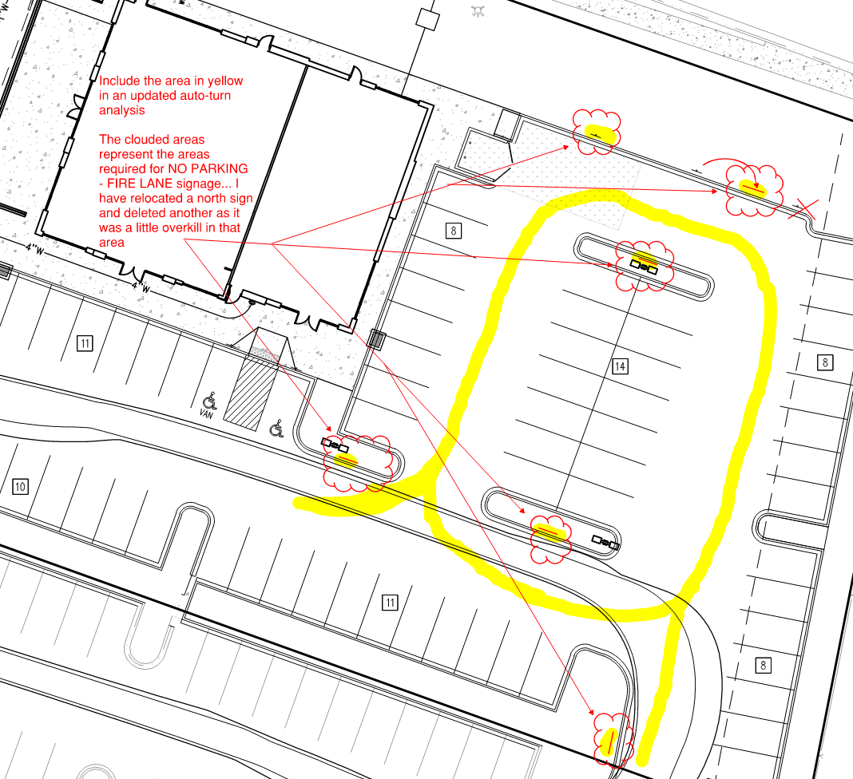

- The items noted above with a comment number (1, 2 etc.) are items that need to be corrected to show compliance with the applicable codes. Please provide a written response to this letter indicating where the corrections are made on the plans (cloud the plans as applicable). This will speed up the review process when resubmitting. Note – This item is listed twice to emphasize the requirement to respond to the fire life safety response letter.

GENERAL COMMENTS (as applicable)
All engineering documents submitted to the Town of Parker shall bear the wet signature and seal of the engineer or architect in responsible charge of the design.

Water distribution and site access components shall be installed and in service prior to the construction of any portion of the structure, except by special permit issued by the Fire District.
FIRE ACCESS ROAD DESIGN CRITERIA

VEHICLE SPECIFICATIONS are provided for the largest apparatus in use by South Metro Fire Rescue. Fire Apparatus Access Roads shall be capable of accommodating this apparatus.
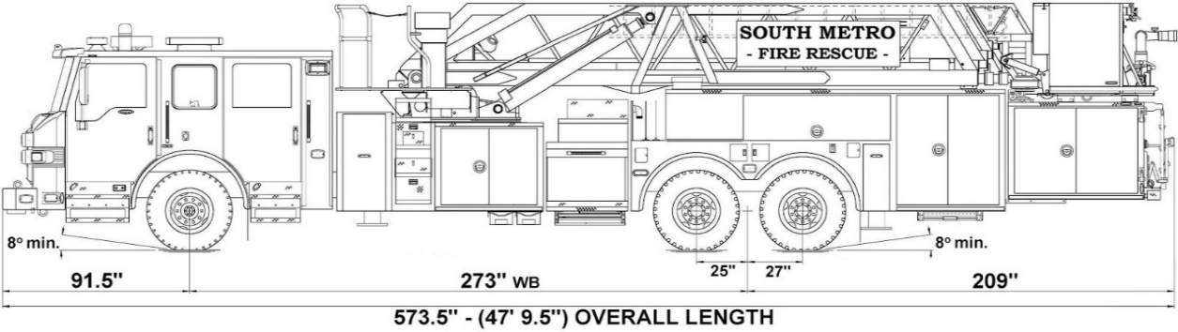

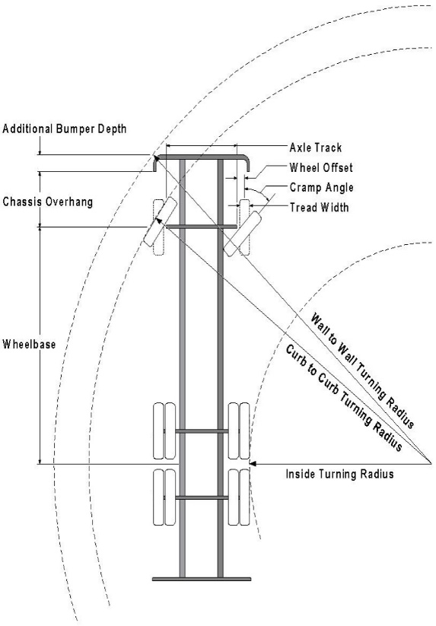

Vehicle Specifications
Length: 47’ 9.5”
Width: 8’ 5” - (10’ 1” mirror to mirror)
Height: 10’ 9”
Wheelbase: 273 in.
Design load: 80,000 pounds Inside Cramp Angle: 40° Axle Track: 83”
Wheel Offset: 5.3”
Tread Width: 13.5”

Turning Radii:
Inside Turn: 26 ft. 1 in. Curb to curb: 41 ft. 11 in. Wall to wall: 46 ft. 8 in.

Where objects are present adjacent to the fire apparatus access road, particularly on turns and turn arounds which require backing, a reasonable safety margin shall be provided to prevent potential damage to the property and to the fire apparatus.

PRIVATE ROADS that provide access to more than two dwellings or one or more commercial buildings shall be constructed to meet the roadway standards approved by the South Metro Fire Rescue Authority for fire apparatus access. Private roads that do not meet the roadway standard may be accepted provided that alternative methods and materials are incorporated into the subdivision that addresses the fire and life safety of the citizens.

Underground fire lines
When thrust blocks are used as part of the pipe restraint system, submitted plans for permit shall provide detailed documentation that the thrust blocks satisfy all requirements of 13 NFPA 24: 10.8.2, including specific thrust block dimensions and mathematical calculations for block dimensions per guidelines provided in Annex A.10.8.2.

FIRE CODE REVIEW BLOCK
All fire hydrants shall be installed according to water utility standards. The number and locations of the fire hydrants as shown on the Overall Utility Plan are correct as specified by the Town of Parker, Community Development Department.

Fire Code Official or Designated Representative Date

(NOTE – Underground Fire Line (UFL) submittal documents must meet the requirements of NFPA 24 when submitting for review.)

Underground Fire Line - Submittal Requirements

Reference: 2019 NFPA 24 Installation of Private Fire Service Mains and Their Appurtenances

A separate permit is required and will be issued pending review of a detailed submittal which must include the following: [21 IFC 901.2]

4.1.1 Working plans shall be submitted for approval to the authority having jurisdiction before any equipment is installed or replaced.

4.1.2 Deviation from approved plans shall require permission of the authority having jurisdiction.

4.1.3 Working plans shall be drawn to an indicated scale on sheets of uniform size, with a plan of each floor as
applicable, and shall include the following items that pertain to the design of the system:

(1) Name of owner
(2) Location, including street address
(3) Point of compass
(4) A graphic representation of the scale used on all plans
(5) Name and address of contractor
(6) Size and location of all water supplies
(7) The following items that pertain to private fire service mains:
(a) Size
(b) Length
(c) Location
(d) Material (ductile-iron, PVC., etc.)
(e) Point of connection to city main
(f) Sizes, types, and locations of valves, depth at which the top of the pipe is laid below grade
(g) Method of restraint (Meg-a-Lug or similar)

4.1.4 The working plan submittal shall include the manufacturer's installation instructions for any specially listed equipment, including descriptions, applications, and limitations for any devices, piping, or fittings. Submittals must include installation specifications for thrust blocks, corrosion protection, restraint system, bedding, detail of pipe under the building up to, and including, the flange. When it is intended that a different contractor will extend the fire line from a stopping point outside the building, to the inside flange, a second submittal and permit is required.

All tees, plugs, reducers, valves, and hydrant branches shall be restrained against movement by thrust blocks [10.8.2] or restrained joint systems [10.8.3]. When thrust blocks are used as part of the pipe restraint system, submitted plans shall provide detailed documentation that the thrust blocks satisfy all requirements of Section 10.8.2, including specific thrust block dimensions and mathematical calculations for block dimensions per guidelines provided in Annex A.10.8.2.

Any individual or company who physically works on or installs any part of a fire suppression system, including underground supply lines, from public water lines to system risers and backflow preventers, must be registered with the Colorado Division of Fire Safety. [Dept of Public Safety, Division of Fire Safety, Fire Suppression Program 8 CCR 1507-11:3.1.2] Documentation of valid annual registration may be required with plan submittal.

The following website for the Colorado Division of Fire Safety will provide registration instructions.
http://dfs.state.co.us/SuppAppsProcInsp.htm

All submittals must display a wet stamp and original signature by a Colorado licensed professional engineer or NICET III, or higher, in fire suppression systems. [Dept. of Public Safety, Division of Fire Safety, Fire Suppression Program 8 CCR 1507

