

Town of Parker Community Development Department
Development Review Division
Attention: Stacey Nerger

Application Type: Site Plan – Non-Residential
Status: First Referral
Application Name: Douglas 234 F6 AMD 2 L8A - Les Schwab Tire
Case/AP#: SP23-054
Referral Received: July 28, 2022
Comments Due: August 18 ,2022

Application Location: Generally located on the northeast corner of Hess Road and Chambers Road.

Review date: August 7, 2022
Plan reviewer: Randall L. Capra, rcapra@parkeronline.org
Phone: 303.805.3163

Narrative: The applicant, Cushing Terrell, is proposing a 10,037 Sq. Ft. tire store and service center. The site is located on the northeast corner of Hess Road and Chambers Road.

Code Reference: 2021 International Fire Code, 2021 International Building Code, 2020 NEC (codes are in effect through December 31, 2024)

TOWN OF PARKER FIRE/LIFE SAFETY:

1st Submittal – Reviewed August 7, 2023
2nd Submittal – Reviewed Sept 25, 2023 Comments in red, italicized font)
3rd Submittal – Reviewed (Comments in bold, red, italicized font)

UNRESOLVED ISSUES/COMMENTS

The items noted below with a comment number (1, 2 etc.) are items that need to be corrected to show compliance with the applicable codes. Provide a REQUIRED written response to this letter indicating where the corrections are made on the plans (cloud the plans as applicable). This will speed up the review process when resubmitting.

The applicant has not addressed any comments specific to this letter; as noted above, a written response to each item is required. Failure on the part of the applicant to address all items (identifying where the modifications can be found and in what document) will result in further delays as Fire Life Safety will not sign off on the project until all issues are resolved satisfactorily.

- The applicant shall be aware that no vertical construction on this site will be allowed until such time that curb gutter and first lift of asphalt are installed; a site inspection will be required to ensure that this requirement is made prior to allowing vertical construction to commence. Not satisfied with the second submittal; issues were not addressed.

- The applicant shall be aware that the internal access hydrant distribution was not planned to address the suppression needs for all commercial properties within this subdivision; this site requires the addition of one hydrant (to be located at the s/e corner island adjacent to the building… as required per NFPA 24 Section 7.2.3. Utility drawings are required to address this requirement.

A fire hydrant has been provided as required though the applicant has not shown that a minimum of 3 feet of clearance is required around the fire hydrant… as measured from the furthest outlets of the hydrant. Show that this is met within the context of the utility plan provided. Not satisfied with the second submittal; issues were not addressed.

- The applicant shall provide an auto turn analysis indicating that apparatus can navigate all portions of this site; Address this issue when resubmitting. Not satisfied with the second submittal; issues were not addressed.

- The applicant shall be aware that vehicles WILL NOT be allowed to be staged or parked in front of the building or along the north side; the applicant will be required to provide to distinct signs along the front of the building that states NO PARKING – FIRE LANE and NO PARKING OR STANDING. This will apply to both customers and to Les Schwab for this site. The applicant shall address this issue when resubmitting: Not satisfied with the second submittal; issues were not addressed.

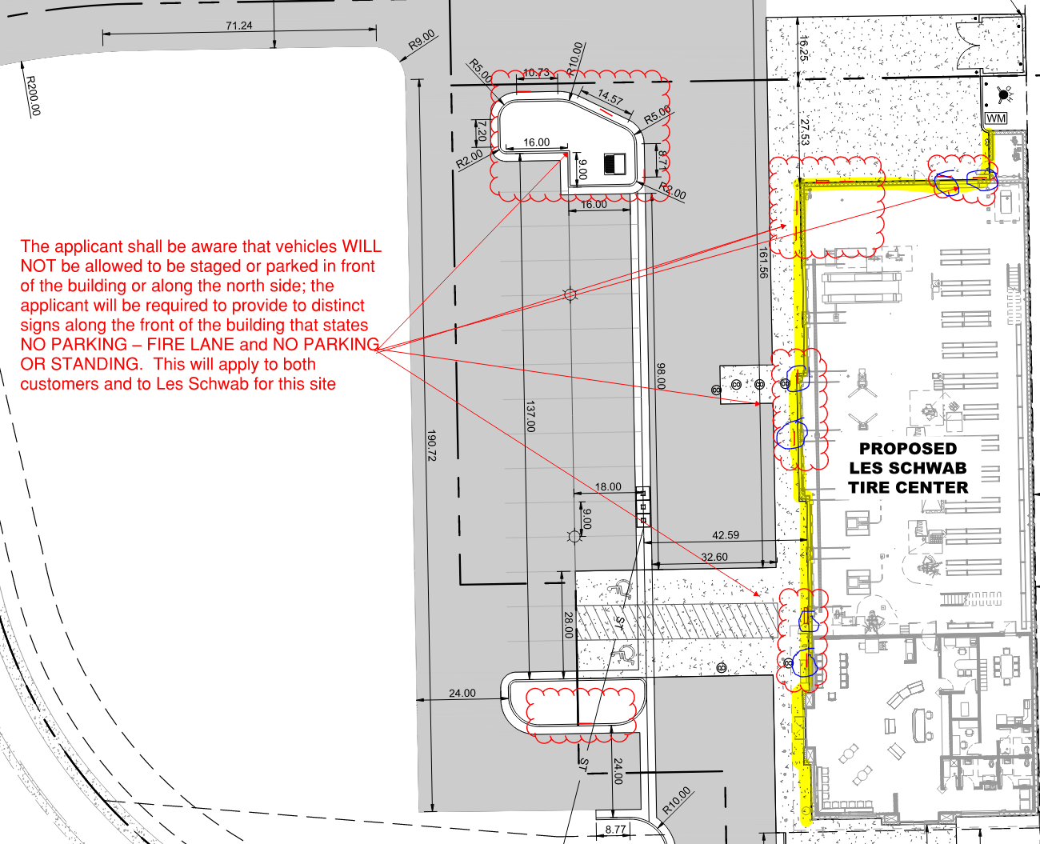

- The utility drawings shall address the following when resubmitting (as applicable):

- The correct Fire Life Safety signature block is provided on the correct pages; the signature block shall only be provided on the cover sheet of the Utility Plan set and the Overall Utility page (the Site Plan cover sheet currently has this signature block located on this sheet… this block shall be deleted from the Site Plan).
- The domestic is not allowed to be pulled off of the underground fire line (UFL) if applicable.
- The UFL is not allowed to share the same line as the fire hydrant.
- The UFL is not allowed to enter any further than 24-inches into the building (and any less than 18-inches into the building) and shall have 12-inches of clearance behind it as well as 36-inches of clearance is front of the riser.
- The Utility drawings shall clearly identify the UFL by name, length and size on the plan set (a note can address this though the line itself shall also bear these notations if applicable.
- The fire alarm control panel (FACP) shall be located in this room and this panel shall be located on an internal wall.
- The FACP shall have a minimum of 36 inches provided in front of this panel.

A floor plan of the fire riser room shall be provided indicating that all issues can be met within the space provided. This requirement is not an option and shall be addressed to the satisfaction of this office prior to approval. Not satisfied with the second submittal; issues were not addressed.

- The applicant shall provide an additional NO PARKING – FIRE LANE signage in the location shown below; this location is on the south side of the access road just south of the building. See item #5 above specific to this issue.

Note - The Town of Parker requires that fire apparatus access roads meet the clear-width and weight-bearing standards of the jurisdiction in which the project is located. Roadways shall be designed to support the imposed weight of fire apparatus, 30-ton, two axle and 40-ton, three axle vehicles. An unimpeded clear width of 26-feet shall be maintained at all times. As such, any location where parked vehicles would obstruct this clear width requirement will require “NO PARKING – FIRE LANE” signage. This signage shall be red on white. Update design criteria has been provided at the end of this document; ensure compliance when resubmitting.
Not satisfied with the second submittal; issues were not addressed.

GENERAL COMMENTS (as applicable)
All engineering documents submitted to the Town of Parker shall bear the wet signature and seal of the engineer or architect in responsible charge of the design.

Water distribution and site access components shall be installed and in service prior to the construction of any portion of the structure, except by special permit issued by the Fire District.

Underground fire lines
When thrust blocks are used as part of the pipe restraint system, submitted plans for permit shall provide detailed documentation that the thrust blocks satisfy all requirements of 19 NFPA 24: 10.8.2, including specific thrust block dimensions and mathematical calculations for block dimensions per guidelines provided in Annex A.10.8.2.

FIRE ACCESS ROAD DESIGN CRITERIA

VEHICLE SPECIFICATIONS are provided for the largest apparatus in use by South Metro Fire Rescue. Fire Apparatus Access Roads shall be capable of accommodating this apparatus.

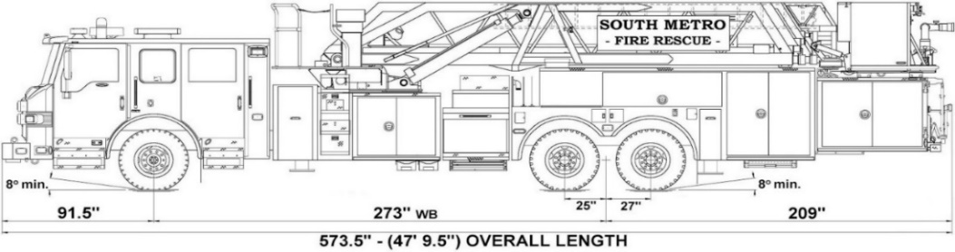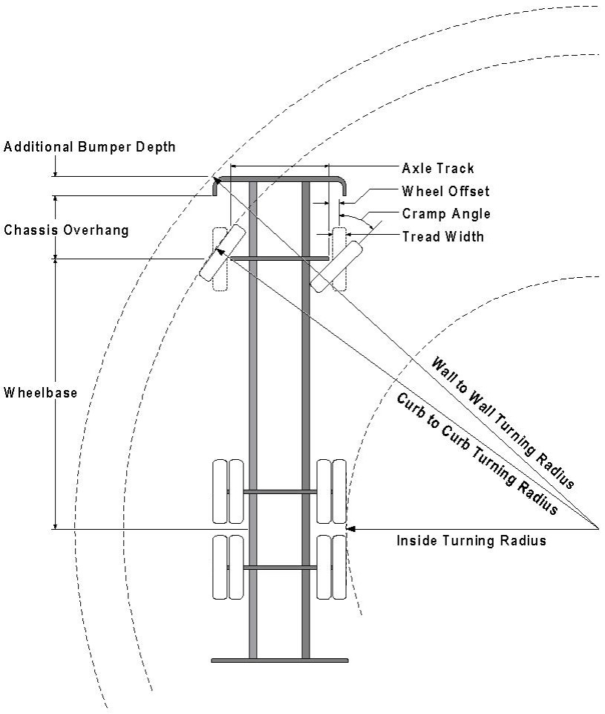

Vehicle Specifications
Length: 47’ 9.5”
Width: 8’ 5” - (10’ 1” mirror to mirror)
Height: 10’ 9”
Wheelbase: 273 in.
Design load: 80,000 pounds Inside Cramp Angle: 40° Axle Track: 83”
Wheel Offset: 5.3”
Tread Width: 13.5”

Turning Radii:
Inside Turn: 26 ft. 1 in. Curb to curb: 41 ft. 11 in. Wall to wall: 46 ft. 8 in.

Where objects are present adjacent to the fire apparatus access road, particularly on turns and turn arounds which require backing, a reasonable safety margin shall be provided to prevent potential damage to the property and to the fire apparatus.

PRIVATE ROADS that provide access to more than two dwellings or one or more commercial buildings shall be constructed to meet the roadway standards approved by the South Metro Fire Rescue Authority for fire apparatus access. Private roads that do not meet the roadway standard may be accepted provided that alternative methods and materials are incorporated into the subdivision that addresses the fire and life safety of the citizens.

FIRE CODE REVIEW BLOCK
All fire hydrants shall be installed according to water utility standards. The number and locations of the fire hydrants as shown on the Overall Utility Plan are correct as specified by the Town of Parker, Community Development Department.

Fire Code Official or Designated Representative Date

(NOTE – Underground Fire Line (UFL) submittal documents must meet the requirements of NFPA 24 when submitting for review.)

Underground Fire Line - Submittal Requirements

Reference: 2019 NFPA 24 Installation of Private Fire Service Mains and Their Appurtenances

A separate permit is required and will be issued pending review of a detailed submittal which must include the following: [21 IFC 901.2]

4.1.1 Working plans shall be submitted for approval to the authority having jurisdiction before any equipment is installed or replaced.

4.1.2 Deviation from approved plans shall require permission of the authority having jurisdiction.

4.1.3 Working plans shall be drawn to an indicated scale on sheets of uniform size, with a plan of each floor as
applicable, and shall include the following items that pertain to the design of the system:

(1) Name of owner
(2) Location, including street address
(3) Point of compass
(4) A graphic representation of the scale used on all plans
(5) Name and address of contractor
(6) Size and location of all water supplies
(7) The following items that pertain to private fire service mains:
(a) Size
(b) Length
(c) Location
(d) Material (ductile-iron, PVC., etc.)
(e) Point of connection to city main
(f) Sizes, types, and locations of valves, depth at which the top of the pipe is laid below grade
(g) Method of restraint (Meg-a-Lug or similar)

4.1.4 The working plan submittal shall include the manufacturer's installation instructions for any specially listed equipment, including descriptions, applications, and limitations for any devices, piping, or fittings. Submittals must include installation specifications for thrust blocks, corrosion protection, restraint system, bedding, detail of pipe under the building up to, and including, the flange. When it is intended that a different contractor will extend the fire line from a stopping point outside the building, to the inside flange, a second submittal and permit is required.

All tees, plugs, reducers, valves, and hydrant branches shall be restrained against movement by thrust blocks [10.8.2] or restrained joint systems [10.8.3]. When thrust blocks are used as part of the pipe restraint system, submitted plans shall provide detailed documentation that the thrust blocks satisfy all requirements of Section 10.8.2, including specific thrust block dimensions and mathematical calculations for block dimensions per guidelines provided in Annex A.10.8.2.

Any individual or company who physically works on or installs any part of a fire suppression system, including underground supply lines, from public water lines to system risers and backflow preventers, must be registered with the Colorado Division of Fire Safety. [Dept of Public Safety, Division of Fire Safety, Fire Suppression Program 8 CCR 1507-11:3.1.2] Documentation of valid annual registration may be required with plan submittal.

The following website for the Colorado Division of Fire Safety will provide registration instructions.
http://dfs.state.co.us/SuppAppsProcInsp.htm

All submittals must display a wet stamp and original signature by a Colorado licensed professional engineer or NICET III, or higher, in fire suppression systems. [Dept. of Public Safety, Division of Fire Safety, Fire Suppression Program 8 CCR 1507

