

Town of Parker Community Development Department
Development Review Division
Attention: Stacey Nerger

Application Type: Site Plan Major Amendment – Non-Residential
Status: First Referral
Application Name: The Exchange L1 – Site Plan Amendment Addition & Remodel
Case/AP#: SP23-080
Referral Received: October 17, 2023
Comments Due: November 15, 2023

Application Location: Located at the southwest corner of Mainstreet and Pikes Peak Drive.

Review date: November 3, 2023
Plan reviewer: Randall L. Capra, rcapra@parkeronline.org
Phone: 303.805.3163

NARRATIVE: The applicant, Galloway and Company, is proposing a Site Plan Amendment to add 1182 sq. ft. to an existing building, make changes to the existing elevation and amend the parking and landscaping, The site is located on the southwest corner of Mainstreet and Pikes Peak Drive.

Code Reference: 2021 International Fire Code, 2021 International Building Code, 2020 NEC, and IFC code referenced NFPA Standards (adopted codes valid through Dec 31, 2024)

TOWN OF PARKER - FIRE/LIFE SAFETY:

1st Submittal – Reviewed October 3, 2023
2nd Submittal – Reviewed December 21, 2023 (Comments in red, italicized font)
3rd Submittal – Reviewed February 8, 2024 (Comments in bold, red, italicized font)
4th Submittal – (Comments in bold, red, italicized font with a yellow highlight)

UNRESOLVED ISSUES/COMMENTS: The items noted below with a comment number (1, 2 etc.) are items that need to be corrected to show compliance with the applicable codes. Provide a written response indicating where the corrections are made on the plans… clouding the plans in the process. This will speed up the second review process.

- The applicant shall be aware that no vertical construction on this site will be allowed until such time that curb gutter and first lift of asphalt are installed; a site inspection will be required to ensure that this requirement is made prior to allowing vertical construction to commence. Satisfied; the applicant has noted, acknowledged, or addressed with the second submittal.

- The applicant shall be aware that the access road hydrant distribution was not planned to address the suppression needs for all commercial properties within this subdivision; this site requires the addition of one hydrant on the east side of the building. Note – this issue was addressed by the applicant; thank you! Satisfied; the applicant has noted, acknowledged, or addressed with the second submittal.

- Per the requirements of [21 IFC Section 503.1.1 Buildings and Facilities] approved fire apparatus access roads shall be provided for every facility, building, portion of a building hereafter constructed or moved into or within the jurisdiction. The fire apparatus access road shall comply with the requirements of this section and shall extend to within 150 feet of all portions of the facility and all portions of the exterior walls of the first story of the building as measured by an approved route around the exterior of the building or facility (the building, as approximately 4,000 sf (or 40’x 100’) cannot meet the requirement as measured from the center line of the fire apparatus as measured by an approved route from any point that a fire engine might park when responding to a call at this building).

Per the requirements of the code, the fire code official is allowed to increase the dimension of the 150 feet provided that the applicant meets Exception 1.1 of this section… “The building is equipped throughout with an approved automatic sprinkler suppression system installed in accordance with section 903.1.1, 903.1.2, or 903.3.1.3; a sprinkler suppression system will be required. As access cannot be met this building is required to be sprinklered per the requirements of the code (this was also noted as a requirement during the pre-application meeting discussions). Note – this issue was addressed; thank you! Satisfied; the applicant has noted, acknowledged, or addressed with the second submittal. The building is to be fully sprinkled. Note – The applicant has indicated that a fire hydrant is located within 225 feet while the applicant has already acknowledged that a fire hydrant is required (and to be located within 40 feet of the building to be served). I am not sure why the comment was made though the requirement for the new hydrant, as currently shown on the overall utility plan, is required to remain; see below:

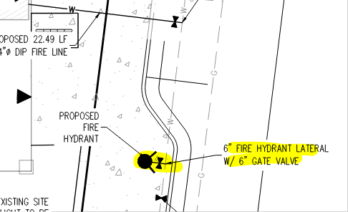

- The overall utility plan provided needs to be cleaned up to address the following: Partially satisfied; the applicant has noted, acknowledged, or addressed with the second submittal though the required signature block has not been applied in the format that was provided. In its current form, the stamp will not fit in the block; the applicant shall correct this issue before submitting the utility drawings for signature. Address this issue when resubmitting. Not satisfied with the third submittal; see redlined drawings, as well as this document, for the correct signature block. Address this issue when resubmitting.

- When resubmitting, ensure that the required Fire Life Safety signature block is provided in two locations on the utility drawings (this information has been shared with Galloway on multiple occasions making the information here a reminder); the locations of the required Fire Life Safety signature block are required on the cover page and on the overall utility page. This signature block can be found at the end of this document.

- The length of the UFL, as measured from the “T” in the road to the flange in the building, shall be documented on the overall utility plan (not a note on the side of the plan) in the same area that the size of the ULF is noted on the plan set.

- The applicant shall provide a room layout (in advance of a plan set for the commercial building permit) so as to ensure that the riser room is sized appropriately. With regard to the fire sprinkler control valve room, ensure that the following is addressed: Not satisfied; the applicant has noted, acknowledged, with the second submittal while the floor plan for the room was not provided. The purpose of this requirement, and why it is noted at this time, is to ensure that there is not a problem down the road. This issue is required to be addressed prior to life safety sign off… which is why it was mentioned in the first response. Not satisfied with the third submittal; the utility plans do not show the location of the riser room let alone dimensions, locations of FACP and riser, clearances, etc. This issue shall be readdressed with the fourth submittal. Note – I did find a location on the Site Plan though the layout has not been provided as REQUIRED; see below:

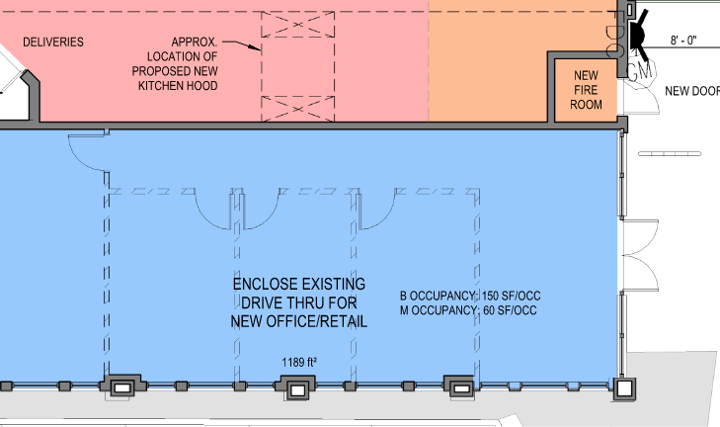

- Exterior access is required into the riser room with access into the building provided either adjacent to the riser room or through the riser room.
- The FACP will be required to be located on an interior wall in the fire sprinkler control valve room; ensure that the riser room is sized to accommodate the FACP and the riser. A three-foot clearance is required in front of the FACP as well as the sprinkler riser.
- The underground shall enter the building and turn up no further than 24 inches from foundation wall; three feet of clearance is required in front of the fire riser with a minimum of 12” of clearance behind the riser and 18” to each side of the riser.
- The FDC location requires three feet of clear space on either side of the FDC… just as a fire hydrant requires the same clear spaces.

Note – This is a requirement that is not allowed to be deferred until the building submittal has been made. Exterior door access, riser room location, water entry, etc. all must be confirmed prior to site plan approval. Please work with your design team to ensure that the required information is provided. The site plan will not be approved without the required information.

- A sidewalk shall be extended to the riser room door as well as the FDC; a 5’x 5’ pad shall be provided in front of the FDC. Note – It appears that the existing sidewalks will satisfy this requirement. Confirmation is all that is required. Satisfied; the applicant has noted, acknowledged, or addressed with the second submittal.

- Utility Plan Set: The applicant shall provide a utility plan that identifies the locations of all utilities on the site (including natural gas and electricity). The overall utility plan shall identify the location of the required fire hydrant(s) and the required underground fire line UFL). The plan set shall identify the UFL on the plan (not just providing a note) while providing the length and diameter of the UFL (as measured from the T at the water main to the flange within the building. Not satisfied; the applicant has noted, acknowledged, and only partially addressed with the second submittal. The overall utility plan does not show the existing utilities as noted above when required to identify “all utilities”) on this document. Address this issue when resubmitting. Satisfied; the applicant has noted, acknowledged, or addressed with the third submittal.

Note – The UFL shall have its own tap; domestic water and the required fire hydrant shall have separate taps.

- The Town of Parker requires that fire apparatus access roads meet the clear-width and weight-bearing standards of the jurisdiction in which the project is located. Roadways shall be designed to support the imposed weight of fire apparatus, 30-ton, two axle and 40-ton three, axle vehicles. An unimpeded clear width of 20-feet shall be maintained at all times (though Planning and Zoning requirements may require a minimum of 24 feet). Where building exceed 30 feet in height, a fire department access is required to be 26 feet in width. As such, any location where parked vehicles would obstruct this clear width requirement will require “NO PARKING – FIRE LANE” signage. This signage shall be red on white. Update design criteria has been provided at the end of this document; ensure compliance when resubmitting. For this application, this signage is required on both the inside and outside islands shown south of the building and east along the access drive. Note – as the modifications to this site do not address this requirement, documentation as to why the access provided is not typical of the code requirements when resubmitting. Satisfied; the applicant has noted, acknowledged, or addressed with the second submittal.

- The applicant shall provide an auto turn analysis indicating that apparatus can navigate all portions of this site (both sides of the gas canopy). As noted in item # 8, NO PARKING – FIRE LANE signage is required for any portion of the access where the 20-foot clear width requirement cannot be met. See below the areas required for the auto-turn analysis and address when resubmitting: Not satisfied; in pre-application meetings was required as discussed. Failure to address requirements as noted will only result in further delays for this project. Address this issue as required when resubmitting. Satisfied; the applicant has noted, acknowledged, or addressed with the third submittal.

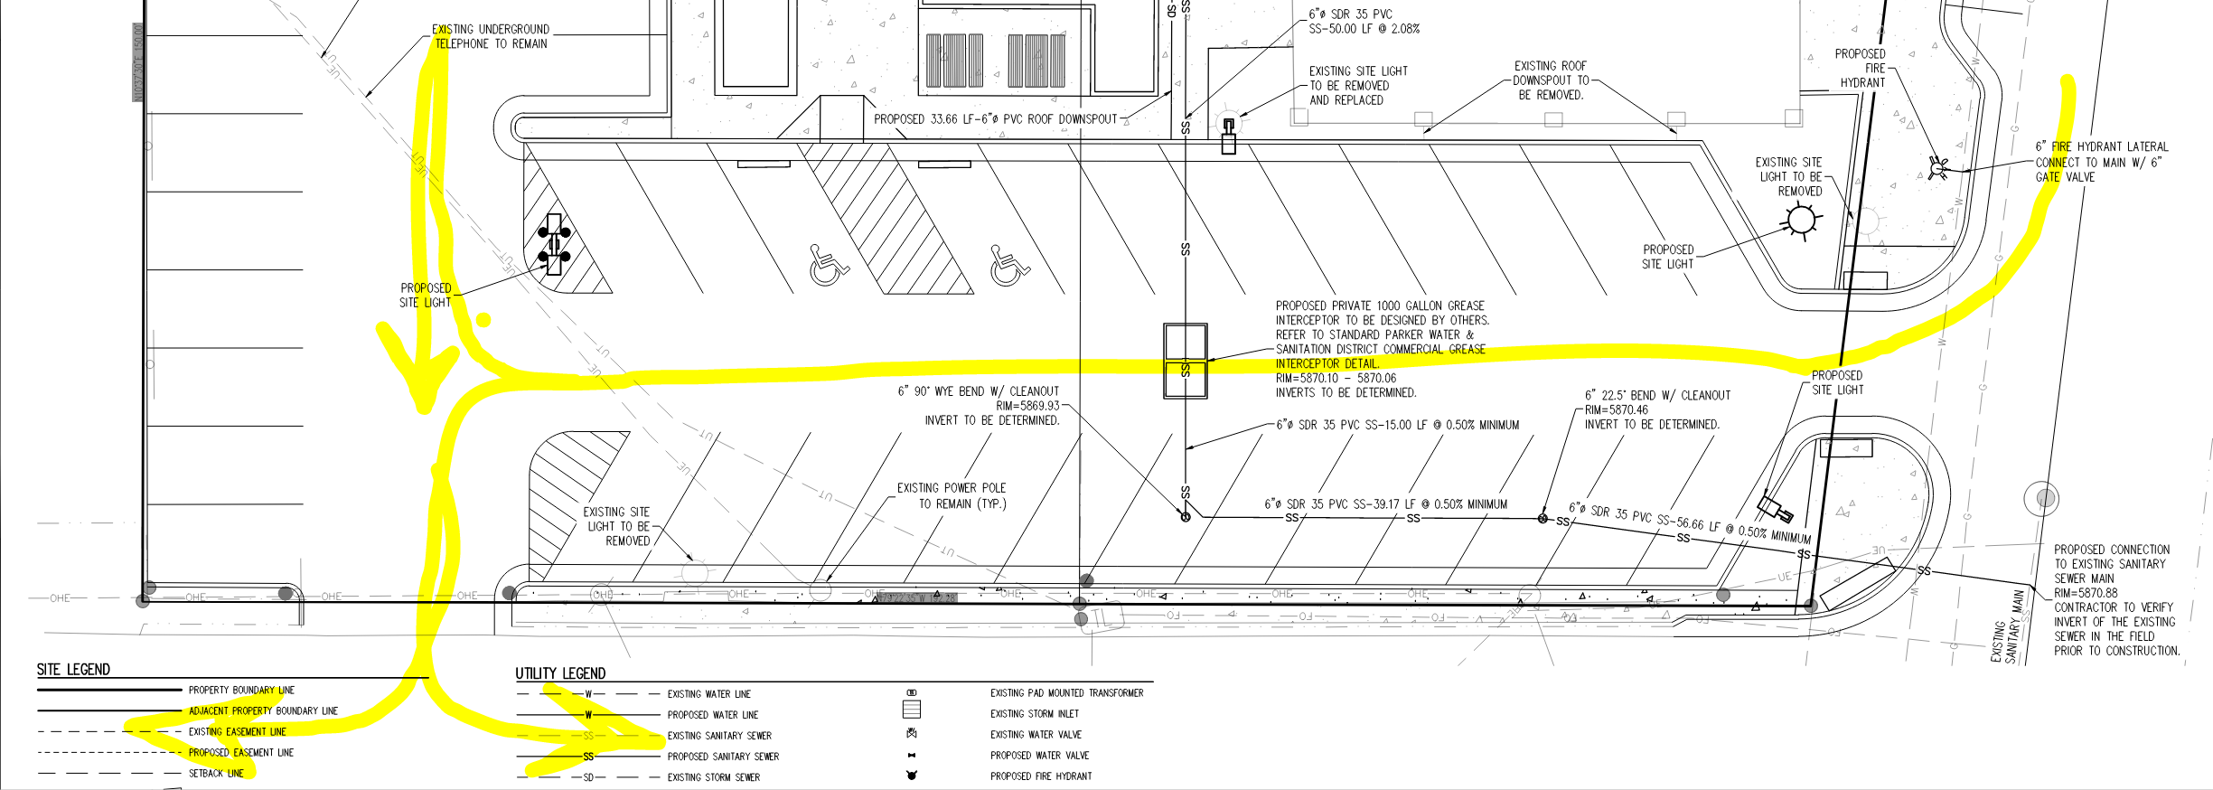

- As noted in item 9, the site is tight and the areas on the west end of the angled parking create an opportunity for people to park when the parking lot is at capacity; signage shall be provided indicating that this area is a NO PARKING – FIRE LANE in both areas shown (either side of the parking lot). Address this issue when resubmitting. Not satisfied; regardless of what is “intended” by the applicant, this issue was discussed in the pre-application meeting and is required to be met. Failure to address requirements as noted will only result in further delays for this project. Address this issue as required when resubmitting. Satisfied; the applicant has noted, acknowledged, or addressed with the third submittal.

- Anticipated deferred submittals for this project would include the following (as Applicable): Satisfied; the applicant has noted, acknowledged, or addressed with the second submittal.

- Underground Fire Line
- Sprinkler Suppression
- Fire Alarm System
- Radio Amplification System (Dependent upon test results)
- Access Control (as applicable)

GENERAL COMMENTS (as applicable)
All engineering documents submitted to the Town of Parker shall bear the wet signature and seal of the engineer or architect in responsible charge of the design.

Water distribution and site access components shall be installed and in service prior to the construction of any portion of the structure, except by special permit issued by the Fire District.

Underground fire lines
When thrust blocks are used as part of the pipe restraint system, submitted plans for permit shall provide detailed documentation that the thrust blocks satisfy all requirements of 19 NFPA 24: 10.8.2, including specific thrust block dimensions and mathematical calculations for block dimensions per guidelines provided in Annex A.10.8.2.

FIRE ACCESS ROAD DESIGN CRITERIA

VEHICLE SPECIFICATIONS are provided for the largest apparatus in use by South Metro Fire Rescue. Fire Apparatus Access Roads shall be capable of accommodating this apparatus.
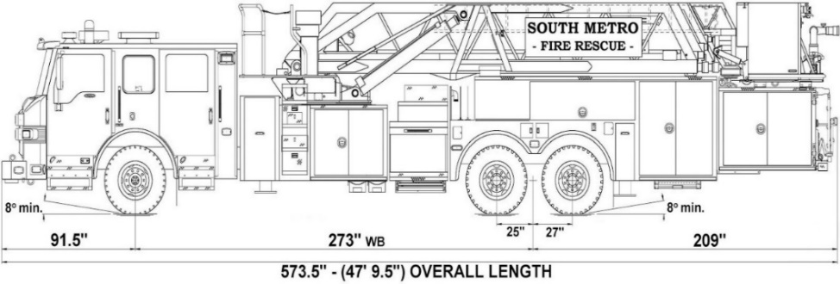

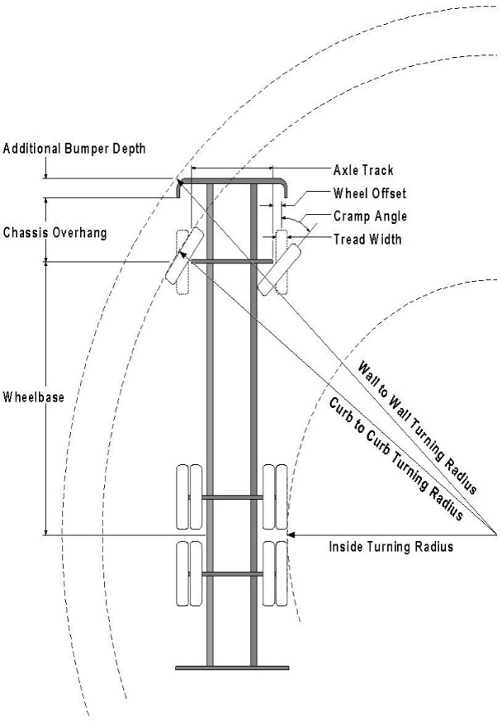

Vehicle Specifications
Length: 47’ 9.5”
Width: 8’ 5” - (10’ 1” mirror to mirror)
Height: 10’ 9”
Wheelbase: 273 in.
Design load: 80,000 pounds Inside Cramp Angle: 40° Axle Track: 83”
Wheel Offset: 5.3”
Tread Width: 13.5”

Turning Radii:
Inside Turn: 26 ft. 1 in. Curb to curb: 41 ft. 11 in. Wall to wall: 46 ft. 8 in.

Where objects are present adjacent to the fire apparatus access road, particularly on turns and turn arounds which require backing, a reasonable safety margin shall be provided to prevent potential damage to the property and to the fire apparatus.

PRIVATE ROADS that provide access to more than two dwellings or one or more commercial buildings shall be constructed to meet the roadway standards approved by the South Metro Fire Rescue Authority for fire apparatus access. Private roads that do not meet the roadway standard may be accepted provided that alternative methods and materials are incorporated into the subdivision that addresses the fire and life safety of the citizens.

FIRE CODE REVIEW BLOCK
All fire hydrants shall be installed according to water utility standards. The number and locations of the fire hydrants as shown on the Overall Utility Plan are correct as specified by the Town of Parker, Community Development Department.

Fire Code Official or Designated Representative Date

(NOTE – Underground Fire Line (UFL) submittal documents must meet the requirements of NFPA 24 when submitting for review.)

Underground Fire Line - Submittal Requirements

Reference: 2019 NFPA 24 Installation of Private Fire Service Mains and Their Appurtenances

A separate permit is required and will be issued pending review of a detailed submittal which must include the following: [21 IFC 901.2]

4.1.1 Working plans shall be submitted for approval to the authority having jurisdiction before any equipment is installed or replaced.

4.1.2 Deviation from approved plans shall require permission of the authority having jurisdiction.

4.1.3 Working plans shall be drawn to an indicated scale on sheets of uniform size, with a plan of each floor as
applicable, and shall include the following items that pertain to the design of the system:

(1) Name of owner
(2) Location, including street address
(3) Point of compass
(4) A graphic representation of the scale used on all plans
(5) Name and address of contractor
(6) Size and location of all water supplies
(7) The following items that pertain to private fire service mains:
(a) Size
(b) Length
(c) Location
(d) Material (ductile-iron, PVC., etc.)
(e) Point of connection to city main
(f) Sizes, types, and locations of valves, depth at which the top of the pipe is laid below grade
(g) Method of restraint (Meg-a-Lug or similar)

4.1.4 The working plan submittal shall include the manufacturer's installation instructions for any specially listed equipment, including descriptions, applications, and limitations for any devices, piping, or fittings. Submittals must include installation specifications for thrust blocks, corrosion protection, restraint system, bedding, detail of pipe under the building up to, and including, the flange. When it is intended that a different contractor will extend the fire line from a stopping point outside the building, to the inside flange, a second submittal and permit is required.

All tees, plugs, reducers, valves, and hydrant branches shall be restrained against movement by thrust blocks [10.8.2] or restrained joint systems [10.8.3]. When thrust blocks are used as part of the pipe restraint system, submitted plans shall provide detailed documentation that the thrust blocks satisfy all requirements of Section 10.8.2, including specific thrust block dimensions and mathematical calculations for block dimensions per guidelines provided in Annex A.10.8.2.

Any individual or company who physically works on or installs any part of a fire suppression system, including underground supply lines, from public water lines to system risers and backflow preventers, must be registered with the Colorado Division of Fire Safety. [Dept of Public Safety, Division of Fire Safety, Fire Suppression Program 8 CCR 1507-11:3.1.2] Documentation of valid annual registration may be required with plan submittal.

The following website for the Colorado Division of Fire Safety will provide registration instructions.
http://dfs.state.co.us/SuppAppsProcInsp.htm
All submittals must display a wet stamp and original signature by a Colorado licensed professional engineer or NICET III, or higher, in fire suppression systems. [Dept of Public Safety, Division of Fire Safety, Fire Suppression Program 8 CCR 1507

