

Town of Parker Community Development Department
Development Review Division
Attention: Stacey Nerger

Application Type: Site Plan
Status: First Referral
Application Name: Parker Town Hall Exemption Plat AMD3 L1 Town Hall Addition
Case/AP#: SP23-097
Referral Received: November 17, 2023
Comments Due: December 19, 2023

Application Location: Generally located at the southeast corner of Parker Road and Stroh Road

Review date: December 12, 2023
Plan reviewer: Randall L. Capra, rcapra@parkeronline.org
Phone: 303.805.3163

Narrative: The applicant, the Town of Parker, is proposing 32,043 square feet in addition to the existing Town Hall Building. The site is located at the southwest corner of Mainstreet and Line Drive.

Code Reference: 2021 International Fire Code, 2021 International Building Code, 2020 NEC (Note – as of January 1, 2025, all submittal documents will be required to meet the 2024 edition of the ICC Code family as well as meeting the required editions of any referenced standard, as documented in the newly adopted codes).

TOWN OF PARKER FIRE/LIFE SAFETY:

1st Submittal – Reviewed December 12, 2023
2nd Submittal – Reviewed February 15, 2024 (Comments in red, italicized font)

UNRESOLVED ISSUES/COMMENTS

The items noted below with a comment number (1, 2 etc.) are items that need to be corrected to show compliance with the applicable codes. Please provide a written response to this letter indicating where the corrections are made on the plans (cloud the plans as applicable). This will speed up the second review process.

It appears that not all documentation was provided with the second submittal as the APPLICANT has not provided the REQURIED response to this letter with the current documentation (see the comment in blue above). In addition to the missing response, many items have not been addressed as required (though the big item was… thank you… that being the aerial apparatus access through the plaza area). When resubmitting, ensure that the following is addressed:

The applicant is required to respond (in writing) to the fire life safety letter provided. To assist the applicant, the response is provided in a word document, along with the pdf, so that the applicant can easily and quickly respond using the provided word document.

- The applicant shall be aware that no vertical construction on this site will be allowed until such time that curb gutter and first lift of asphalt are installed; a site inspection will be required to ensure that this requirement is made prior to allowing vertical construction to commence. Note – While access is currently in place, modifications to the site will disrupt this access; part of the applicant’s response will be to address how access will be provided throughout the duration of the construction process. A site inspection is required prior to demolition and construction. Not satisfied; applicant has not addressed this issue with the second submittal.
[AMD response] A comprehensive plan (including phasing and life safety) will be included in the permit submittal. The GC (JHL Constructors) will furnish this content and shared a preview of this at the 04/12/2024 pre-application meeting.

- The applicant has noted that the project Is comprised of an expansion and a “phased” renovation. The applicant shall be aware that TWO separate permits will be required for this project with one permit for the building expansion and one permit for the “phased” remodel of the existing building. Deferred permits such as for fire suppression, fire alarm notification, and access control will also be required to be submitted accordingly for each permit type.

Plans will be required to be submitted as two separate submittal packages (specific to the scope of work); an overall sheet specific to the architectural and MEP’s shall be provided so that a quick overview of the entire project can be quickly performed and the plan sets broken up according to the project type i.e.; new construction, remodel. Not satisfied; applicant has not addressed this issue with the second submittal.
[AMD response] Per discussion with the Town of Parker building department, this project will be submitted for two separate permits (one for the addition and one for the renovation). However those submittal packages will be identical in composition due to overlapping scope areas.

- The applicant has only partially addressed the requirements of [21 IFC Appendix D for Aerial Apparatus Access roads. This sections requires that an aerial apparatus road be provided along the ENTIRE length of the building. In this case, only a portion of the reworked southern access was reworked to meet this requirement. Further, Appendix D requires that “access routes meeting this condition shall be located not less than 15 feet from the building and not greater than 30 feet from the building and shall be parallel to the entire side of the building”.

The portion of the access drive that does not meet the width requirement is shown below: Not satisfied; applicant has not addressed this issue with the second submittal. The westerly portion of the access (see immediately below, does not meet aerial apparatus road requirements of the code (though I would allow the applicant to meet the required LDO requirements of the Town placing this part of the road at the required 24-feet in width. In addition, the auto-turn analysis does not work with the non-conforming access width. Address this issue as required when resubmitting. [AMD response] See revised AutoTurn exhibit

First submittal Comment: Second Submittal Comment
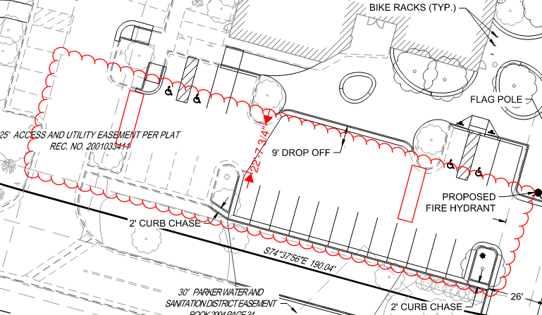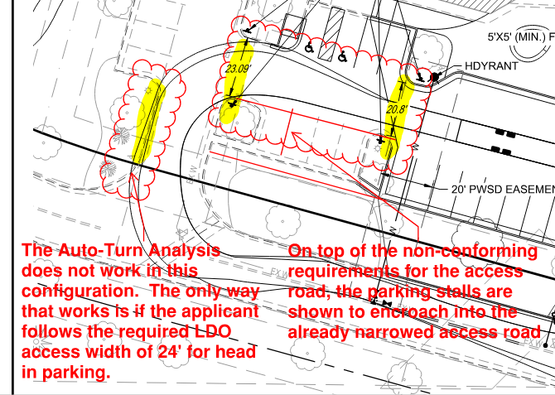

The portion of the access drive that does not meet the “proximity the building requirements is shown below: Satisfied; the applicant has addressed this issue with the second submittal. Thank you!

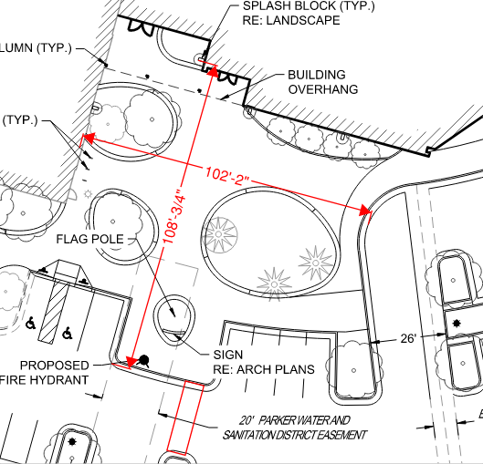

An option to solve the “proximity to the building” issue would be to extend the new main entry up towards the building and over to the north allowing for the access requirements to be met.

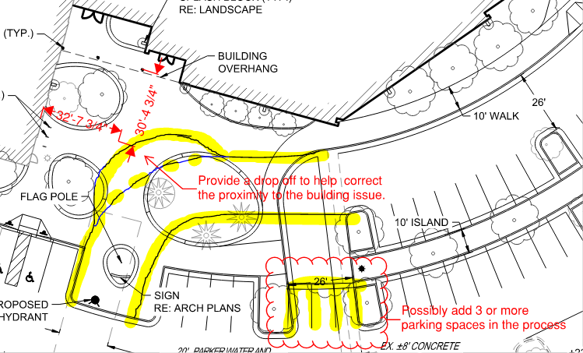

Note – another option would be to design the plaza to incorporate the required fire access road in the area identified above. Ultimately, it will be up to the design team to show how they can meet the requirements for aerial apparatus roads. Address this issue when resubmitting to ensure compliance with the requirements of the fire code.

3A. The FDC appears to be buried behind landscaping; revise the drawings to provide a five-foot-wide walkway and pad in front of the FDC. Ensure that landscaping is modified to ensure that there is no overgrowth on this walkway. Address this issue when resubmitting. [AMD response] See revised sheets, a concrete pad has been provided.

- The applicant appears to have provided an outdated utility drawings with the submittal package; hydrant distribution was discussed at length and the modifications required specific to the fire hydrant(s) and underground fire line have not been addressed with the current submittal package. The applicant shall address the following: Satisfied; the applicant has addressed this issue with the second submittal.

- The “approved” fire life safety signature block is required on both the cover sheet and the overall utility sheet of the utility plans; a copy of the block is provided at the end of this document. Not satisfied with the second submittal; while the applicant has provided the correct signature block on the overall utility page, the applicant has not provided the correct signature block on the cover sheet of the utility drawings. When providing the correct signature block, do not modify the configuration of the block as doing so will not accommodate the electronic stamp that is used by Fire Life Safety to stamp the drawings. The configuration of the incorrect block used by the applicant is too narrow. See below: [AMD response] See revised sheet C-311.

Incorrect Block/Configuration: Correct Signature Block/Configuration:

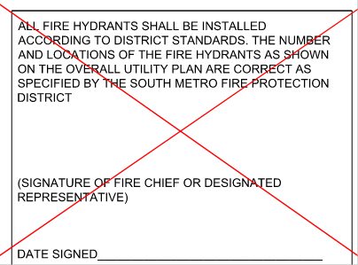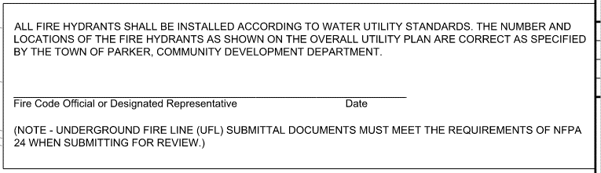

- Modifications to the underground fire line (UFL) will be required to remove the existing domestic tap; the utility drawings have not addressed this requirement. Not satisfied with the second submittal; while the applicant has documented the new domestic water service, the UFL has been shown as existing. This is not correct. A portion of the UFL is being modified to remove the existing domestic. This should be identified as “new”, and a deferred permit will be required to address this scope of work. [AMD response] See revised sheets.
- A fire hydrant is required to be provided on the east side of the new building (north end of inside parking lot). Satisfied; the applicant has addressed this issue with the second submittal. Thank you!
- The fire hydrant located at the new main entry was to have been relocated to the west (based upon the aerial apparatus access road, I would suggest relocating the fire hydrant in an area shown below: Satisfied; the applicant has addressed this issue with the second submittal. Thank you!

Note – Based upon the modifications noted to meet the aerial appraisal requirements of the code, the fire hydrant located at the s/w corner of the existing building (that was to be relocated) shall be relocated in the area shown in the snapshot below. I will include both the access routes (whether plaza access or access road) with the proposed relocation for the fire hydrant as either scenario will require the hydrant to be relocated to the same general location.

Marked up Utility Drawing
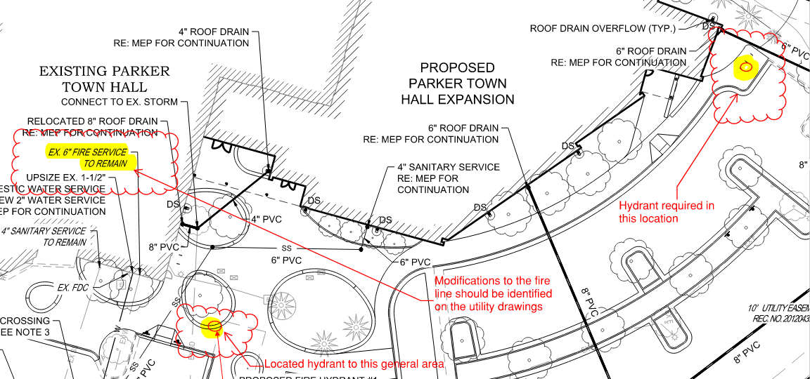

Marked up Site Plan with Aerial Access location (whether through Plaza or part of required
Access Road

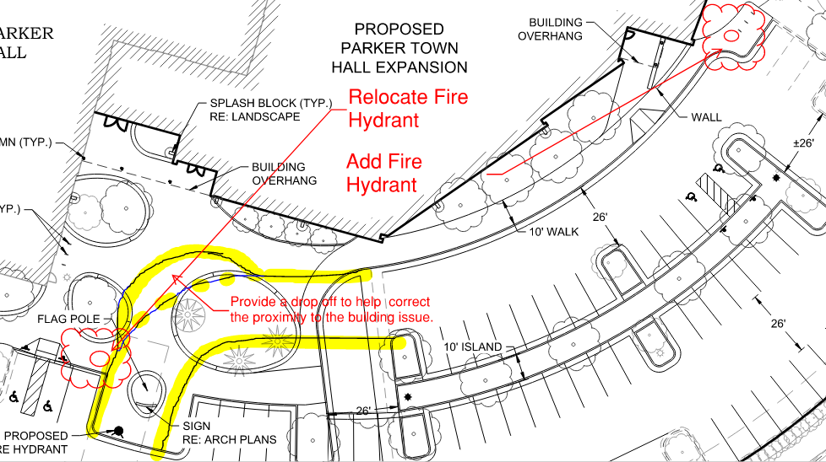

- While not anticipating changes to the riser, as the riser room doubles as a mechanical room, the applicant shall ensure that the riser room shall be sized to accommodate the following (understanding that most of this will be an existing condition): Not satisfied with the second submittal; this issue was not addressed, noted, or acknowledged by the applicant. [AMD response] See revised sheets with details for existing and proposed conditions of the combined water line (existing) and the fire/domestic lines (proposed).

- The underground fire line is not allowed to have domestic tapped off of it. (The domestic is to be removed from the fire line)
- The sprinkler riser is allowed to enter no further than 24-inches into the building (and any less than 12-inches into the building).
- A three-foot clearance shall be provided in front of the riser (with 18” of clearance on either side of the riser).
- The fire alarm control panel (FACP) is required to be located on an interior wall.
- A three-foot clearance is required in front of the FACP.
- Exterior access is required to be provided into the riser room; this access shall be approved.
- Access into the building shall be provided through the riser room or immediately adjacent to the riser room.
- While domestic water can be located in the riser room, the domestic cannot be located in any way that conflicts with the access requirements for both the FACP and the sprinkler riser.
- A sidewalk is required to the riser room and a 5 x 5 pad is required in front of the FDC.

The applicant shall ensure that the requirements noted above are adequately addressed; modifications to the building are significant which will require that all requirements are fully met with some minor modifications to existing system due modifications to site infrastructure as applicable.

- The applicant shall provide an auto turn analysis indicating that apparatus can navigate all portions of this site; NO PARKING – FIRE LANE signage is required for any portion of the access where the 20-foot clear width requirement cannot be met. Not satisfied with the second submittal; the auto-turn analysis does not work at the western entry/egress of the site. Address this issue when resubmitting: Note - This issue was identified above and is shown again, below. [AMD response] See revised sheets

Current Auto-Turn:
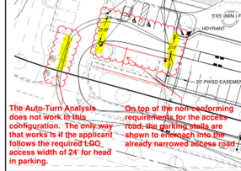

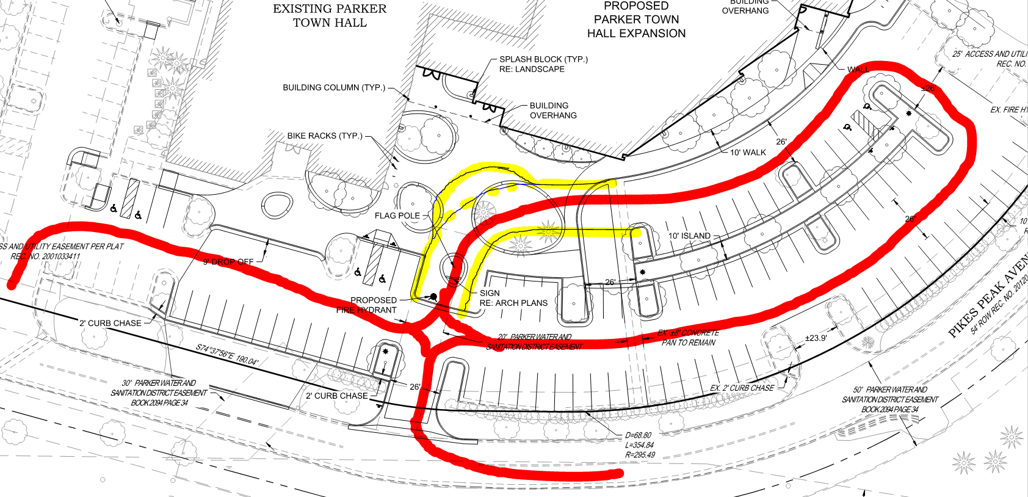

Note – the area identified with the two blue rectangles is of particular concern. People tend to not stay within the lines and the 20-foot drive aisle on the south end creates a potential for delays in response specific to staged or waiting vehicles in this area. Ensure that this issue is addressed adequately or provide signage that states NO PARKING OR STANDING – FIRE LANE in this area (area shown on west side of building… south end as well as the south side of the building).

- The applicant has not addressed the required NO PARKING – FIRE LANE signage for this site (See Sheat C-421 of the Civil Construction Drawings). The applicant shall provide NO PARKING – FIRE LANE signage for any portion of the access where the 24-foot/26-foot clear width requirement cannot be me; areas that are required to have this signage are to be located in the areas highlighted in yellow below: Not satisfied with the second submittal; while the applicant [AMD response] See revised sheets.

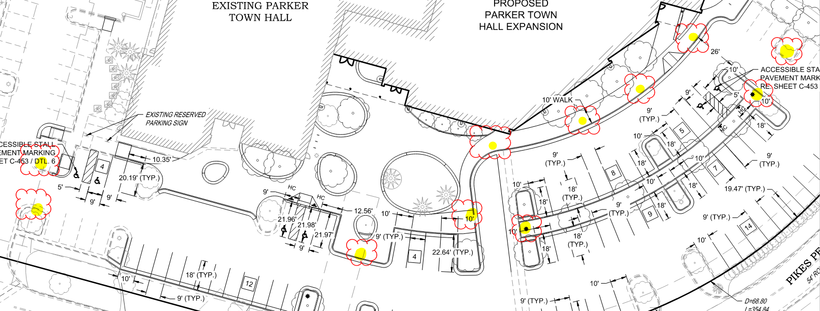

Note - The Town of Parker requires that fire apparatus access roads meet the clear-width and weight-bearing standards of the jurisdiction in which the project is located. Roadways shall be designed to support the imposed weight of fire apparatus, 30-ton, two axle and 40-ton, three axle vehicles. An unimpeded clear width of 24-feet shall be maintained at all times. As such, any location where parked vehicles would obstruct this clear width requirement will require “NO PARKING – FIRE LANE” signage. This signage shall be red on white. Design criteria has been provided at the end of this document; ensure compliance when resubmitting.

GENERAL COMMENTS (as applicable)
All engineering documents submitted to the Town of Parker shall bear the wet signature and seal of the engineer or architect in responsible charge of the design.

Water distribution and site access components shall be installed and in service prior to the construction of any portion of the structure, except by special permit issued by the Fire District.

Underground fire lines
When thrust blocks are used as part of the pipe restraint system, submitted plans for permit shall provide detailed documentation that the thrust blocks satisfy all requirements of 19 NFPA 24: 10.8.2, including specific thrust block dimensions and mathematical calculations for block dimensions per guidelines provided in Annex A.10.8.2.

FIRE ACCESS ROAD DESIGN CRITERIA

VEHICLE SPECIFICATIONS are provided for the largest apparatus in use by South Metro Fire Rescue. Fire Apparatus Access Roads shall be capable of accommodating this apparatus.

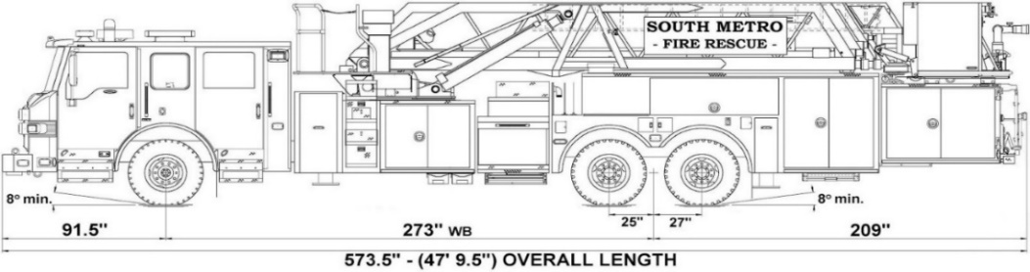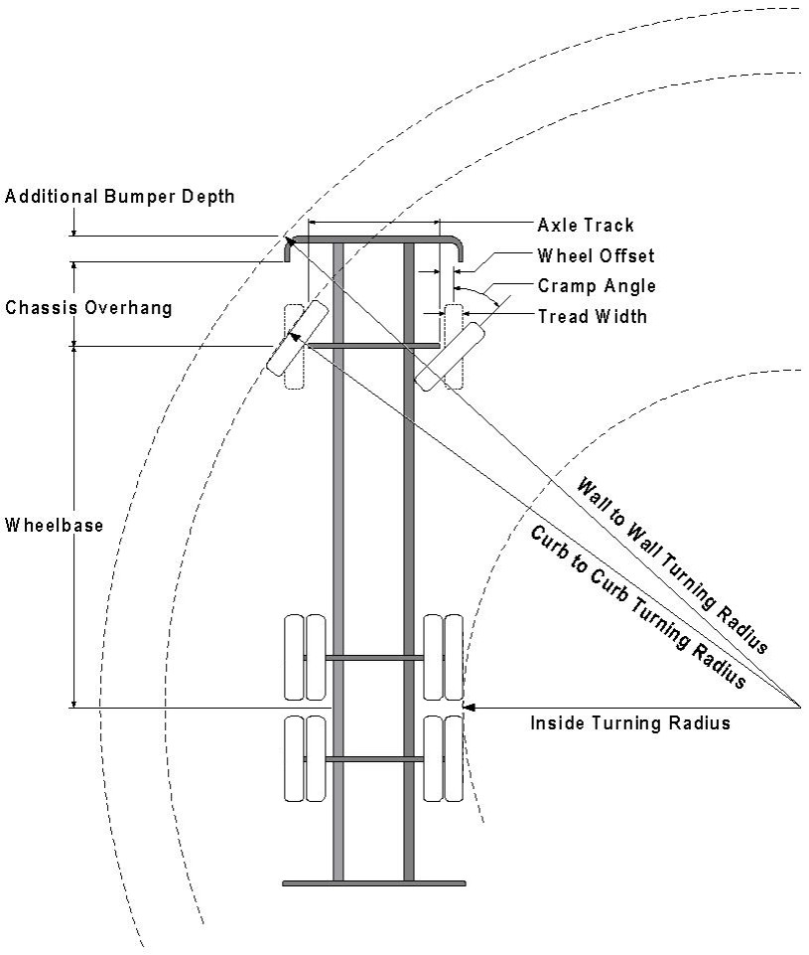

Vehicle Specifications
Length: 47’ 9.5”
Width: 8’ 5” - (10’ 1” mirror to mirror)
Height: 10’ 9”
Wheelbase: 273 in.
Design load: 80,000 pounds Inside Cramp Angle: 40° Axle Track: 83”
Wheel Offset: 5.3”
Tread Width: 13.5”

Turning Radii:
Inside Turn: 26 ft. 1 in. Curb to curb: 41 ft. 11 in. Wall to wall: 46 ft. 8 in.

Where objects are present adjacent to the fire apparatus access road, particularly on turns and turn arounds which require backing, a reasonable safety margin shall be provided to prevent potential damage to the property and to the fire apparatus.

PRIVATE ROADS that provide access to more than two dwellings or one or more commercial buildings shall be constructed to meet the roadway standards approved by the South Metro Fire Rescue Authority for fire apparatus access. Private roads that do not meet the roadway standard may be accepted provided that alternative methods and materials are incorporated into the subdivision that addresses the fire and life safety of the citizens.

Posting of Fire Lanes: The posting of the “Fire Lanes” is required.
Fire Lane Sign Dimensions. NO PARKING – FIRE LANE signs shall be 12 inches wide and 18 inches high.
3” High
¼ ” Stroke Red Letters
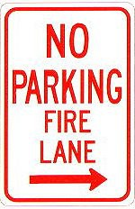
12”
18”

Fire Lane Sign Characteristics: Signs shall be engineer grade reflective sheeting on 0.80 aluminum with red lettering on a white background.
2 ” High 1/8 ”
Stroke
Red letters
Fire Lane Sign Locations. Fire apparatus access roadways between 20 and 28 feet wide, signs shall be posted on both sides. Fire apparatus access roadways between 28 feet wide and 34 feet wide, signs may be posted on one side only.
Fire Lane Sign Installation. NO PARKING – FIRE LANE signs shall be installed as follows:
- Bottom edge of the signs shall be 7 feet above surface (sidewalk) and post shall be placed 24 inches from flow line (curb).
- One sign at the beginning of the restriction (one arrow pointing towards the restriction zone).
- One sign at the end of the restriction (one arrow pointing back into restricted zone).
- One sign at least every 150 ft. within the restricted area (double arrow pointing in each direction, to indicate the continuing restriction).
- Spaced evenly within the restriction (for straight curbs/zones). For example, if the parking restriction zone is 300 ft long, only one double arrow sign is required at a distance of 150 ft. from the beginning of the restriction. If the restriction zone is 400 ft. long, two double arrow signs are required; spaced 100 ft. evenly from each other and from the beginning/ending signs.
- Spaced so that at least one readable sign is visible in front of a parked vehicle from any point along the restriction (for curved curbs/zones and areas that may present visual obstacles.)
- Set at an angle of no fewer than 30 degrees and no more than 45 degrees with the lane of traffic flow visible to approaching traffic.
- Signs shall be provided at all normal and emergency access points to structures and within 20 feet of each fire hydrant and fire department connection (FDC) in compliance with UFC 901.4.2.
- Some areas may need additional fire lane signs. Check with the Division of Life Safety for any additional requirements.

Fire Lane Sign Types. The diagrams below indicate the types of signs that may be used, and the recommended placement.
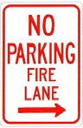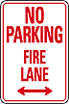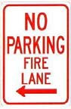
200 feet
200 feet
Additional sign styles may be used – provided the same type is used consistently.
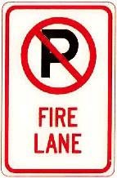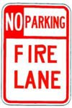

Painting of Curbs or Streets. In addition to the required signage, South Metro Fire Rescue does permit fire lanes to be painted with curb or street markings. However, these markings shall not replace the required fire lane signs. Curbs may be painted red with 3-inch white block letters stating NO PARKING – FIRE LANE. Lettering shall be spaced every 15 feet.

Underground Fire Line - Submittal Requirements

Reference: 2019 NFPA 24 Installation of Private Fire Service Mains and Their Appurtenances

A separate permit is required and will be issued pending review of a detailed submittal which must include the following: [21 IFC 901.2]

4.1.1 Working plans shall be submitted for approval to the authority having jurisdiction before any equipment is installed or replaced.

4.1.2 Deviation from approved plans shall require permission of the authority having jurisdiction.

4.1.3 Working plans shall be drawn to an indicated scale on sheets of uniform size, with a plan of each floor as
applicable, and shall include the following items that pertain to the design of the system:

(1) Name of owner
(2) Location, including street address
(3) Point of compass
(4) A graphic representation of the scale used on all plans
(5) Name and address of contractor
(6) Size and location of all water supplies
(7) The following items that pertain to private fire service mains:
(a) Size
(b) Length
(c) Location
(d) Material (ductile-iron, PVC., etc.)
(e) Point of connection to city main
(f) Sizes, types, and locations of valves, depth at which the top of the pipe is laid below grade
(g) Method of restraint (Meg-a-Lug or similar)

4.1.4 The working plan submittal shall include the manufacturer's installation instructions for any specially listed equipment, including descriptions, applications, and limitations for any devices, piping, or fittings. Submittals must include installation specifications for thrust blocks, corrosion protection, restraint system, bedding, detail of pipe under the building up to, and including, the flange. When it is intended that a different contractor will extend the fire line from a stopping point outside the building, to the inside flange, a second submittal and permit is required.

All tees, plugs, reducers, valves, and hydrant branches shall be restrained against movement by thrust blocks [10.8.2] or restrained joint systems [10.8.3]. When thrust blocks are used as part of the pipe restraint system, submitted plans shall provide detailed documentation that the thrust blocks satisfy all requirements of Section 10.8.2, including specific thrust block dimensions and mathematical calculations for block dimensions per guidelines provided in Annex A.10.8.2.

Any individual or company who physically works on or installs any part of a fire suppression system, including underground supply lines, from public water lines to system risers and backflow preventers, must be registered with the Colorado Division of Fire Safety. [Dept of Public Safety, Division of Fire Safety, Fire Suppression Program 8 CCR 1507-11:3.1.2] Documentation of valid annual registration may be required with plan submittal.

The following website for the Colorado Division of Fire Safety will provide registration instructions.
http://dfs.state.co.us/SuppAppsProcInsp.htm

All submittals must display a wet stamp and original signature by a Colorado licensed professional engineer or NICET III, or higher, in fire suppression systems. [Dept. of Public Safety, Division of Fire Safety, Fire Suppression Program 8 CCR 1507

FIRE CODE REVIEW BLOCK
All fire hydrants shall be installed according to water utility standards. The number and locations of the fire hydrants as shown on the Overall Utility Plan are correct as specified by the Town of Parker, Community Development Department.

Fire Code Official or Designated Representative Date

(NOTE – Underground Fire Line (UFL) submittal documents must meet the requirements of NFPA 24 when submitting for review.)

