

Town of Parker Community Development Department
Development Review Division
Attention: Amber Wood-Hicken

Application Type: Site Plan
Status: First Referral
Application Name: Canvas F1 L2 - Quick Quack Carwash
Case/AP#: SP24-86
Referral Received: August 19, 2024
Comments Due: September 16, 2024

Application Location: East side of Parker Road south of Stroh Road.

Review date: August 20, 2024
Plan reviewer: Randall L. Capra, rcapra@parkeronline.org
Phone: 303.805.3163

Narrative: The applicant, Mister Car Wash, is requesting a Site Plan for a tunnel car wash. The site is located on the east side of Parker Road south of Stroh Road.

Code Reference: 2021 ICC Codes including 2021 International Fire Code, 2021 International Building Code, 2020 NEC

TOWN OF PARKER - FIRE/LIFE SAFETY:

1st Submittal – Reviewed August 20, 2024
2nd Submittal – Reviewed (Comments in red, italicized font)
3rd Submittal – Reviewed (Comments in bold, red, italicized font)
4th Submittal – Reviewed (Comments in bold, red, italicized font with a yellow highlight)

UNRESOLVED ISSUES/COMMENTS

The items noted below with a comment number (1, 2 etc.) are items that need to be corrected to show compliance with the applicable codes. Please provide a REQUIRED written response to this letter indicating where the corrections are made on the plans (cloud the plans as applicable). This will speed up the review process when resubmitting.

The applicant was notified of the requirement to sprinkle this building during the pre-application process (it is perplexing as to why the sprinkler issue was not addressed); the submittal does not address the required sprinklers or the required fire hydrant. Failure to address the requirements for this site will result in the project being placed into revisions required until all requirements have been met.

- The applicant shall be aware that no vertical construction on this site will be allowed until such time that curb gutter and first lift of asphalt are installed; a site inspection will be required to ensure that this requirement is made prior to allowing vertical construction to commence.

- During the pre-application meetings, the applicant was instructed on requirements for this site; these requirements such as sprinkling the building per 2019 edition of NFPA 13 was not addressed. Failure to address these issues will result in additional reviews and ultimately delay approval. The applicant has a responsibility to address all comments as required when resubmitting.

- Per the requirements of [21 IFC Appendix D Section D105 Aerial Apparatus Access Roads], an aerial apparatus road shall be provided that meet the required widths for a building that exceeds 30 feet in height. Per D105.2, Aerial fire apparatus access roads shall have a minimum unobstructed width of 26 feet, exclusive of shoulders, in the immediate vicinity of the building. Per D105.3, one or more of the required access routes meeting this condition shall be located not less than 15 feet and not greater than 30 feet from the building. This issue shall be addressed (required) due to the building height and shall be provided along the entire length of the east side of the building (in the location of the vacuum bays). Address this issue when resubmitting.
- Per the requirements of [21 IFC Section 503.1.1 Buildings and Facilities] approved fire apparatus access roads shall be provided for every facility, building, portion of a building hereafter constructed or moved into or within the jurisdiction. The fire apparatus access road shall comply with the requirements of this section and shall extend to within 150 feet of all portions of the facility and all portions of the exterior walls of the first story of the building as measured by an approved route around the exterior of the building or facility (the building is a 133+ feet long and 45.5 feet wide and cannot meet the requirement as measured from the center line of the fire apparatus as measured by an approved route from any point that a fire engine might park when responding to a call at this building). This submittal does not provide for this requirement of the code. Per the requirements of the code, the fire code official is allowed to increase the dimension of the 150 feet provided that the applicant meets Exception 1.1 of this section… “The building is equipped throughout with an approved automatic sprinkler suppression system installed in accordance with section 903.1.1, 903.1.2, or 903.3.1.3”.

- The applicant shall be aware that the internal access hydrant distribution was not planned to address the suppression needs for all commercial properties within this subdivision; this site requires the addition of one hydrant (to be located at the s/e corner island adjacent to east end of the building… as required per NFPA 24 Section 7.2.3. Utility drawings are required to address this requirement.

- The applicant shall provide a fire sprinkler control valve room on the south/ease end of the building. A fire hydrant shall be located in the island just east of the end of the building. The riser room shall be provided with the following:

- An exterior door shall be provided into the riser room
- A door, either adjacent to the riser room or a door that provides immediate access into the building through the riser room shall be provided
- The riser room shall be sized such that a three-foot clear space is provided around the sprinkler riser with the Fire Alarm Control Panel being located on an interior wall. A three-foot clear space is required in front of the FACP. A minimum of 12” is required behind the riser.
- A sidewalk is required to be provided from the drive aisle to the riser room
- A 5’ x 5’ concrete pad shall be provided in front of the FDC with a sidewalk provided to the FDC.
- A detail of the riser room is required to show how the room is to be laid out (arranged), that all clearances are met, and that the exterior access has been provided into the riser room with the required access into the building. This is a requirement and will not be allowed to be deferred.

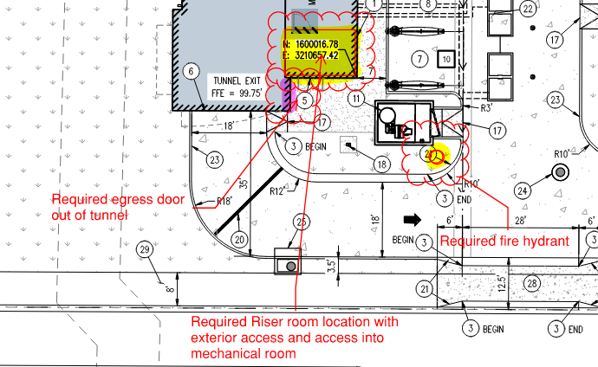

- When resubmitting, the applicant shall provide a REQUIRED floor plan of the riser room, addressing the items noted above and showing that the riser room is designed to accommodate all required clearances specific to the fire riser and the fire alarm control panel. Failure to provide this plan will result in an automatic rejection of the site.

- When resubmitting, the applicant shall provide a REQUIRED code analysis for this building including construction type, occupancy type (this will be a mixed use occupancy that is both a group B and a group S occupancy), total square footage, height of the building, occupant load (including the worst case scenario including the number of cars/vans/trucks that can be in this building based upon high passenger counts, etc.). Address this issue when resubmitting.

- The code requires that egress, meeting all components of the code, be provided. EM and EXIT signage shall be provided along with an exterior egress door (bay doors are not egress doors and will not be accepted. See the site plan above for an acceptable location for the REQUIRED egress door. Address this issue when resubmitting.

- The submittal documents lack the required utility drawings; an underground fire line is required for the site along with the required fire hydrant. The utility drawings shall address the following when resubmitting: The domestic is not allowed to be pulled off of the underground fire line (UFL) if applicable.
- The UFL is not allowed to share the same line as the fire hydrant.
- The UFL is not allowed to enter any further than 24-inches into the building (and any less than 12-inches into the building (as noted above) if applicable.
- The Utility drawings shall clearly identify the UFL by name, length and size on the plan set (a note can address this though the underground fire line itself shall also bear these notations. The measurement shall be made from the “T” at the water main ending at the flange in the fire sprinkler control valve room.

- Ensure that the correct Fire Life Safety signature block is provided on the correct pages; the signature block shall only be provided on the cover sheet of the Utility Plan set and the Overall Utility page. This block can be seen at the end of this response letter.

- The Town of Parker requires that fire apparatus access roads meet the clear-width and weight-bearing standards of the jurisdiction in which the project is located. Roadways shall be designed to support the imposed weight of fire apparatus, 30-ton, two axle and 40-ton three, axle vehicles. An unimpeded clear width of 26-feet shall be always maintained per the requirements of D103.6.1. As such, any location where parked vehicles would obstruct this clear width requirement will require “NO PARKING – FIRE LANE” signage. This signage shall be red on white. Update design criteria has been provided at the end of this document; ensure compliance when resubmitting. Note – See below for NO PARKING – FIRE LANE signage locations

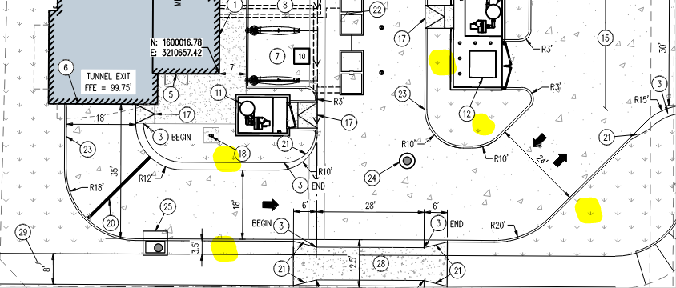

- The applicant shall provide an auto turn analysis indicating that apparatus can navigate all portions of this site (both sides of the gas canopy); NO PARKING – FIRE LANE signage is required for any portion of the access where the 20-foot clear width requirement cannot be met. This is applicable for the loop around the canopy as well as for each entry. The access on each side of the canopy shall meet his requirement with no portion of the canopy encroaching into the required fire lane access road. See below for the areas required to be included in the auto turn analysis and address when resubmitting:

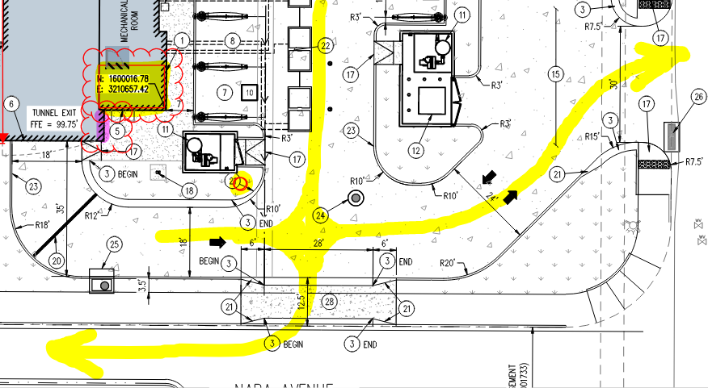

The items noted above with a comment number (1, 2 etc.) are items that need to be corrected to show compliance with the applicable codes. Please provide a written response to this letter indicating where the corrections are made on the plans (cloud the plans as applicable). This will speed up the review process when resubmitting. Note – This item is listed twice to emphasize the requirement to respond to the fire life safety response letter.

GENERAL COMMENTS (as applicable)
All engineering documents submitted to the Town of Parker shall bear the wet signature and seal of the engineer or architect in responsible charge of the design.

Water distribution and site access components shall be installed and in service prior to the construction of any portion of the structure, except by special permit issued by the Fire District.

FIRE ACCESS ROAD DESIGN CRITERIA

VEHICLE SPECIFICATIONS are provided for the largest apparatus in use by South Metro Fire Rescue. Fire Apparatus Access Roads shall be capable of accommodating this apparatus.
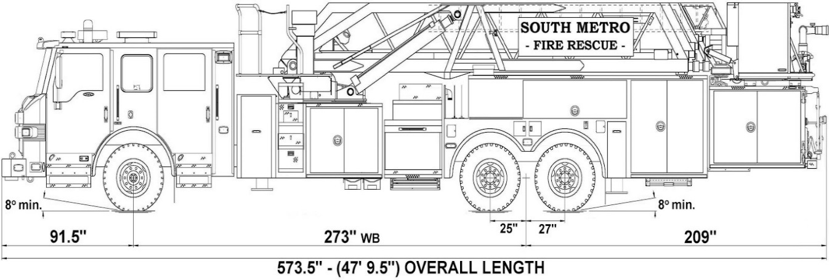

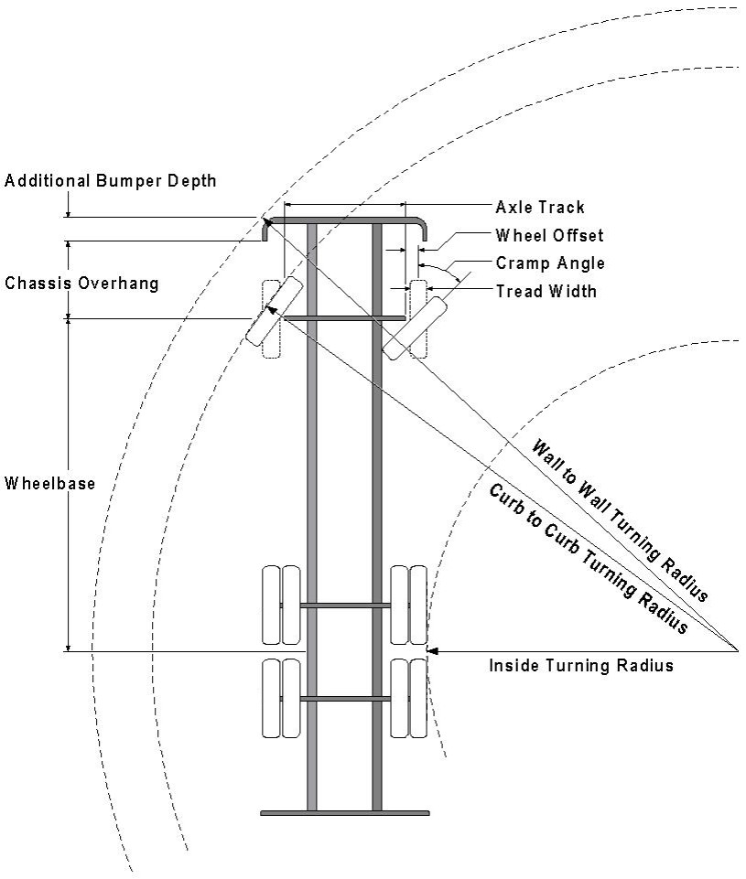

Vehicle Specifications
Length: 47’ 9.5”
Width: 8’ 5” - (10’ 1” mirror to mirror)
Height: 10’ 9”
Wheelbase: 273 in.
Design load: 80,000 pounds Inside Cramp Angle: 40° Axle Track: 83”
Wheel Offset: 5.3”
Tread Width: 13.5”

Turning Radii:
Inside Turn: 26 ft. 1 in. Curb to curb: 41 ft. 11 in. Wall to wall: 46 ft. 8 in.

Where objects are present adjacent to the fire apparatus access road, particularly on turns and turn arounds which require backing, a reasonable safety margin shall be provided to prevent potential damage to the property and to the fire apparatus.

PRIVATE ROADS that provide access to more than two dwellings or one or more commercial buildings shall be constructed to meet the roadway standards approved by the South Metro Fire Rescue Authority for fire apparatus access. Private roads that do not meet the roadway standard may be accepted provided that alternative methods and materials are incorporated into the subdivision that addresses the fire and life safety of the citizens.

Underground fire lines
When thrust blocks are used as part of the pipe restraint system, submitted plans for permit shall provide detailed documentation that the thrust blocks satisfy all requirements of 13 NFPA 24: 10.8.2, including specific thrust block dimensions and mathematical calculations for block dimensions per guidelines provided in Annex A.10.8.2.

FIRE CODE REVIEW BLOCK
All fire hydrants shall be installed according to water utility standards. The number and locations of the fire hydrants as shown on the Overall Utility Plan are correct as specified by the Town of Parker, Community Development Department.

Fire Code Official or Designated Representative Date

(NOTE – Underground Fire Line (UFL) submittal documents must meet the requirements of NFPA 24 when submitting for review.)

Underground Fire Line - Submittal Requirements

Reference: 2019 NFPA 24 Installation of Private Fire Service Mains and Their Appurtenances

A separate permit is required and will be issued pending review of a detailed submittal which must include the following: [21 IFC 901.2]

4.1.1 Working plans shall be submitted for approval to the authority having jurisdiction before any equipment is installed or replaced.

4.1.2 Deviation from approved plans shall require permission of the authority having jurisdiction.

4.1.3 Working plans shall be drawn to an indicated scale on sheets of uniform size, with a plan of each floor as
applicable, and shall include the following items that pertain to the design of the system:

(1) Name of owner
(2) Location, including street address
(3) Point of compass
(4) A graphic representation of the scale used on all plans
(5) Name and address of contractor
(6) Size and location of all water supplies
(7) The following items that pertain to private fire service mains:
(a) Size
(b) Length
(c) Location
(d) Material (ductile-iron, PVC., etc.)
(e) Point of connection to city main
(f) Sizes, types, and locations of valves, depth at which the top of the pipe is laid below grade
(g) Method of restraint (Meg-a-Lug or similar)

4.1.4 The working plan submittal shall include the manufacturer's installation instructions for any specially listed equipment, including descriptions, applications, and limitations for any devices, piping, or fittings. Submittals must include installation specifications for thrust blocks, corrosion protection, restraint system, bedding, detail of pipe under the building up to, and including, the flange. When it is intended that a different contractor will extend the fire line from a stopping point outside the building, to the inside flange, a second submittal and permit is required.

All tees, plugs, reducers, valves, and hydrant branches shall be restrained against movement by thrust blocks [10.8.2] or restrained joint systems [10.8.3]. When thrust blocks are used as part of the pipe restraint system, submitted plans shall provide detailed documentation that the thrust blocks satisfy all requirements of Section 10.8.2, including specific thrust block dimensions and mathematical calculations for block dimensions per guidelines provided in Annex A.10.8.2.

Any individual or company who physically works on or installs any part of a fire suppression system, including underground supply lines, from public water lines to system risers and backflow preventers, must be registered with the Colorado Division of Fire Safety. [Dept of Public Safety, Division of Fire Safety, Fire Suppression Program 8 CCR 1507-11:3.1.2] Documentation of valid annual registration may be required with plan submittal.

The following website for the Colorado Division of Fire Safety will provide registration instructions.
http://dfs.state.co.us/SuppAppsProcInsp.htm

All submittals must display a wet stamp and original signature by a Colorado licensed professional engineer or NICET III, or higher, in fire suppression systems. [Dept. of Public Safety, Division of Fire Safety, Fire Suppression Program 8 CCR 1507

