

Town of Parker Community Development Department
Development Review Division
Attention: Amber Wood-Hicken

Application Type: Site Plan – Non-Residential
Status: First Referral
Application Name: Douglas 234 F6 AMD 2 L10B – Commercial Bldg
Case/AP#: SP25-021
Referral Received: April 7, 2025
Comments Due: May 5, 2025

Application Location: Generally located on the northeast corner of Hess Road and Chambers Road.

Review date: April 25, 2025
Plan reviewer: Randall L. Capra, rcapra@parkeronline.org
Phone: 303.805.3163

Narrative: The applicant, Adragna Architecture, is proposing a Site Plan for a 15,877 sq. ft. commercial building.. The site is located on the northeast corner of Hess Road and Chambers Road.

Code Reference: 2021 International Fire Code, 2021 International Building Code, 2023 NEC (codes are in effect through approximately May 2026)

TOWN OF PARKER FIRE/LIFE SAFETY:

1st Submittal – Reviewed April 25, 2025
2nd Submittal – (Comments in red, italicized font)
3rd Submittal – (Comments in bold, red, italicized font)
4th Submittal – (Comments in bold, red, italicized font with a yellow highlight)

UNRESOLVED ISSUES/COMMENTS

The items noted below with a comment number (1, 2 etc.) are items that need to be corrected to show compliance with the applicable codes. Provide a REQUIRED written response to this letter indicating where the corrections are made on the plans (cloud the plans as applicable). This will speed up the review process when resubmitting.

- The applicant shall be aware that no vertical construction on this site will be allowed until such time that curb gutter and first lift of asphalt are installed; a site inspection will be required to ensure that this requirement is made prior to allowing vertical construction to commence.

- The applicant has not provided code information on proposed the building. This information, as well as information about the construction type, proposed occupancies, occupant loading, etc., shall be provided to this office when resubmitting. The code analysis will be used to analyze fire flow for both the existing building and the proposed building expansion and address parking requirements. This information is required prior to approval for this project.

- The applicant shall provide an auto turn analysis indicating that apparatus can navigate all portions of this site; Address this issue when resubmitting.

- The applicant shall be aware that the internal access hydrant distribution was not planned to address the suppression needs for all commercial properties within this subdivision; this site requires the addition of one hydrant (to be located at the s/e corner island adjacent to the building… as required per NFPA 24 Section 7.2.3. Utility drawings are required to address this requirement.

The fire hydrant shall be provided within 40 feet of the building (specifically the riser room… with the water room shown on the north side of the building not being acceptable for this project). See the bullet points that must be addressed for the riser room and the utility drawings noted in item #5 below.

This issue was addressed on November 20,2024. This document identified the location of two riser room locations that were deemed to be acceptable. The document also required that the applicant provide an auto turn analysis and fire hydrant. See a copy of the redlined document below. Note – the fire hydrant will be required to be located in the center island on the south side of the building now that a more complete site plan has been provided. See a snapshot of this document below (the constraints of the site are more obvious with the current submittal):

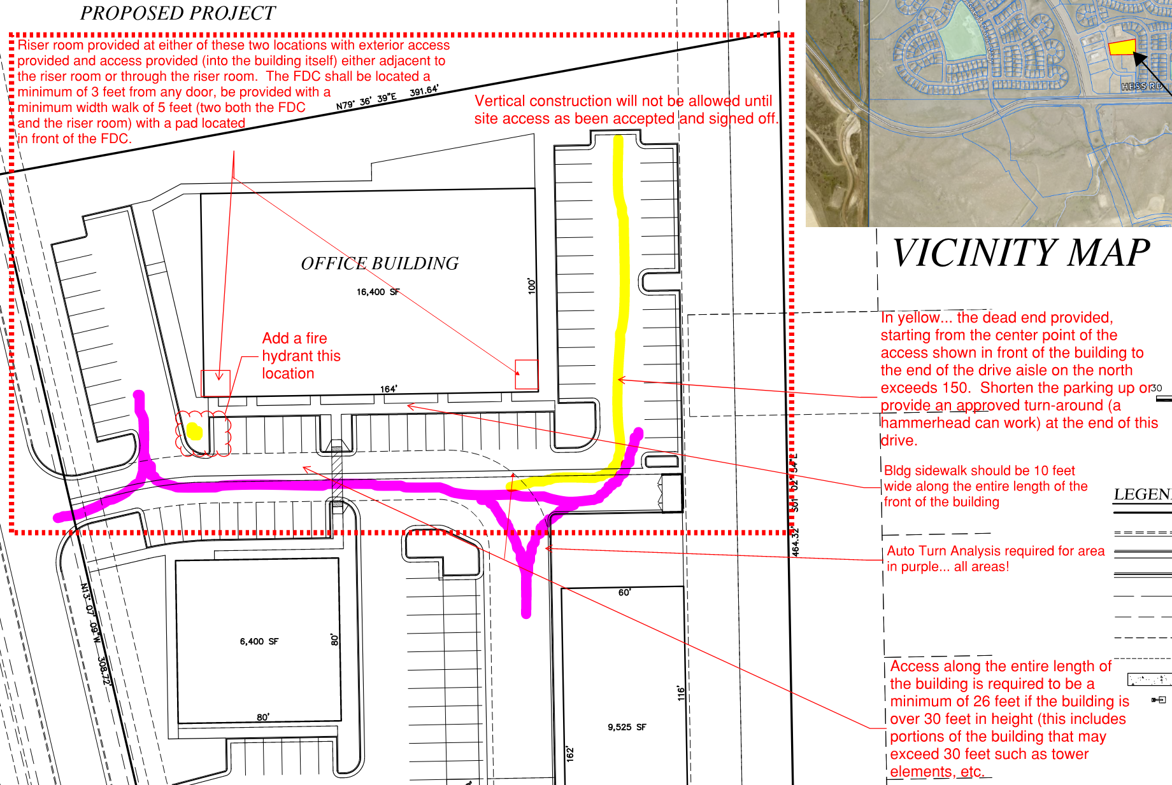

- Along with required code analysis for the building, the applicant shall provide a floor plan of the riser room (as applicable) indicating that the following conditions can be met when resubmitting. If the building is to be treated as a building addition, access from this location shall still be required to be provided into the building from this area.

- An exterior door shall be provided into the riser room.
- A door, either adjacent to the riser room or a door that provides immediate access into the building through the riser room shall be provided. This issue has not been shown to be addressed with the current submittal although the requirement was addressed at length during the pre-application meeting… see below.
- The FACP will be required to be located on an interior wall in the fire sprinkler control valve room; ensure that the riser room is sized to accommodate both the FACP and the riser.
- A three-foot clearance is required in front of the FACP.
- The underground shall enter the building and turn up no further than 24 inches from foundation wall; three feet of clearance is required in front of the fire riser with a minimum of 18” of clearance behind the riser and 18” to each side of the riser.
- The domestic is not allowed to tie into the underground fire line (UFL).
- Unless looped, the UFL and the hydrant are not allowed to be shared with the same dead-end water main.
- A sidewalk is required to be provided from the drive aisle to the riser room.
- A 5’ x 5’ concrete pad shall be provided in front of the FDC with a sidewalk provided to the FDC.
- A detail of the riser room is required to show how the room is to be laid out (arranged), that all clearances are met, and that exterior access has been provided into the riser room with the required access into the building. This is a requirement and will not be allowed to be deferred.
- The location of the required fire department connection (FDC) shall be in the area of the riser room and required fire hydrant. The FDC shall be a minimum of 3 feet away from any door are architectural feature/column). The applicant shall provide a minimum 5-foot sidewalk from the emergency access lane to the riser room. Address this issue when resubmitting.
- The applicant shall provide a minimum 5 x 5 pad in the area where the FDC will be located outside of the riser room. Address this issue when resubmitting.
- While additional utilities are allowed to be located in the riser room, the additional utilities are not allowed to encroach in any of the required areas for either FACP or the riser. This is one of the reasons why the floor plan is required.

The utility drawings shall address the following when resubmitting (reiterating some information):

- Use the correct Fire Life Safety signature block is provided on the correct pages; the signature block shall only be provided on the cover sheet of the Utility Plan set and the Overall Utility page. This block can be seen at the end of this response letter.
- The domestic is not allowed to be pulled off of the underground fire line (UFL) if applicable.
- The UFL is not allowed to share the same line as the fire hydrant.
- The UFL is not allowed to enter any further than 24-inches into the building (and any less than 12-inches into the building (as noted above) if applicable.
- The Utility drawings shall clearly identify the UFL by name, length and size on the plan set (a note can address this though the underground fire line itself shall also bear these notations. The measurement shall be made from the “T” at the water main ending at the flange in the fire sprinkler control valve room.

- The applicant shall be aware that all egress doors are required to be equipped with door hardware and a locking key system (with the building placed on a building master key system). Address this issue when resubmitting.

- The applicant shall be aware that the ENTIRE south side of the building shall be provided with a fire access lane that is no less than 26 feet in width; this is a requirement of the 2021 IFC Appendix D – Aerial Apparatus Access Roads. Buildings that are taller than 30 feet in height are required to be provided with an access road, along the entire length of the longest side of the building, that is 26 feet in width. The access road shall not be closer than 15 feet or further than 30 feet. Ensure that all requirements of this portion of the code are addressed when resubmitting.

- The Town of Parker requires that fire apparatus access roads meet the clear-width and weight-bearing standards of the jurisdiction in which the project is located. Roadways shall be designed to support the imposed weight of fire apparatus, 30-ton, two axle and 40-ton three, axle vehicles. An unimpeded clear width of 26-feet shall be maintained at all times (26-feet for buildings that exceed 30-feet in height). The applicant has met the required 26-foot access road on all four sides of the accessible portion of the building though the applicant has not provided the required auto-turn analysis required for all projects. This analysis shall be performed for all portions of the site including the 24-foot drive aisle provided on the s/w side of the front of the building.
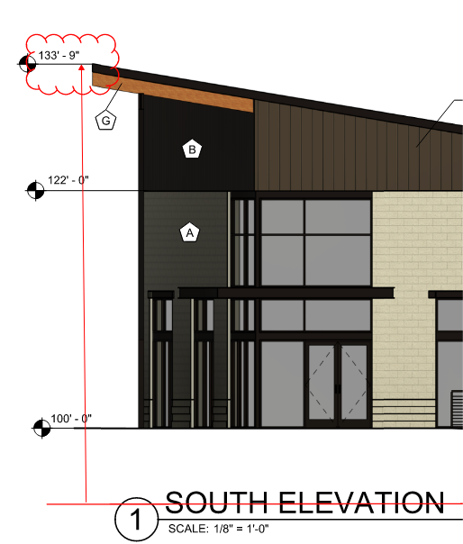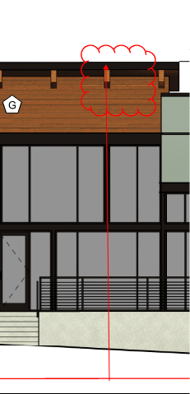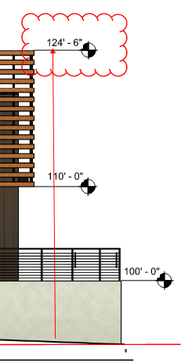

- The applicant has not provided a signage plan; the signage plan shall address all signage including the requirement for NO PAKRING – Fire Lane Signage. See the redlines below for location of required NO PARKING – FIRE LANE (with double sided directional arrows) signage in the location shown below;.

Note - The Town of Parker requires that fire apparatus access roads meet the clear-width and weight-bearing standards of the jurisdiction in which the project is located. Roadways shall be designed to support the imposed weight of fire apparatus, 30-ton, two axle and 40-ton, three axle vehicles. An unimpeded clear width of 26-feet shall be maintained at all times. As such, any location where parked vehicles would obstruct this clear width requirement will require “NO PARKING – FIRE LANE” signage. This signage shall be red on white. Update design criteria has been provided at the end of this document; ensure compliance when resubmitting.

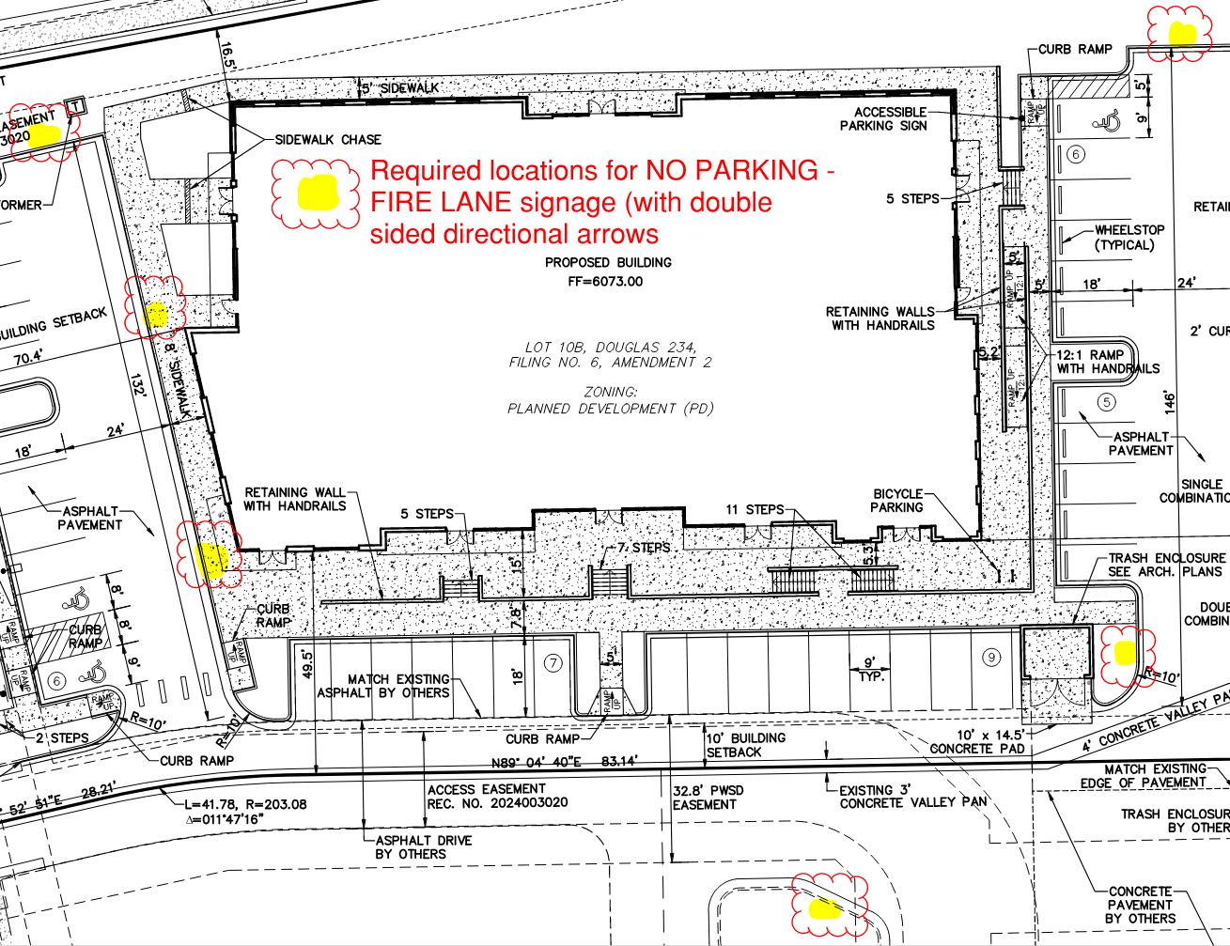

GENERAL COMMENTS (as applicable)
All engineering documents submitted to the Town of Parker shall bear the wet signature and seal of the engineer or architect in responsible charge of the design.

Water distribution and site access components shall be installed and in service prior to the construction of any portion of the structure, except by special permit issued by the Fire District.

Underground fire lines
When thrust blocks are used as part of the pipe restraint system, submitted plans for permit shall provide detailed documentation that the thrust blocks satisfy all requirements of 19 NFPA 24: 10.8.2, including specific thrust block dimensions and mathematical calculations for block dimensions per guidelines provided in Annex A.10.8.2.

FIRE ACCESS ROAD DESIGN CRITERIA

VEHICLE SPECIFICATIONS are provided for the largest apparatus in use by South Metro Fire Rescue. Fire Apparatus Access Roads shall be capable of accommodating this apparatus.

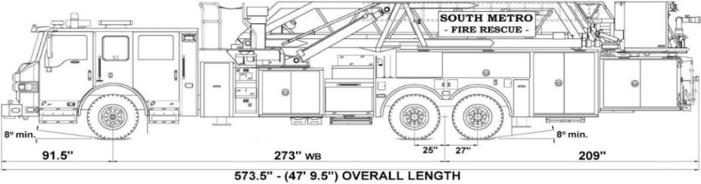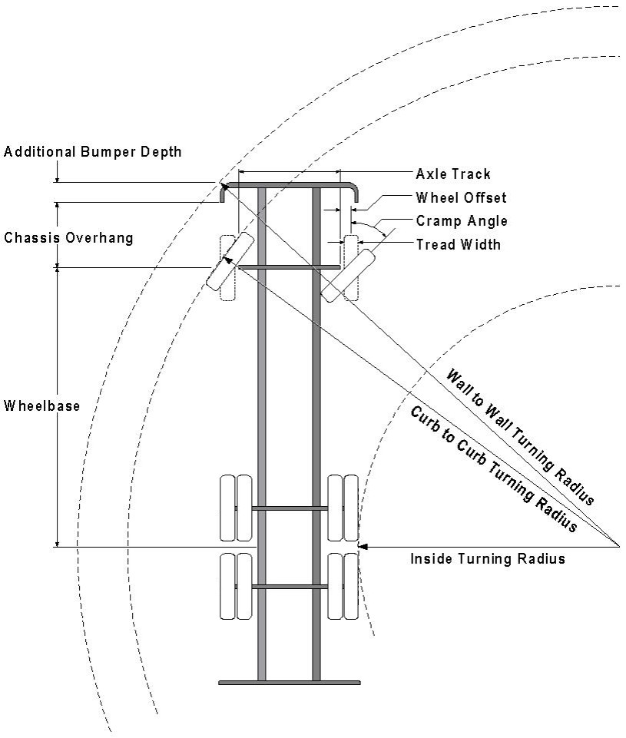

Vehicle Specifications
Length: 47’ 9.5”
Width: 8’ 5” - (10’ 1” mirror to mirror)
Height: 10’ 9”
Wheelbase: 273 in.
Design load: 80,000 pounds Inside Cramp Angle: 40° Axle Track: 83”
Wheel Offset: 5.3”
Tread Width: 13.5”

Turning Radii:
Inside Turn: 26 ft. 1 in. Curb to curb: 41 ft. 11 in. Wall to wall: 46 ft. 8 in.

Where objects are present adjacent to the fire apparatus access road, particularly on turns and turn arounds which require backing, a reasonable safety margin shall be provided to prevent potential damage to the property and to the fire apparatus.

PRIVATE ROADS that provide access to more than two dwellings or one or more commercial buildings shall be constructed to meet the roadway standards approved by the South Metro Fire Rescue Authority for fire apparatus access. Private roads that do not meet the roadway standard may be accepted provided that alternative methods and materials are incorporated into the subdivision that addresses the fire and life safety of the citizens.

FIRE CODE REVIEW BLOCK
All fire hydrants shall be installed according to water utility standards. The number and locations of the fire hydrants as shown on the Overall Utility Plan are correct as specified by the Town of Parker, Community Development Department.

Fire Code Official or Designated Representative Date

(NOTE – Underground Fire Line (UFL) submittal documents must meet the requirements of NFPA 24 when submitting for review.)

Underground Fire Line - Submittal Requirements

Reference: 2019 NFPA 24 Installation of Private Fire Service Mains and Their Appurtenances

A separate permit is required and will be issued pending review of a detailed submittal which must include the following: [21 IFC 901.2]

4.1.1 Working plans shall be submitted for approval to the authority having jurisdiction before any equipment is installed or replaced.

4.1.2 Deviation from approved plans shall require permission of the authority having jurisdiction.

4.1.3 Working plans shall be drawn to an indicated scale on sheets of uniform size, with a plan of each floor as
applicable, and shall include the following items that pertain to the design of the system:

(1) Name of owner
(2) Location, including street address
(3) Point of compass
(4) A graphic representation of the scale used on all plans
(5) Name and address of contractor
(6) Size and location of all water supplies
(7) The following items that pertain to private fire service mains:
(a) Size
(b) Length
(c) Location
(d) Material (ductile-iron, PVC., etc.)
(e) Point of connection to city main
(f) Sizes, types, and locations of valves, depth at which the top of the pipe is laid below grade
(g) Method of restraint (Meg-a-Lug or similar)

4.1.4 The working plan submittal shall include the manufacturer's installation instructions for any specially listed equipment, including descriptions, applications, and limitations for any devices, piping, or fittings. Submittals must include installation specifications for thrust blocks, corrosion protection, restraint system, bedding, detail of pipe under the building up to, and including, the flange. When it is intended that a different contractor will extend the fire line from a stopping point outside the building, to the inside flange, a second submittal and permit is required.

All tees, plugs, reducers, valves, and hydrant branches shall be restrained against movement by thrust blocks [10.8.2] or restrained joint systems [10.8.3]. When thrust blocks are used as part of the pipe restraint system, submitted plans shall provide detailed documentation that the thrust blocks satisfy all requirements of Section 10.8.2, including specific thrust block dimensions and mathematical calculations for block dimensions per guidelines provided in Annex A.10.8.2.

Any individual or company who physically works on or installs any part of a fire suppression system, including underground supply lines, from public water lines to system risers and backflow preventers, must be registered with the Colorado Division of Fire Safety. [Dept of Public Safety, Division of Fire Safety, Fire Suppression Program 8 CCR 1507-11:3.1.2] Documentation of valid annual registration may be required with plan submittal.

The following website for the Colorado Division of Fire Safety will provide registration instructions.
http://dfs.state.co.us/SuppAppsProcInsp.htm

All submittals must display a wet stamp and original signature by a Colorado licensed professional engineer or NICET III, or higher, in fire suppression systems. [Dept. of Public Safety, Division of Fire Safety, Fire Suppression Program 8 CCR 1507

