The Grandview Estates Rural

Water Conservation District
12460 North Third Street, P.O. Box 4292, Parker CO 80134, (303) 805-1690 Phone, (303) 805-2340 Fax
“Working to Preserve Water Resources for Future Generations”

July 26, 2016

NOTE CORRECTION TO JULY 21 RESPONSE IN RED BELOW:
Mr. Patrick Mulready, Senior Planner
Mr. Tom Williams, Director of Engineering
20130 East Mainstreet
Parker, Colorado 80138

REF: Case Number: SUB15-0054
Application Type: SUBDIVISION MINOR DEVELOPMENT PLAT
Application Name: Compark Village South F1 MDP Belford

Dear Mr. Mulready and Mr. Williams,

Grandview Estates Rural Conservation District (GERWCD) has the following concerns related to the above-referenced minor development plat. GERWCD states that the following standards below should be applied and have not been met.

- Riparian Resources.

The Town of Parker Land Development Code 13.07.090(d)(1) provides that a minor development plat must be consistent with the Master Plan. Under goals and strategies, the Master Plan Natural Resource Protection Section 12 requires preservation and protection of plants, animals and their associated ecosystems significant natural areas that provide habitat essential for the conservation of plants, animals, and their associated ecosystems. The section further requires preservation of riparian corridors and wetlands. There is no mention in the application of how the Grandview Tributary and Happy Canyon Creek will be preserved and protected as wildlife corridors and wetlands. The Master Plan identifies a particularly sensitive area in the northwest quadrant of Grandview Estates. Directly north, a dense housing area and major connector highway is contemplated for development by Compark. A small open space is planned in the floodplain area. This is inadequate based upon the Master Plan criteria. See for reference Figure 1 page 2. The Code at 13.07.090 (f) (14) requires delineation of all regulatory one hundred-year floodplains and floodways, all existing and proposed water courses, retention and detention areas, wetlands, known aquifer recharge areas, streams, lakes, inlets, storm sewers and culverts and environmentally sensitive areas on the affected property. The environmentally sensitive area on the Master Plan is not considered in the application.

Figure 1. Master Plan Identification of Sensitive Areas for the Project to Consider

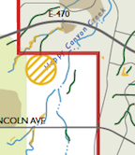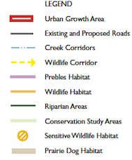
- Hazard Considerations.
The Town of Parker Land Development Code 13.07.090 (e) requires identification of any hazards in the completed land use application. This application by attachment Exhibit D states that there are no hazards. The master plan identifies the flood plain and slope hazards present, see Figures 2-5.
Additionally, there are three existing abandoned homes on the property which will require demolition. Asbestos mitigation is to be implemented for these old homes. These homes are situated close to the southern section line of the property, within 200 feet of a Grandview home, 300 feet of another, and also possibly affecting the historic Stone House (Kaiser Ranch) which sits just south of the northern boundary of Grandview. The Parker Historical Society has already filed its concerns in this subplat application, that heavy machinery, dust, and earth disturbances may well damage the historic home.
Now we are being informed of plans to take demolition traffic and detritus through private property and through Grandview dirt and paved roads, a direct violation of the IGA between Town of Parker and Douglas County that construction traffic will enter by way of newly constructed Belford Avenue from Peoria. Apparently, there is an attempt to make an artificial distinction between “demolition” and “construction”.
The cul de sac at the end of Third was to be used for emergency access only. Review of the Block 31 vacation in 2007 verified that the entry into the two driveways to the north through the cul-de-sacs was identified as the Filbert Avenue Temporary Easement. There is no mention of this demolition, or the cost thereof, in the application. The demolition must be postponed until Belford is open for traffic.
- Open Space.

The Master Plan Goal states growth shall be appropriately directed and site-planned to sustain our community’s needs as we grow. For this subplat, the Master Plan Strategy Section 4D would require increased open space using the criteria set forth in the Open Space, Trails and Greenways Master Plan which emphasize supporting a regional greenway network that provides a community separation buffer from development in neighboring jurisdictions while maintaining the viability and connectivity of the natural ecosystem.

The Neighborhood Center Section of the Master Plan requires for calculation purposes that the gross density exclude the 100-year floodplain as mapped by FEMA and slopes of 20% or greater. Recalculation of the gross density of open space is shown in Table 1, based on visual estimation and deduction of the flood plain Figures 2-4. About 16.8 acres were in the flood plain which reduced the gross density of open space from 14.5% to 10.8%, significantly below the 26% for Parker at large.
The sheet 2 of 4 of the Minor Development Plan accounts for tracts E and F as open space drainage and they are mostly in the flood plain and they are included in the land use summary percentage of total area, which is not consistent with the master plan. The master plan shows 26% open space and trails.
Table 1 Recalculation of Gross Density of Flood Plain and Open Space
Tract | Gross Acres | OS, Acres | % FP | Net Acres | %OS | OS, Acres
A | 22.7 | 0 | 5 | 21.6 | 0 | 0
B | 16.7 | 0 | 50 | 8.4 | 0 | 0
C | 19.2 | 0 | 5 | 18.2 | 0 | 0
D | 5.27 | 5.27 | 0 | 5.27 | 100 | 5.27
E | 1.2 | 1.2 | 90 | 0.12 | 100 | 0.12
F | 7.79 | 7.79 | 75 | 1.95 | 100 | 1.95
G | 22.7 | 0 | 0 | 22.7 | 0 | 0
H | 32.9 | 0 | 0 | 32.9 | 0 | 0
I | 2.41 | 0 | 0 | 2.41 | 0 | 0
J | 0.74 | 0.74 | 0 | 0.74 | 100 | 0.74
K | 5.13 | 5.13 | 0 | 5.13 | 100 | 5.13
L | 0.17 | 0 | 0 | 0.17 | 0 | 0
Total | 137 | 20.1 |  | 120 |  | 13.2
% |  | 14.7 | 17.4 |  | 11.0

It is recommended that the gross density of open space be increased to 20% to be consistent with the Master Plan.

Figure 2. Eastern Section of Minor Development Replat Showing Floodplains

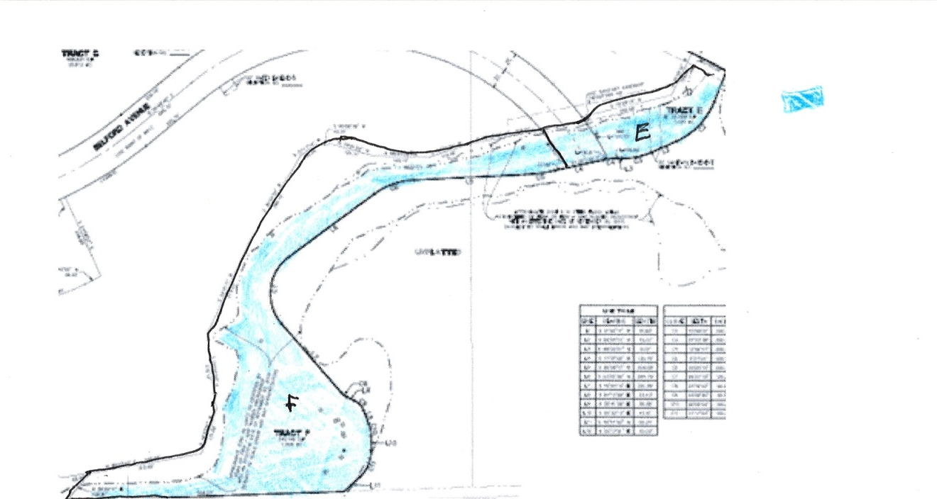
Figure 3. Middle Section of Minor Development Replat Showing Floodplain
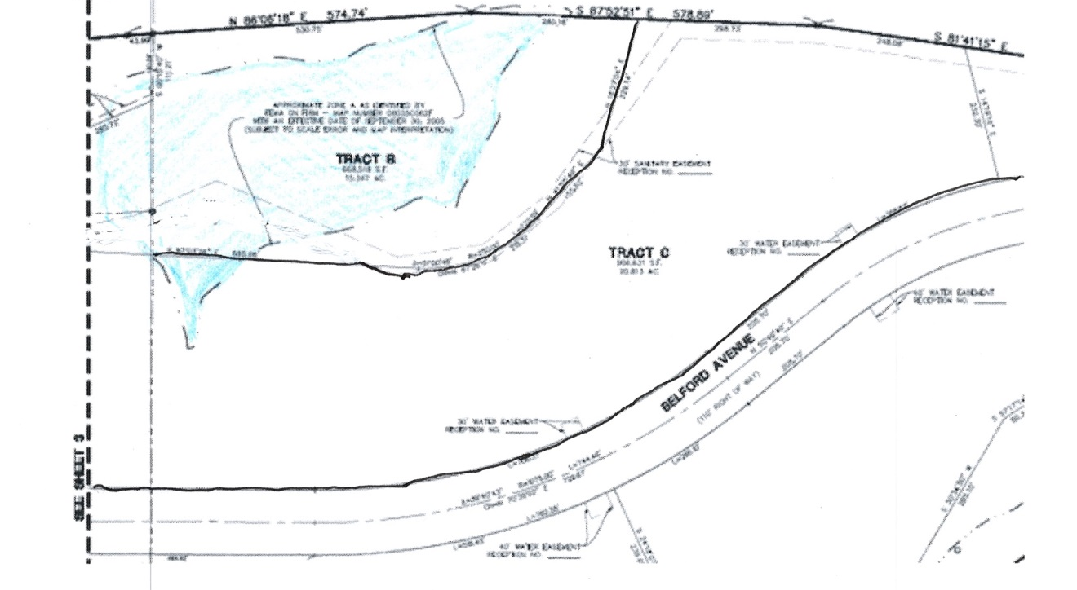
Figure 4. Western Section of Minor Development Replat Showing Floodplains

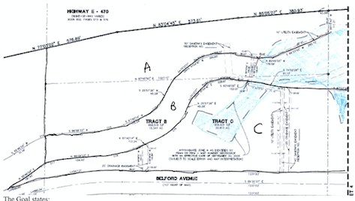

Figure 5 Master Plan Map Showing Flood Plain and Steep Slope Hazards
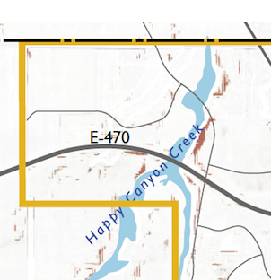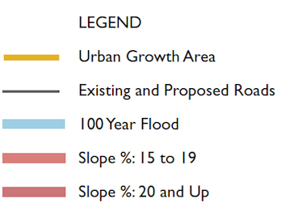

- Identification of Trails, Plats, Easements and Ownership.

The Town of Parker Land Development Code 3.07.090 (f) (11) provides that all lots, tracts and, when requested by staff, appropriate building envelopes, shall be located, identified and labeled with the appropriate dimension with sufficient linear, bearing and curve data. No ditto marks shall be used for dimensions. All lots and, whenever practical, blocks shall be shown in their entirety on one (1) sheet. The present application includes no lots, only tracts. It is recommended that all planned lots be included on one sheet of the Minor Development Replat to put the other attributes in perspective. 13.07.090 (f) (13) requires that the purpose, widths and location (with fine dashed lines) of all easements and all abutting easements be included, with the widths of all easements and sufficient data to definitely locate the same with respect to the subdivision and each lot must be shown. All easements must be clearly labeled and identified.
Applicant has identified this development as Filbert Street, which no longer exists and is private property in Grandview. The name and implied right of use should be changed. The minor development plat Page 4 of 4 shows Filbert Street, which was Filbert Avenue, which does not exist there. It also identifies Block 31 where it is vacated, but not where it is not vacated. The following rights of way for the original property owners of the Stone House (Kaiser Ranch) are not shown from deed exceptions (13, 14 and 54) should be shown on the plat.
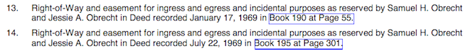
The creek bed is suitable for equestrian use and the right of way should be labeled.
We recommend that the use of Filbert Avenue/Street be discontinued, since it has been mostly vacated and all that is left are some remnants of block 31. There are two remaining sections of block 31 that are used for equestrian purposes:
- Starting at block 3 Lot 6 in Grandview Estates and going East to 5th Street by about 2/3 of block 2 lot 10 as shown in Figure 6.
- Starting at block 2 Lot 11going west to the end of block 1 lot 6 as shown in Figure 7.
These easements must be identified on the Minor Development Plat

- Road Construction

The Town of Parker Development Code 13.07.090 (g) (3) requires that a minor development plat include final road construction plans be submitted. There is only a preliminary a road construction report issued in this application. It is crucial at this point to know that the plan will not be further changed, and what we can depend on. A final plan would assure us that roads will

Figure 6. Un-Labeled Remnants of Block 31 by 5th Street
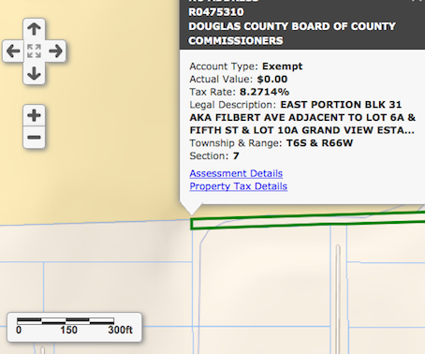
. Figure 7. Un-Labeled Remnants of Block 31 by 6th Street
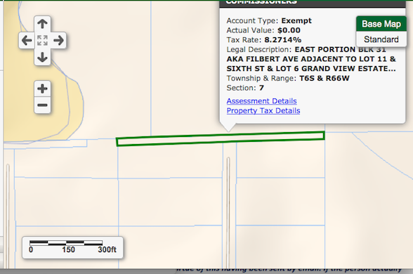
be completed before construction as originally stated (to include construction-related demolition) and that Grandview roads will not be used.

- Sanitation.

The Town of Parker Development Code 13.07.090 (g) (4) requires evidence of the physical and legal capability to provide sanitation. For a subdivision of land located within a sanitation district, a letter of commitment to serve the proposed subdivision stating the capacity to serve and feasibility of extending service to that area. There is no letter of commitment included in the present application.

- Water.

The Town of Parker Development Code 13.07.090 (g) (5) requires evidence that an adequate water supply, sufficient in terms of quality and quantity, is available. For a subdivision of land located within a water district, a letter of commitment to serve the proposed subdivision stating the amount of water available for use within the subdivision and the feasibility of extending service to that area. There is no will serve letter included in the present application

- Park Facilities Master Plan. The Town of Parker Development Code 13.07.090 (g) (7) requires a park facilities master plan and construction plans. No Park Master Plan has been issued

- Final Landscape Plan and Tree Conservation

The Town of Parker Development Code 13.07.090 (g) (12) requires tree conservation. There should be notation of the native trees which will be saved. We request that the maximum number of trees be saved, and that the applicant list those trees salvaged. Code 13.07.090 (g) (13) requires a final landscape plan for the subdivision prepared in accordance with the Town of Parker Construction Specifications and Design Consideration for Parks, Trails and Streetscapes that includes road rights-of-way, landscaped tracts and common areas, if applicable.
10’ tall and 10’ wide trail under bridge on plan LB09 has a 3’ wide side buffer width beside the multi-use trail and should have a 4’ side buffer width according to Page 33 of Town of Parker Construction Specifications and Design Consideration for Parks, Trails and Streetscapes. See Figure 7.Bridge stream should be labeled Happy Canyon Creek, not Green Acres Tributary. Concrete surfacing must take into account equestrian use.

Figure 7 Comparison of Bridge Underpass with Design Requirement



