

FIRE LANE SIGN INSTALLATION

Where the posting of designated “Fire Lane” signage is required, the following information shall serve as the guideline for said installation and shall in accordance with the traffic code adopted by the local city or county.

Fire Lane Sign Dimensions: NO PARKING – FIRE LANE signs shall be 12 inches wide and 18 inches high.

12”

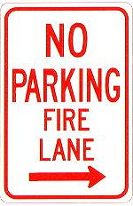
2 ” High
1/8 ” Stroke
Red letters
3” High
¼ ” Stroke
Red Letters
18”

Fire Lane Sign Characteristics: Signs shall be engineer grade reflective sheeting on 0.80 aluminum with red lettering on a white background.

IFC Section 503.3: Fire lanes shall be designated on site design documents along with sign locations and details. Fire apparatus access roads shall be signed “NO PARKING FIRE LANE” as follows:
- On both sides of roads less than 27 feet wide;
- On one side of roads at least 27 feet wide and less than 34 feet wide;
- Roads at least 36 feet wide do not need fire lane signs;
- Other locations as determined by the fire department.

Fire Lane Sign Installation: NO PARKING – FIRE LANE signs shall be installed as follows:
- Bottom edge of the signs shall be 7 feet above surface (sidewalk) and post shall be placed 24 inches from flow line (curb).
- One sign at the beginning of the restriction (one arrow pointing towards the restriction zone).
- One sign at the end of the restriction (one arrow pointing back into restricted zone).
- One sign at least every 150 ft. within the restricted area (double arrow pointing in each direction, to indicate the continuing restriction).
- Spaced evenly within the restriction (for straight curbs/zones). For example, if the parking restriction zone is 300 ft. long, only one double arrow sign is required at a distance of 150 ft. from the beginning of the restriction. If the restriction zone is 400 ft. long, two double arrow signs are required; spaced 100 ft. evenly from each other and from the beginning/ending signs.
- Spaced so that at least one readable sign is visible in front of a parked vehicle from any point along the restriction (for curved curbs/zones and areas that may present visual obstacles.)
- Set at an angle of no fewer than 30 degrees and no more than 45 degrees with the lane of traffic flow visible to approaching traffic.
- Signs shall be provided at all normal and emergency access points to structures and within 20 feet of each fire hydrant and fire department connection (FDC).

Fire Lane Sign Types: The diagrams below indicate the types of signs that may be used, and the recommended placement.

200 feet |  | 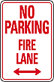  200 feet |  | 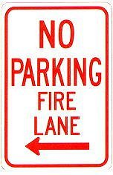

Additional sign styles may be used – provided the same type is used consistently.

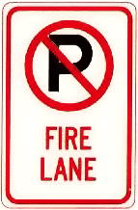 | 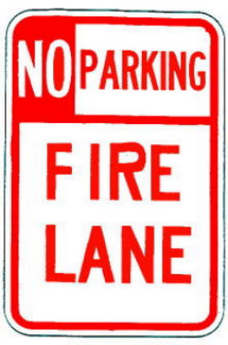

Painting of Curbs or Streets: In addition to the required signage, the Town of Parker, in conjunction with South Metro Fire Rescue, does permit fire lanes to be painted with curb or street markings. However, these markings shall not replace the required fire lane signs. Curbs may be painted red with 3 inch white block letters stating NO PARKING – FIRE LANE. Lettering shall be spaced every 15 feet.

