

Town of Parker Community Development Department
Development Review Division
Attention: Patrick Mulready

Application Type: Subdivision Plan
Status: First Referral
Application Name: Trails at Crowfoot
Case/AP#: SUB16-050 & Sub16-051
Referral Received: November 15, 2016
Comments Due: December 15, 2016

Application Location: Generally at the proposed Chambers/Bayou Gulch Road and North Pinery Parkway intersections

Review date: December 7, 2016
Plan reviewer: Randall L. Capra, rcapra@parkeronline.org
Phone: 303.805.3168

Narrative: Proposed Sketch/Preliminary Plan for the portion of the Hess Ranch Planned Development located south/east of Crowfoot Valley Road. Applicant proposes to establish 824 dwelling units, in a variety of styles and densities, a 17 acre major park site as well as internal pocket parks, and mixed use commercial/multifamily residential areas congregated around the intersection of Chambers/Bayou Gulch Road and North Pinery Parkway.

Code Reference: 2015 International Fire Code, 2015 International Building Code

UNRESOLVED ISSUES/COMMENTS

- It is the intent of the fire service to require that interconnectivity be provided between subdivisions; with regard to this project, Richlawn Parkway shall be interconnected with Bayou Gulch Road (possibly Street Q can be considered at an interconnection. A fire hydrant shall be extended to the connection at Richlawn Parkway.

- The Town of Parker requires that fire apparatus access roads meet the clear-width and weight-bearing standards of the jurisdiction in which the project is located. Roadways shall be designed to support the imposed weight of fire apparatus, 24 ton two axle and 30 ton three axle vehicles. An unimpeded clear width of 20 feet shall be maintained at all times. As such, any location where parked vehicles would obstruct this clear width requirement will require “NO PARKING – FIRE LANE” signage. This signage shall be red on white.

- The applicant shall ensure that all dead-end access roads do not exceed 150 feet (as measured from the center point of the street perpendicular to the dead end) without providing an approved turn-around; this would be applicable with the pair home product locations shown on Sheet 4 of the utility drawings as the dead end that is shown on the east side of Bayou… east end off of Pinery Parkway that appears to be a road that will interconnect with other sub-areas.

- The hydrant distribution layout is difficult to pinpoint due to the lack of an overall site plan; the following are examples of distribution deficiencies. The applicant shall provide a scaled overall utility plan so that the distribution can be correctly evaluated:

- Address the addition of fire hydrants along Bayou Gulch Road (none have been provided); divided roads require that hydrant distribution meet the requirements of [15 IFC Appendix C] with regard to spacing. The applicant must address N Pinery Parkway in the same way.
- Add a fire hydrant mid-point of Street G between Street F and Street D
- Add a fire hydrant at the entry point of Crowfoot Valley Road and N Pinery Parkway
- Add a fire hydrant mid-point between Crowfoot Valley Road and Street F
- Add a fire hydrant at the intersection of Bayou Gulch Road and North Pinery Parkway (on the stagger s/w corner)
- Add a fire hydrant on Street D (Between Street E and Street A) and locate such that the distance between the hydrants does not exceed 500 feet (in some cases, more than one hydrant shall be required).
- Add a fire hydrant on Street C (Between Street E and Street A) and locate such that the distance between the hydrants does not exceed 500 feet (in some cases, more than one hydrant shall be required).
- Add a fire hydrant on Street B (Between Street E and Street A) and locate such that the distance between the hydrants does not exceed 500 feet (in some cases, more than one hydrant shall be required).
- Add a fire hydrant on the corner of Street D and Street I
- Relocate the hydrant on the knuckle of Street K (where it makes the curve) to the inside corner lot
- Add a fire hydrant to the side corner lot of Street K and Street L
- There are two adjacent hydrants at Street J and the un-temp named street to the right of Street O; move the extra hydrant up Street J so that the spacing between the hydrant at Street D and the un named street has correct spacing coverage
- Add a fire hydrant mid-point of Street O Between Street D and Street J.
- The hydrant distribution along the curve to the left of Street N exceeds 500 feet between hydrants…
- The hydrant distribution along Street E in the areas of Street Y, Street W, etc. does not meet hydrant spacing requirements of the code

The applicant shall set up a time to meet with me and we can work together to red-line a utility drawing so as to correctly address the hydrant distribution needs for this subdivision.

- The applicant shall reach out to Chief Vince Turner (South Metro Fire Rescue Authority) to coordinate at what time the future fire station location shall be deeded to the fire authority. Chief Turner can be reached at 720.989.2000 or at vince.turner@southmetro.org.

- An updated signature block has been created with regard to the utility drawing package; typically, this signature block is located on the cover sheet and the overall utility page of the water drawings. The signature block is noted below.

GENERAL COMMENTS
All engineering documents submitted to the Town of Parker shall bear the wet signature and seal of the engineer or architect in responsible charge of the design.

Water distribution and site access components shall be installed and in service prior to the construction of any portion of the structure, except by special permit issued by the Fire District.

Underground fire lines
When thrust blocks are used as part of the pipe restraint system, submitted plans for permit shall provide detailed documentation that the thrust blocks satisfy all requirements of 10 NFPA 24: 10.8.2, including specific thrust block dimensions and mathematical calculations for block dimensions per guidelines provided in Annex A.10.8.2.

FIRE ACCESS ROAD DESIGN CRITERIA

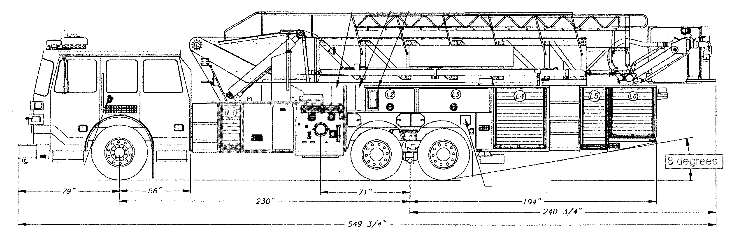
Vehicles specifications
Length = 47.5’
Width = 10’ 1” mirror to mirror
Height = 11’ 6” [a minimum unobstructed vertical clearance of 13’ 6” is required] 06, 09 IFC 503.2.1
Inside Turning Radius = 27 feet
Outside Turning Radius = 45 feet

Access Roads
Width unobstructed: 20 feet minimum [15 IFC 503.2.1]

Grade: 6% maximum within 150 feet of structures. Grades for other roads shall not exceed that of the appropriate county or municipal roadway standard. [15 IFC 503.2.7]

Design load: 72,000 pounds [15 IFC 503.2.3]

Surface: All-weather material of asphalt or concrete

FIRE CODE REVIEW BLOCK
All fire hydrants shall be installed according to water utility standards. The number and locations of the fire hydrants as shown on the Overall Utility Plan are correct as specified by the Town of Parker, Community Development Department.

Fire Code Official or Designated Representative Date

(NOTE – Underground Fire Line (UFL) submittal documents must meet the requirements of NFPA 24 when submitting for review.)

