
6901 South Pierce Street, Suite 315 Littleton, Colorado 80128 303-232-8088

1June 25, 2018

Ms. Morgan Lynch, PE, CFM
Urban Drainage and Flood Control District
240 West 26th Ave., Suite 156B
Denver, Colorado 80211

SUBJECT: Parker Pointe Response to Comments UD MEP ID: 106644
Dear Ms. Lynch,

Below I have reproduced your comment letter on the above project and added responses in red.

- Repeat Comment: Please determine if the improvements in the OSP are needed at this time. The OSP had recommended stream stability measures be implemented in Kinney Creek. We recommend that the stream stability be evaluated with adjacent development to determine the impacts to the stream with the change in hydrology and disturbance in the floodplain. Please document the current conditions of the creek adjacent to the site. The developer has retained Kiowa Engineering to perform analysis and design of required stream improvements. They will do some preliminary analysis and schedule a meeting of all parties to review their findings and come to consensus on what will be required.

- Please include the following note on the construction documents:
The Urban Drainage and Flood Control District will conduct site visits during the project construction within or near the channel to observe construction for conformance with the approved plans and specifications. Please contact UDFCD (303-455-6227), to schedule a preconstruction meeting. All structural and grouted boulder work require 48-hours prior notice to any construction or concrete placement. Standards and specifications for all outfall and channel work can be accessed at www.udfcd.org under the References section. Failure to notify may result in project ineligibility. Requested note added to the cover sheet.
- Please show the proposed grade to the end of the outfall on the profile. It is unclear if channel improvements are being proposed at this location. In the profile it appears the rundown is proposed on an existing slope, but that is not reflected in the profile. UDFCD would prefer the invert of the outfall be placed two feet above the invert of the channel if the sight allows. Pond overflow and rundown is proposed further upstream adjacent to the detention pond. Grades do not permit the piped outfall at this location. Existing and proposed grades are shown in the profile with existing extended thru the thalweg up the opposite bank. Grades do not allow for the outfall to be raised up.

Thank you for your review and comments. Please contact me if additional revisions or clarifications are required.

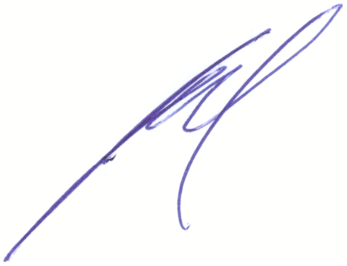
Professionally,

Jerry W. Davidson, P.E.
For and on Behalf of
Perception Design Group, Inc.

