

Town of Parker Community Development Department
Development Review Division
Attention: Carolyn Freeland

Application Type: Minor Development Plat
Status: First Referral
Application Name: Douglas 234 F5 MDP
Case/AP#: SUB20-002
Referral Received: February 28, 2020
Comments Due: March 30, 2020

Application Location: Generally located on the southeast corner of Twenty Mile Road and Ponderosa Drive

Review date: March 18, 2020
Plan reviewer: Randall L. Capra, rcapra@parkeronline.org
Phone: 303.805.3169

Narrative: The applicant, Rick Engineering Company, is proposing a Minor Development Plat to create 11 commercial lots. The site is located on the northeast corner of Chambers Road and Hess Road.
Code Reference: 2018 International Fire Code, 2018 International Building Code, and 2017 NEC

TOWN OF PARKER | FIRE/LIFE SAFETY DIVISION:

1st Submittal – Reviewed March 18, 2020
2nd Submittal – (comments in red, italicized font)

UNRESOLVED ISSUES/COMMENTS

- The applicant has incorrectly identified South Metro Fire Rescue Authority (SMFRA) as the “approving agency for this project; the applicant shall delete references specific to SMFRA and use an approved signature block. The updated Fire Life Safety signature block has been created with regard to the utility drawing package; typically, this signature block is located on the cover sheet and the overall utility page of the water drawings. The signature block is noted below; address as applicable.

- <Informational> The applicant shall be aware that additional hydrants (on each individual lot) maybe required based upon access, occupancy type, etc.; this requirement will be evaluated for each individual lot as applications are submitted.

- <Informational> The applicant shall be aware that no vertical construction on this site will be allowed until such time that curb gutter and first lift of asphalt are installed; a site inspection will be required to ensure that this requirement is made prior to allowing vertical construction to commence.

- <Informational> Per the requirements of [18 IFC Section 503.1.1 Buildings and Facilities] approved fire apparatus access roads shall be provided for every facility, building, portion of a building hereafter constructed or moved into or within the jurisdiction. The fire apparatus access road shall comply with the requirements of this section and shall extend to within 150 feet of all portions of the facility and all portions of the exterior walls of the first story of the building as measured by an approved route around the exterior of the building or facility. Per the requirements of the code, the fire code official is allowed to increase the dimension of the 150 feet provided that the applicant meets Exception 1.1 of this section… “The building is equipped throughout with an approved automatic sprinkler suppression system installed in accordance with section 903.1.1, 903.1.2, or 903.3.

- <Informational> The Town of Parker requires that fire apparatus access roads meet the clear-width and weight-bearing standards of the jurisdiction in which the project is located. Roadways shall be designed to support the imposed weight of fire apparatus, 30-ton two axle and 40-ton three axle vehicles. An unimpeded clear width of 20-feet shall be maintained at all times. As such, any location where parked vehicles would obstruct this clear width requirement will require “NO PARKING – FIRE LANE” signage.

- <Informational> The applicant shall provide an auto turn analysis indicating that apparatus can navigate all portions each individual lot at the time of the site plan submittal; NO PARKING – FIRE LANE signage is required for any portion of the access where the 20-foot clear width requirement cannot be met. This signage shall be red on white. Update design criteria has been provided at the end of this document; ensure compliance when resubmitting.

GENERAL COMMENTS (as applicable)
All engineering documents submitted to the Town of Parker shall bear the wet signature and seal of the engineer or architect in responsible charge of the design.

Water distribution and site access components shall be installed and in service prior to the construction of any portion of the structure, except by special permit issued by the Fire District.

Underground fire lines
When thrust blocks are used as part of the pipe restraint system, submitted plans for permit shall provide detailed documentation that the thrust blocks satisfy all requirements of 16 NFPA 24: 10.8.2, including specific thrust block dimensions and mathematical calculations for block dimensions per guidelines provided in Annex A.10.8.2. .

FIRE ACCESS ROAD DESIGN CRITERIA

VEHICLE SPECIFICATIONS are provided for the largest apparatus in use by South Metro Fire Rescue. Fire Apparatus Access Roads shall be capable of accommodating this apparatus.
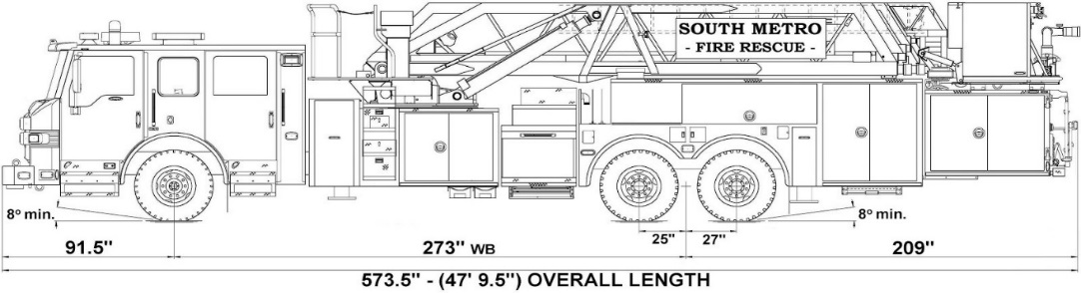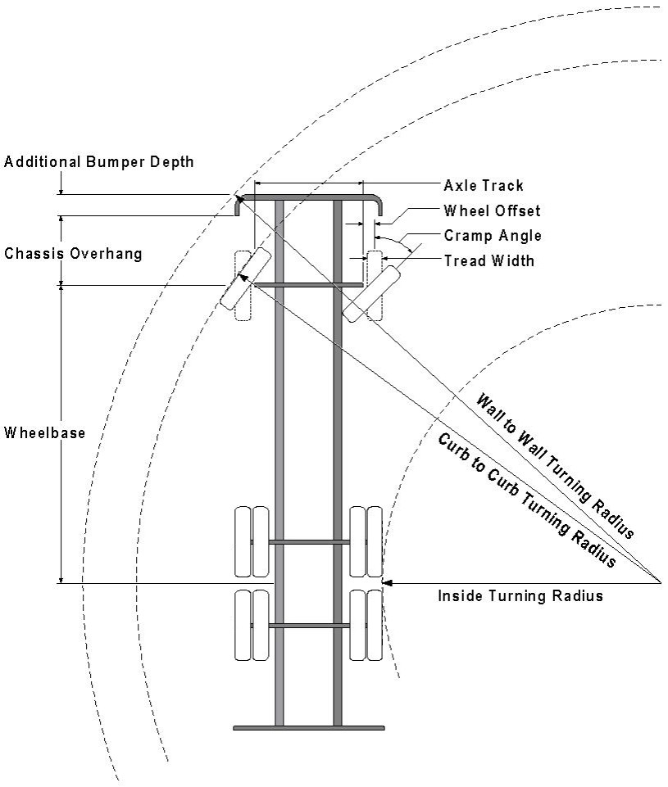

Vehicle Specifications
Length: 47’ 9.5”
Width: 8’ 5” - (10’ 1” mirror to mirror)
Height: 10’ 9”
Wheelbase: 273 in.
Design load: 80,000 pounds Inside Cramp Angle: 40° Axle Track: 83”
Wheel Offset: 5.3”
Tread Width: 13.5”

Turning Radii:
Inside Turn: 26 ft. 1 in. Curb to curb: 41 ft. 11 in. Wall to wall: 46 ft. 8 in.

Where objects are present adjacent to the fire apparatus access road, particularly on turns and turn arounds which require backing, a reasonable safety margin shall be provided to prevent potential damage to the property and to the fire apparatus.

PRIVATE ROADS that provide access to more than two dwellings or one or more commercial buildings shall be constructed to meet the roadway standards approved by the South Metro Fire Rescue Authority for fire apparatus access. Private roads that do not meet the roadway standard may be accepted provided that alternative methods and materials are incorporated into the subdivision that addresses the fire and life safety of the citizens.

FIRE CODE REVIEW BLOCK
All fire hydrants shall be installed according to water utility standards. The number and locations of the fire hydrants as shown on the Overall Utility Plan are correct as specified by the Town of Parker, Community Development Department.

Fire Code Official or Designated Representative Date

(NOTE – Underground Fire Line (UFL) submittal documents must meet the requirements of NFPA 24 when submitting for review.)

Underground Fire Line - Submittal Requirements

Reference: 2016 NFPA 24 Installation of Private Fire Service Mains and Their Appurtenances

A separate permit is required and will be issued pending review of a detailed submittal which must include the following: [15 IFC 901.2]

4.1.1 Working plans shall be submitted for approval to the authority having jurisdiction before any equipment is installed or replaced.

4.1.2 Deviation from approved plans shall require permission of the authority having jurisdiction.

4.1.3 Working plans shall be drawn to an indicated scale on sheets of uniform size, with a plan of each floor as
applicable, and shall include the following items that pertain to the design of the system:

(1) Name of owner
(2) Location, including street address
(3) Point of compass
(4) A graphic representation of the scale used on all plans
(5) Name and address of contractor
(6) Size and location of all water supplies
(7) The following items that pertain to private fire service mains:
(a) Size
(b) Length
(c) Location
(d) Material (ductile-iron, PVC., etc.)
(e) Point of connection to city main
(f) Sizes, types, and locations of valves, depth at which the top of the pipe is laid below grade
(g) Method of restraint (Meg-a-Lug or similar)

4.1.4 The working plan submittal shall include the manufacturer's installation instructions for any specially listed equipment, including descriptions, applications, and limitations for any devices, piping, or fittings. Submittals must include installation specifications for thrust blocks, corrosion protection, restraint system, bedding, detail of pipe under the building up to, and including, the flange. When it is intended that a different contractor will extend the fire line from a stopping point outside the building, to the inside flange, a second submittal and permit is required.

All tees, plugs, reducers, valves, and hydrant branches shall be restrained against movement by thrust blocks [10.8.2] or restrained joint systems [10.8.3]. When thrust blocks are used as part of the pipe restraint system, submitted plans shall provide detailed documentation that the thrust blocks satisfy all requirements of Section 10.8.2, including specific thrust block dimensions and mathematical calculations for block dimensions per guidelines provided in Annex A.10.8.2.

Any individual or company who physically works on or installs any part of a fire suppression system, including underground supply lines, from public water lines to system risers and backflow preventers, must be registered with the Colorado Division of Fire Safety. [Dept. of Public Safety, Division of Fire Safety, Fire Suppression Program 8 CCR 1507-11:3.1.2] Documentation of valid annual registration may be required with plan submittal.

The following website for the Colorado Division of Fire Safety will provide registration instructions.
http://dfs.state.co.us/SuppAppsProcInsp.htm
All submittals must display a wet stamp and original signature by a Colorado licensed professional engineer or NICET III, or higher, in fire suppression systems. [Dept. of Public Safety, Division of Fire Safety, Fire Suppression Program 8 CCR 1507]

