SUBDIVISION AGREEMENT
Trails at Crowfoot Filing No. 8

THIS AGREEMENT is made this day of , 2018, by and between the Town of Parker, Colorado, a home rule municipality (the “Town”), and Polestar Hess Ranch LLC, a Colorado limited liability company (the “Developer”).

RECITALS:

- The Developer is the owner of certain real property located in the Town of Parker known as Trails at Crowfoot Filing No. 8, which is more particularly described in Exhibit A, attached hereto and incorporated herein (the “Property”).

- The Town Council and the Planning Commission of the Town of Parker held all necessary public hearings concerning the plat for the Property. A copy of the final plat is attached hereto as Exhibit B and incorporated herein.

- The approvals cited above are contingent upon the express condition that all duties created by this Agreement are faithfully performed by the Developer.

AGREEMENT

NOW, THEREFORE, for and in consideration of the mutual promises and covenants contained herein, the sufficiency of which are mutually acknowledged, the parties hereto agree as follows:

  - Purpose. The purpose of this Agreement is to set forth the terms, conditions and fees to be paid by the Developer, upon subdivision of the Property. All conditions contained herein are in addition to any and all requirements of the Town of Parker Subdivision Ordinance and Zoning Ordinance, the Town of Parker Charter, any and all state statutes, and any other sections of the Parker Municipal Code, and are not intended to supersede any requirements contained therein.

  - Agreements and Other Requirements. The Developer hereby agrees to perform any and all requirements of the Annexation Agreement entered into between the Town and the Developer on September 21, 2015, which was recorded at Reception No. 2015089338 of the Douglas County real estate records. The requirements of the Annexation Agreement are in addition to the requirements of this Agreement and are not intended to supersede any requirements contained herein.

  - Fees. The following fees shall be paid to the Town by the Developer.

    - The Developer hereby agrees to pay the Town the actual cost to the Town for plan review, engineering review, hydrological and surveying review, prior to and during the development process, and for construction observation, inspection and materials testing during the construction process for public improvements, and for construction observation, inspection and materials testing and electronic deliverable review during the warranty period for public

improvements, and for legal services (the “actual costs”) rendered in connection with the review of the subdivision of the Property, including related administrative fees not to exceed one hundred fifteen percent (115%) of the actual costs. In addition, the Developer shall reimburse the Town for the costs of making corrections or additions to the master copy of the official Town map and for the fee for recording the final plat and accompanying documents with the Douglas County Clerk and Recorder.

    - The Developer shall pay the impact fees, as established by Town ordinances, in effect at the time this Agreement is executed. The Developer shall pay the foregoing impact fees in effect at the time specified by such ordinances.

    - The Developer acknowledges and agrees that the Town, pursuant to this Agreement, shall be granted construction easement(s) that are reasonably sufficient to complete the public improvements.

  - Specific Conditions. The Developer hereby agrees that:

    - Any approval obtained from the Town of Parker does not obviate the Developer’s need to comply with the requirements of Sections 7 and 9 of the Endangered Species Act of 1973, 16 U.S.C. 1531, et seq., as amended, or with any other applicable federal, state or local laws and regulations.

    - Prior to probationary acceptance of the Public Improvements for the Property, the Developer shall install all plant material and related irrigation facilities as described in the landscape plans approved by the Town for the Property (the “Streetscape Improvements”). If installation of Streetscape Improvements cannot be reasonably accomplished prior to probationary acceptance of the Public Improvements for the Property, the Developer shall post a letter of credit amounting to one hundred ten percent (110%) (the “Streetscape Security”) of the materials cost as described in Exhibit E, attached hereto and incorporated herein, and will complete the Streetscape Improvements according to the landscape plans as provided by Section 13.07.150(c)(2) of the Town’s Land Development Ordinance. The Town may reduce the Streetscape Security, in the exercise of its sole discretion, as the Streetscape Improvements are completed and accepted by the Town for final acceptance, subject to Section 13.07.150(c) of the Town's Land Development Ordinance for the Streetscape Improvements.

    - The Final Plat for the Property shall not be recorded until the Trails at Crowfoot Filing No. 1 Final Plat is recorded.

    - Prior to probationary acceptance of the Public Improvements for the Property, the Developer shall obtain probationary acceptance of the Public Improvements within Trails at Crowfoot Filing No. 1.

    - The Development currently plans to construct model homes on Lot 1, Block1, Lot 4, Block 2, Lot 6, Block 1, Lot 2, Block 2 and Lot 6 Block 6, of the Property. The Developer and the Town agree that building permits may be issued for these model lots prior to Probationary Acceptance of Public Improvements, subject to compliance with applicable building and fire codes; however, such model lots may not be sold to third parties prior to Probationary Acceptance by the Town of the Public Improvements.

    - Prior to issuance of the 250th building permit for the entire Trails at Crowfoot development as described in Trails at Crowfoot Filing No. 1 and No. 9, including all thirteen filings proposed at the time of this agreement, and all future subdivisions of these filings, the Developer shall construct and receive a certificate of occupancy for the clubhouse and pool to be located on Lot 1 of the Trails at Crowfoot Filing No. 1.

    - Trails at Crowfoot Filing No. 8 is for Clustered Age Targeted Development defines as a mix of one and two story homes on smaller lots clustered together to preserve the maximum amount of natural open space.

  - Title Commitment. A title commitment for the Property shall be provided to the Town. The title commitment shall show that all property to be dedicated to the Town is or shall be, subsequent to the execution and recording of the final plat, free and clear of all liens and encumbrances (other than real estate taxes which are not yet due and payable), which would make the dedications unacceptable as the Town, in its sole discretion, determines.

  - Breach by the Developer; the Town's Remedies. In the event of a breach of any of the terms and conditions of this Agreement by the Developer, the Town Council shall be notified immediately and the Town may take such action, as permitted and/or authorized by law, this Agreement or the ordinances and Charter of the Town, as the Town deems necessary to protect the public health, safety and welfare; to protect lot buyers and builders; and to protect the citizens of the Town from hardship and undue risk. The remedies include, but are not limited to:

    - The refusal to issue any building permit or certificate of occupancy;

    - The revocation of any building permit previously issued under which construction directly related to such building permit has not commenced, except a building permit previously issued to a third party;

    - A demand that the security given for the completion of the public improvements be paid or honored; or

    - Any other remedy available at law.

Unless necessary to protect the immediate health, safety and welfare of the Town, or to protect the interest of the Town with regard to security given for the completion of the public improvements, the Town shall provide the Developer thirty (30) days' written notice of its intent to take any action under this paragraph, during which thirty-day period the Developer may cure the breach described in the notice and prevent further action by the Town.

  - Public Improvements and Warranty. All drainage structures, paved streets, including sidewalk, curb, gutter and slope easements, and necessary appurtenances, as shown on the final plat, landscape plans and the associated construction documents (the "Public Improvements"), as approved by the Director of Engineering/Public Works of the Town, shall be installed and completed at the expense of the Developer and dedicated and/or conveyed to the Town. The Public Improvements required by this Agreement and shown on the final plat, as well as associated construction documents approved by the Director of Engineering/Public Works of the Town and the costs of these Public Improvements, are set forth on Exhibit C, attached hereto

and incorporated herein. All Public Improvements covered by this Agreement shall be made in accordance with the final plat and associated construction documents drawn according to regulations and construction standards for such improvements and approved by the Director of Engineering/Public Works of the Town.

The Developer shall warrant any and all Public Improvements, which are conveyed to the Town, pursuant to this Agreement, for a period of two (2) years from the date the Town's Director of Engineering/Public Works grants probationary acceptance of the Public Improvements, as approved by the Town. The warranty period shall extend to the date final acceptance is granted in writing by the Town's Director of Engineering/Public Works. The Developer shall be responsible for scheduling the necessary inspections for probationary and final acceptance. Specifically, but not by way of limitation, the Developer shall warrant the following:

    - That the title conveyed shall be marketable and its transfer rightful;

    - Any and all facilities conveyed shall be free from any security interest or other lien or encumbrance; and

    - Any and all facilities so conveyed shall be in conformity with the Town’s specifications and shall be free of defects in materials or workmanship for a period of two (2) years, as stated above, including, but not limited to, cracks, breakage, settling, or other deterioration of the Public Improvements, no matter the cause, for a period of two (2) years, as stated above.

The Town will accept for maintenance all Public Improvements after the warranty period has expired, provided all warranty work has been completed. The Town shall accept for snow removal purposes only all dedicated public streets after probationary acceptance has been granted in writing by the Director of Engineering/Public Works. The Developer shall make all corrections necessary to bring the Public Improvements into conformity with the Town’s specifications, prior to final acceptance.

Notwithstanding anything to the contrary contained in this Agreement, the Town will not accept for ownership, maintenance or operation any private improvements that are described as Public Improvements in this Agreement, that include, but are not limited to, private streets, private parks, private open space, drainage facilities, landscaping and medians that will be privately maintained, as described on the final plat and/or subject to a license agreement as provided by Paragraph 14 of this Agreement.

  - Observation. The Town shall have the right to make reasonable engineering observations at the Developer's expense, as the Town may request. Observation, acquiescence in, or approval by any engineering inspector of the construction of physical facilities at any particular time shall not constitute the approval by the Town of any portion of the construction of such Public Improvements. Such approval shall be made by the Town only after completion of construction and in the manner hereinafter set forth.

  - Completion of Public Improvements. The obligations of the Developer provided for in paragraph 7 of this Agreement, including the inspections hereof, shall be performed on or before December 31, 2020, and proper application for acceptance of the Public Improvements shall

be made on or before such date. Upon completion of construction by the Developer of such Public Improvements, the Town’s Director of Engineering/Public Works or his designee shall inspect the improvements and certify with specificity their conformity or lack thereof to the Town’s specifications. The Developer shall make all corrections necessary to bring the improvements into conformity with the Town’s specifications. Once approved by the Town’s Director of Engineering/Public Works, the Town shall accept said improvements upon conveyance, pursuant to paragraph 11; provided, however, the Town shall not be obligated to accept the Public Improvements until the actual costs described in paragraphs 3.a. and b. of this Agreement are paid in full by the Developer.

  - Related Costs – Public Improvements. The Developer shall provide all necessary engineering designs, surveys, field surveys and incidental services related to the construction of the Public Improvements, at its sole cost and expense, including reproducible “as built” drawings certified accurate by a professional engineer registered in the State of Colorado.

  - Improvements to be the Property of the Town. All Public Improvements for roads, concrete curbs and gutters, storm sewers, and drainage improvements accepted by the Town shall be dedicated to the Town and warranted for a period of two (2) years following probationary acceptance by the Town, as provided above.

  - Performance Guarantee. In order to secure the construction and installation of the Public Improvements, the Developer shall, prior to recording the final plat in the real estate records of Douglas County, which recording shall occur no later than ninety (90) days after the execution of this Agreement, furnish the Town, at the Developer’s expense, with the performance guarantee described herein. The performance guarantee provided by the Developer shall be an irrevocable letter of credit in which the Town is designated as beneficiary in an amount equal to one hundred ten percent (110%) of the estimated costs of the Public Improvements to be constructed and installed, as set forth in Exhibit C, to secure the performance and completion of the Public Improvements. The Developer agrees that approval of the final plat by the Town is contingent upon the Developer’s provision of an irrevocable letter of credit to the Town within ninety (90) days of the execution of this Agreement, in the amount and form provided herein. Failure of the Developer to provide an irrevocable letter of credit to the Town, in the manner provided herein, shall negate the Town's approval of the final plat. Letters of credit shall be substantially in the form and content set forth in Exhibit D, attached hereto and incorporated herein, and shall be subject to the review and approval of the Town Attorney. The Developer shall not start the construction of any public or private improvement on the Property, including, but not limited to, staking, earth work, overlot grading or the erection of any structure, temporary or otherwise, until the Town has received and approved the irrevocable letter of credit.

The estimated costs of the Public Improvements shall be a figure mutually agreed upon by the Developer and the Town’s Director of Engineering/Public Works, as set forth in Exhibit C. If, however, they are unable to agree, the Director of Engineering/Public Works’ estimate shall govern after giving consideration to information provided by the Developer, including, but not limited to, construction contracts and engineering estimates. The purpose of the cost estimate is solely to determine the amount of security. No representations are made as to the accuracy of these estimates and the Developer agrees to pay the actual costs of all such Public Improvements.

The estimated costs of the Public Improvements may increase in the future. Accordingly, the Town reserves the right to review and adjust the cost estimates on an annual basis. Adjusted cost estimates will be made according to changes in the Construction Costs Index, as published by the Engineering News Record. If the Town adjusts the cost estimate for the Public Improvements, the Town shall give written notice to the Developer. The Developer shall, within thirty (30) days after receipt of said written notice, provide the Town with a new or amended letter of credit in the amount of the adjusted cost estimates. If the Developer refuses or fails to so provide the Town with a new or amended letter of credit, the Town may exercise the remedies provided for in paragraph 6 of this Agreement; provided, however, that prior to increasing the amount of additional security required, the Town shall give credit to the Developer for all required Public Improvements which have actually been completed so that the amount of security required at any time shall relate to the cost of required Public Improvements not yet constructed.

In the event the Public Improvements are not constructed or completed within the period of time specified by paragraph 9 of this Agreement or a written extension of time mutually agreed upon by the parties to this Agreement, the Town may draw on the letter of credit to complete the Public Improvements called for in this Agreement. In the event the letter of credit is to expire within fourteen (14) calendar days and the Developer has not yet provided a satisfactory replacement, the Town may draw on the letter of credit and either hold such funds as security for performance of this Agreement or spend such funds to finish the Public Improvements or correct problems with the Public Improvements, as the Town deems appropriate.

Upon completion of performance of such improvements, conditions and requirements within the required time and the approval of the Town’s Director of Engineering/Public Works, the Developer shall issue an irrevocable letter of credit to the Town in the amount of twenty percent (20%) of the total cost of construction and installation of the Public Improvements, to be held by the Town during the two-year warranty period. If the Public Improvements are not completed within the required time, the monies may be used to complete the improvements.

  - Nuisance Conditions. The Developer agrees to prevent the existence of any nuisances by way of its construction activities, as nuisances are defined by Title 6 of the Parker Municipal Code, and as referenced in Title 11 of the Parker Municipal Code. In the event the authorized inspector/designated Town authority determines that a nuisance exists, the Developer shall be subject to the provisions set forth in Parker Municipal Code Sections 11.12.040 and 11.12.050, regarding the abatement of nuisances and the cost assessed for the abatement thereof.

In addition to the provisions above, if the nuisance is not abated or an abatement plan is not submitted to the satisfaction of the Town, the Town may, upon thirty (30) days’ notice under this Agreement, exercise the right to draw upon the performance guarantee specified in paragraph 12 of this Agreement. The Town may draw on the performance guarantee in order to pay the cost of abating the nuisance, including any expenses and penalties incurred under the Parker Municipal Code. The Town may exercise this right in addition to, or in lieu of, the withholding of permits and/or the withholding of certificates of occupancy. The right to draw on the performance guarantee shall be subject to the sole discretion of the Town, provided the Developer has received thirty (30) days' notice, as provided herein.

The Town Planning Department and the Department of Engineering/Public Works shall be authorized to cease processing any land use or permit applications submitted by the same developer for the property that is contained within the same Planned Unit Development, until the nuisance is abated. This shall include, but not be limited to, acceptance of applications, sending referrals, scheduling meetings or hearings, or conducting reviews of projects.

  - Homeowners’ Association. A homeowners’ association shall be created by the Developer under the laws of the State of Colorado or the Property shall be included in an existing homeowners’ association, if possible. The homeowners’ association must be lawfully established before any properties within the development are sold to third parties. The articles of incorporation shall be reviewed by the Town Attorney to insure that they have met the Town’s requirements and the articles provide that the homeowners’ association will maintain the private improvements, including, but not limited to, private streets, private parks, private open space, drainage facilities, landscaping and medians, as identified on the final plat and/or subject to a license agreement(s) entered into between the Developer and the Town, contemporaneously with this Agreement or prior to final acceptance of the Public Improvements, and to assume all responsibilities therefor as shown on the final plat and/or described in the license agreement(s), including sufficient funding to meet these responsibilities.

  - Indemnification. The Developer shall indemnify and hold harmless the Town, its officers, employees, agents or servants from any and all suits, actions and claims of every nature and description caused by, arising from or on account of any act or omission of the Developer, or of any other person or entity for whose act or omission the Developer is liable, with respect to construction of the Public Improvements; and the Developer shall pay any and all judgments rendered against the Town as the result of any suit, action or claim, together with all reasonable expenses and attorney fees incurred by the Town in defending any such suit, action or claim.

The Developer shall pay all property taxes on the Property dedicated to the Town, and shall indemnify and hold harmless the Town for any property tax liability.

The Developer shall require that all contractors and other employees engaged in construction of Public Improvements shall maintain adequate workers’ compensation insurance and public liability coverage and shall faithfully comply with the provisions of the Federal Occupational Safety and Health Act.

  - Waiver of Defects. In executing this Agreement the Developer waives all objections it may have concerning defects, if any, in the formalities whereby it is executed, or concerning the power of the Town to impose conditions on the Developer, as set forth herein, and concerning the procedure, substance and form of the ordinances or resolutions adopting this Agreement.

  - Modifications. This Agreement shall not be amended, except by subsequent written agreement of the parties.

  - Release of Liability. It is expressly understood that the Town cannot be legally bound by the representations of any of its officers or agents or their designees, except in accordance with the Parker Municipal Code and the laws of the State of Colorado.

  - Captions. The captions to this Agreement are inserted only for the purpose of convenient reference and in no way define, limit or prescribe the scope or intent of this Agreement or any part thereof.

  - Binding Effect. This Agreement shall be binding upon and inure to the benefit of the parties hereto and their respective heirs, successors and assigns, as the case may be.

  - Invalid Provision. If any provision of this Agreement shall be determined to be void by any court of competent jurisdiction, then such determination shall not affect any other provision hereof, and all of the other provisions shall remain in full force and effect. It is the intention of the parties hereto that if any provision of this Agreement is capable of two constructions, one of which would render the provision void and the other which would render the provision valid, then the provision shall have the meaning which renders it valid.

  - Governing Law. The laws of the State of Colorado shall govern the validity, performance and enforcement of this Agreement. Should either party institute legal suit or action for enforcement of any obligation contained herein, it is agreed that venue of such suit or action shall be in Douglas County, Colorado.

  - Attorney Fees. Should this Agreement become the subject of litigation to resolve a claim of default of performance by the Developer and a court of competent jurisdiction determines that the Developer was in default in the performance of the Agreement, the Developer shall pay the attorney fees, expenses and court costs of the Town.

  - Notice. All notice required under this Agreement shall be in writing and shall be hand delivered or sent by registered or certified mail, return receipt requested, postage prepaid, to the addresses of the parties herein set forth. All notices so given shall be considered effective seventy-two (72) hours after deposit in the United States mail with the proper address, as set forth below. Either party, by notice so given, may change the address to which future notices shall be sent.

Notice to the Town: Town of Parker
Attn: Director of Engineering/Public Works 20120 E. Mainstreet
Parker, Colorado 80138

With copy to: Town of Parker
Attn: Town Attorney 20120 E. Mainstreet
Parker, Colorado 80138

Notice to Developer: Polestar Hess Ranch LLC
Attn: Taylor Dudley
8191 Southpark Lane, Suite 205
Littleton, Colorado 80120 tsdudley@hotmail.com

  - Force Majeure. Whenever the Developer is required to complete the construction, repair or replacement of Public Improvements by an agreed deadline, the Developer shall be entitled to an extension of time equal to a delay in completing the foregoing, due to unforeseeable causes beyond the control and without the fault or negligence of the Developer, including, but not limited to, acts of God, weather, fires and strikes.

  - Approvals. Whenever approval or acceptance of the Town is necessary, pursuant to any provision of this Agreement, the Town shall act reasonably and in a timely manner in responding to such request for approval or acceptance.

  - Assignment or Assignments. There shall be no transfer or assignment of any of the rights or obligations of the Developer under this Agreement, without the prior written approval of the Town. The Developer agrees to provide the Town with at least fourteen (14) days’ advance written notice of the transfer or assignment of any of the rights and obligations of the Developer under this Agreement.

  - Recording of Agreement. This Agreement shall be recorded in the real estate records of Douglas County and shall be a covenant running with the Property, in order to put prospective purchasers or other interested parties on notice as to the terms and provisions hereof.

  - Title and Authority. The Developer expressly warrants and represents to the Town that it is the record owner of the property constituting the Property and further represents and warrants, together with the undersigned individuals, that the undersigned individuals have full power and authority to enter into this Subdivision Agreement. The Developer and the undersigned individuals understand that the Town is relying on such representations and warranties in entering into this Agreement.

WHEREFORE, the parties hereto have executed this Agreement on the day and year first above written.

TOWN OF PARKER, COLORADO

By: John Fussa, Community Development Director

ATTEST:
By: Tom Williams, Director of Engineering/Public Works

Carol Baumgartner, Town Clerk APPROVED AS TO FORM:

James S. Maloney, Town Attorney

DEVELOPER: POLESTAR HESS RANCH
LLC, a Colorado limited liability company

STATE OF COLORADO )
)ss.
COUNTY OF )
By:
[Name, title]

The foregoing instrument was acknowledged before me this day of , 2018, by , as of Polestar Hess Ranch LLC.
My commission expires: . (SEAL)

Notary Public

EXHIBIT LIST

Exhibit A Legal Description of the Property Exhibit B Copy of the Final Plat
Exhibit C Estimated Cost of Public Improvements Exhibit D Form of Letter of Credit
Exhibit E Estimated Cost of Streetscape Improvements

EXHIBIT A

LEGAL DESCRIPTION
A PARCEL OF LAND BEING A PART OF SECTION 9, TOWNSHIP 7 SOUTH, RANGE 66 WEST OF THE 6TH PRINCIPAL MERIDIAN, TOWN OF PARKER, COUNTY OF DOUGLAS, STATE OF COLORADO, BEING MORE PARTICULARLY DESCRIBED AS FOLLOWS:

TRACT P OF TRAILS AT CROWFOOT SUBDIVISION FILING NO. 1 AS RECORDED AT RECEPTION NO. TOWN OF PARKER, COUNTY OF DOUGLAS, STATE OF COLORADO.

TRACT T OF TRAILS AT CROWFOOT SUBDIVISION FILING NO. 1 AS RECORDED AT RECEPTION NO. TOWN OF PARKER, COUNTY OF DOUGLAS, STATE OF COLORADO.

TRACT W OF TRAILS AT CROWFOOT SUBDIVISION FILING NO. 1 AS RECORDED AT RECEPTION NO. TOWN OF PARKER, COUNTY OF DOUGLAS, STATE OF COLORADO.

TRACT Y OF TRAILS AT CROWFOOT SUBDIVISION FILING NO. 1 AS RECORDED AT RECEPTION NO. TOWN OF PARKER, COUNTY OF DOUGLAS, STATE OF COLORADO.

TRACT Z OF TRAILS AT CROWFOOT SUBDIVISION FILING NO. 1 AS RECORDED AT RECEPTION NO. TOWN OF PARKER, COUNTY OF DOUGLAS, STATE OF COLORADO.

EXHIBIT B
TRAILS AT CROWFOOT FILING NO. 8

A REPLAT OF
TRACT P, TRACT T,
TRACT W,
TRACT Y,
AND TRACT Z;
OF TRAILS AT
CROWFOOT FILING NO. 1

A PART OF
THE

SECTION 9,
TOWNSHIP 7 SOUTH,
RANGE 66 WEST
OF THE 6th PRINCIPAL
MERIDIAN,

TOWN OF PARKER,
COUNTY OF
SHEET
DOUGLAS, STA TE OF
1 OF 5
COLORADO

TOTAL ACREAGE 10.688 ACRES, 31 LOTS, 0 TRACTS

DED I CA TI ON STA TEMEN T
THE UNDERSIGNED, BEING AL L THE OWNERS, MORTGAGEES, BENEFICI ARIES OF DEEDS OF TRUS T AND HOLDERS OF OTHER INTERESTS OF THE LANDS DESCRIBED HEREIN, HAVE LAID OUT, SUBDIVIDED AN D PLATTED SAID LANDS IN TO LOTS, TRACTS, BLOCKS, STREETS AND
E ASEMEN TS AS SHOWN HEREON UNDER THE NAME AND SUBDI VISION OF THE TRAI LS AT CROWFOOT FILING NO. 8. THE UTILI TY EAS EMENTS AS SHOWN HEREON ARE HEREBY DEDICA TED FOR PUBLIC UTILI TIES AND CAB LE COMMUNICATION SYSTEMS AND OTHER
PURPOSES AS SHOWN HEREON. THE EN TITIES RESPONSIBLE FOR PROVIDING THE UTILITY SERVICES FOR WHICH THE E AS EMENTS ARE
;wJ
/
(

--j
PL AN NI NG COMM I SSI ON STATEMENT :

THE PRELIMINARY PLAN FOR THIS PLAT WAS REVIEWED BY THE PLANNING COMMISSION ON

OCTOBER 1 2 2017.

ESTABLISHED ARE HEREBY GRA NTED THE PERPETUAL RIGHT OF INGRESS AND EGRESS FROM AND TO AD J AC EN T PROPER TIES FOR INSTALLA TION, MAI NTENANCE AND REPLACEMEN T OF UTILITY LINES AND RELA TED FACILITIES. THE OWNERS OF THE L ANDS DESCRIBED HEREIN ARE RESPONSIBLE FOR THE MAI NTENANCE AND OPERATION OF DRA INAGE EASEMENTS SHOWN HEREON AND REL AT ED FACILITIES, AS PROVIDED IN THE STORM DRA INAGE AND ENVIRONMEN TAL CRI TERI A MANUAL, AS AME NDED. THE UNDERSIGNED GRANTS THE TOWN OF PARKER A PERPETUAL RIGH T OF INGRESS AND EGRESS FROM AND TO AD JAC ENT PROP ERT Y TO MAIN TAIN, OP ERAT E AND RECONSTRUC T THE DRAINAGE E ASEMENTS AND REL ATED FACILI TIES COVERED BY CHAPT ER 4.08 OF THE P ARK ER MUNICIP AL CODE, AS AMEND ED; AND TO MAINTAIN, OP ERATE AND RECONS TRUCT THE DRAINAGE EAS EMENTS AND REL ATED FACILI TIES NOT COVERED BY CH APTER 4 08 OF THE P AR KER MUN ICIP AL CODE AS AMENDED, WHEN THE OWNER(S) FAIL TO ADEQUATELY MAINTAIN SUCH DRA INAGE EASEMENTS AND RELATED
FACILITIES, WHICH MA INTEN ANCE, OPERATION AND RECONS TRUCTION SHALL BE AT THE COST OF THE OWNER( S). ALL PUBLIC STREE TS AND RIGH TS- OF- WAY SHOWN HEREON ARE DEDICAT ED AND CONV EYED TO THE TOWN OF PARKER, COLORADO, IN FEE SIMPLE ABSO LUTE, FOR PUBLIC USES AND PURPOSES. DRAINAGE AND DETEN TION EASEMENTS AS SHOWN HEREON AR E HEREBY DEDICATED TO THE TOWN. THE TOWN IS HEREBY GRANTED THE PERPET UA L RIGHT OF INGRESS AND EGRESS FROM AND TO THE AD JACENT PROPER TIES FOR CONSTRUCTION, REPAIR, MAINTEN ANCE, OPERA TION AND REPLAC EMENT OF STORM SEWERS AND DR AINAGE FAC ILITIES. THE UNDERS IGNED
GRA NTS TO THE TOWN A SIGHT EASEME NT( S) AS SHOW HEREON WITHIN THE SUBDI VISION TO MA INTAIN ADEQUA TE SIGH T DISTANCE AT
PLAN NING DIRECTOR, ON BEHA LF OF THE PLAN NING COMMISSION

CLERK AND RECORDER'S CERT IFI CA TION :

STA TE OF COLORADO )
)SS COUN TY OF DOUGLAS )

I HEREB Y CERTIFY THAT THI S PLAT WAS FILED IN MY OFFICE ON THI S
DATE

DAY OF , 201 8 A.O.,

ALL ROADWAY INTERSECTIONS AS PROVIDED BY THE TOWN OF P ARK ER ROADWAY DESIGN AND CONS TRUCT ION CRITERI A MANUA L , AS AMEND ED. THE TOWN IS HEREBY GRANTED THE PERP ETUAL RIGHT OF INGRESS AND EGRESS ACROSS ALL LOTS AND TRACTS WI THIN THE SUBDI VISION TO REMOV E ANY OBSTRUC TION TO THE PROPER SITE DISTANCE, INCLUDING, BUT NOT LIMITED TO, ANY STRUCTURE, FENCE,
AT
A.M./P.M AT REC EPTION NUMBER

UTILIT Y BOX, RAISED MEDI AN AND LANDSCAPING, AT THE SOLE COS T AND EXPENSE OF THE OWNER OF THE LOT AND/OR TRAC T UPON WHICH SUCH OBSTRUCTION IS SITU ATED. THE OWNERS OR ADJACENT PRO PERTY OWNERS OF THE LANDS ARE RESPONSIBLE FOR THE MAIN TENA NCE AND OPERAT ION OF SIGHT EASEMENTS SHOWN HEREON. WHEN THE OWNER(S) OR ADJACEN T OWNERS FAIL TO ADEQU ATE LY MAIN TAIN SUCH SIGHT EASEME NTS, THE MAINTENAN CE, OPERAT ION AND RECONS TRUCTION SHALL BE AT THE COST OF THE OWNER( S).
THE UNDERSIGNED HEREBY DEDICA TES SIDEWALK E ASEMENTS AS SHOWN FOR PUBLIC SIDEWALK PURPO SES. THE PROPERTY OWNER SHALL
BE RESPONS IBLE FOR MA INTAINING ALL SIDEWALK ADJACENT TO THE PROPERTY IN GOOD CONDI TION AND FREE FROM ANY HAZARD. THE UNDERSIGNED GRANTS THE TOWN THE PERPETUAL RIGHTS OF INGRESS AND EGRESS UPON THE PROPERTY FOR THE OPERAT ION ,
MAIN TENANCE, AND RECONS TRUCTION OF THE PUBLIC SIDEWA LK WHEN THE OWNERS FAIL TO MAI N TAI N SUCH PUBLIC SIDEWALK, WHICH MAIN TENANCE, OPERAT ION AND RECO NSTRUCTION SHALL BE AT THE COST OF THE OWNER(S). THE TOWN SHALL ALSO HAVE THE RIGH T TO REMOVE AN OBS TRUCT ION THA T WOULD ADVERSE LY AFFECT THE OPERATION AND MAIN TENA NCE OF THE SIDEWALK, AS DETERMINED BY THE TOWN.

ACKNOWLEDGEME NT

THE UNDERSIGNED, BEING ALL THE OWNERS, MORTGAGEES, BENEFICI ARIES OF DEEDS OF TRUST AND HOLDERS OF OTHER INTERESTS OF THE LANDS DESCRIBED HEREIN, HEREBY ACK NOWL EDGE TH AT ANY SUBDI VISION APPROVAL OB TAINED BY THE TOWN OF P AR KER DOES
NOT OBV IATE SAID UNDERSIGNED' S NEED OR RESPO NSIBILITY TO COMPLY WITH THE REQUIREMEN TS OF THE ENDA NGERED SPECIES ACT OF 1973, 16 U.C.S. 1 53 1, ET SEQ., AS AMENDED OR WI TH ANY OTHER APP LICABLE FEDERA L, STATE OR LOCAL LAWS OR REGULATIONS.

OWNER

POLES TAR HESS RANC H, LLC, A COLORADO LIMITED LIABILITY COMPANY

VICINITY MAP
SC A LE: 1 " = 1 0 0 0 '
1/-

/
- 1 - -
- • -

COUNTY CLERK AND RECORDER

TI TLE VERIFICA TI ON:
WE, COMMONWEAL TH LAN D TITLE INSURANCE COMP ANY, A QUALIFIED TITLE INSURANC E COMPANY, DO HEREBY CER TIFY TH AT WE HAVE EXAMINED THE TITLE OF ALL LAND PLAT TED HERON AND THAT TITLE TO SUCH LAND IS IN THE DEDICA TOR( S) FREE AND CLEAR OF ALL LIENS, TAXES AND ENCUMBRANC ES EXCEPT FOR THOSE ITEMS SHOWN IN TITLE COMM ITMEN T NO. H0 51396 5- 023 - CNX- CN AMENDMENT NO. 3.

SIGNA TURE

BY:

AS , OF COMMONWEALTH LAND TITLE INSURA NCE COMPANY.

LEGAL DESCR IPTION : THE FOREGOING INSTRUMENT WAS ACKNOWLEDG ED BEFORE ME THIS
DAY OF , 2018 BY

SIGNATURE

BY:

AS OF POLESTAR HESS RANC H, LLC, A COLORADO LIMITED LI AB ILITY COMPANY

A P AR CEL OF LAND BEING A P AR T OF SECTION 9, TOWNS HI P 7 SOUTH, RANGE 66 WEST OF THE 6 TH PRINCIP AL MERIDIAN, TOWN OF P ARKER, COUN TY OF DOUGLAS, STATE OF COLORADO, BE ING MORE P AR TICULAR L Y DESCRIBED AS FOLLOWS:

TRAC T P OF TRA ILS AT CROWFOOT SUBDIVISION FILING NO. 1 AS RECORDED AT REC EPTION NO.
TOWN OF PARKER, COUNTY OF DOUGLAS, STATE OF COLORADO.
AS OF COMMONWEAL TH LAND TITLE INSURANCE COMPANY. WITNESS MY HAND AND OFFICI AL SE AL

NOTARY PUBLIC
MY COMMISSION EXPIRES

SUBSCRIBED AND SWOR N BEFORE ME THIS=

DAY OF , 20 18. BY AS

OF POLESTAR HESS RANC H, 7 LLC, A COLORADO LIMITED LI AB ILITY COMPANY. WITNESS MY HAND AND OFFICI AL SE AL

NOTARY PUBLIC

TRACT T OF TRAILS AT CROWFOOT SUBDIVISION FILING NO. 1 AS RECORDED AT RECEPTION NO. TOWN OF P ARKER, COUN TY OF DOUGLAS, STATE OF COLORADO.

TRACT W OF TRA ILS A T CROWFOOT SUBDIVISION FILING NO. 1 AS RECORDED A T RECEPTION NO. TOWN OF PARKER, COUNTY OF DOUGLAS, STATE OF COLORADO.

APPROVAL OF TOWN COUNC IL:
THIS PLA T WAS APPROVED BY TOWN COUNCIL AND/OR, WHERE APPLICABLE, THE PLANNING DIRECTOR AND DIRECTOR OF ENGINEERING OF THE TOWN OF

MY COMMISSION EXPIRES TRAC T Y OF TRA ILS AT CROWFOOT SUBDI VISION FILING NO . 1 AS RECORDED AT RECEP TION NO.
TOWN OF PARKER, COUNTY OF DOUGLAS, STATE OF COLORADO.

TRACT Z OF TRA ILS A T CROWFOOT SUBDI VISION FILING NO. 1 AS RECORDED A T RECEPTION NO.
TOWN OF PARKER, COUNTY OF DOUGLAS, STATE OF COLORADO.

PARKER, COLORADO, ON THE DAY OF , 2018, FOR FI LING. THE DEDICATIO NS ARE HEREBY ACCEPTED.

ALL EXPENSES INCURRED WITH RESPECT TO IMPROV EMENTS FOR AL L UTILITY SERVICES, P AVING, GRA DING, CURBS, GU TTER, SIDEWA LKS, ROAD LIGHTING, ROAD SIGNS, FLOOD PROTECT ION DEVICES, DRA INAGE STRUC TURES, AND ALL OTHER IMPROV EMENTS THAT MAY BE REQ UIRED SHALL BE THE
RESPONSIB ILI TY OF THE SUBDIVIDER AND NOT THE TOWN OF PARKER. THE TOWN SH ALL ONLY ACCEPT MA INTENANCE OF THE ROADWAY IMPROVEMENTS AFTER CONS TRUCTION HAS BEEN COMP LETED, AND AFTER THE WARRANTY PERIOD, IN ACCORDANCE WITH TOWN REG ULATIONS.

THIS ACCEPTANCE DOES NOT GU ARA N TEE THAT THE SOIL CONDITIONS, SUBSURFACE GEOLOGY, GROUNDWATER COND ITIONS OR FLOODING CONDI TIONS OF
ANY LOT SHOWN HEREON ARE SUCH TH AT A BUILDING PERMIT WILL BE ISSUED.

PLANNING DIRECTOR, TOWN OF PARKER

DIREC TOR OF ENGINEERING, TOWN OF P ARK ER

SURVEYOR'S CERT IFI C AT ION:
I, WILLIAM F. HESSELBACH , JR. , A PROFESSIONA L L AND SURVE YOR LICENSED TO PRACT ICE LAND SURVE YING IN THE STA TE OF COLORADO , DO HEREBY CERTIFY THAT THE SURVEY OF TRAILS AT CROWFOO T FILING. NO. 8 WAS MADE BY ME OR DIRECTLY UNDER MY SUPERV ISION ON OR ABOUT
THE DA Y OF , 201 8 , AND TH AT THE SURVEY IS B AS ED UPON MY KNOWLEDGE, INFORMA TION AND BELIEF THA T ALL MON UMENTS EXIST AS SHOWN HEREON; IT HAS BEEN PREP ARE D IN ACCORDA NCE WITH APP LICABL E STANDARDS OF PRACTICE, THAT MAT HEMATICAL CLOSUR E ERRORS ARE LESS THAN 1: 50,000 (SECOND ORDER); AND THAT SAID PLAT HAS BEEN PREPARED IN FULL COMPLI ANCE WI TH ALL APP LICABLE LAWS OF THE STATE OF COLORADO DEA LING WITH MONUMENTS, SUBDI VISIONS OR SURVEYING OF L AND AND ALL PROVISI ONS, WITHIN MY CONTROL, OF THE TOWN SUBDI VISION REGULA TIONS. THIS SURVEY IS NOT A GUARANTY OR WARRA NTY, EITHER EXPRESSED OR IMPLIED, AND THE ACCOMPANYING PLAT
ACCURATE L Y AND PRO PERLY SHOWS SAID MINOR DEVELOPMENT PLAT AND THE SURV EY THEREOF.

I ATTEST THE ABOVE ON THI S DAY OF 2018.

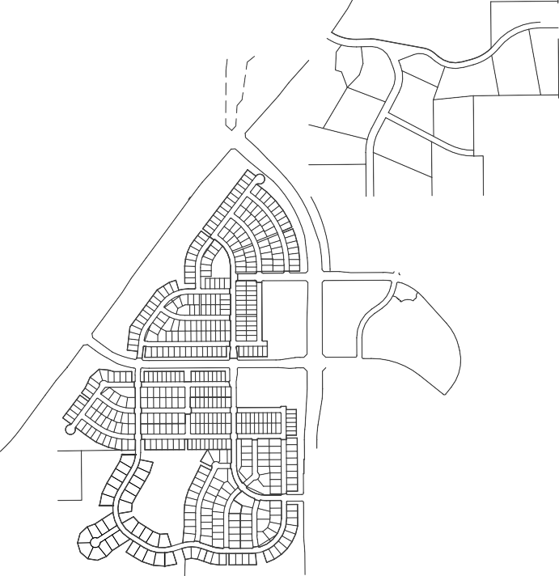
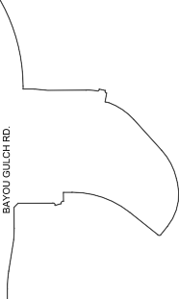
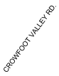
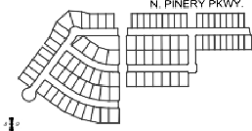
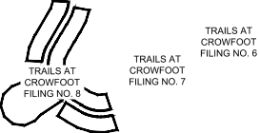
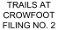
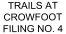
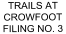
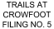

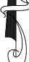
WILLIAM F. HESSELBACH, JR, PLS NO. 25369
FOR AND ON BEHAL F OF CVL CONSULTAN TS OF COLORADO, INC. 1 0333 E. DRY CREEK ROAD, SUITE 240
ENGLEWOOD, CO 80 11 2
( 720) - 2 49- 35 42

TRAILS AT CROWFOOT FILING N O. 8 FINAL PLAT J.N, 8130263701 PREP ARED: 09/20/2016 RE\/l SED: 06/ 06/ 20 18 SHEET 1 OF 5

ENGINEER/SURVEYOR
Consul tant s
-
of Colorado, Inc.
10333 E. Dry Creek Rd., Suite 240 Englewood, CO 80112
Tel: (720) 482-9526 / Fax: (720) 482-9546

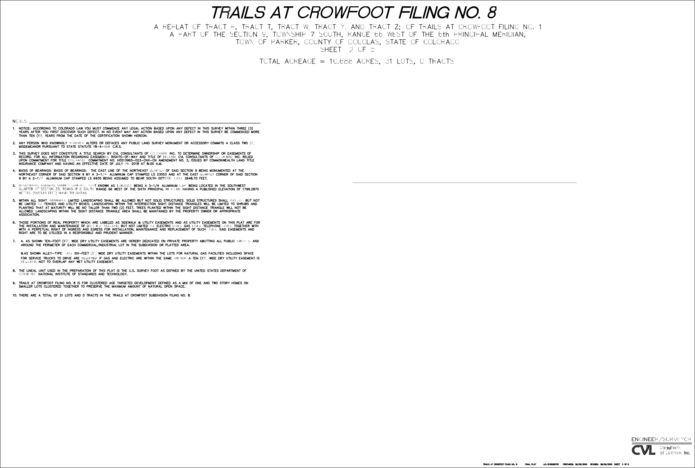

”
LAND USE SUMMARY CHART
TYPE | SQ. FT. | AREA | % OF TOTAL AREA
SINGLE FAMILY RESIDENTIAL LOTS | 443,733 S.F. | 10.187 AC. | 95.31%
ROAD RIGHTS OF WAY  TOTAL | 21,835 S.F.  465,568 S.F. | 0.501 AC.  10.688 AC. | 4.69%  100%

”

FILING 8 MIN, MAX, AND AVERAGE LOT SIZE
TYPE | SQ. FT. | AREA
MINIMUM LOT SIZE | 12,600 S.F. | 0.289 AC.
MAXIMUM LOT SIZE | 17,025 S.F. | 0.391 AC.
AVERAGE LOT SIZE | 14,314 S.F. | 0.328 AC.

10333 E. Dry Creek Rd., Suite 240 Englewood, CO 80112
Tel: (720) 482-9526 / Fax: (720) 482-9546

SW. COR. SEC. 4 FOUND 3-1/4" ALUMINUM
CAP "LS 6935"

TRAILS AT CROWFOOT FILING NO. 2

N. 1/4 COR. SEC. 9 FOUND 2-1/2" ALUMINUM CAP "LS 6935 1991"
RICHLAWN PKWY.

NE. 1/4 CORNER SEC. 9 FOUND 3-1/4" ALUMINUM CAP "LS 23053 1988"
CROWFOOT VALLEY RD.

TRAILS AT CROWFOOT FILING NO. 3
BAYOU GULCH RD.
S00 15'06"E 2648.70'
(BASIS OF BEARINGS)

N. PINERY PKWY.

GRAPHIC SCALE

TRAILS AT CROWFOOT FILING NO. 4

W. 1/4 COR. SEC. 9 FOUND 3-1/4" ALUMINUM CAP "LS 6935 1991"

TRAILS AT CROWFOOT
FILING NO. 5 TRAILS AT CROWFOOT FILING NO. 6
SHASTA DAISY ST

CEN. 1/4 COR. SEC. 9 FOUND 3-1/4" ALUMINUM
CAP "LS 6935"

E. 1/4 COR. SEC. 9 FOUND 3-1/4" ALUMINUM
CAP "LS 6935"
( IN FEET )
1 inch = 300 ft.

SHEET 4
ROSE MALLOW AVE

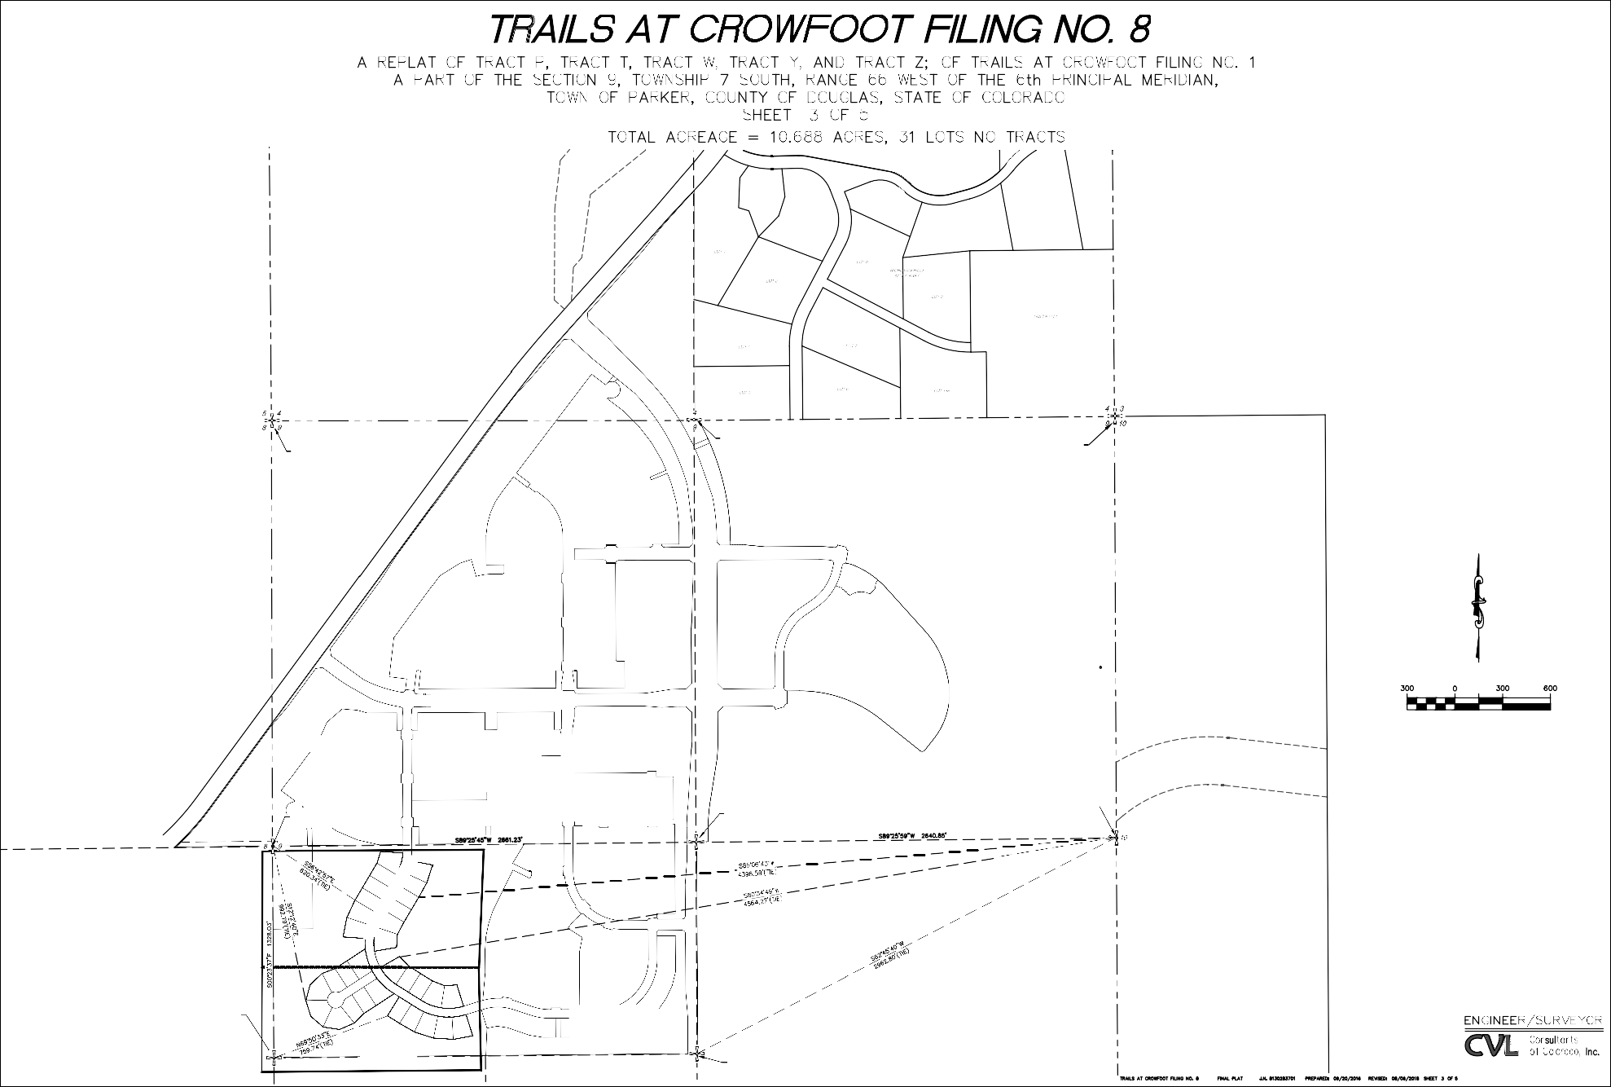
RICHLAWN DR.
RICHLAWN LN.
S. 1/16 COR. SEC. 9 FOUND 2-1/2" ALUMINUM CAP "LS 6935 1991"

SHEET
5
TRAILS AT CROWFOOT FILING NO. 7

CEN. S. 1/16 COR. SEC. 9 FOUND 2-1/2" ALUMINUM CAP "LS 6935 1991"

10333 E. Dry Creek Rd., Suite 240 Englewood, CO 80112
Tel: (720) 482-9526 / Fax: (720) 482-9546

CEN. 1/4 COR. SEC. 9 FOUND 3-1/4" ALUMINUM CAP "LS 6935"

1
W. 1/4 COR. SEC. 9 FOUND 3-1/4" ALUMINUM CAP "LS 6935 1991"
∆

1
∆

2

2
ROSE MALLOW AVE
3

3
ZONED - AGRICULTURAL ONE
4

4
55' R.O.W.
27.5'
27.5'

5
TOWN OF PARKER
DOUGLAS COUNTY

TRACT H TRAILS AT CROWFOOT
SUBDIVISION FILING NO. 1 (NOT PART OF PLAT)

TRACT F TRAILS AT CROWFOOT
SUBDIVISION FILING NO. 1 (NOT PART OF PLAT)
TRAILS AT CROWFOOT FIL. 1

5

6
∆
∆

6

S. 1/16 COR. BETWEEN SEC . 8 & SEC. 9 FOUND 2-1/2" ALUMINUM
CAP "LS 6935 1991" 7
MATCHLINE - SEE SHEET 5

GRAPHIC SCALE

( IN FEET )
1 inch = 50

ft.

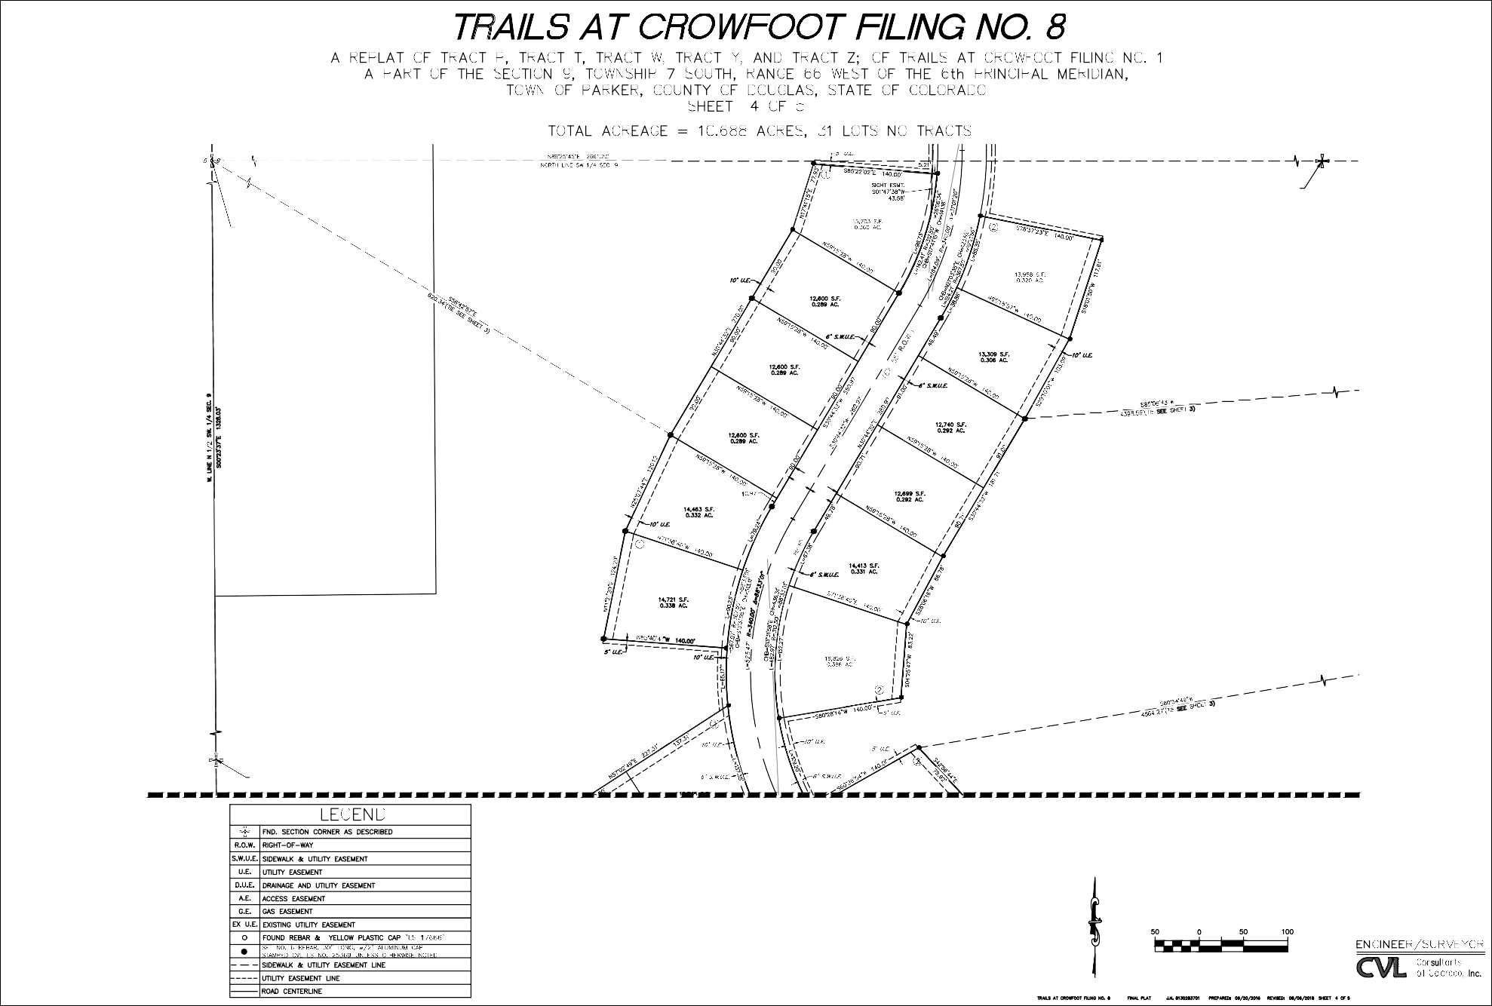
10333 E. Dry Creek Rd., Suite 240 Englewood, CO 80112
Tel: (720) 482-9526 / Fax: (720) 482-9546

MATCHLINE - SEE SHEET 4

6

10

6

11

7
S. 1/16 COR.
BETWEEN SEC . 8 & SEC. 9 FOUND 2-1/2" ALUMINUM
CAP "LS 6935 1991" 7

W. 1/4 COR. SEC. 9 FOUND 3-1/4" ALUMINUM CAP "LS 6935 1991"

12

7

TRAILS AT CROWFOOT
SHASTA DAISY TERR

55' R.O.W.
27.5' 27.5' 8

8 SUBDIVISION FILING NO. 7
(NOT PART OF PLAT)

8 13
TOWN OF PARKER
DOUGLAS COUNTY

9
∆
9
∆

9

10
55' R.O.W.
27.5'
14
ROSE MALLOW WAY
15

10 10
27.5'
11

14
ROSE MALLOW AVE

13
TRAILS AT CROWFOOT FIL. 1
∆
11 16

12 17

TRAILS AT CROWFOOT SUBDIVISION FILING NO. 7 (NOT PART OF PLAT)
∆
1 2
∆

3

18
20
19

TRACT H TRAILS AT CROWFOOT
SUBDIVISION FILING NO. 1 (NOT PART OF PLAT)

TRACT I TRAILS AT CROWFOOT
SUBDIVISION FILING NO. 1 (NOT PART OF PLAT)

S. 1/16 COR. BETWEEN SEC . 8 & SEC. 9 FOUND 2-1/2" ALUMINUM CAP "LS 6935 1991"

SW. 1/16 COR. SEC. 9
FOUND 2-1/2" ALUMINUM CAP LS "6935-1991"

CEN. S. 1/16 COR. SEC. 9 FOUND 2-1/2" ALUMINUM CAP "LS 6935 1991"

TOWN OF PARKER
DOUGLAS COUNTY

CURVE TABLE

GRAPHIC SCALE

( IN FEET )
1 inch = 50

ft.

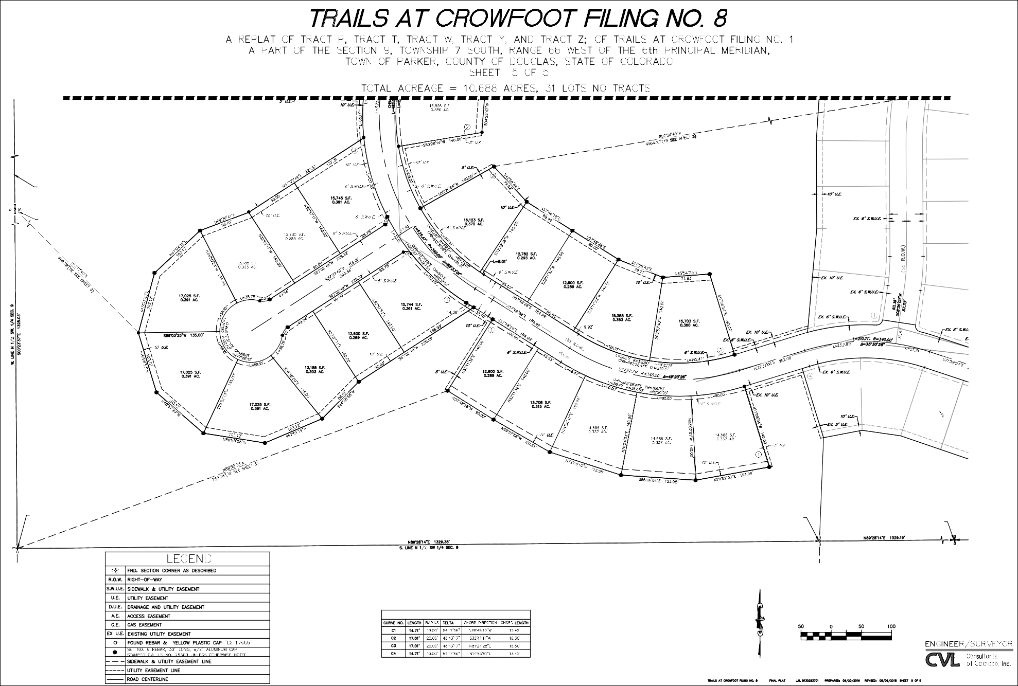
10333 E. Dry Creek Rd., Suite 240 Englewood, CO 80112
Tel: (720) 482-9526 / Fax: (720) 482-9546

EXHIBIT C



CVL Consultants of Colorado, Inc.
10333 E. Dry Creek Rd
Suite 240
Englewood, Colorado 80112
720.482.9526 Fax 720.482.9546

ROADWAY

ENGINEERS PUBLIC IMPROVEMENT COST ESTIMATE TRAILS AT CROWFOOT FILING 8
12/5/2017

No. | Description | Quantity | Unit | Cost/Unit | Total Cost
 | 6" VERTICAL CURB & GUTTER (2' PAN) | 0 | L.F. | $22.00 | $0.00
 | 6" VERTICAL CURB & GUTTER (1' PAN) | 0 | L.F. | $22.00 | $0.00
 | 4" MOUNTABLE CURB & GUTTER | 744 | L.F. | $24.00 | $17,856.00
 | HOT MIX ASPHALT PAVEMENT (5" DEPTH) | 1,502 | S.Y. | $23.50 | $35,298.65
 | CONCRETE PAVEMENT | 0 | S.Y. | $90.00 | $0.00
 | AGGRIGATE BASE COURSE | 406 | C.Y. | $40.50 | $16,447.53
 | SUBGRADE STABILIZATION | 406 | S.Y. | $2.10 | $852.84
 | ROADWAY SUBGRADE PREP (EXTEND 2' OUTSIDE CURB) | 406 | S.Y. | $1.25 | $507.64
 | 5' DETACHED CONCRETE SIDEWALK | 764 | L.F. | $27.00 | $20,628.00
 | SIDEWALK SUBGRADE PREP (MIN 1' OUTSIDE LIMITS) | 594 | S.Y. | $1.25 | $742.78
 | CORNER CURB RAMP (INCLUDES SUBGRADE PREP) | 0 | EA. | $2,200.00 | $0.00
 | MIDBLOCK CURB RAMP (INCLUDES SUBGRADE PREP) | 0 | EA. | $2,200.00 | $0.00
 | CROSS PAN (INCLUDES SUBGRADE PREP) | 0 | S.Y. | $103.50 | $0.00
 | TRENCH DRAIN | 0 | L.F. | $19.00 | $0.00
 | MEDIAN COVER | 0 | S.Y. | $90.00 | $0.00
 | ADJUST MANHOLE | 2 | EA. | $760.00 | $1,520.00
 | ADJUST WATER VALVE | 1 | EA. | $425.00 | $425.00
Total Cost $94,278.44
Total Cost | $0.00
PUBLIC IMPROVMENTS (TOWN) SUBTOTAL | $95,088.44
CONSTRUCTION CONTINGENCY (10%) | $9,508.84
MOBILIZATION (5%) | $4,754.42
SURVEYING (3%) | $2,852.65
CONSTRUCTION MANAGEMENT & TESTING (12%) | $11,410.61
PUBLIC IMPROVEMENT TOTAL | $123,614.97
SECURITY AT 110% = | $135,976.47

STRIPING
Item | Description | Quantity | Unit | Cost/Unit | Total Cost
 | LONG LINE EPOXY PVMT. MARKING | 0 | GAL | $105.00 | $0.00
 | CROSSWALK BAR | 0 | S.F. | $8.00 | $0.00
 | STOP BAR | 0 | S.F. | $0.93 | $0.00
 | ARROW | 0 | EA. | $120.00 | $0.00
Total Cost $0.00

SIGNAGE (INCLUDE POST AND ANCHOR)
Item | Description | Quantity | Unit | Cost/Unit | Total Cost
 | STREET NAME SIGN WITH STOP SIGN | 1 | EA. | $530.00 | $530.00
 | GROUND SIGN | 0 | EA. | $280.00 | $0.00
 | TYPE III BARRICADE | 0 | EA. | $2,500.00 | $0.00
 | SPECIAL SIGN | 1 | EA. | $280.00 | $280.00
Total Cost $810.00

DRAINAGE AND STORMWATER IMPROVMENTS
Item | Description | Quantity | Unit | Cost/Unit | Total Cost
 | 18" RCP | 0 | L.F. | $64.00 | $0.00
 | 24" RCP | 0 | L.F. | $83.00 | $0.00
 | 30" RCP | 0 | L.F. | $100.00 | $0.00
 | 36" RCP | 0 | L.F. | $136.00 | $0.00
 | 48" RCP | 0 | L.F. | $200.00 | $0.00
 | 30" FES WITH CONCRETE CUTOFF WALL | 0 | EA. | $2,400.00 | $0.00
 | 36" FES WITH CONCRETE CUTOFF WALL | 0 | EA. | $3,000.00 | $0.00
 | 48" FES WITH CONCRETE CUTOFF WALL | 0 | EA. | $3,400.00 | $0.00
 | 4' MANHOLE | 0 | EA. | $2,500.00 | $0.00
 | 5' MANHOLE | 0 | EA. | $3,070.00 | $0.00
 | 6' MANHOLE | 0 | EA. | $4,380.00 | $0.00
 | 5' TYPE R INLET | 0 | EA. | $9,000.00 | $0.00
 | 10' TYPE R INLET (SPECIFIC ON 10" INCREMENT) | 0 | EA. | $10,700.00 | $0.00
 | 15' TYPE R INLET | 0 | EA. | $11,000.00 | $0.00

EXHIBIT D

FORM – IRREVOCABLE LETTER OF CREDIT

Issuing Bank's Letterhead

Irrevocable Letter of Credit

Issuing Bank: [Type in bank name.] Issuance Date: [Type LOC issuance date.] Letter of Credit No.: [Type LOC number.] Expiry Date: [Type LOC expiration date.]
Amount: [Type in aggregate amount.] Name of Developer: [Type in name of developer.]

Town of Parker 20120 East Mainstreet
Parker, Colorado 80138

Attention: Mayor and Town Attorney Ladies and Gentlemen:
We hereby establish this Irrevocable Letter of Credit in your favor for an amount up to the aggregate sum of $ U.S. Dollars.

Funds under this credit are available to you by your draft or drafts drawn at sight on us containing the number of this Letter of Credit, as set forth above, in the Form of Sight Draft attached hereto as Exhibit 1 and incorporated by this reference. Partial drawings are permitted. The amount of the funds available under this Letter of Credit may not be reduced, except by payment of drafts drawn hereunder, or pursuant to written authorization given to us by the Town. The sole condition for payment of any draft under this Letter of Credit is that the draft be accompanied by a letter, on the Town's letterhead, signed by the Mayor or designee, stating that one or more of the following conditions exist:

- The Town has determined that the Developer is in default of its obligations under that certain [type in "agreement" or "permit"], to secure the performance of the [type in the name of the agreement, such as "Subdivision Improvements Agreement between the Town and Developer" and the name of the project, or "Development Agreement between the Town and Developer" and the name of the project] or [for permit, type in the name of the project];

or

- That the expiry date of this Irrevocable Letter of Credit is less than fourteen (14) days from the date of the Mayor or designee's letter and the Developer has not provided the Town with a replacement letter of credit in an amount and form acceptable to the Town to secure the performance of the [type in name of the agreement] or [for permit, type in the name of the project] described herein.

Drafts for payment by the Town, pursuant to this Letter of Credit, shall be deemed timely presented if, prior to the date of expiration of the Letter of Credit, the draft is deposited in the
U.S. mail or otherwise delivered for transmission by any other usual means of communication

with postage or cost of transmission prepaid and properly addressed to the above letterhead address.

We hereby agree with the Town that such drafts will be processed in good faith and duly honored, upon presentation to us, as provided herein. In case of wrongful dishonor, we agree to reimburse the Town for all court costs, investigative costs and reasonable attorneys fees the Town may incur in obtaining payment, according to the terms of this Letter of Credit. This Letter of Credit shall be governed by and construed in accordance with the laws of the State of Colorado. We further agree that the exclusive venue for any action concerning this Letter of Credit shall be the District Court for Douglas County, Colorado.

Very truly yours, [Name of Bank]

By: Signature of Authorized Signing Officer

Print Name

[Signature Must Be Notarized]

STATE OF COLORADO )
)ss.
COUNTY OF )

The foregoing instrument was acknowledged before me this day of , 200 , by , as of .
My commission expires: . SEAL
Notary Public

EXHIBIT 1

FORM OF SIGHT DRAFT

[Name of Issuing Bank] [Address of Issuing Bank]

Date:

At sight, pay to the order of Town of Parker

Dollars

($ ), for value received and charge to the account of [name of Developer].

Drawn under Letter of Credit No. , dated [type in letter of credit issuance date].

By:
, Mayor Town of Parker

EXHIBIT E

Trails at Crowfoot Filing 8-Landscape Cost Estimate Streetscape PCS Group
Opinion of Probable Cost Date: 7.31.2018
Filing 8-Streetscape Landscaping
Improvement | Quantity | Unit | Unit Cost | Total
Landscape Material
Deciduous Trees (2.5" cal) | 65 | EA | $ 560.00 | $ 36,400.00
2" Diam. Cobble Rock mulch (3" depth) | 3,441 | SF | $ 1.25 | $ 4,301.25
Landscape Boulders (2'-3') | 14 | EA | $ 400.00 | $ 5,600.00
EnviroTurf (w/prep) | 24,163 | SF | $ 1.00 | $ 24,163.00
Irrigation (Spray for native and turf areas) | 24,163 | SF | $ 0.90 | $ 21,746.70
Hardscape Material & Site Furnishings
Steel Edger | 65 | LF | $ 3.00 | $ 195.00
Mailbox kiosk (16 doors) | 2 | EA | $ 1,400.00 | $ 2,800.00
 |  |  | Sub-Total | $ 95,205.95
 |  |  | 15% Contigency | $ 14,280.89
 |  |  | Total | $ 109,486.84
 |  |  | 110% SIA Total | $ 120,435.53

*Temporary native seed for disturbed areas and detention areas are included in the Earthwork budget by civil engineer.

