

Town of Parker Community Development Department
Development Review Division
Attention: Stacey Nerger

Application Type: Replat
Status: First Referral
Application Name: Parker Auto Plaza F1 AMD 2
Case/AP#: SUB20-0025
Referral Received: September 25, 2020
Comments Due: October 23, 2020

Application Location: Generally located S of Pine Lane, E of Twenty Mile & W of Parker Road

Review date: September 30, 2020
Plan reviewer: Randall L. Capra, rcapra@parkeronline.org
Phone: 303.805.3169

Narrative: The applicant is proposing a re-plat of Parker and Pine F1 Tract A and Parker Auto Plaza F1 Tract C to create a single buildable lot. The site is located southeast of Twenty Mile Road and Pine Lane.

Code Reference: 2018 International Fire Code, 2018 International Building Code, 2017 NEC (until Dec 31, 2020)

TOWN OF PARKER FIRE/LIFE SAFETY:

1st Submittal – Reviewed September 30, 2020
2nd Submittal – (Comments in red, italicized font)
3rd Submittal – (Comments in bold, red, italicized font)

UNRESOLVED ISSUES/COMMENTS

- The applicant shall be aware that no vertical construction on this site will be allowed until such time that curb gutter and first lift of asphalt are installed; a site inspection will be required to ensure that this requirement is made prior to allowing vertical construction to commence.

- Per the requirements of [18 IFC Section 503.1.1 Buildings and Facilities] approved fire apparatus access roads shall be provided for every facility, building, portion of a building hereafter constructed or moved into or within the jurisdiction. The fire apparatus access road shall comply with the requirements of this section and shall extend to within 150 feet of all portions of the facility and all portions of the exterior walls of the first story of the building as measured by an approved route around the exterior of the building or facility (the building is a 155+ feet long and 50.56 feet wide and cannot meet the requirement as measured from the center line of the fire apparatus as measured by an approved route from any point that a fire engine might park when responding to a call at this building). This submittal does not provide for this requirement of the code. Per the requirements of the code, the fire code official is allowed to increase the dimension of the 150 feet provided that the applicant meets Exception 1.1 of this section… “The building is equipped throughout with an approved automatic sprinkler suppression system installed in accordance with section 903.1.1, 903.1.2, or 903.3.1.3.

- The applicant shall be aware that the access road hydrant distribution was not planned to address the suppression needs for all commercial properties within this subdivision; this site requires the addition of hydrants beyond what is being proposed by the applicant. Hydrant locations shall comply with the 2018 edition of NFPA 24 Section 7.2.3 and the 2018 edition of the IFC. This issue will be addressed more fully in item #4, below:

- The location of the riser room for all three of the four proposed buildings is not acceptable; the applicant was provided with guidelines in as to approved locations in our pre-application meetings and as such, will be required to revisit the submittal. Bldg 1 riser room location is not acceptable by the main entry and Bldg2 and Bldg 3 are not allowed to have the riser room located on a roadway… even if the access is a private road. Additionally, the applicant will need to identify the location of the fire sprinkler control valve room (more clearly showing its location), provide additional fire hydrants, and ensure the following:

- Exterior access is required into the riser room with access in the building provided either adjacent to the riser room or through the riser room. Access into the fire riser room shall not be through the volley ball court.
- The FACP will be required to be located in the fire sprinkler control valve room; ensure that the riser room is sized to accommodate the FACP and the riser. A three-foot clearance is required in front of the FACP as well as the sprinkler riser.
- The underground shall enter the building and turn up no further than 24 inches from foundation wall.
- The FACP shall be located on an interior wall.

Lot 1 – Bldg 1 & Lot 1 – Bldg 2:

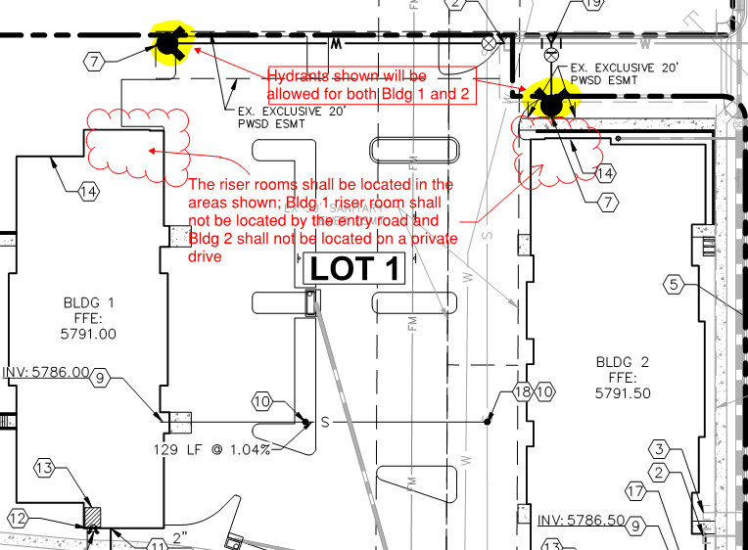

Lot 2 – Bldg 3:

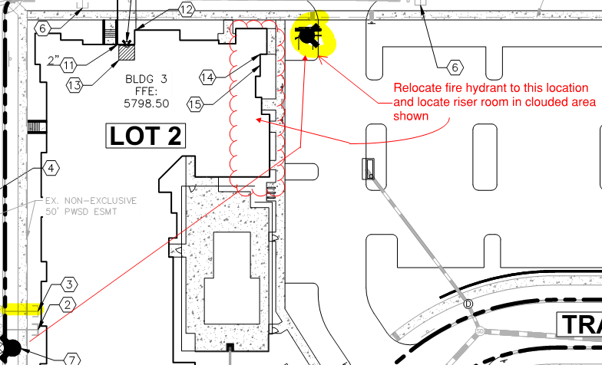

Lot 3 – Bldg 4:

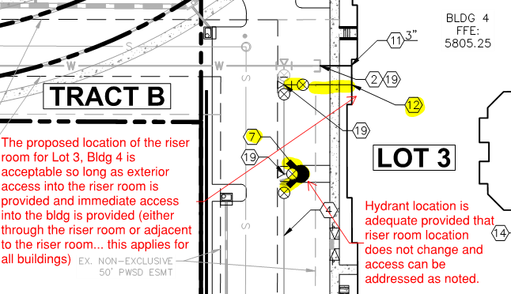

- The applicant shall label each of the underground fire lines (not under just the keynotes) as well as providing the length of the UFL (as measured from the “T’’ at the water main to the flange within the building. Note – the UFL shall not enter the building any further than 24” before turning up.

- The access drives on Lot 3 and Lot 4 shall be 26 feet wide (if not already addressed should the height of these buildings be 30 feet or taller) as required per [18 IFC Appendix D]; address this issue when resubmitting.

- The applicant has provided an access road that exceeds 150’ on the east side of Lot 3, Bldg 4; this access, as measured from the center line of the access perpendicular to this drive, is approximately 205 feet long. The applicant shall revisit the drive and configure the site to ensure that a dead end is not created that exceeds 150 feet, as required per [18 IFC 503.2.5]. Address this issue when resubmitting.

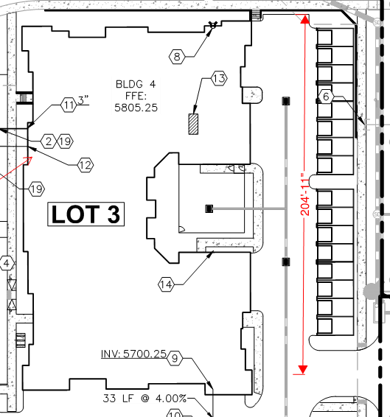

- The applicant shall provide an auto turn analysis indicating that apparatus can navigate all portions of this site (both sides of the gas canopy); NO PARKING – FIRE LANE signage is required for any portion of the access where the 20-foot clear width requirement cannot be met.

- The Town of Parker requires that fire apparatus access roads meet the clear-width and weight-bearing standards of the jurisdiction in which the project is located. Roadways shall be designed to support the imposed weight of fire apparatus, 30 two axle and 40 ton three axle vehicles. An unimpeded clear width of 20 feet shall be maintained at all times. As such, any location where parked vehicles would obstruct this clear width requirement will require “NO PARKING – FIRE LANE” signage. This signage shall be red on white. Update design criteria has been provided at the end of this document; ensure compliance when resubmitting.

- The applicant has used the incorrect signature block for Fire Life Safety on the utility plan set; ensure that the correct FIRE LIFE SAFETY review block is used; the utility cover page and the overall utility plan are required to have this block. A copy of this stamp can be found later on in this document; address this issue when resubmitting.

- The applicant has provided a fire code signature block on the cover of the construction documents; the applicant shall remove this signature block (and any other pages that might have the fire signature block other than the utility pages noted).

GENERAL COMMENTS (as applicable)
All engineering documents submitted to the Town of Parker shall bear the wet signature and seal of the engineer or architect in responsible charge of the design.

Water distribution and site access components shall be installed and in service prior to the construction of any portion of the structure, except by special permit issued by the Fire District.

Underground fire lines
When thrust blocks are used as part of the pipe restraint system, submitted plans for permit shall provide detailed documentation that the thrust blocks satisfy all requirements of 13 NFPA 24: 10.8.2, including specific thrust block dimensions and mathematical calculations for block dimensions per guidelines provided in Annex A.10.8.2.

Underground Fire Line - Submittal Requirements

Reference: 2013 NFPA 24 Installation of Private Fire Service Mains and Their Appurtenances

A separate permit is required and will be issued pending review of a detailed submittal which must include the following: [15 IFC 901.2]

4.1.1 Working plans shall be submitted for approval to the authority having jurisdiction before any equipment is installed or replaced.

4.1.2 Deviation from approved plans shall require permission of the authority having jurisdiction.

4.1.3 Working plans shall be drawn to an indicated scale on sheets of uniform size, with a plan of each floor as
applicable, and shall include the following items that pertain to the design of the system:

(1) Name of owner
(2) Location, including street address
(3) Point of compass
(4) A graphic representation of the scale used on all plans
(5) Name and address of contractor
(6) Size and location of all water supplies
(7) The following items that pertain to private fire service mains:
(a) Size
(b) Length
(c) Location
(d) Material (ductile-iron, PVC., etc.)
(e) Point of connection to city main
(f) Sizes, types, and locations of valves, depth at which the top of the pipe is laid below grade
(g) Method of restraint (Meg-a-Lug or similar)

4.1.4 The working plan submittal shall include the manufacturer's installation instructions for any specially listed equipment, including descriptions, applications, and limitations for any devices, piping, or fittings. Submittals must include installation specifications for thrust blocks, corrosion protection, restraint system, bedding, detail of pipe under the building up to, and including, the flange. When it is intended that a different contractor will extend the fire line from a stopping point outside the building, to the inside flange, a second submittal and permit is required.

All tees, plugs, reducers, valves, and hydrant branches shall be restrained against movement by thrust blocks [10.8.2] or restrained joint systems [10.8.3]. When thrust blocks are used as part of the pipe restraint system, submitted plans shall provide detailed documentation that the thrust blocks satisfy all requirements of Section 10.8.2, including specific thrust block dimensions and mathematical calculations for block dimensions per guidelines provided in Annex A.10.8.2.

Any individual or company who physically works on or installs any part of a fire suppression system, including underground supply lines, from public water lines to system risers and backflow preventers, must be registered with the Colorado Division of Fire Safety. [Dept of Public Safety, Division of Fire Safety, Fire Suppression Program 8 CCR 1507-11:3.1.2] Documentation of valid annual registration may be required with plan submittal.

The following website for the Colorado Division of Fire Safety will provide registration instructions.
http://dfs.state.co.us/SuppAppsProcInsp.htm

All submittals must display a wet stamp and original signature by a Colorado licensed professional engineer or NICET III, or higher, in fire suppression systems. [Dept. of Public Safety, Division of Fire Safety, Fire Suppression Program 8 CCR 1507

FIRE ACCESS ROAD DESIGN CRITERIA

VEHICLE SPECIFICATIONS are provided for the largest apparatus in use by South Metro Fire Rescue. Fire Apparatus Access Roads shall be capable of accommodating this apparatus.

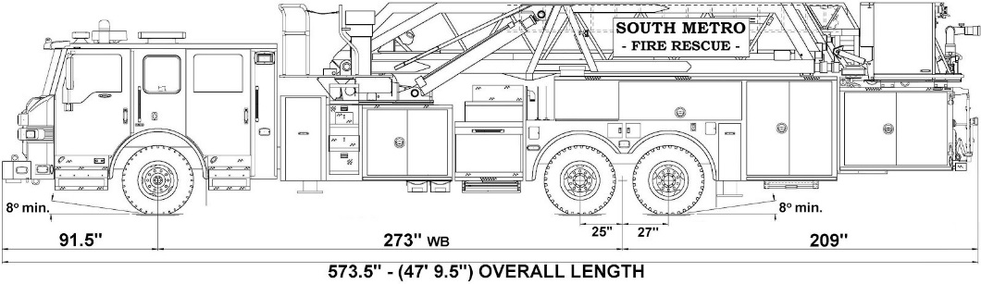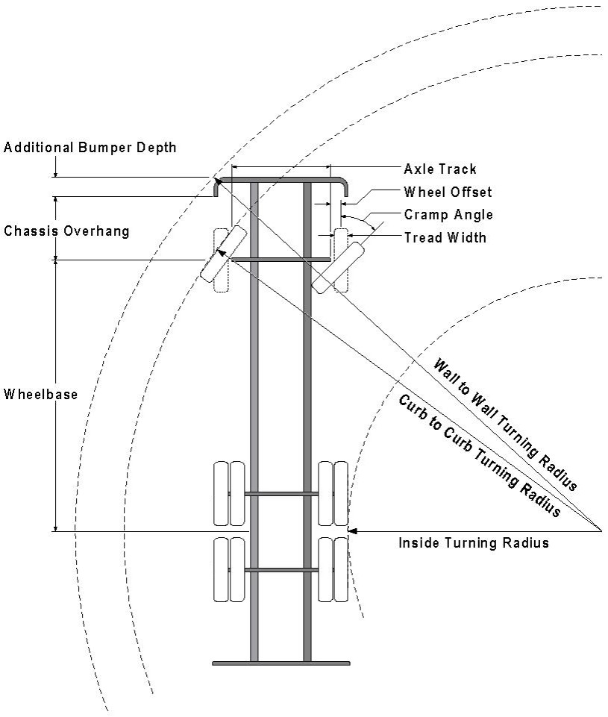

Vehicle Specifications
Length: 47’ 9.5”
Width: 8’ 5” - (10’ 1” mirror to mirror)
Height: 10’ 9”
Wheelbase: 273 in.
Design load: 80,000 pounds Inside Cramp Angle: 40° Axle Track: 83”
Wheel Offset: 5.3”
Tread Width: 13.5”

Turning Radii:
Inside Turn: 26 ft. 1 in. Curb to curb: 41 ft. 11 in. Wall to wall: 46 ft. 8 in.

Where objects are present adjacent to the fire apparatus access road, particularly on turns and turn arounds which require backing, a reasonable safety margin shall be provided to prevent potential damage to the property and to the fire apparatus.

PRIVATE ROADS that provide access to more than two dwellings or one or more commercial buildings shall be constructed to meet the roadway standards approved by the South Metro Fire Rescue Authority for fire apparatus access. Private roads that do not meet the roadway standard may be accepted provided that alternative methods and materials are incorporated into the subdivision that addresses the fire and life safety of the citizens.

FIRE CODE REVIEW BLOCK
All fire hydrants shall be installed according to water utility standards. The number and locations of the fire hydrants as shown on the Overall Utility Plan are correct as specified by the Town of Parker, Community Development Department.

Fire Code Official or Designated Representative Date

(NOTE – Underground Fire Line (UFL) submittal documents must meet the requirements of NFPA 24 when submitting for review.)

