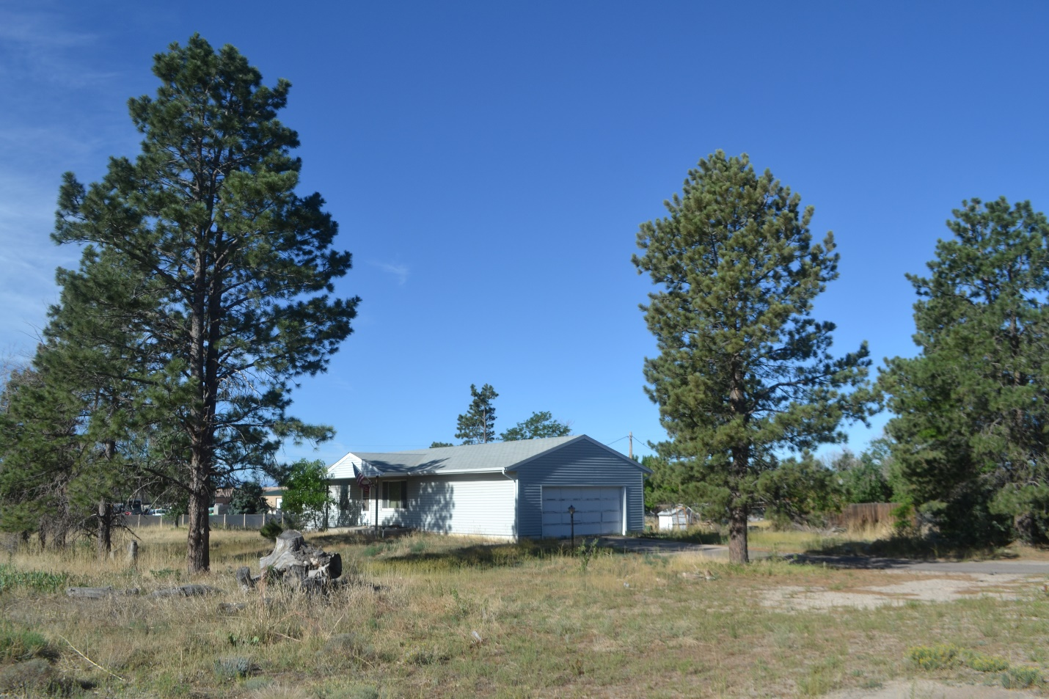
11964 Dransfeldt Road
Tree Survey and Assessment
Prepared for:
Ryanne Sass, Vice President of Pre-Development
Plaza Street Partners
2400 W. 75 Street, Suite 220
Prairie Village, KS 66208
Prepared by:
Scott Grimes, ISA Certified Arborist
ASCA Consulting Arborist
Colorado Tree Consultants
1600 S. Carr Street
Lakewood, CO 80232
July 6, 2022

Colorado Tree Consultants
1600 South Carr Street, Lakewood, Colorado 303-720-8170

July 06, 2022

Ryanne Sass, Vice President of Pre-Development
Plaza Street Partners
2400 W.75th Street, Suite 220
Prairie Village, KS 66208

RE: Tree Survey and Assessment: 11964 Dransfeldt Road

Dear M. Ryanne Sass:

Thank you for the opportunity to provide an assessment of the trees at the development site at 11964 Dransfeldt Road in Parker, Colorado. On July 05, 2022, I inventoried the size, species and condition and confirmed or marked the approximate location of 64 trees on an aerial image of the site. I appraised the trees using the trunk formula method developed by the Council of Tree and Landscape Appraisers Guide for Plant Appraisal 9th Edition and supplemented with regional information from the Species Rating and Appraisal Factors Guide, 2011, published by the Rocky Mountain Chapter of the International Society of Arboriculture (ISARMC). I also identified and estimated the square footage of three shrub thickets which are included in the tree and shrub conservation and replacement requirements found in Section 13.10.110 of the Parker development code. Replacement costs for the shrub thickets were calculated using average wholesale prices for # 5 container plants at five foot on center spacing. Estimating tree and shrub value is subjective: I can discuss and support my ratings for species, condition and location with Town of Parker representatives as needed.

The trunk formula method is used to appraise the monetary value of trees considered too large to replace with nursery grown or field dug trees. The basic value of a tree is based on the installed cost of the largest commonly available transplantable tree plus the increase in value due to the larger size of the tree being appraised. This value is then depreciated based on the species, condition and location of the appraised trees. Species rating is from the ISARMC guide, location is based on a combination of the site, the placement of the trees on the site and the contribution the trees make to the site benefits accrued. My condition ratings range from Dead (0 – 10%), Poor (11% - 35%), Fair (36% - 65%), Good (66% - 89%) and Excellent (90% - 100%) and consider the structure and health of the roots, trunk, scaffold branches, secondary branches and twigs and the foliage and buds.

Colorado Tree Consultants 1600 South Carr Street, Lakewood, Colorado 303-720-8170
RE: Tree Survey and Assessment: 11964 Dransfeldt Road Page 2.

Twenty-seven trees rated in Good condition, ten of which are potential candidates for Preserving and Protecting (Trees # 2, 3, 4, 5, 8, 9, 10, 12, 13, and 14). One nice pinion pine (Tree # 26) is a good candidate for transplanting/re-locating on site. Four tallied trees are dead and at least 10 other trees are dead but were not assessed. The estimated value of all trees assessed totals just over $ 180,350 primarily due to the large size of the older cottonwoods and pine trees.

I have attached the tree assessment spreadsheet that indicates the size, species and condition of each stem assessed and the estimated value. Also attached is the sketch showing the approximate locations of the 61 trees and three shrub thickets inventoried. If you choose to preserve and protect the ten trees along the drive, a tree protection plan and fencing is likely required. Successfully transplanting the pinion pine is best done with a mechanical tree spade capable of digging and transporting a 50” minimum diameter root ball.

If you need additional information, including tree preservation and protection plans or transplanting and after care specifications feel free to contact me. Thank you for allowing Colorado Tree Consultants to assist with your project.

Sincerely,

Scott Grimes
ISA Certified Arborist
ISA Tree Risk Assessment Qualified
ASCA Consulting Arborist

Assumptions and Limiting Conditions
- Any legal description provided to the consultant/appraiser is assumed correct. Any titles and ownerships to any property are assumed good and marketable.
- Care was taken to obtain all information from reliable sources. All data was verified insofar as possible; however the consultant/appraiser can neither guarantee nor be responsible for the accuracy of information provided by others.
- The consultant/appraiser shall not be required to give testimony or attend court by reason of this report unless subsequent contractual arrangements are made, including payment of an additional fee for such services as described and agreed to in a new fee schedule and contract of engagement.
- Loss or alteration of any part of this report invalidates the entire report.
- Possession of this report or a copy thereof does not imply right of publication or use for any purpose by any other person than the person to whom it is addressed, without the prior, written consent of the consultant/appraiser.
- This report and values expressed herein represent the opinion of the consultant/appraiser, and the consultant’s/appraiser’s fee is in no way contingent upon the reporting of a specified value, a stipulated result, the occurrence of a subsequent event, nor upon any finding to be reported.
- Sketches, diagrams, graphs, and photographs in this report, being intended as visual aids, are not necessarily to scale and should not be construed as engineering or architectural reports or surveys.
- Unless otherwise expressed: 1) information contained in this report covers only those items that were examined and reflects the condition of those items at the time of inspection; and 2) the inspection is limited to visual inspection of accessible items without dissection, excavation, probing, or coring. There is no warranty or guarantee, expressed or implied, that problems or deficiencies of the trees or property in question may not arise in the future.

Certification of Performance
I, Scott Grimes, certify that:
- I personally inspected the trees and the property referred to in this report and have stated my findings accurately.
- I have no current or prospective interest in the vegetation or the property that is the subject of the report and have no personal interest or bias with respect to the parties involved.
- The analysis, opinions, and conclusions were developed and this report prepared according to commonly accepted arboricultural practices.
- No one provided significant professional assistance to me, except as indicated in the report.
- My compensation is not contingent upon the reporting of a predetermined conclusion that favors the cause of the client or any other party or upon the results of the assessment, the attainment of stipulated results, or the occurrence of any subsequent events.
I further certify I am a member in good standing of the American Society of Consulting Arborists and I am an International Society of Arboriculture Certified Arborist and Qualified Tree Risk Assessor. I have practiced arboriculture and the care and study of trees for over 35 years.
Scott Grimes
July 06, 2022

Colorado Tree Consultants 1600 South Carr Street, Lakewood, Colorado 303-720-8170

