

Town of Parker Community Development Department
Development Review Division
Attention: Stacey Nerger

Application Type: Minor Development Plat
Status: First Referral
Application Name: Lincoln Professional Park Filing No. 1 MDP
Case/AP#: SUB20-002
Referral Received: September 22, 2021
Comments Due: October 20, 2021

Application Location: Generally located at the southeast corner of Dransfeldt Road and Lincoln Avenue

Review date: October 14, 2021
Plan reviewer: Randall L. Capra, rcapra@parkeronline.org
Phone: 303.805.3163

Narrative: The applicant, Harris Kocher Smith, is proposing a Minor Development Plat to create 3 commercial lots and 4 tracts. The site is located at the southeast corner of Lincoln Avenue and Dransfeldt Road.

Code Reference: 2018 International Fire Code, 2018 International Building Code, and 2017 NEC (valid through 12/31/21)

TOWN OF PARKER | FIRE/LIFE SAFETY DIVISION:

1st Submittal – Reviewed October 14, 2021
2nd Submittal – Review December 3, 2021 (comments in red, italicized font)

UNRESOLVED ISSUES/COMMENTS

See below the following and address all comments as required (a written response is also required):

- The applicant shall be aware that the Town of Parker has officially adopted the 2018 ICC codes as of January 1, 2019; all submittal documents are required to comply with the 2018 ICC codes. Note – The Town of Parker will have officially adopted the 2021 ICC family on January 1, 2022; the 2020 NEC will be adopted at this time, as well. Any submittals received after December 31, 2021 will be required to meet the newly adopted codes. Satisfied; the applicant has noted/acknowledged/address with second submittal.

- The applicant shall be aware that no vertical construction on this site will be allowed until such time that curb gutter and first lift of asphalt are installed; a site inspection will be required to ensure that this requirement is made prior to allowing vertical construction to commence. Satisfied; the applicant has noted/acknowledged/address with second submittal.

- The applicant shall be aware that the access road hydrant distribution was not planned to address the suppression needs for all commercial properties within this subdivision; this site requires the addition of one hydrant (to be located at the s/w corner island of the building… as required per NFPA 24 Section 7.2.3… more information on this will be provided further down in this document. Satisfied; the applicant has noted/acknowledged/address with second submittal.

- Per the requirements of [18 IFC Section 503.1.1 Buildings and Facilities] approved fire apparatus access roads shall be provided for every facility, building, portion of a building hereafter constructed or moved into or within the jurisdiction. The fire apparatus access road shall comply with the requirements of this section and shall extend to within 150 feet of all portions of the facility and all portions of the exterior walls of the first story of the building as measured by an approved route around the exterior of the building or facility (i.e. a building is a 120 feet long and 45 feet wide and cannot meet the requirement as measured from the center line of the fire apparatus as measured by an approved route from any point that a fire engine might park when responding to a call at this building). Satisfied; the applicant has noted/acknowledged/address with second submittal.

- The applicant shall provide an auto turn analysis indicating that apparatus can navigate all portions of this site; NO PARKING – FIRE LANE signage is required for any portion of the access where the 20-foot clear width requirement cannot be met. Address this issue when resubmitting. Note - Information on South Metro Fire Rescue Apparatus has been provided at the end of this document. Satisfied; the applicant has noted/acknowledged/address with second submittal.

- The Town of Parker requires that fire apparatus access roads meet the clear-width and weight-bearing standards of the jurisdiction in which the project is located. Roadways shall be designed to support the imposed weight of fire apparatus, 30-ton, two-axle and 40-ton, three-axle vehicles. An unimpeded clear width of 24-feet shall be maintained at all times. As such, any location where parked vehicles would obstruct this clear width requirement will require “NO PARKING – FIRE LANE” signage. This signage shall be red on white. Update design criteria has been provided at the end of this document; ensure compliance when resubmitting. Satisfied; the applicant has noted/acknowledged/address with second submittal.

- Reference Information: The applicant has not provided information as to the height of the proposed buildings; a minimum 26-foot-wide aerial fire lane is required through the site when a building is 30 feet tall (See appendix D of the 2018 IFC). Address this issue when resubmitting. When considering the site development, this information is critical to ensure that the design of infrastructure works for any proposed structures. Satisfied; the applicant has noted/acknowledged/address with second submittal. Note – Access road configuration maybe required to be modified should buildings exceed 30’ in height.

- Sheet 3 Overall Utility: The overall utility drawings are incomplete; the plan set does not address fire hydrant locations for the spine roads proposed. The applicant shall address this issue and fire hydrants will be required in the following locations while noting that additional hydrants will be required on the internal lots depending upon access and use (the gas station will be required to be sprinklered as will Lot 3… as currently shown): Partially satisfied; the applicant has noted/acknowledged/address with second submittal and has provided all fire hydrants. See location of hydrant beneath yellow highlighted notation below:

- The entry off of Dransfeldt Road on to Road A
- The entry off of Lincoln Ave and the current Private Drive
- Road A (required extension) into Lot 1 Filing No.2 Peaslee Subdivision at Road A and Lot 1

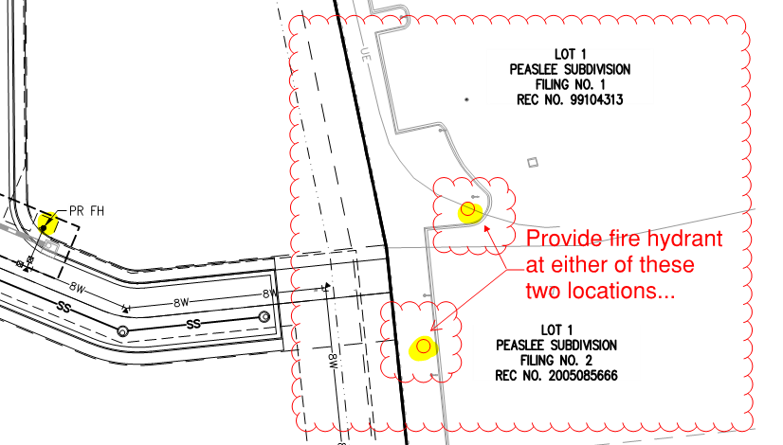

- At the corner of Road B and the Private Drive
- At the corner of Road A and Road B
- At the entry of the gas station off or Road A

See below for locations required:

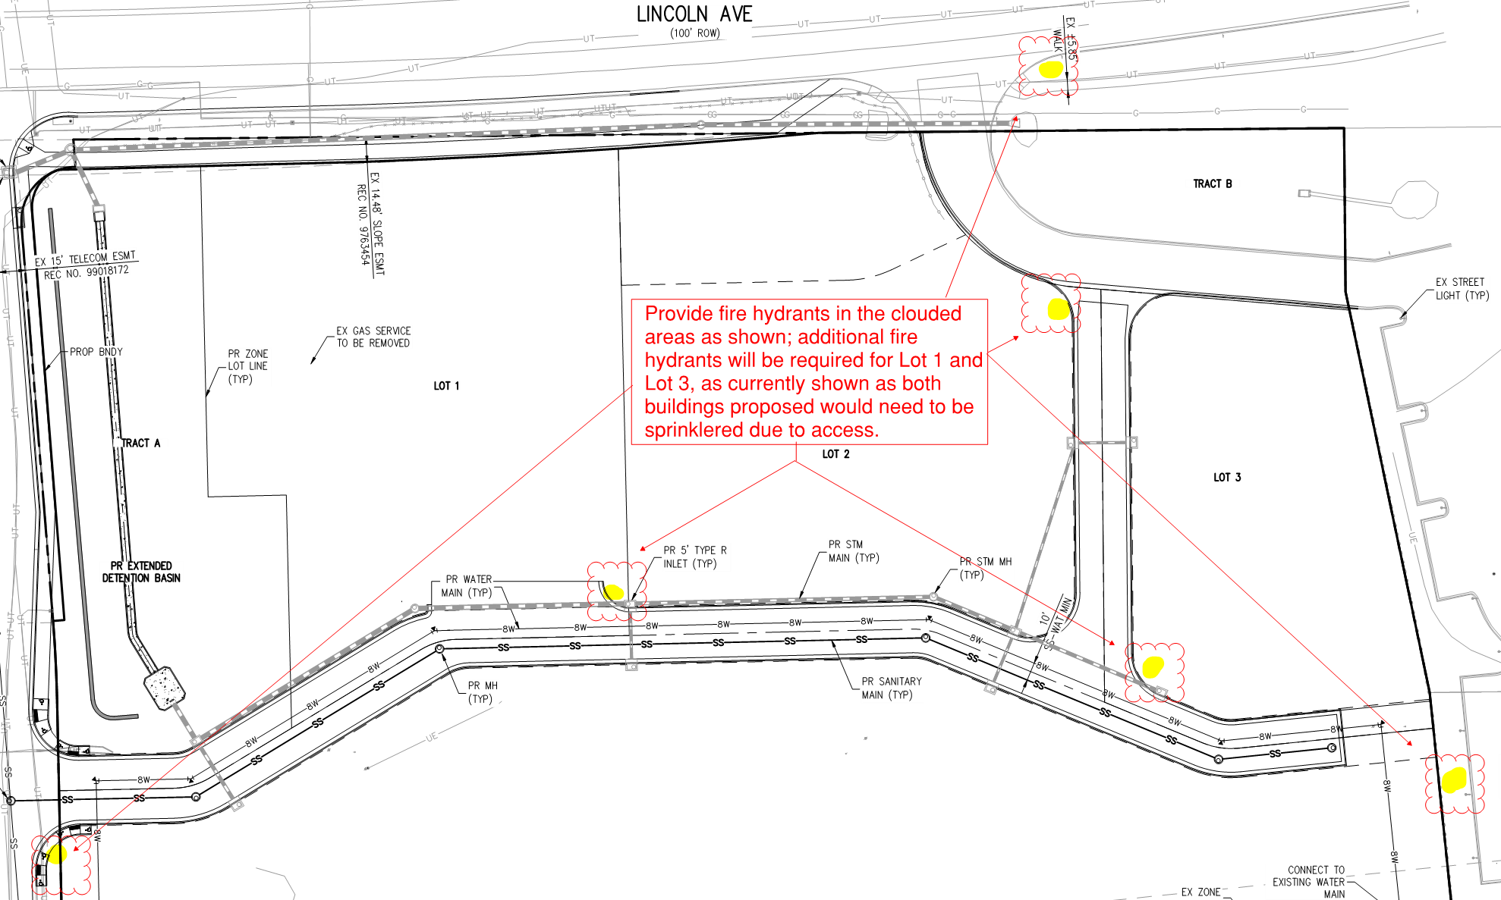

- The applicant shall be aware that additional fire hydrants (on each individual lot) will be required based upon access, occupancy type, etc. (and certainly based upon what was shown on the submittal documents). This requirement (complying with NFPA 24, section 7.2.3) will be evaluated for each individual lot as applications are submitted though it would be advisable for the applicant to plan accordingly so that cuts into new infrastructure can be avoided.

As noted above, the buildings on Lot 1 and Lot 3 (in the configuration shown) will be required to be sprinklered due to the inability to provide access to all portions of the building (as measured by an approved route by the “fire code official”. Per [18 IFC 503.1.1 Buildings and Facilities], the code does allow the distance to be increased when the building is fully sprinklered. This issue shall be addressed when resubmitting. NOTE - The location of the riser rooms must be approved; the required fire hydrants for each of the condominium buildings. Satisfied; the applicant has noted/acknowledged/address with second submittal.

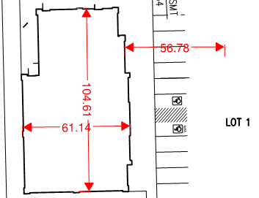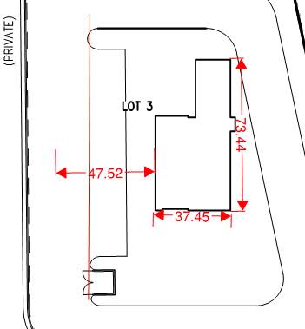

- The applicant is proposing 3 lots within this commercial area with what appears to be a 4th lot on the south side of Road A. Depending on how this area is developed, additional fire hydrants will be required for this area. Satisfied; the applicant has noted/acknowledged/address with second submittal.

- The applicant has not provided the required Fire Life Safety signature blocks on the utility drawings; the Fire Life Safety signature block, provided later in this document, shall be provided on the both utility cover sheet and on the overall utility plan. Satisfied; the applicant has noted/acknowledged/address with second submittal.

- Reference Information: For any area within the proposed development, based upon the requirements of [18 IFC 503.2.5 Dead-Ends], dead-ends are not allowed to exceed 150 feet without provide an approved turn around. This measurement shall be taken at the end of the access road and shall terminate at the access perpendicular to that access road. Satisfied; the applicant has noted/acknowledged/address with second submittal.

- Reference Information: With regard to the fire sprinkler control valve room, this room shall be sized to accommodate the following: Satisfied; the applicant has noted/acknowledged/address with second submittal.

- Exterior access is required into the riser room with access into the building provided either adjacent to the riser room or through the riser room.
- The FACP will be required to be located in the fire sprinkler control valve room; ensure that the riser room is sized to accommodate the FACP and the riser. A three-foot clearance is required in front of the FACP as well as the sprinkler riser (as well as the three foot 18” to center or FACP/riser... each side.
- The underground fire line shall enter the building and turn up no further than 24 inches from foundation wall; three feet of clearance is required in front of the fire riser.
- The FACP shall be located on an interior wall.
- A 5’x5’ pad is required in front of the FDC.
- A sidewalk is required to both the FDC location and the riser room

The riser room layout shall be provided in advance to assure that all requirements are met.

GENERAL COMMENTS (as applicable)
All engineering documents submitted to the Town of Parker shall bear the wet signature and seal of the engineer or architect in responsible charge of the design.

Water distribution and site access components shall be installed and in service prior to the construction of any portion of the structure, except by special permit issued by the Fire District.

Underground fire lines
When thrust blocks are used as part of the pipe restraint system, submitted plans for permit shall provide detailed documentation that the thrust blocks satisfy all requirements of 16 NFPA 24: 10.8.2, including specific thrust block dimensions and mathematical calculations for block dimensions per guidelines provided in Annex A.10.8.2.

FIRE ACCESS ROAD DESIGN CRITERIA

VEHICLE SPECIFICATIONS are provided for the largest apparatus in use by South Metro Fire Rescue. Fire Apparatus Access Roads shall be capable of accommodating this apparatus.

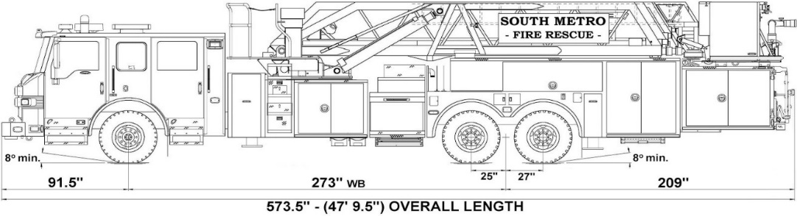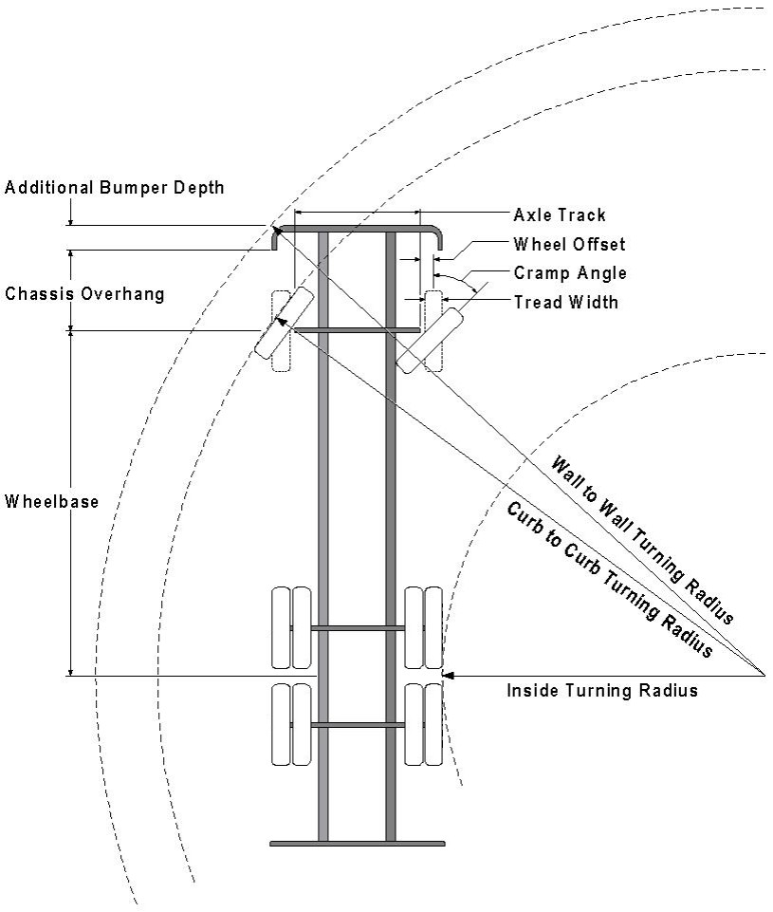

Vehicle Specifications
Length: 47’ 9.5”
Width: 8’ 5” - (10’ 1” mirror to mirror)
Height: 10’ 9”
Wheelbase: 273 in.
Design load: 80,000 pounds Inside Cramp Angle: 40° Axle Track: 83”
Wheel Offset: 5.3”
Tread Width: 13.5”

Turning Radii:
Inside Turn: 26 ft. 1 in. Curb to curb: 41 ft. 11 in. Wall to wall: 46 ft. 8 in.

Where objects are present adjacent to the fire apparatus access road, particularly on turns and turn arounds which require backing, a reasonable safety margin shall be provided to prevent potential damage to the property and to the fire apparatus.

PRIVATE ROADS that provide access to more than two dwellings or one or more commercial buildings shall be constructed to meet the roadway standards approved by the South Metro Fire Rescue Authority for fire apparatus access. Private roads that do not meet the roadway standard may be accepted provided that alternative methods and materials are incorporated into the subdivision that addresses the fire and life safety of the citizens.

Underground Fire Line - Submittal Requirements

Reference: 2016 NFPA 24 Installation of Private Fire Service Mains and Their Appurtenances

A separate permit is required and will be issued pending review of a detailed submittal which must include the following: [15 IFC 901.2]

4.1.1 Working plans shall be submitted for approval to the authority having jurisdiction before any equipment is installed or replaced.

4.1.2 Deviation from approved plans shall require permission of the authority having jurisdiction.

4.1.3 Working plans shall be drawn to an indicated scale on sheets of uniform size, with a plan of each floor as
applicable, and shall include the following items that pertain to the design of the system:

(1) Name of owner
(2) Location, including street address
(3) Point of compass
(4) A graphic representation of the scale used on all plans
(5) Name and address of contractor
(6) Size and location of all water supplies
(7) The following items that pertain to private fire service mains:
(a) Size
(b) Length
(c) Location
(d) Material (ductile-iron, PVC., etc.)
(e) Point of connection to city main
(f) Sizes, types, and locations of valves, depth at which the top of the pipe is laid below grade
(g) Method of restraint (Meg-a-Lug or similar)

4.1.4 The working plan submittal shall include the manufacturer's installation instructions for any specially listed equipment, including descriptions, applications, and limitations for any devices, piping, or fittings. Submittals must include installation specifications for thrust blocks, corrosion protection, restraint system, bedding, detail of pipe under the building up to, and including, the flange. When it is intended that a different contractor will extend the fire line from a stopping point outside the building, to the inside flange, a second submittal and permit is required.

All tees, plugs, reducers, valves, and hydrant branches shall be restrained against movement by thrust blocks [10.8.2] or restrained joint systems [10.8.3]. When thrust blocks are used as part of the pipe restraint system, submitted plans shall provide detailed documentation that the thrust blocks satisfy all requirements of Section 10.8.2, including specific thrust block dimensions and mathematical calculations for block dimensions per guidelines provided in Annex A.10.8.2.

Any individual or company who physically works on or installs any part of a fire suppression system, including underground supply lines, from public water lines to system risers and backflow preventers, must be registered with the Colorado Division of Fire Safety. [Dept. of Public Safety, Division of Fire Safety, Fire Suppression Program 8 CCR 1507-11:3.1.2] Documentation of valid annual registration may be required with plan submittal.

The following website for the Colorado Division of Fire Safety will provide registration instructions.
http://dfs.state.co.us/SuppAppsProcInsp.htm
All submittals must display a wet stamp and original signature by a Colorado licensed professional engineer or NICET III, or higher, in fire suppression systems. [Dept. of Public Safety, Division of Fire Safety, Fire Suppression Program 8 CCR 1507]

FIRE CODE REVIEW BLOCK
All fire hydrants shall be installed according to water utility standards. The number and locations of the fire hydrants as shown on the Overall Utility Plan are correct as specified by the Town of Parker, Community Development Department.

Fire Code Official or Designated Representative Date

(NOTE – Underground Fire Line (UFL) submittal documents must meet the requirements of NFPA 24 when submitting for review.)

