

Town of Parker Community Development Department
Development Review Division
Attention: Stacey Nerger

Application Type: Replat
Status: First Referral
Application Name: Trails at Crowfoot F9 AMD 1 Gas and Convenience Store
Case/AP#: SUB22-048
Referral Received: October 27, 2022
Comments Due: November 29, 2022

Application Location: Southeast corner of Bayou Gulch Road an N. Pinery Pkwy
Review date: November 10, 2022
Plan reviewer: Randall L. Capra, rcapra@parkeronline.org
Phone: 303.805.3163

Narrative: The applicant, Entitlement and Engineering Solutions, is proposing subdividing Tract E, Trails at Crowfoot Filing No. 9 into 3 commercial lots. The site is located at the southeast corner of Bayou Gulch Road and N. Pinery Pkwy.

Code Reference: 2021 International Fire Code, 2021 International Building Code, 2020 NEC, and IFC code referenced NFPA Standards (adopted codes valid through Dec 31, 2024)

TOWN OF PARKER - FIRE/LIFE SAFETY:

1st Submittal – Reviewed November 10, 2022
2nd Submittal – April 7, 2023 (Comments in red, italicized font)
3rd Submittal – July 20, 2023 (Comments in bold, red, italicized font)
4th Submittal – (Comments in bold, red, italicized font with a yellow highlight)

UNRESOLVED ISSUES/COMMENTS: The items noted below with a comment number (1, 2 etc.) are items that need to be corrected to show compliance with the applicable codes. Provide a written response indicating where the corrections are made on the plans… clouding the plans in the process. This will speed up the second review process.

The applicant did not provide the REQUIRED response to this letter; comments were addressed the same as comments for SP22-119.

Not Satisfied; the applicant has not provided the required written response for this application; the submittal will be put into revisions required until all issues are addressed, and the required written response is provided.

- The applicant shall be aware that no vertical construction on this site will be allowed until such time that curb gutter and first lift of asphalt are installed; a site inspection will be required to ensure that this requirement is made prior to allowing vertical construction to commence. Satisfied; applicant has acknowledged or addressed with second submittal.

- The applicant shall be aware that the access road hydrant distribution was not planned to address the suppression needs for the commercial properties; this submittal is required to address the installation of one additional hydrant on site. The hydrant shall be located on the south side of the building (in the island) with a fire sprinkler control valve room to be located on the s/e corner of the building (see item number 3 below addressing the requirement to sprinkler the building); exterior access is required into the riser room. see the following with regard to hydrant location and riser room location: Satisfied; applicant has located riser room and hydrant to the north side of the building w/ second submittal; I will accept this location.

- Per the requirements of [21 IFC Section 503.1.1 Buildings and Facilities] approved fire apparatus access roads shall be provided for every facility, building, portion of a building hereafter constructed or moved into or within the jurisdiction. The fire apparatus access road shall comply with the requirements of this section and shall extend to within 150 feet of all portions of the facility and all portions of the exterior walls of the first story of the building as measured by an approved route around the exterior of the building or facility (the building, as approximately 4,000 sf (or 40’x 100’) cannot meet the requirement as measured from the center line of the fire apparatus as measured by an approved route from any point that a fire engine might park when responding to a call at this building).

Per the requirements of the code, the fire code official is allowed to increase the dimension of the 150 feet provided that the applicant meets Exception 1.1 of this section… “The building is equipped throughout with an approved automatic sprinkler suppression system installed in accordance with section 903.1.1, 903.1.2, or 903.3.1.3; a sprinkler suppression system will be required. The building is to be sprinkled for pre-application meeting discussions. Satisfied; applicant has acknowledged or addressed with second submittal.

- The applicant shall provide a room layout that (in advance of a plan set for the commercial building permit) to ensure that the riser room is sized appropriately. With regard to the fire sprinkler control valve room, ensure that the following is addressed: Not satisfied; the only plan that I found of the interior of the building was on Sheet 16 of 17 in the Site Plan set. This plan showed the entry into the building and a Utility room without showing the locations of the riser and the fire alarm control panel. This room layout is a requirement of Fire Life Safety and must be addressed prior to signoff of the Site Plan. The “fit test” is required to ensure that there is no conflict at time of building review. Address this issue as required. Not satisfied with the third submittal; applicant has not noted or acknowledged or addressed as required.

- Exterior access is required into the riser room with access into the building provided either adjacent to the riser room or through the riser room.
- The FACP will be required to be located on an interior wall in the fire sprinkler control valve room; ensure that the riser room is sized to accommodate the FACP and the riser. A three-foot clearance is required in front of the FACP as well as the sprinkler riser.
- The underground shall enter the building and turn up no further than 24 inches from foundation wall; three feet of clearance is required in front of the fire riser with a minimum of 12” of clearance behind the riser and 18” to each side of the riser.

Example of room layout… ensure that all requirements noted above are met:

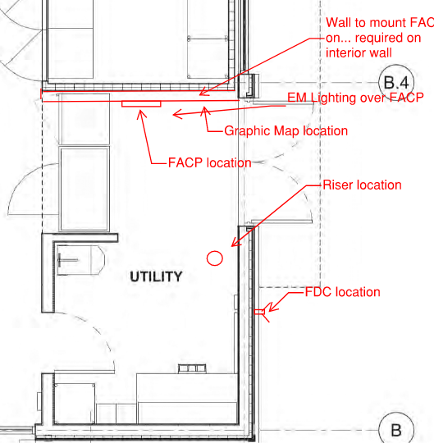

- A sidewalk shall be extended to the riser room door as well as the FDC; a 5’x5’ pad shall be provided in front of the FDC. Address this issue when resubmitting. Satisfied; applicant has acknowledged or addressed with second submittal.

- Utility Plan Set: The applicant shall provide a utility plan that identifies the locations of all utilities on the site (including natural gas and electricity). The overall utility plan shall identify the location of the required fire hydrant(s) and the required underground fire line UFL). The plan set shall identify the UFL on the plan (not just providing a note) while providing the length and diameter of the UFL (as measured from the T at the water main to the flange within the building. Address this issue on the plan set when resubmitting. In addition to the on-site hydrant required above, two additional fire hydrants will be required; a fire hydrant shall be located at the intersection of the private road access and Bayou Gulch Road as well as at the intersection of the private access road and Alpine Phlox Street. Address this issue on the plan set when resubmitting (see below for location of the two required hydrants for the private access road. Not satisfied; while the applicant has not provided the required hydrant at the access road and Alpine Phlox Street. To note that an “existing hydrant near Alpine Phlox is to be utilized. Address this hydrant when resubmitting. Not satisfied with the third submittal; applicant has not noted or acknowledged or addressed as required.

Note – The UFL shall have its own tap; domestic water and the required fire hydrant shall have separate taps.

- Utility Plan Set: The applicant shall utilize the correct signature block for Fire Life Safety on the cover page of the utility documents as well as on the overall utility sheet. The applicant shall not use this signature block on any other pages within the document. This issue must be addressed when resubmitting. Not satisfied; while the applicant has provided the signature block on the cover sheet, the Fire Life Safety signature block has not been provided on the overall utility sheet as required. Address this issue when resubmitting. Not satisfied with the third submittal; applicant has not noted or acknowledged or addressed as required.

Note - An updated signature block has been created with regard to the utility drawing package; typically, this signature block is located on the cover sheet and the overall utility page of the water drawings. The signature block is noted later on in this document, address as applicable.

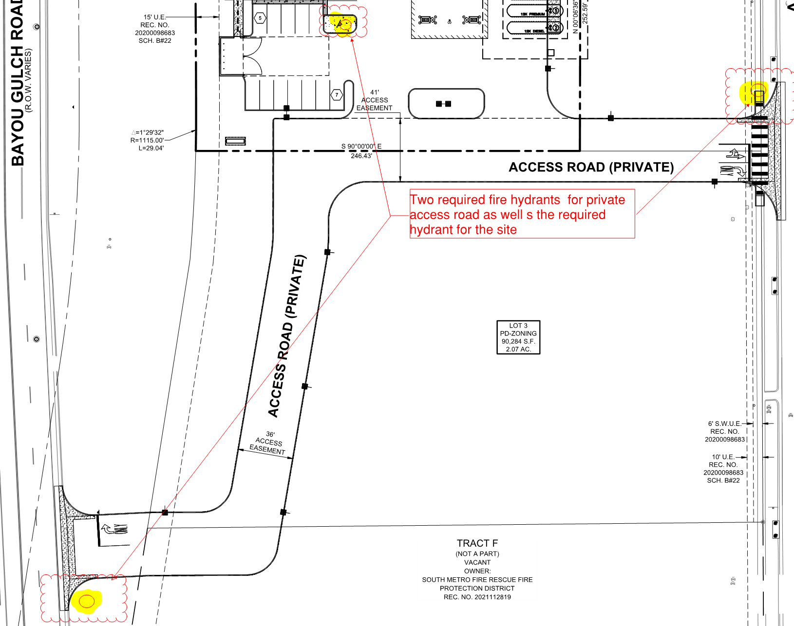

- The Town of Parker requires that fire apparatus access roads meet the clear-width and weight-bearing standards of the jurisdiction in which the project is located. Roadways shall be designed to support the imposed weight of fire apparatus, 30-ton, two axle and 40-ton three, axle vehicles. An unimpeded clear width of 20-feet shall be maintained at all times (though Planning and Zoning requirements may require a minimum of 24 feet). Where building exceed 30 feet in height, a fire department access is required to be 26 feet in width. As such, any location where parked vehicles would obstruct this clear width requirement will require “NO PARKING – FIRE LANE” signage. This signage shall be red on white. Update design criteria has been provided at the end of this document; ensure compliance when resubmitting. Satisfied; applicant has acknowledged or addressed with second submittal.

- The applicant shall provide an auto turn analysis indicating that apparatus can navigate all portions of this site (both sides of the gas canopy); NO PARKING – FIRE LANE signage is required for any portion of the access where the 20-foot clear width requirement cannot be met. This is applicable for the loop around the canopy as well as for each entry. The access on each side of the canopy shall meet his requirement with no portion of the canopy encroaching into the required fire lane access road. See below for the areas required to be included in the auto turn analysis and address when resubmitting (failure to address all locations will result in a delay in approval for this project: Not satisfied; in addition to what was provided, the applicant shall address what was required… see below… there are two area where the applicant has not provided the auto-turn analysis as required; see below and address when resubmitting:

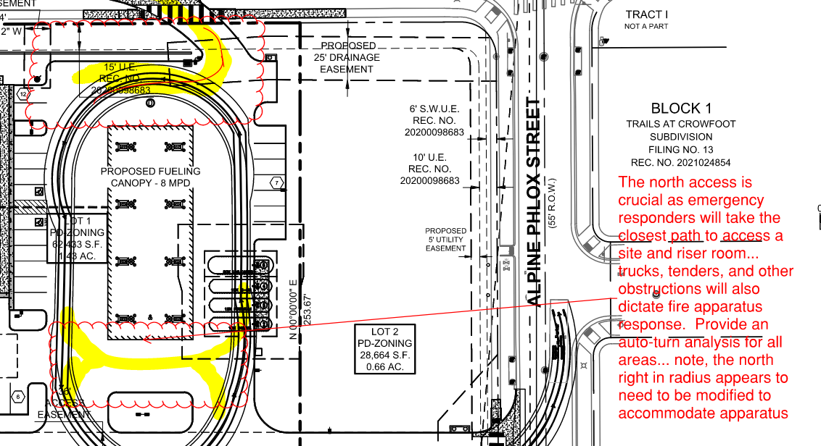

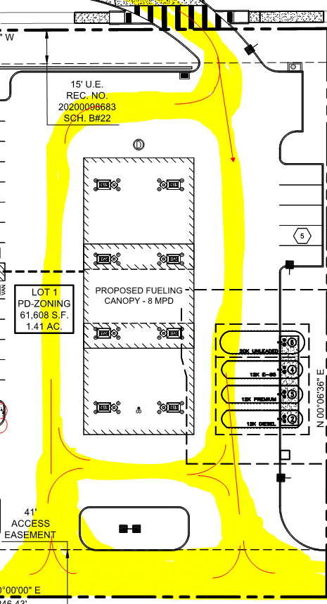

- Should applicant be considering locating such items as propane cages, CO2 systems, ice machines, etc., the applicant should address these issues with the site plan as approval for these items is required with the site plan. Address this issue when resubmitting. Satisfied; applicant has acknowledged or addressed with second submittal.

- Anticipated deferred submittals for this project would include the following (as Applicable):
- Underground Fire Line
- Sprinkler Suppression
- Underground Storage Tanks
- CO2 Beverage System
- Fire Alarm System
- Radio Amplification System
- Access Control

GENERAL COMMENTS (as applicable)
All engineering documents submitted to the Town of Parker shall bear the wet signature and seal of the engineer or architect in responsible charge of the design.

Water distribution and site access components shall be installed and in service prior to the construction of any portion of the structure, except by special permit issued by the Fire District.

Underground fire lines
When thrust blocks are used as part of the pipe restraint system, submitted plans for permit shall provide detailed documentation that the thrust blocks satisfy all requirements of 19 NFPA 24: 10.8.2, including specific thrust block dimensions and mathematical calculations for block dimensions per guidelines provided in Annex A.10.8.2.

FIRE ACCESS ROAD DESIGN CRITERIA

VEHICLE SPECIFICATIONS are provided for the largest apparatus in use by South Metro Fire Rescue. Fire Apparatus Access Roads shall be capable of accommodating this apparatus.
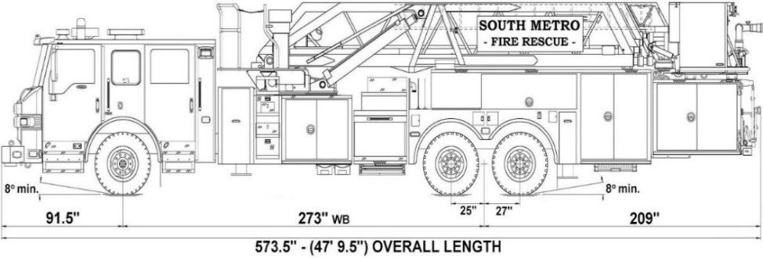

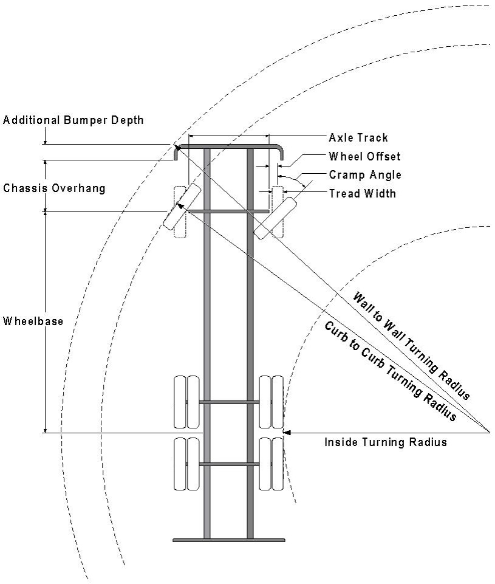

Vehicle Specifications
Length: 47’ 9.5”
Width: 8’ 5” - (10’ 1” mirror to mirror)
Height: 10’ 9”
Wheelbase: 273 in.
Design load: 80,000 pounds Inside Cramp Angle: 40° Axle Track: 83”
Wheel Offset: 5.3”
Tread Width: 13.5”

Turning Radii:
Inside Turn: 26 ft. 1 in. Curb to curb: 41 ft. 11 in. Wall to wall: 46 ft. 8 in.

Where objects are present adjacent to the fire apparatus access road, particularly on turns and turn arounds which require backing, a reasonable safety margin shall be provided to prevent potential damage to the property and to the fire apparatus.

PRIVATE ROADS that provide access to more than two dwellings or one or more commercial buildings shall be constructed to meet the roadway standards approved by the South Metro Fire Rescue Authority for fire apparatus access. Private roads that do not meet the roadway standard may be accepted provided that alternative methods and materials are incorporated into the subdivision that addresses the fire and life safety of the citizens.

FIRE CODE REVIEW BLOCK
All fire hydrants shall be installed according to water utility standards. The number and locations of the fire hydrants as shown on the Overall Utility Plan are correct as specified by the Town of Parker, Community Development Department.

Fire Code Official or Designated Representative Date

(NOTE – Underground Fire Line (UFL) submittal documents must meet the requirements of NFPA 24 when submitting for review.)

Underground Fire Line - Submittal Requirements

Reference: 2019 NFPA 24 Installation of Private Fire Service Mains and Their Appurtenances

A separate permit is required and will be issued pending review of a detailed submittal which must include the following: [21 IFC 901.2]

4.1.1 Working plans shall be submitted for approval to the authority having jurisdiction before any equipment is installed or replaced.

4.1.2 Deviation from approved plans shall require permission of the authority having jurisdiction.

4.1.3 Working plans shall be drawn to an indicated scale on sheets of uniform size, with a plan of each floor as
applicable, and shall include the following items that pertain to the design of the system:

(1) Name of owner
(2) Location, including street address
(3) Point of compass
(4) A graphic representation of the scale used on all plans
(5) Name and address of contractor
(6) Size and location of all water supplies
(7) The following items that pertain to private fire service mains:
(a) Size
(b) Length
(c) Location
(d) Material (ductile-iron, PVC., etc.)
(e) Point of connection to city main
(f) Sizes, types, and locations of valves, depth at which the top of the pipe is laid below grade
(g) Method of restraint (Meg-a-Lug or similar)

4.1.4 The working plan submittal shall include the manufacturer's installation instructions for any specially listed equipment, including descriptions, applications, and limitations for any devices, piping, or fittings. Submittals must include installation specifications for thrust blocks, corrosion protection, restraint system, bedding, detail of pipe under the building up to, and including, the flange. When it is intended that a different contractor will extend the fire line from a stopping point outside the building, to the inside flange, a second submittal and permit is required.

All tees, plugs, reducers, valves, and hydrant branches shall be restrained against movement by thrust blocks [10.8.2] or restrained joint systems [10.8.3]. When thrust blocks are used as part of the pipe restraint system, submitted plans shall provide detailed documentation that the thrust blocks satisfy all requirements of Section 10.8.2, including specific thrust block dimensions and mathematical calculations for block dimensions per guidelines provided in Annex A.10.8.2.

Any individual or company who physically works on or installs any part of a fire suppression system, including underground supply lines, from public water lines to system risers and backflow preventers, must be registered with the Colorado Division of Fire Safety. [Dept of Public Safety, Division of Fire Safety, Fire Suppression Program 8 CCR 1507-11:3.1.2] Documentation of valid annual registration may be required with plan submittal.

The following website for the Colorado Division of Fire Safety will provide registration instructions.
http://dfs.state.co.us/SuppAppsProcInsp.htm
All submittals must display a wet stamp and original signature by a Colorado licensed professional engineer or NICET III, or higher, in fire suppression systems. [Dept of Public Safety, Division of Fire Safety, Fire Suppression Program 8 CCR 1507

