

Town of Parker Community Development Department
Development Review Division
Attention: Ashley Chasez

Application Type: Subdivision - Final Plat
Status: First Referral
Application Name: Compark Village South F1 AMD 3
Case/AP#: SUB23-006
Referral Received: April 11, 2023
Comments Due: May 9, 2023

Application Location: Generally located south of the future Belford Avenue west of Chambers.

Review date: April 12, 2023
Plan reviewer: Randall L. Capra, rcapra@parkeronline.org
Phone: 303.805.3163

TOWN OF PARKER - FIRE/LIFE SAFETY:

1st Submittal – Reviewed April 3, 2023
2nd Submittal – Reviewed July 5, 2023 (Comments in red, italicized font)
3rd Submittal – Reviewed (Comments in bold, red, italicized font)

Narrative: The applicant, Century Communities, is proposing a Final Plat for 33 single family detached lots, park space and open space. The site is located south of the future Belford Avenue west of Chambers.

Code Reference: 2021 International Fire Code, 2021 International Building Code, 2020 NEC

UNRESOLVED ISSUES/COMMENTS

The items noted below with a comment number (1, 2 etc.) are items that need to be corrected to show compliance with the applicable codes. Please provide a written response to this letter indicating where the corrections are made on the plans (cloud the plans as applicable) or acknowledgements are required. This will speed up the second review process.

- The applicant shall be aware that no vertical construction on this site will be allowed until such time that curb gutter and first lift of asphalt are installed; a site inspection will be required to ensure that this requirement is made prior to allowing vertical construction to commence. Satisfied; the applicant has noted with the second submittal.

- The Town of Parker requires that fire apparatus access roads meet the clear-width and weight-bearing standards of the jurisdiction in which the project is located. Roadways shall be designed to support the imposed weight of fire apparatus, 30-ton two axle and 40-ton three axle vehicles. An unimpeded clear width of 20-feet shall be maintained at all times. As such, any location where parked vehicles would obstruct this clear width requirement will require “NO PARKING – FIRE LANE” signage. This signage shall be red on white. Satisfied; the applicant has noted with the second submittal.

- See criteria for hydrant spacing below:

- Fire hydrant spacing shall not exceed 500 feet
- A fire hydrant shall be located at each entry into the site
- Fire hydrants shall be staggered with regard to layout (alternating between one side of the street for another side of the street where applicable)
- Fire hydrants shall be located at the end of cull-da-sacs (a reduction for spacing is required for dead-end streets.
- Fire hydrants shall be located at corners (in this way, fire personnel do not have to pass a home to catch a hydrant only to have to back track)
- Fire hydrants shall be staggered when placing fire hydrants.

The applicant has done a good job with the hydrant distribution for this project; no specific comments have been made though other than all hydrants required on either side of Deertrack Lane (outside of the current proposal). Requires that the hydrants shaded in gray will need to be installed with the current proposal. This includes the hydrants on the west end of Bunny Hop Lane and the west end of Deertrack Lane, as well. Not satisfied; the applicant has not addressed with the second submittal. Missing from the submittal documents is a pdf of the required utility drawings showing compliance with the criteria noted below. Additionally, many items look as if an attempt to respond to them was to have been made, it appears that there were not followed through with. Utility drawings have been provided and comments addressed. The fire hydrants shaded in gray have been installed concurrent with the completion of the infrastructure in Compark Village South Filing 2 and Compark Village South Filing 2, Amendment 1.

- The individual builders shall be made aware that no more than thirty homes can be under construction without having two points of access provided/completed/accepted. This will require that Belford be completed to both Belford and Chambers as well as two access points, split by one half the diagonal of the subdivision be provided before a thirty-first building permit can be issued. This is applicable to not just this filing but is a cumulative number based upon the number of homes and not specific to filing or builder. Apartments count towards this number as well. Address this issue when resubmitting. Not satisfied; the applicant has not noted or addressed with the second submittal. Belford Avenue is now paved from South Peoria Street east to South Chambers Road. With regard to access, Applicant responds that the infrastructure, including roadways, for Compark Village South Filing 2 and Compark Village South Filing 2, Amendment 1 is complete. Accordingly, there are only 21 lots on Bunny Hop Lane until the roadway connection with the apartment site is complete. The lots on Deertrack Lane already have two points of access via Badger Run Street and Lynx Cat Street in Compark Village South Filing 2 and Wolf Fox Street in Compark Village South Filing 2, Amendment 1.

- The individual builders (this is reiterated) shall be made aware that vertical construction (either down or up) will not be allowed until the following can be met (inspections by Fire Life Safety of the site will be required prior to going vertical): Permanent access is required for all structures; curb, gutter, and first lift of asphalt must be installed - All fire hydrants are installed, accepted, and are fully operable - All streets signs are installed - Addresses are provided/permanently posted for each structure that is to be constructed - Dead-end access roads cannot exceed 150 feet without an approved turn-around. Not satisfied; the applicant has not acknowledged or addressed with the second submittal. Applicant acknowledges the stated requirements. Applicant anticipates that the connection of Bunny Hop Lane to the apartment site will be completed prior to requesting building permits on this road. In the event that the connection through the apartment site is delayed, Applicant will submit for approval of a turn-around and construct the same prior to seeking building permits.

- The applicant shall be aware that storage tanks used for fuel are required to be “permitted” through the building department before being brought out to any construction site. This information shall be disseminated to all construction teams as applicable. Not satisfied; the applicant has not acknowledged or addressed with the second submittal. Applicant acknowledges the stated requirements.

- Specific to future applications (beyond spine roads), the applicant shall provide an overall site plan for each filing that shows the proposed street names (once these names have been approved by Douglas County). Please work with Caitlin Zeiler, with Douglas County, with regard to addressing and street names for this site; Caitlin’s email is Caitlin Zeiler czeiler@douglas.co.us. Note – Lot numbers do not constitute “addressing” even as these documents are generally named “address plat”. Not satisfied; the applicant has not acknowledged or addressed with the second submittal. Applicant acknowledges the stated requirements and has worked with Caitlin Zeiler to obtain lot addresses. The only new road in this application is already named (Bunny Hop Lane) as it is an extension of the existing Bunny Hop Lane.

GENERAL COMMENTS
All engineering documents submitted to the Town of Parker shall bear the wet signature and seal of the engineer or architect in responsible charge of the design.

Water distribution and site access components shall be installed and in service prior to the construction of any portion of the structure, except by special permit issued by the Fire District.

Underground fire lines
When thrust blocks are used as part of the pipe restraint system, submitted plans for permit shall provide detailed documentation that the thrust blocks satisfy all requirements of 19 NFPA 24: 10.8.2, including specific thrust block dimensions and mathematical calculations for block dimensions per guidelines provided in Annex A.10.8.2.

FIRE CODE REVIEW BLOCK – This block shall be provided on all pages of the Overall Utility Drawings (as well as the cover sheet).
FIRE CODE REVIEW BLOCK
All fire hydrants shall be installed according to water utility standards. The number and locations of the fire hydrants as shown on the Overall Utility Plan are correct as specified by the Town of Parker, Community Development Department.

Fire Code Official or Designated Representative Date

(NOTE – Underground Fire Line (UFL) submittal documents must meet the requirements of NFPA 24 when submitting for review.)

FIRE ACCESS ROAD DESIGN CRITERIA

VEHICLE SPECIFICATIONS are provided for the largest apparatus in use by South Metro Fire Rescue. Fire Apparatus Access Roads shall be capable of accommodating this apparatus.

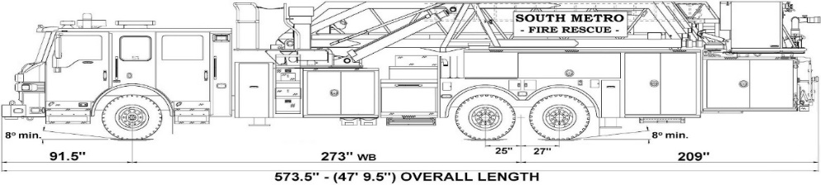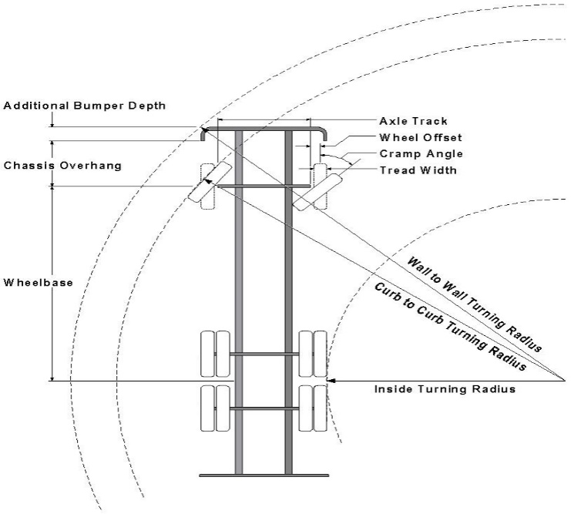

Vehicle Specifications
Length: 47’ 9.5”
Width: 8’ 5” - (10’ 1” mirror to mirror)
Height: 10’ 9”
Wheelbase: 273 in.
Design load: 80,000 pounds Inside Cramp Angle: 40° Axle Track: 83”
Wheel Offset: 5.3”
Tread Width: 13.5”

Turning Radii:
Inside Turn: 26 ft. 1 in. Curb to curb: 41 ft. 11 in. Wall to wall: 46 ft. 8 in.

Where objects are present adjacent to the fire apparatus access road, particularly on turns and turn arounds which require backing, a reasonable safety margin shall be provided to prevent potential damage to the property and to the fire apparatus.

PRIVATE ROADS that provide access to more than two dwellings or one or more commercial buildings shall be constructed to meet the roadway standards approved by the Town of Parker for fire apparatus access. Private roads that do not meet the roadway standard may be accepted provided that alternative methods and materials are incorporated into the subdivision that addresses the fire and life safety of the citizens.

Underground Fire Line - Submittal Requirements

Reference: 2019 NFPA 24 Installation of Private Fire Service Mains and Their Appurtenances

A separate permit is required and will be issued pending review of a detailed submittal which must include the following: [21 IFC 901.2]

4.1.1 Working plans shall be submitted for approval to the authority having jurisdiction before any equipment is installed or replaced.

4.1.2 Deviation from approved plans shall require permission of the authority having jurisdiction.

4.1.3 Working plans shall be drawn to an indicated scale on sheets of uniform size, with a plan of each floor as
applicable, and shall include the following items that pertain to the design of the system:

(1) Name of owner
(2) Location, including street address
(3) Point of compass
(4) A graphic representation of the scale used on all plans
(5) Name and address of contractor
(6) Size and location of all water supplies
(7) The following items that pertain to private fire service mains:
(a) Size
(b) Length
(c) Location
(d) Material (ductile iron, PVC, etc.)
(e) Point of connection to city main
(f) Sizes, types, and locations of valves, depth at which the top of the pipe is laid below grade
(g) Method of restraint (Meg-a-Lug or similar)
(h) Stamped and signed thrust block calculations specific to the soils conditions for the site
(i) Copy of the installer’s state license

4.1.4 The working plan submittal shall include the manufacturer's installation instructions for any specially listed equipment, including descriptions, applications, and limitations for any devices, piping, or fittings. Submittals must include installation specifications for thrust blocks, corrosion protection, restraint system, bedding, detail of pipe under the building up to, and including, the flange. When it is intended that a different contractor will extend the fire line from a stopping point outside the building, to the inside flange, a second submittal and permit is required.

All plans shall be combined into a single pdf prior to uploading to the Town of Parker website.

All tees, plugs, reducers, valves, and hydrant branches shall be restrained against movement by thrust blocks [10.8.2] or restrained joint systems [10.8.3]. When thrust blocks are used as part of the pipe restraint system, submitted plans shall provide detailed documentation that the thrust blocks satisfy all requirements of Section 10.8.2, including specific thrust block dimensions and mathematical calculations for block dimensions per guidelines provided in Annex A.10.8.2.

Any individual or company who physically works on or installs any part of a fire suppression system, including underground supply lines, from public water lines to system risers and backflow preventers, must be registered with the Colorado Division of Fire Safety. [Dept. of Public Safety, Division of Fire Safety, Fire Suppression Program 8 CCR 1507-11:3.1.2] Documentation of valid annual registration is required with plan submittal.

The following website for the Colorado Division of Fire Safety will provide registration instructions.
http://dfs.state.co.us/SuppAppsProcInsp.htm
All submittals must display a wet stamp and original signature by a Colorado licensed professional engineer or NICET III, or higher, in fire suppression systems. [Dept. of Public Safety, Division of Fire Safety, Fire Suppression Program 8 CCR 1507

