Aldridge Transportation Consultants, LLC

Advanced Transportation Planning and Traffic Engineering

John M.W. Aldridge, P.E. 1082 Chimney Rock Road
Colorado Licensed Professional Engineer Highlands Ranch, CO 80126
303-703-9112
Mobile: 303-594-4132
john@atceng.com
November 30, 2023

Parker Pointe - SUB23-016
Response to TOP Comments dated July 19, 2023

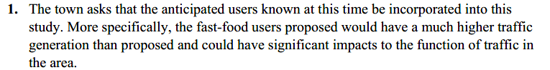

The anticipated users are not known at this time. We have assumed a shopping plaza use that includes high traffic generating uses such as a gas station with a convenience store, coffee shops, and fast-food restaurants.

Significant improvements to the traffic signal are underway. They include a southbound dual left turn and lane widening/revision of signal heads on the westbound approach to better accommodate the eastbound movements. Note that the signal is fully actuated, and as such the phase splits and cycle times adjust based on demand and optimization. A LOS F movement in one cycle could be LOS A in the next.

Acknowledged.


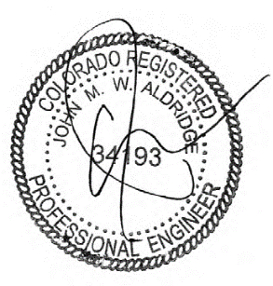
Respectfully submitted,
Aldridge Transportation Consultants, LLC

John M.W. Aldridge, P.E.
Principal

