

Town of Parker Community Development Department
Development Review Division
Attention: Krista Flynt

Application Type: Site Plan – Minor Amendment
Status: First Referral
Application Name: Parkglenn F3 L1 B2 - Coffee Shop and Car Wash
Case/AP#: SP20-119
Referral Received: January 22, 2021
Comments Due: February 23, 2021

Application Location: Generally located on the southeast corner of Parkglenn and Parker Road

Review date: February 12, 2021
Plan reviewer: Randall L. Capra, rcapra@parkeronline.org
Phone: 303.805.3169

TOWN OF PARKER - FIRE/LIFE SAFETY:

1st Submittal – Reviewed January 6, 2021
2nd Submittal – Reviewed April 19, 2021 (comments in red, italicized font)
3rd Submittal – Reviewed June 28, 2021 (comments in bold, red, italicized font)
4th Submittal – Reviewed August 3, 2021 (comments in bold, red, italicized font with a yellow highlight)

Narrative: The applicant, Masterworks, LLC, is proposing a Site Plan Amendment to replace an existing gas station with a coffee shop. The existing carwash is to remain. The site is located at the southeast corner of Parker Road and Parkglenn Drive.

Code Reference: 2018 International Fire Code, 2018 International Building Code, 2017 NEC (adopted codes valid through Dec 31, 2021; projects submitted for building permits will be required to meet the 2021 ICC codes and the 2020 NEC when submitted after December 31, 2021).

UNRESOLVED ISSUES/COMMENTS

It appears that the parking requirements for this site cannot be met; the applicant is indicating that off site parking can be used (or on street parking). The applicant shall be advised that where any street or private drive is less than 28 feet in width, parking is not allowed on either side of the street or private drive. Where the Drive is 28 feet to 34 feet in width, parking is allowed on one side of the street or private drive and for streets or private drives where the road width exceeds 34 feet, parking is allowed on both sides of the street.

Please see the section on FIRE LANE signage, located later on within this document. It appears that NO PARKING - FIRE LANE signage will be required on both sides of the private drive (as the private drives are only 24 feet in width) to avoid the possibility/problem associated with customers/personnel parking on the drives. This issue shall be addressed when resubmitting. Satisfied; applicant address with current submittal.

- The applicant shall be aware that no vertical construction on this site will be allowed until such time that curb gutter and first lift of asphalt are installed; a site inspection will be required to ensure that this requirement is made prior to allowing vertical construction to commence. Not satisfied; applicant did not address/acknowledge with current submittal. Requirement is applicable though applicant was silent on this issue.

- The applicant shall be aware that the Town of Parker has officially adopted the 2018 ICC codes as of January 1, 2019; all submittal documents are required to comply with the 2018 ICC codes. Note – The Town of Parker will have officially adopted the 2021 ICC family on January 1, 2022; the 2020 NEC will be adopted at this time, as well. Any submittals received after December 31, 2021 will be required to meet the newly adopted codes. Not satisfied; applicant did not address/acknowledge with current submittal. Requirement is applicable though applicant was silent on this issue.

- The Town of Parker requires that fire apparatus access roads meet the clear-width and weight-bearing standards of the jurisdiction in which the project is located. Roadways shall be designed to support the imposed weight of fire apparatus, 30-ton two axle and 40 ton three axle vehicles. An unimpeded clear width of 20-feet shall be maintained at all times. As such, any location where parked vehicles would obstruct this clear width requirement will require “NO PARKING – FIRE LANE” signage. This signage shall be red on white. Update design criteria has been provided at the end of this document; ensure compliance when resubmitting. Note – information on fire lane signage can be found at the end of this document. Not satisfied; applicant did not address/acknowledge with current submittal. Requirement is applicable though applicant was silent on this issue.

- The site plan indicates that some modifications are to occur to the site; an auto-turn analysis is required to ensure that emergency apparatus can navigate the site. Specs on fire apparatus are provided later in this document; use this information to create the required auto-turn analysis. Satisfied; applicant has addressed with current submittal.

- The Overall Utility plan does not include the required Fire Life Safety signature block; a Fire Life Safety signature block is required on the cover sheet and the Overall Utility plan (an example of the signature block is provided in the body of this response); the Fire Life Safety signature block is not required on the rest of the utility plan set of other civil or construction documents. Satisfied; applicant has addressed with current submittal.

GENERAL COMMENTS (as applicable)

All engineering documents submitted to the Town of Parker shall bear the wet signature and seal of the engineer or architect in responsible charge of the design.

Water distribution and site access components shall be installed and in service prior to the construction of any portion of the structure, except by special permit issued by the Fire District.

Underground fire lines
When thrust blocks are used as part of the pipe restraint system, submitted plans for permit shall provide detailed documentation that the thrust blocks satisfy all requirements of 13 NFPA 24: 10.8.2, including specific thrust block dimensions and mathematical calculations for block dimensions per guidelines provided in Annex A.10.8.2.

Underground Fire Line - Submittal Requirements

Reference: 2016 NFPA 24 Installation of Private Fire Service Mains and Their Appurtenances

A separate permit is required and will be issued pending review of a detailed submittal which must include the following: [18 IFC 901.2]

4.1.1 Working plans shall be submitted for approval to the authority having jurisdiction before any equipment is installed or replaced.

4.1.2 Deviation from approved plans shall require permission of the authority having jurisdiction.

4.1.3 Working plans shall be drawn to an indicated scale on sheets of uniform size, with a plan of each floor as
applicable, and shall include the following items that pertain to the design of the system:

(1) Name of owner
(2) Location, including street address
(3) Point of compass
(4) A graphic representation of the scale used on all plans
(5) Name and address of contractor
(6) Size and location of all water supplies
(7) The following items that pertain to private fire service mains:
(a) Size
(b) Length
(c) Location
(d) Material (ductile iron, PVC, etc.)
(e) Point of connection to city main
(f) Sizes, types, and locations of valves, depth at which the top of the pipe is laid below grade
(g) Method of restraint (Meg-a-Lug or similar)
(h) Stamped and signed thrust block calculations specific to the soils conditions for the site
(i) Copy of the installer’s state license

4.1.4 The working plan submittal shall include the manufacturer's installation instructions for any specially listed equipment, including descriptions, applications, and limitations for any devices, piping, or fittings. Submittals must include installation specifications for thrust blocks, corrosion protection, restraint system, bedding, detail of pipe under the building up to, and including, the flange. When it is intended that a different contractor will extend the fire line from a stopping point outside the building, to the inside flange, a second submittal and permit is required.

All plans shall be combined into a single pdf prior to uploading to the Town of Parker website.

All tees, plugs, reducers, valves, and hydrant branches shall be restrained against movement by thrust blocks [10.8.2] or restrained joint systems [10.8.3]. When thrust blocks are used as part of the pipe restraint system, submitted plans shall provide detailed documentation that the thrust blocks satisfy all requirements of Section 10.8.2, including specific thrust block dimensions and mathematical calculations for block dimensions per guidelines provided in Annex A.10.8.2.

Any individual or company who physically works on or installs any part of a fire suppression system, including underground supply lines, from public water lines to system risers and backflow preventers, must be registered with the Colorado Division of Fire Safety. [Dept. of Public Safety, Division of Fire Safety, Fire Suppression Program 8 CCR 1507-11:3.1.2] Documentation of valid annual registration is required with plan submittal.

The following website for the Colorado Division of Fire Safety will provide registration instructions.
http://dfs.state.co.us/SuppAppsProcInsp.htm
All submittals must display a wet stamp and original signature by a Colorado licensed professional engineer or NICET III, or higher, in fire suppression systems. [Dept. of Public Safety, Division of Fire Safety, Fire Suppression Program 8 CCR 1507

FIRE ACCESS ROAD DESIGN CRITERIA

VEHICLE SPECIFICATIONS are provided for the largest apparatus in use by South Metro Fire Rescue. Fire Apparatus Access Roads shall be capable of accommodating this apparatus.

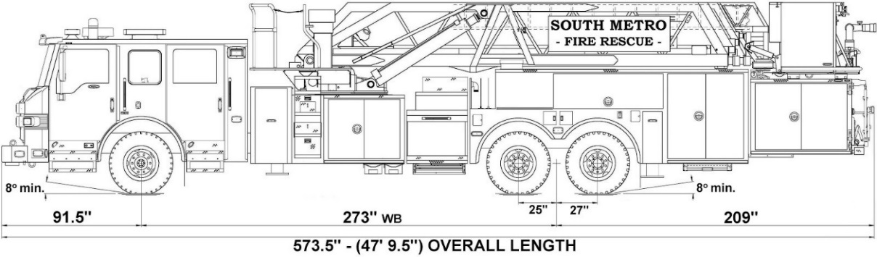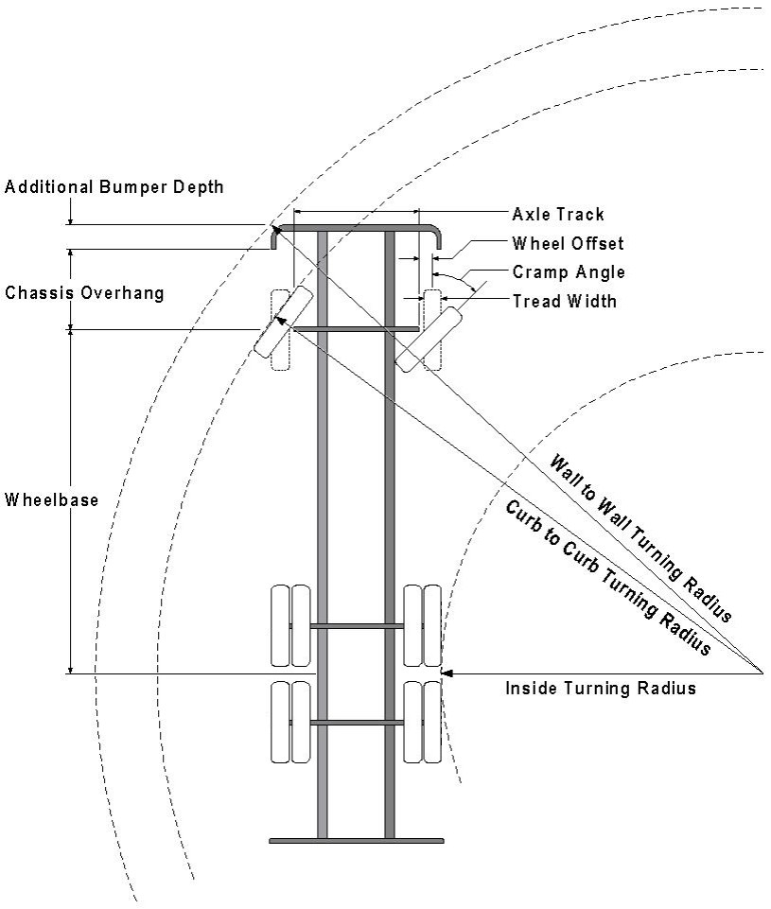

Vehicle Specifications
Length: 47’ 9.5”
Width: 8’ 5” - (10’ 1” mirror to mirror)
Height: 10’ 9”
Wheelbase: 273 in.
Design load: 80,000 pounds Inside Cramp Angle: 40° Axle Track: 83”
Wheel Offset: 5.3”
Tread Width: 13.5”

Turning Radii:
Inside Turn: 26 ft. 1 in. Curb to curb: 41 ft. 11 in. Wall to wall: 46 ft. 8 in.

Where objects are present adjacent to the fire apparatus access road, particularly on turns and turn arounds which require backing, a reasonable safety margin shall be provided to prevent potential damage to the property and to the fire apparatus.

PRIVATE ROADS that provide access to more than two dwellings or one or more commercial buildings shall be constructed to meet the roadway standards approved by the South Metro Fire Rescue Authority for fire apparatus access. Private roads that do not meet the roadway standard may be accepted provided that alternative methods and materials are incorporated into the subdivision that addresses the fire and life safety of the citizens.

FIRE CODE REVIEW/SIGNATURE BLOCK
All fire hydrants shall be installed according to water utility standards. The number and locations of the fire hydrants as shown on the Overall Utility Plan are correct as specified by the Town of Parker, Community Development Department.

Fire Code Official or Designated Representative Date

(NOTE – Underground Fire Line (UFL) submittal documents must meet the requirements of NFPA 24 when submitting for review.)

FIRE LANE SIGN PLACEMENT

Posting of Fire Lanes: The posting of the “Fire Lanes” is required.

Fire Lane Sign Dimensions. NO PARKING – FIRE LANE signs shall be 12 inches wide and 18 inches high.
3” High
¼ ” Stroke Red Letters

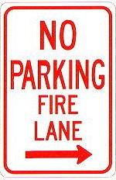
12”
18”

Fire Lane Sign Characteristics: Signs shall be engineer grade reflective sheeting on 0.80 aluminum with red lettering on a white background.
2 ” High 1/8 ”
Stroke
Red letters
Fire Lane Sign Locations. Fire apparatus access roadways between 20 and 28 feet wide, signs shall be posted on both sides. Fire apparatus access roadways between 28 feet wide and 34 feet wide, signs may be posted on one side only.
Fire Lane Sign Installation. NO PARKING – FIRE LANE signs shall be installed as follows:
- Bottom edge of the signs shall be 7 feet above surface (sidewalk) and post shall be placed 24 inches from flow line (curb).
- One sign at the beginning of the restriction (one arrow pointing towards the restriction zone).
- One sign at the end of the restriction (one arrow pointing back into restricted zone).
- One sign at least every 150 ft. within the restricted area (double arrow pointing in each direction, to indicate the continuing restriction).
- Spaced evenly within the restriction (for straight curbs/zones). For example, if the parking restriction zone is 300 ft long, only one double arrow sign is required at a distance of 150 ft. from the beginning of the restriction. If the restriction zone is 400 ft. long, two double arrow signs are required; spaced 100 ft. evenly from each other and from the beginning/ending signs.
- Spaced so that at least one readable sign is visible in front of a parked vehicle from any point along the restriction (for curved curbs/zones and areas that may present visual obstacles.)
- Set at an angle of no fewer than 30 degrees and no more than 45 degrees with the lane of traffic flow visible to approaching traffic.
- Signs shall be provided at all normal and emergency access points to structures and within 20 feet of each fire hydrant and fire department connection (FDC) in compliance with UFC 901.4.2.
- Some areas may need additional fire lane signs. Check with the Division of Life Safety for any additional requirements.

Fire Lane Sign Types. The diagrams below indicate the types of signs that may be used, and the recommended placement.

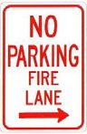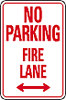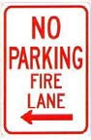
200 feet
200 feet

Additional sign styles may be used – provided the same type is used consistently.

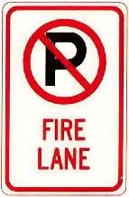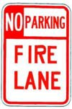

Painting of Curbs or Streets. In addition to the required signage, South Metro Fire Rescue does permit fire lanes to be painted with curb or street markings. However, these markings shall not replace the required fire lane signs. Curbs may be painted red with 3-inch white block letters stating NO PARKING – FIRE LANE. Lettering shall be spaced every 15 feet.

