
6901 South Pierce Street, Suite 315 Littleton, Colorado 80128 303-232-8088

1June 19, 2018

Mr. Randall Capra
Town of Parker Fire Department
20120 East Mainstreet
Parker, CO 80138

SUBJECT: ANX17-008, SUB17-058, and Z17-024 Annexation, Minor Development Plat, and Zoning for Parker Pointe
Dear Mr. Capra,

Below I have reproduced your comment letter on the above project and added responses in blue.

UNRESOLVED ISSUES/COMMENTS

- The submittal documents do not address the full extent of the site infrastructure that is to take place prior to the construction of a any building within the proposed subdivision; the submittal documents shall indicate clearly the level of infrastructure to be completed before work on Lot 10 is allowed to progress (i.e. the ring road, all hydrants around the ring road, all access three access points into the subdivision, etc.). Address this issue when resubmitting. The civil CD set presented represents work to be completed prior to construction on Lots 10 and 11. Lots 10 and 11 submittals are being delayed as this work will need to be completed prior to construction of individual lots. Completed work will need to include the water lines complete and live, as well as paved access roads.

Sheet C7.02: The applicant has used the incorrect signature block for fire sign off; see below (later in response letter) information on the correct signature block. Ensure that this block is noted on the cover page of the utility drawings and on the Overall Utility page. Satisfied; applicant addressed with the current submittal.

- Sheet C7.02: The proposed hydrant distribution system is not adequate; the hydrant distribution shall meet the requirements of the 2015 IFC, Sections 507.5 and Appendix B and Appendix C as well as NFPA 24, Section 7.2.3 where this section requires that a fire hydrant be located not less than 40 feet from the building to be protected. Fire hydrants shall be located at each of the three entry ways into the site as well as locating hydrants around the ring road proposed (there are currently no fire hydrants shown on the east side of the ring road). The applicant shall include the east entry on the Overall Utility plan set.

I would encourage the applicant to reach out to me with any questions. Not satisfied; a fire hydrant shall be added to the entrance of the right in/right out at the Parker Road entry or at the leg of road section that will come in east of the project at Stroh Road (this portion of the site was not shown on the utility drawings). See below for the area indicated as missing: A hydrant is added at the easterly access drive as well as additional hydrants on the rear access drive located along the east property line per our meeting.

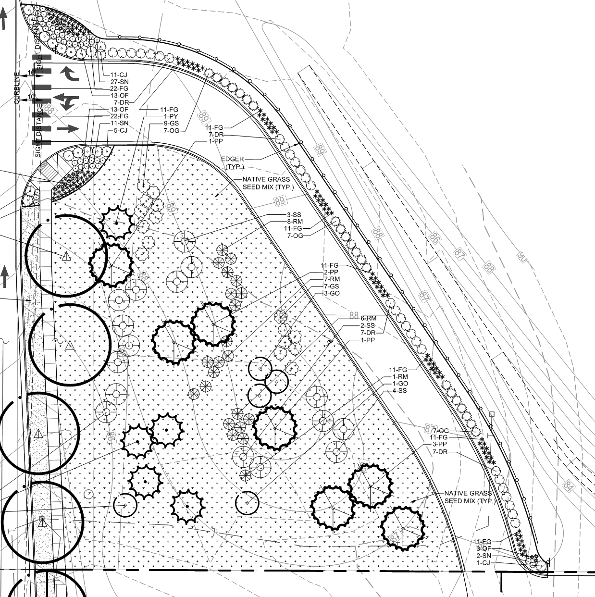

- The Parker Pointe Utility Study indicates that applicant is using a fire-flow of 1,000 gpm as the fire-flow for a fully sprinklered building; the demand is not correct. The applicant must be able to define the fire-flow for each building to be constructed; the fire-flow is based upon the square footage of the building as well as the construction type of the building. A 25% reduction in the fire-flow is allowed for a fully sprinklered building, in accordance with NFPA 13 and section 903.3.1.1 though the minimum fire-flow for a fully sprinklered Type V-B, 3,600 square foot (or smaller building) would be 1,125 gpm.

The applicant shall revisit the utility study and correct the fire flow requirements to correctly reflect the requirements of the code.

I would encourage the applicant to reach out to me for assistance in this area. Satisfied; applicant addressed with the current submittal.

- Sheet C7.02: The Utility plan set shall show the size of all water lines; the plans shall show the size of the water mains, hydrant lines, and the size of the underground fire lines (UFL); the submittal shall also identify each UFL on the plan set. The size and design of all water lines and hydrants is shown on sheets C7.10 thru C7.13. UFL’s will be constructed when the plans come in for individual lots. Only stubs for Lots 10 and 11 are to be constructed for UFL’s at this time.

- Sheet C7.02 (Sheet identified as the applicant has not provided an overall site plan page): The access shown for Lot 11 seems to indicate that only one point of access is to be provided; the applicant shall be aware that full movement access shall be provided to all lots with that access being made available off of the yet to be named ring road. Individual lot access will be presented when plans for individual lots come in. Comment noted that full access will be required for each lot as well as adequate turn around or thru path for truck access be provided.

- Sheet C7.02: The Overall Utility documents shall not be used for the UFL submittal package; a separate package shall be created that complies with all requirements of NFPA 24 (i.e. includes stamped and signed thrust block calculations, identifies length of the UFL, provides the full scope of work to be installed,etc. I have included the submittal requirements below to assist the applicant as the project progresses. Comment noted. These plans will be provided as individual buildings come in for review.

TYPICAL COMMENTS (as applicable)

- The applicant shall provide an auto turn analysis indicating that apparatus can navigate all portions of this site (both sides of the gas canopy); An Autoturn plan is included for the infrastructure currently proposed. This will need to be expanded as individual lots come in for review.

- NO PARKING – FIRE LANE signage is required for any portion of the access where the 20 foot clear width requirement cannot be met; this requirement is applicable for both the ring road and any internal lot. No Parking Fire Lane signs are added to sheets C1.10 and C1.11.

- The Town of Parker requires that fire apparatus access roads meet the clear-width and weight-bearing standards of the jurisdiction in which the project is located. Roadways shall be designed to support the imposed weight of fire apparatus, 24 ton two axle and 30 ton three axle vehicles. An unimpeded clear width of 20 feet shall be maintained at all times. As such, any location where parked vehicles would obstruct this clear width requirement will require “NO PARKING – FIRE LANE” signage. This signage shall be red on white. No Parking Fire Lane signs are added to sheets C1.10 and C1.11.

- The applicant shall provide first lift of asphalt and curb and gutter before going vertical on this site. All fire hydrants, street signage, and building address are required to be installed prior to going vertical. Comment noted.

- An updated signature block has been created with regard to the utility drawing package; typically, this signature block is located on the cover sheet and the overall utility page of the water drawings. The signature block is noted below. New signature block is included on the plans.

GENERAL COMMENTS (as applicable)
All engineering documents submitted to the Town of Parker shall bear the wet signature and seal of the engineer or architect in responsible charge of the design. Comment noted.

Water distribution and site access components shall be installed and in service prior to the construction of any portion of the structure, except by special permit issued by the Fire District. Comment noted.

Underground fire lines
When thrust blocks are used as part of the pipe restraint system, submitted plans for permit shall provide detailed documentation that the thrust blocks satisfy all requirements of 13 NFPA 24: 10.8.2, including specific thrust block dimensions and mathematical calculations for block dimensions per guidelines provided in Annex A.10.8.2. Comment noted.

